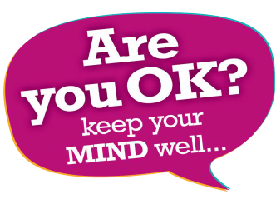

North East Lincolnshire’s Transformation Plan for Children & Young People’s

Mental Health & Emotional Wellbeing October 2017 - March 2021



|  |  |  |
| --- | --- | --- |
| **Section** | **Contents** | **Page Number** |
| 1 | Foreword |  |
| 2 | Introduction |  |
| 3 | What are the Mental Health Needs of CYP in North East Lincolnshire? |  |
| 4 | Current Service Offer |  |
| 5 | Where Are We Now? |  |
| 6 | Building the Workforce |  |
| 7 | Engagement, Participation and Multi-agency Working |  |
| 8 | Sustainability Plans |  |
| 9 | Future Allocation and Spend |  |
| 10 | Outcome and Performance Monitoring |  |
| 11 | Governance |  |
| 12 | Supporting Documents |  |

1. **Foreword**

This document should be read as an additional supplement to North East Lincolnshire Council (NELC) and North East Lincolnshire Clinical Commissioning Group (NELCCG) Transformation Plan 2015-2020 and North East Lincolnshire’s Transformation Plan Children and Young People’s Mental Health and Emotional Wellbeing October 2016 – March 2018.

The document will be refreshed and published by 31st October 2017, and acknowledged by the following boards:

* Health and Wellbeing Board
* Local Safeguarding Children’s Board
* Children’s Partnership Board
* Healthwatch
* North East Lincolnshire Parent Participation Forum
* Youth Action Group

We are working in collaboration with Youth Action Group to create a summary document for Children and Young People (CYP) to understand what the Future in Mind re-fresh 2016 -2021 means to them. .

The refreshed plan will be published on the following websites:

* North East Lincolnshire Council
* Local Safeguarding Children’s Board
* North East Lincolnshire Clinical Commissioning Group

1. **Introduction**

The purpose of this document is to outline the key achievements and to detail future areas of focus for children and young people’s mental health until 31st March 2020. It is intended that this document will be live to ensure responsiveness to local and national need.

NELC and NELCCG are uniting together to further enhance partnership working. This union will allow for an integrated approach to the future direction by exploring new models, considering connectivity within the wider context of local, regional and national drivers and identify opportunities to deliver benefits by working more closely together.

There will be single leadership across both organisations, overseen by governance that promotes joint democratic and clinical leadership which shares the vision that, the well-being of the area and the people we serve are at the core of what we do.

Furthermore, we are currently in a three year transformation programme which is being implemented by NELC, for children and young people (CYP) aged between 0-19 years. The programme aims to improve resilience in families, strengthen communities and reduce the need for statutory intervention. In addition, many of the issues locally centre around three demand drivers, domestic abuse, substance misuse and emotional and mental health needs. This programme focuses on prevention and early help for CYP and their families so that they can become more resilient and the right care at the right time can be provided.

Therefore, as we are experiencing significant change within North East Lincolnshire (NEL) in terms of the ways in which health and social care is delivered, we propose a further re-fresh plan in 2018/2019 to update on the progress of the partnership working across the borough.

Within NEL we have a vision of what the local pathways and services will look like in 2020:

* *Children, young people and their families will be empowered to become resilient and be able to look after their own emotional wellbeing and mental health*
* *Intervene early in children’s and young people’s lives with the appropriate support when issues emerge for children, young people and their families*
* *Local pathways for mental health support will be effective across the life course and transitions into services will be smooth*
* *Local services will be evidence based, appropriate, accessible and will meet the needs of the children, young people and their families who need additional support*
* *Staff at all levels will have the necessary training, skills, knowledge and awareness so that they can support children, young people and their families*

Despite local challenges in terms of an increased demand for specialist services and a reduction in budget across children’s services there has been some good progress made across the pathway which is detailed in the sections below.

1. **What are the Mental Health Needs of Children and Young People in North East Lincolnshire?**

**Overview of North East Lincolnshire**

In order to commission support services effectively, local organisations need an accurate picture of the needs within NEL.

* The total population of NEL is estimated at 159,827
* The percentage of the local population who are of working age, (16 to 64), is slightly below National and regional comparator estimates at 62.1% (99,276). 18.9% (30,145) of the local population are of pensionable age
* The most recent population estimates suggest that there are 37,800 CYP (CYP) aged 0-19 in NEL
* CYP under the age 20 years make up 23.7% of population in NEL and 7.1% of school children are from a minority ethnic group
* Population projections suggest that the under 19 population will actually reduce slightly to 23.6% by 2025
* The health and wellbeing of CYP in NEL is generally worse than the England average
* The level of child poverty is worse than the England average with 29.1% of children aged under than 16 years live in poverty

`

In NEL there are many vulnerable groups within the child population who will have additional mental health needs, it should be noted that CYP can fall under more than one category listed below:

* 295 looked after children (LAC) (actual)
* 550 have learning disabilities (estimate) of which 225 are estimated to have mental health problems
* 481 children/young people with a statement of education health and care plan (actual)
* 385 children have attention deficit hyperactivity disorder (estimate)
* 200 children are on the autistic spectrum (estimate)
* 230 children are not in education, employment or training (actual)
* 441 young people who have offended (actual)
* 277 young carers (actual)
* 750 children from black and minority ethnic communities (actual)
* 2277 children with physical disabilities (actual)

Source: Chimat, Public Health England, Office of National Statistics, Department for Work and pensions, Department for Education, School Census 2014, Office for Disability Issues

**Social and Emotional Mental Health in North East Lincolnshire**

The estimated prevalence of mental health disorders in CYP aged between 5 – 16 years is 10.4% and the estimated prevalence of emotional disorders is 4% of the population within NEL.

The tables below show estimates of CYP with mental health disorders in NEL. The numbers in the age groups 5-10 years and 11-16 years do not add up to those in the 5-16 year age group as the rates are different within each age group. All data has been sourced from the National Child and Maternal (ChiMat) Health Intelligence Team which is part of PHE.

|  |  |  |  |
| --- | --- | --- | --- |
| **Estimated number of children with mental health disorders by age group & sex** | | | |
| Age Group | **All** | **Boys** | **Girls** |
| 5 – 10 | 980 | 655 | 325 |
| 11 - 16 | 1,340 | 755 | 600 |
| 5 - 16 | 2,320 | 1,395 | 925 |
| **Estimated number of children with conduct disorders by age group & sex** | | | |
| Age Group | **All** | **Boys** | **Girls** |
| 5 – 10 | 635 | 455 | 185 |
| 11 - 16 | 850 | 495 | 310 |
| **Estimated number of children with emotional disorders by age group & sex** | | | |
| Age Group | **All** | **Boys** | **Girls** |
| 5 – 10 | 305 | 145 | 165 |
| 11 - 16 | 605 | 250 | 355 |
| **Estimated number of children with hyperkinetic disorders by age group & sex** | | | |
| Age Group | **All** | **Boys** | **Total** |
| 5 – 10 | 220 | 195 | 30 |
| 11 - 16 | 165 | 145 | 25 |
| **Estimated number of children with less common disorders by age group & sex** | | | |
| Age Group | **All** | **Boys** | **Total** |
| 5 – 10 | 155 | 130 | 30 |
| 11 - 16 | 140 | 95 | 50 |

**Hospital Admissions for Mental Health Disorders**

NEL has a rate of 70.2 inpatient admissions for mental health disorders per 100,000 populations in 2015/16; the rate is lower than the England average of 85.9, but higher than the Yorkshire and Humber (Y&H) average of 66.3.

Source: Public Health England

**Self-Harm**

Locally we have been looking into self-harm in greater detail, due to the fact that within NEL there is a higher incidence rate of self-harm compared to eating disorder presentations. NEL has rates which are significantly higher than the National and regional rates. The following information is a local analysis of PHE data.

NEL has the fifth highest rate for hospital admissions of young people for self-harm (10 – 24 years) in the Y&H region, with a rate of 432.8 per 100,000 populations which is significantly higher than the regional and England average.

The trend of self-harm hospital admissions episodes among young people (10-24 years) has risen both Nationally and regionally between 2007/08-2009/10 to 2010/11-2012/13 with the Y&H region consistently having a higher rate than the collective England rate.

NEL has shown a significant increase in self-harm hospital episodes; 252.00 per 100,000 in 2007/08-2009/10 to 432.76 per 100,000 in 2010/11-2012/13, this was an overall increase of 42%.

**3 year pooled directly standardised rate of finished hospital admission episodes for self-harm per 100,000 aged 10-24 years trend (Source: Public Health England, 2015)**

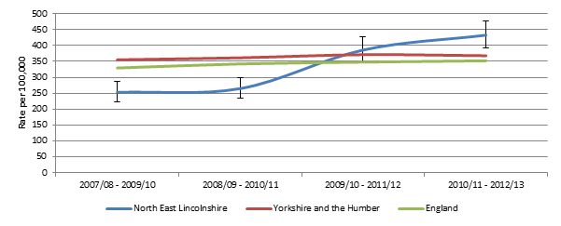

**Local Emergency Self-Harm Admissions**

Analysis of data determined that there were in total between 2013 and 2015/16 2515 deliberate self-harm emergency admissions across all ages for residents of NEL, of which 365 were those aged under 18 years old. Females are considerably more likely to attend A&E as a result of deliberate self-harm than males and the number of admissions increase with age. There are considerable differences between the proportion of females and males, almost half (46.3%) of all females are admitted to hospital whereas less than a quarter (23.1%) of males were admitted.

|  |  |  |  |
| --- | --- | --- | --- |
| **Number of A&E Deliberate Self-harm Admissions by Age and Gender, 2013/14 to 2015/16 (Source: NEL CCG, 2016)** | | | |
| **Age** | **Female** | **Male** | **Total** |
| **12 and under** | <5 | 10 | - |
| **13** | 17 | 6 | 23 |
| **14** | 35 | 7 | 42 |
| **15** | 75 | 19 | 94 |
| **16** | 52 | 28 | 80 |
| **17** | 74 | 38 | 112 |
| **Total** | 257 | 108 | 365 |

The overall crude of A&E admissions for deliberates self-harm amongst 0-17 year old in NEL is 1067.1 per 100,000. There is a correlation between the rate of admissions per ward and their respective deprivation score. Almost a third (31.8%) of admissions were residents in the most deprived quintile and over a half (56.7%) were residents in the 40% most deprived areas of NEL.

**3 year pooled A&E admissions for deliberate self-harm crude rate per 100,000 by 2015 IMD quintile, 2013/14 to 2015/16 (Source: NEL CCG, 2016):**

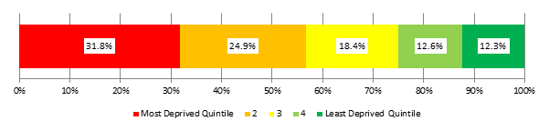

The average number of admissions varies from month to month although there are notable peaks in admissions around January, June and November with troughs in March and summer months of July, August and September.

**3 year pooled A&E deliberate self-harm admissions per month, 2013/15 to 2015/16 (Source: NEL CCG, 2016)**

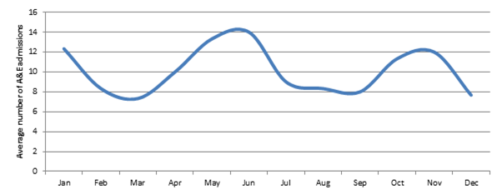

**Location of where deliberate self-harm occurred prior to admission, 2013/14 to 2015/16**

|  |  |  |
| --- | --- | --- |
| **Location of Self-Harm** | **Emergency Admissions** | |
|  | n | % |
| **Home** | 252 | 69% |
| **Public Place** | 58 | 15.9% |
| **Educational Establishment** | 32 | 8.8% |
| **Other** | 23 | 6.3% |
| **Total** | 265 | 100% |

1. **Current Service Offer**

NELC has delegated responsibility for the commissioning of children’s and young people’s mental health services from NELCCG. NEL Children and Adolescent Mental Health Services (CAMHs) provides client support through the services for CYP with additional vulnerabilities these include those with learning disabilities, looked after children, those in the criminal justice system, who misuse substances and those in alternative provision (e.g. pupil referral units).

CAMHs provide a range of interventions and support which is appropriate to the needs of CYP. Assessment and diagnosis of autistic spectrum conditions for CYP is undertaken by a multi-disciplinary panel which includes CAMHs involvement. Post diagnosis support is provided through accredited targeted parenting programmes, inclusion support workers linked to school localities and a small number of specialist units within mainstream schools

Traditionally the CAMHs contract has been commissioned on a four-tiered framework, however this model is now over 20 years old and there is a lack of support for low and medium level emotional wellbeing and mental health issues.

Therefore, NEL recognises that there have been significant changes in Government policies and strategies during the last 3 years and it is essential to move to a new delivery model to align with the ambitions set out in Future in Mind and the Five Year Forward View for Mental Health.

In January 2016 NELC commissioned ‘Unique Improvements’ to undertake a needs assessment of the CYP’s emotional and mental health needs. This needs assessment was designed to inform the development of a new emotional wellbeing and mental health pathway, to review the services current offer and to align to the aspirations set out in Future in Mind.

One of the key points raised from the needs assessment was **‘*The THRIVE model should be considered as a way to move away from tiers and ensure that services are arranged around the needs of CYP****’.*

Therefore, we are responding to these recommendations by reviewing our current service and commissioning a new delivery model from April 2018.

This new service will be goal-focused, patient-centred and consider a whole-systems approach to support CYP with emotional wellbeing and mental health issues. CAMHs will become the champion across the system, utilising other services to form part of the wider local offer so that CYP can access the support and treatment they need in a timely and integrated manner.

We are moving towards innovative ways of commissioning and expecting service provision to be creative using non-traditional approaches to improve outcomes for CYP, for example using a range of technologies, apps and social media platforms.

There will be an increased focus on the provider engaging and consulting with CYP, their families and carers to ensure that the services provided meet their needs and we are encouraging that a range of methods are used to capture the voice of the child and joint co-production for future planning of services.

The new specification for the ‘Children and Adolescent Emotional Wellbeing and Mental Health Service (including CAMHs)’ has been developed around outcome based commissioning and centres on the effect the interventions are having on the emotional wellbeing and mental health of the CYP locally. We are putting the needs of the child or young person at the centre and allowing the Provider to be innovative to achieve these agreed goals and priorities.

*Please refer to the supporting documents for a copy of the ‘Children and Adolescent Emotional Wellbeing and Mental Health Service (including CAMHs)’ service specification.*

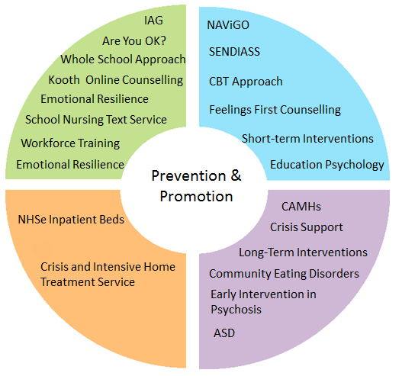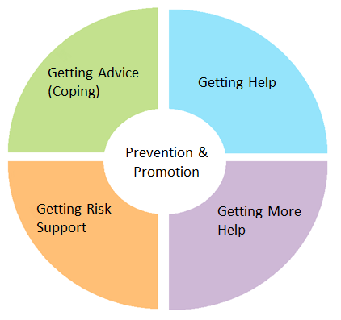The diagram below demonstrates the quadrants within the [THRIVE](http://www.annafreud.org/media/3214/thrive-elaborated-2nd-edition29042016.pdf) model:

|  |  |
| --- | --- |
| **Getting Advice (Coping)** | This quadrant focuses on building and promoting resilience within children, young people, families, schools and the wider community. Appropriate for CYP who are adjusting to life circumstances with mild or temporary difficulties who are choosing to manage their own health. |
| **Getting Help** | Services for CYP who have clinical presentations that would benefit from focussed evidence based treatments in line with NICE guidance. |
| **Getting More Help** | Services for CYP that require extensive and long-term interventions into in-patient care or with extensive out-patient provision from healthcare professionals. |
| **Getting Risk Support** | Services for CYP who are unable to benefit from evidence based treatments but remain a significant risk or concern and are supported by a multi-agency team. |

**Governance and Workforce**

Underpinning this new model of care will require transparent governance and reporting arrangements and identifying workforce training and development requirements to ensure this delivery model can embed itself across the whole system.

**Transition**

Ensuring a smooth transition from CAMHs into the adult mental pathway or other appropriate community health services is a key outcome areas in the new service delivery model and will build upon activity currently being undertaken across providers during this financial year.

CAMHs are currently working on the following activities to support the transition pathway:

* Develop joint engagement plans across all local providers
* Map out the current state of transition planning/level of need and to submit a joint report on findings to commissioners
* Develop implementation plans to address identified needs and agree the approach with commissioners
* Case note audit assessing those who have transitioned
* Discharge questionnaires for those who have transitioned out of CYP mental health services
* Report on the overall C-Quin update

**NHS England Tier 4**

In NEL we are moving to a tireless model of care, however NHS England Specialist Commissioning, commission very specific specialist services known as Tier 4. CAMHs are expected to interface with these systems. This service provision is for those CYP with the most serious mental health problems. This can include day units, highly specialised outpatient teams and inpatient units.

**ChiMat Estimates for Support at for each Tier (Tier 1-4)**

The table below represents estimates of CYP in NEL who would require support at each of the tiers which has been mapped against mental health and emotional wellbeing activity for 2015/16 and 2016/17 to demonstrate the number of CYP who are accessing support in North East Lincolnshire.

|  |  |  |  |  |
| --- | --- | --- | --- | --- |
| **Tier** | **Expected prevalence** | **CYP Activity Data 2015/16** | **CYP Activity Data 2016/17** | **Comments** |
| 1 | 5,150 | 557 | 1,025 | New Tier 1 programmes commencing throughout 16/17 |
| 2 | 2,405 | 727 | 962 | Difficult to break down due to block contract with CAMHs |
| 3 | 635 |
| 4 | 30 | ≤5 | ≤5 |  |

Many of the new tier 1 programmes which commenced in 2016/17 began in Q3/Q4 and therefore the activity data does not represent a full year, it is anticipated that the figures would be greater once the services have been established for a full year. However, we can already see increased activity from the previous year’s figures with more CYP being able to access mental health and emotional wellbeing support in North East Lincolnshire.

This table further supports the need to target more CYP at a prevention and early help level and supports the 0-19 programme developing locally. However, the difference between the expected prevalence and those receiving support identifies a significant number of CYP still not receiving the support they need, it should be noted that this is not an unusual situation and mirrors national trends.

**Activity Data Collection Tool**

This table details the specific services which have contributed to the mental health and emotional wellbeing activities above.

|  |  |  |  |  |
| --- | --- | --- | --- | --- |
| **NEL Activity Data 16/17** | | | | |
| **Name of Service** | **Provider** | **No. of referrals** | **No. accepted into service** | **Active cases** |
| Core CAMHS (Tier 2) | CAMHS | 609 | 247 | 152 |
| Looked After Children | CAMHS | 37 | 35 | 49 |
| Youth Offending Teams | CAMHS | 12 | ≤5 | ≤5 |
| Learning Disability | CAMHS | 32 | 32 | 23 |
| ADHD | CAMHS | 60 | 59 | 152 |
| Eating Disorders | CAMHS | 12 | 10 | 11 |
| Crisis and Intensive Home Treatment Team (Tier 3 Plus) | CAMHS | 200 | 187 | 43 |
| Early Intervention in Psychosis | NAViGO | 19 | 16 | 6 |
| Criminal Justice Liaison and Diversion Service (14-18 years) | NAViGO | 86 | 66 | 13 |
| Community Eating Disorders (17.5 – 18 years) | NAViGO | 6 | ≤5 | 0 |
| Open Minds (16-18 years) | NAViGO | 226 | 224 | 75 |
| Educational Psychology | NELC |  |  |  |
| CBT Approach | NELC | 299 | 299 | N/K |
| Feelings First | NELC | 219 | 219 | 64 |
| Kooth – Online Counselling | Xenzone | 186 | 186 | N/K |

*N/K not known

As we are moving towards the THRIVE model we have applied an algorithm to our CYP population and the table below highlights the predicted percentage of CYP in the needs-based groupings, which we will consider alongside the new delivery model in terms of activity data.

|  |  |  |
| --- | --- | --- |
| **Need-based**  **groupings** | **Predicted % in groupings based on application of the algorithm** | **Estimated prevalence within NEL** |
| Getting Advice (Coping) | 28% | 2,302 |
| Getting Help | 61% | 5014 |
| Getting More Help | 11% | 904 |

*As per the expected prevalence these would be the approximate figures for each quadrant in NEL

1. **Where Are We Now?**

As described above since 16/17 in NEL we have focused on reviewing services, designing and developing new services and models of care and have implemented these changes within the system. We have undertaken a needs assessment and continued engagement with CYP, their parents/carers, professionals and key stakeholders.

We have prioritised the development of new services locally and have invested money into prevention and early intervention services such as, Kooth online counselling (see below for further information on these interventions).

We recognise within NEL that the data recorded and collected is mainly activity based and focuses on how many CYP have been treated, whereas our aspirations moving forwards are to develop an outcomes framework. The outcomes framework will ensure programmes are evidence based and demonstrate positive impact on CYP’s lives linked to the wider 0-19 service re-design.

Please refer the summary documents to view a summary of the activity undertaken within 16/17 and service user and professional comments from a range of training courses and interventions.

**Getting Advice (Coping)**

**‘ChatHealth’ School Nursing Text Service**

A school nursing text service has been implemented since October 2016 through ‘ChatHealth’ which allows CYP to access a service from the school nursing team regardless of what educational setting they attend. The secure messaging service is available for all pupils attending a school (including home schooling) within NEL, aged between 11-16 years. The service is manned 9:00am – 5:00pm Monday to Friday and can be an anonymous service or children can share their personal data if they wish.

Popular topics which CYP can contact school nurses for discussion on are around:

* Self-harm
* Low mood
* Anxiety/stress
* Relationship worries
* Health conditions
* Weight and growth concerns

**Relationships and Resilience**

Throughout 2016/17 the Safe Relationships for Young People (SR4YP) project was delivered into primary Schools across the borough. 3 lessons have been delivered in year 5 and a further 3 lessons in year 6 with schools in areas of high health inequalities receiving an additional 6 week after school multisport activity sessions, which reinforces the messages that were delivered in the classroom.

The three lessons consisted of the following topics:

* Online safety
* Awareness of substance misuse
* Emotional wellbeing

These sessions were delivered by youth workers and school nurses and the evaluations were positive showing that recall of the key themes averaged 88%. In the last year, 478 children within 7 primary schools have received the classroom input, with a further 58 children receiving the 6 week extension. Also, 108 primary school staff has received training in CEOPs and the principles of drug education.

In secondary schools the relationship and resilience programme was delivered to year 7 and 11 (3 session programmes) and year 8, 9 and 10 (5 session programmes). These assemblies have been delivered to 7 secondary schools with a total of 68 SR4YP assemblies being delivered to over 1,469 pupils.

Therefore overall over 1,947 school children within NEL have received SR4YP training. This project is expected to continue into the 18/19 as part of the Relationships and Resilience strand of the 0-19 restructure.

**Whole School Approach to Mental Health and Emotional Wellbeing**

We have recently employed an assistant psychologist whose role is to work alongside educational settings to implement the Whole School Approach (WSA) to mental health and emotional wellbeing. Schools have been completing an audit and making action plans to help them implement the WSA principles and to promote emotional wellbeing and good mental health.

Currently 24 schoolshave completed the audit and further schools are scheduled to complete the audit. This is out of 10 secondary schools and 47 primary/junior schools within NEL.

* 16 out of 17 schools without an SEMH policy have been sent one to adapt to their own school/academy
* 10 schools/academies now have a named mental health champion
* Every school has been informed about the free FiM training and sent the catalogue of courses available
* Many schools had barriers to receiving particular training programmes, such as attachment training due to costs etc. and Educational Psychology are now in the process of developing their own free attachment training package for schools/academies

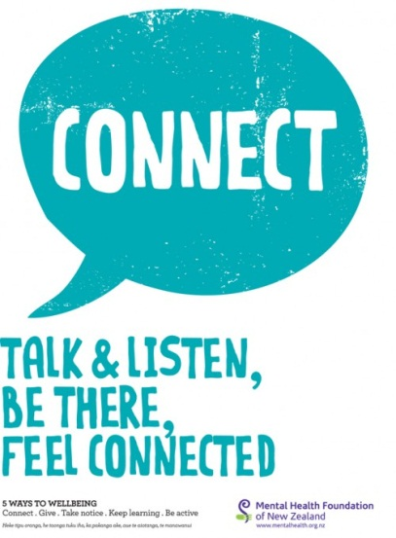**Getting Help**

**The CBT Approach: Are You Ok?**

Staff from the school nursing and youth offending service have both undertaken Cognitive Behaviour Therapy (CBT) basic skills training to be able better to support CYP with low mood, depression, anxiety and self-harm. This support programme ensures that CYP have the opportunity to discuss and receive structured, evidence based support.

The following is a breakdown of the type of problems CYP present with:

* Relationship problems
* Self-esteem
* Self-harm
* Body image
* Behaviour
* Bereavement
* Anxiety

Staff members have embraced their new knowledge and skills with regards to implementing the CBT tools and strategies and they feel much more confident when dealing with pupils who self-harm by using a structured approach. CAMHs have offered support to staff when they do not feel that the intervention is working or progressing and this has then given CAMHs a much more detailed and appropriate referral. The school nurses and the Youth Offending team use goal based outcomes (GBO) to measure the effectiveness of an intervention and to evaluate the progress a child or young person is making towards a goal in the clinical intervention.

School nurses have developed a pilot anxiety group session and the effectiveness will be evaluated at the end of the academic year.

**Kooth Online Counselling**

[Kooth](http://www.kooth.com) our online counselling service has been in operation since December 1st 2016 and is a free, safe, confidential and non-stigmatised way for young people to receive counselling, advice and support on-line 365 days a year, up to 10:00pm for 11 – 25 year olds.

The service includes the following:

* A chat function for a young person to speak to a readily available counsellor
* A messaging function for young people to contact the service
* A schedule function to provide booked sessions with a named counsellor on a regular basis
* A range of forums, all of which are pre-moderated, offering facilitated peer support
* Live discussion groups - run by professionals (with all comments moderated) to enable groups of CYP to interact with each other in a safe environment
* An online magazine will full content moderation, creation and editing which includes opportunities for CYP to submit their stories or write articles, all of which is moderated
* Information, activities and self-care tools and resources on the site for CYP to download.

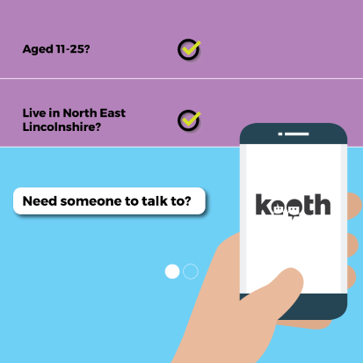This digital approach will enable an extended provision for CYP to access support and tackle the stigma associated with physically accessing a mental health service. The Kooth service is linked into existing care pathways to ensure that if a child or young person is in crisis or needs a specialist service that they are directed to the most appropriate service.

Kooth is being promoted through the popular social media channel, Instagram to target more CYP and increase the number of registrations. Adverts are appearing on Instagram, targeting certain times of the day and being able to reach CYP in the school holidays, out of school hours and at weekends. Kooth is also being displayed on the screens within the GP surgeries locally to promote the service and encourage registrations.

**Bereavement Support Group**

'Feelings First' have delivered 2 bereavement support groups over a 6 week roll on, roll off period. This group will continue to run through St Andrew’s Hospice with Feelings First offering support to this group to provide signposting and informal support to the staff running the groups

**Suicide Prevention Strategy**

Every local area is expected to have a multi-agency suicide prevention action plan. The current suicide prevention action plan within NEL is due to expire and therefore, the plan is due to be refreshed.

Work has been on-going to capture updates from the current action plan to identify current progress. To help identify priority areas a suicide prevention workshop took place in September 2017, which a number of key stakeholders attended. Going forward work will begin to utilise the information gathered from the workshop and continue to work with key stakeholders, to inform priority areas to develop a refreshed multi-agency suicide prevention action plan.

**Getting More Help**

**Children and Adolescent Mental Health Service (CAMHs)**

In 2016/17 there were 1,493 referrals received into the CAMH service (508 were identified as ineligible at intake), which is a decrease in referrals from 1,755 since 2015/16.

The highest number of referrals were made by the GP, hospital based paediatrics and accident and emergency and the highest number of diagnoses at initial assessment was for anxiety – general, ADHD and depression.

**Care Options**

The table below shows the number of young people assigned to a care option, with the majority of referrals assigned to the NEL Intake team (1493). Intake team referrals refer to initial referrals where eligibility for CAMHs is determined. All other care options relate to a care pathway.

Total number of referrals to CAMHs for each care option, 2015/16 and 2016/17:

|  |  |  |  |
| --- | --- | --- | --- |
| **Care Option** | **2015/16** | **2016/17** | **% difference** |
| Intake Team | 1755 | 1493 | -26% |
| Core | 341 | 621 | 82% |
| Tier 3 Plus | 243 | 200 | -17% |
| LAC Team | 53 | 37 | -30% |
| ADHD Team | 37 | 60 | 62% |
| LD Team | 35 | 32 | -8.5% |
| Eating Disorders | 12 | 12 | 0% |

Source: Lincolnshire Partnership Foundation Trust

**Waiting Times**

Please see the breakdown of access and waiting times for CAMHs in the below table:

|  |  |  |  |  |
| --- | --- | --- | --- | --- |
| **Mental Health Services Data Set** | | | | |
| **2016/17** | **Q1** | **Q2** | **Q3** | **Q4** |
| Average waiting time from referral to treatment (days) | 62.3 | 47.5 | 87.8 | 76.8 |
| No. of CYP waiting for treatment for 0-4 weeks | 0 | 0 | 1 | 4 |
| % waiting for 0-4 weeks | 0% | 0% | 4% | 13.3% |
| No. of CYP waiting for treatment for 4-6 weeks | 9 | 0 | 4 | 2 |
| % waiting for 4-6 weeks | 6.5% | 0% | 16% | 6.7% |
| No. of CYP waiting for treatment for 6-8 weeks | 6 | 0 | 2 | 4 |
| % waiting for 6-8 weeks | 4.3% | 0% | 8% | 13.3% |
| No. of CYP waiting for treatment for 8-10 weeks | 12 | 1 | 4 | 3 |
| % waiting for 8-10 weeks | 8.7% | 10% | 14% | 10% |
| No. of CYP waiting for treatment for 10-12 weeks | 0 | 0 | 3 | 6 |
| % waiting for 10-12 weeks | 0% | 0% | 12% | 20% |
| No. of CYP waiting for treatment for more than 12 weeks | 0 | 9 | 11 | 11 |
| % waiting for more than 12 weeks | 0% | 90% | 44% | 36.7% |

**Crisis and Intensive Home Treatment Service**

The crisis and intensive home treatment provision within NEL is a 24 hours, 7 days a week, 365 days per year service for CYP under 18 years of age. The service provision is for CYP experiencing significant mental health difficulties or presenting in mental health crisis. The team consists of a multi-disciplinary team of experienced social workers and mental health nurses with support from psychology and psychiatry.

The service works closely with the local hospital, children’s services and the police, to ensure that a crisis is responded to in a timely and efficient manner. Through working collaboratively with the police, the service has often averted for the need for the police to use Section 136 of the Mental Health Act, which ensures a more caring and personal response to a child’s distress.

Since the service re-design in 2013, the team have considerably reduced the number of inpatient admissions. In fact over the last 3 years there haven’t been any admissions to Tier 4 from the CAMH service. This is achieved by providing a quality community mental health service to support CYP to remain with their families, carers and friends.

The Government’s aspiration through Future in Mind are to have ‘improved crisis care: right place, right time, close to home’ by 2020. The CAMH service is already delivering this to CYP across the borough and feels privileged to be doing so. The service is able to promote, protect and improve our CYP’s mental health and wellbeing, by working flexibly and creatively. These achievements have been recognised by the CQC by the recent inspection of the service and with numerous awards that the service has been nominated for. NEL CAMHS has also been invited to share their successful model as part of an NHSe national conference.

Within the new CYP’s emotional wellbeing and mental health service (including CAMHs) we will continue with the crisis and intensive home treatment model and service provision; however this will be extended up until 19 years old.

**Early Intervention in Psychosis**

NEL CAMHs work closely with the Early Intervention in Psychosis (EIP) Team which is situated within NAViGO, the adult mental health provider. The EIP team has staff within it that have the expertise and experience of providing support to CYP. NEL Early Intervention Team is for people between the ages of 14 and 35 who experience a range of emotional and psychological difficulties which could include psychosis. The main purpose of the service is to help young people resolve some of the emotional and psychological difficulties they experience, and to help them get on with their life again as soon as possible.

|  |  |  |
| --- | --- | --- |
| **Early Intervention in Psychosis** | **2015/16** | **2016/17** |
| Number of referrals to the service (under 18 years) | 41 | 19 |
| Number accepted into the service (under 18 years) | 25 | 16 |

There are currently 6 active cases within NAViGO and their EIP team for 16/17. The service has a target to see and assess individuals within 2 weeks of receipt of the referral and will provide up to 3 years care coordinated support, EIP works closely with CAMHs and Tier 4 provision to escalate or de-escalate cases to ensure coordination of care.

Where a service user is in crisis the service will work in collaboration with the Mental Health Crisis/Home Treatment Team with support being offered from the team at a mutually agreed level. The provider is working towards the principles outlined in the [EIP access and waiting time standards](https://www.england.nhs.uk/mentalhealth/wp-content/uploads/sites/29/2016/04/eip-guidance.pdf) and has clear transition pathways from children’s services into adult services.

**Community Eating Disorder Service**

Within NEL we maintain a very low level of referrals for eating disorders into the CAMH service and NAViGO the adult mental health provider support young adolescents 17.5 to 18 years old.

The most recent UK prevalence study would suggest an incidence of 120 per 100,000 amongst 10-19 year old females, and 31 per 100,000 10-19 year old males. For NEL, this would mean an incidence of 3 males and 11 females each year; however referrals to the services within NEL are lower than this. During the last three years 14/15, 15/16 & 16/17, there have been no Tier 4 inpatient admissions for eating disorders.

|  |  |  |
| --- | --- | --- |
| **Eating Disorders** | **2015/16** | **2016/17** |
| Number of referrals into CAMHS* | 12 | 12 |
| Number of referrals accepted into CAMHS | 10 | 10 |
| Number of referrals into AMHS (17.5 – 18 years)** | 6 | ≤5 |
| Number of referrals accepted into AMHS (17.5 – 18 years) | ≤5 | ≤5 |

*This figure also includes CYP with obesity related disorders  
**This figure also includes CYP that have transitioned from CED CAMHs to AMHs

As part of the transformation plan we have recognised that there may be an under representation of eating disorders within NEL and have planned and commissioned, the eating disorder charity B-EAT to raise awareness of identifying eating disorders across the CYP’s workforce, this has been implemented and will continue throughout 17/18.

The aims of these workshops are as follows:

* Children, young people, their families and carers know how to ask for help in their local areas
* Professionals and parents have better knowledge of how to recognise eating disorders and how to access appropriate care when needed

In addition, CAMHs are providing specific training to school staff and Year 8 pupils to recognise the signs and symptoms of eating disorders and where to go to for further advice and support. We have specifically targeted Year 8 pupils as local analysis showed that there trend for presentation at 13-14 years.

In NEL we have a partnership agreement in which Lincolnshire Partnership Foundation Trust buy in specific support from Lincolnshire County Council CEDS - CYP commissioned model to support the eating disorder pathway. This is done on a case by case basis through a hub and spoke model to ensure that the pathway is NICE compliant. This ensures that LPFT has the appropriate support, capacity and skills-mix to meet the Access and Waiting Time Standard.

**Transforming Care**

North East Lincolnshire is part of the [Humber Transforming Care Partnership](http://www.hullccg.nhs.uk/pages/transforming-care-partnership-learning-disability-vision-and-plan-2016-19) and as a wider Humber footprint commitment has been made to transforming care and services for people with a learning disability and/or autism, especially those who also have, or are at risk of developing, a mental health condition or behaviours described as challenging. This includes people of all ages and those with autism (including those who do not also have a learning disability) as well as those people with a learning disability and/or autism whose behaviour can lead to contact with the criminal justice system.

This three year transformation plan is being implemented across a wide range, including 0-25 years. We are currently reviewing the CETR process in line with the 0-19 transformation programme to ensure young people access the right treatment within their local community, close to home.

**Communications and Interactions Pathway**

In NEL following on from the work undertaken in 15/16, a dedicated steering group has been established, which has a multi-agency membership and parental input to take forward gaps, issues and recommendations. Two workshops have been completed, which focused on the 0-5 years and the 5-16 years pathway. The engagement workshops were open invite and there were updates on the following:

* Local support
* Universal/early help offer
* Diagnosis pathway
* Future of the pathway
* Q&A session

The proposed new pathways have been drafted and are now waiting to be approved by NELC to allow for a consistent approach from all professionals.

NEL is moving away from the terminology of the Autism pathway to be more inclusive and we are exploring options to commission a family support programme for CYP with communication and interaction concerns (including Autism), in which accessing support does not require a diagnosis of Autism.

We have also recognised as part of the 0-19 transformation review that there is a need to develop a single integrated pathway which includes communication and interaction as well as other challenging behaviours and presentations. This has been named the single access pathway which offers models of service centred around CYP and focused on early intervention and the early help offer.

**Health and Justice**

The Health and Justice CYP’s Mental Health Transformation Work stream aims to promote a greater level of collaboration between the various commissioners of services for CYP who are;

* In the Youth Justice System (or at risk of entering it)
* Presenting at Sexual Assault Referral Centres
* Welfare CYP who are being looked after
* Being seen by Liaison and Diversion services

Many of these CYP are already known to service providers and it is important that mental health services for this cohort are not seen as being in a separate silo from other services. Rather, they should be viewed as part of an integrated, continuous pathway in which CYP are able to receive the care they need on an uninterrupted basis.

The Health and Justice Commissioners will work collaboratively with their commissioning counterparts in the CCGs and Local Authorities to co-commission services, where appropriate, to improve mental health outcomes for this group.

**Liaison and Diversion**

Liaison and Diversion is a NHS England funded project to address health inequalities for vulnerable people who enter the criminal justice system. This service operates on a Northern Lincolnshire footprint, which spans North East Lincolnshire and North Lincolnshire, covering adults and CYP.

**Getting Risk Support**

**Tier 4**

National Specialised Commissioning Oversight Group (SCOG) decided in March 2016, that a single National procurement would not be in the best interest of patients and the approach taken would need to strengthen the requirement for regional planning and delivery.  It would need to align with and support the move to population based commissioning and the outputs of this work would need to be embedded in local systems. To reflect this, NHS England revised its approach to one of local ownership and delivery under the umbrella of National co-ordination and oversight and is now referred to as the Mental Health Service Review (MHSR) programme.

A key factor and driver in the service review has been a lack of capacity in some areas that has led to out of area placements. The proposed changes in bed numbers aim to address this and ensure that for the majority of services, the right number of beds are available to meet local demand in each area. It is predicated on the principle that there is regard to patient flows so each local area should “consume its own smoke”. As these services are specialist in nature, there is National oversight of this process but with a strong emphasis on local engagement and ownership.

The implementation of local plans will see the re-distribution of beds across the country so patients will be able to access services closer to home rather than having to travel to access appropriate services, except for a few particularly specialist services that it is uneconomic to provide in each area. NHS England is collaborating with local commissioners on the CAMHS Tier 4 bed changes in Yorkshire and the Humber to ensure the interdependencies between localities are managed effectively.

|  |  |  |  |  |  |  |  |  |
| --- | --- | --- | --- | --- | --- | --- | --- | --- |
| **CAMHS Tier 4 Activity: 2014/2015** | | | | | | | | |
| **NEL CCG** | **AC** | **Child** | **ED** | **LD** | **Low** | **Medium** | **PICU** | **Grand Total** |
| Admissions | ≤5 | 0 | 0 | ≤5 | 0 | 0 | ≤5 | ≤5 |
| Service Category | ≤5 | 0 | 0 | ≤5 | 0 | 0 | ≤5 | **5** |
| Occupied bed days | 126 | 0 | 0 | 81 | 0 | 0 | 66 | **273** |

|  |  |  |  |  |  |  |  |  |
| --- | --- | --- | --- | --- | --- | --- | --- | --- |
| **CAMHS Tier 4 Activity: 2015/16** | | | | | | | | |
| **NEL CCG** | **AC** | **Child** | **ED** | **Low** | **Medium** | **PICU** | **UKNC** | **Grand Total** |
| Admissions | ≤5 | 0 | 0 | 0 | 0 | ≤5 | 0 | ≤5 |
| Service Category | ≤5 | 0 | 0 | 0 | 0 | ≤5 | 0 | ≤5 |
| Occupied bed days | 57 | 0 | 0 | 0 | 0 | 118 | 0 | **175** |

|  |  |  |  |  |  |  |  |  |
| --- | --- | --- | --- | --- | --- | --- | --- | --- |
| **CAMHS Tier 4 Activity: 2016/17** | | | | | | | | |
| **NEL CCG** | **AC** | **Child** | **ED** | **Low** | **Med** | **PICU** | **UKNC** | **Grand Total** |
| Admissions | ≤5 | 0 | 0 | 0 | 0 | 0 | 0 | ≤5 |
| Occupied bed days | 204 | 0 | 0 | 0 | 0 | 0 | 0 | **204** |

1. **Building the Workforce**

Supporting and developing the children’s workforce has been the golden thread to our local transformation plan. We feel that if we provide or facilitate the right training and support to the children’s workforce at a universal and early help level they will have the right mix of skills, competencies and experience to support CYP with mental health and emotional difficulties and promote positive mental health.

Across NEL in partnership with our wellbeing services and NEL CAMHS over the last two years we have developed a comprehensive training programme that has raised awareness of mental health, promoted local pathways and services, updated the workforce on relevant information, policies and guidance and more recently aligned the Future in Mind training portfolio to the [Children's Workforce: Professional Capabilities Framework for North East Lincolnshire](https://www.nelincs.gov.uk/wp-content/uploads/2016/09/NEL-Childrens-Workforce-Professional-Capabilities-Framework1.pdf) as described in the last refresh.

We have made a joint commitment with our CAMH service to participate in the CYPIAPT programme and will be encouraging broader non-health staff such as social workers and voluntary and community organisations to participate in the programme once the 0-19 programme has been embedded.

As part of the re-procurement of our CYP Emotional and Mental Health Service we will be working with the provider to ensure the workforce are appropriately trained to meet the needs of the CYP that they support. We will also consider the interface between specialist services and ensure key partners have the expertise to support the wider emotional wellbeing offer. This review will start to inform an NEL workforce planning model and identify further training required to implement the THRIVE model. This approach also integrates the PCF to ensure a system wide training and delivery model for all professionals and volunteers that support CYP with emotional health and wellbeing.

It has already been identified by the Communications and Interactions Pathway the need for some specialist training to support this pathway; this will be implemented in the forthcoming year.

**Stepping Forward to 2020/21: The Mental Health Workforce Plan for England**

The workforce plan produced by NHSe has set out targets for each CCG to plan to develop and expand their workforce by 2020/21. Targets for this growth have not been confirmed yet, however in NEL we have considered two ratios.

The National Service Framework for Children, Young People and Maternity Services (2004) recommends a minimum ratio of 15 whole time equivalent (WTE) staff for every 100,000 population. On this basis NEL would require 25 WTE meet the needs of CYP.

The Royal College of Psychiatrists (2006) recommended that 20 WTE staff were required to meet the needs of CYP aged 15 and under, per 100,000 population. In addition, the college recommended 5 WTE primary mental health workers per 100,000 populations. This would equate to 25 WTE in the main CAMHs service and 10 WTE primary mental health workers.

In North East Lincolnshire, across the thrive model we feel we have sufficient specialist mental health practioners to meet demand but we do require further primary mental health workers to meet the proposed prevalence estimates of those CYP ‘getting help’. A detailed breakdown of the current workforce can be seen in the table below.

**Current Workforce for CYP’s Mental Health and Emotional Wellbeing**

|  |  |  |
| --- | --- | --- |
| **Workforce Data 16/17** | | |
| **Name of Service** | **Organisation** | **No. of Practitioners/Clinical Staff in Post June 17** |
| CORE CAMHs | CAMHS | 28 |
| Looked After Children | CAMHS | 2 |
| Youth Offending Team | CAMHS | Core CAMHS Team |
| Learning Disability | CAMHS | 2 |
| ADHD | CAMHS | 1 |
| Eating Disorder | CAMHS | Core/Crisis Team |
| Crisis and Intensive Home Treatment Team (Tier 3 Plus) | CAMHS | 10 |
| CBT Approach | NELC | SN – 9.82 |
| Educational Psychology | NELC |  |
| Feelings First | NELC | 3 |
| Behaviour Support | NELC | 1.8 |
| Wellbeing Service | NELC | 2.8 |

*There are other services which contribute to the mental health offer but it is difficult to break this down due to the practitioners working across a variety of age ranges or services areas. Furthermore, those services which are digital are not represented above but provide significant support to CYP.

It is the intension therefore of NEL to invest in further CYPIAPT to ensure that the ‘getting help’ quadrant has the appropriately skilled workforce to support CYP with lower level emotional wellbeing and mental health issues for example psychological wellbeing practitioners, based within 0-19 locality models. We are currently profiling financial trajectories in line with development of accountable care within NEL.

We will continue to review prevalence at each of the quadrants and respond to local need.

**Training across the Children’s Workforce**

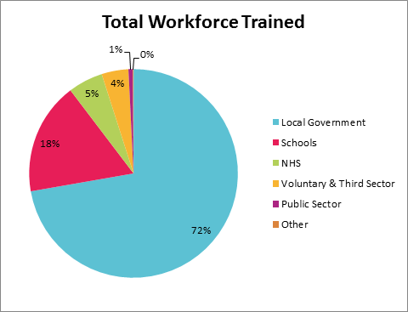Since implementation of Future in Mind, NEL have been providing a range of universal and universal plus training programmes across the children’s workforce. This data has been evaluated and the below pie-chart demonstrates the distribution of staff from each type of workplace setting who have attended on one or more of the universal and universal plus FiM funded courses. Please refer to the summary documents to see activity data and impact statements from all of the training courses delivered.

**Universal and Universal plus Mental Health Training Programme**

The ‘Wellbeing Service’ in NEL has been commissioned to deliver training and support to the children’s workforce at a universal/universal plus level to ensure they have the right mix of skills, competencies and experiences to support CYP with mental health and emotional difficulties and promote positive mental. All staff across the children’s workforce and from external organisations can attend the training free of charge (e.g. schools/academies, further and higher educational settings, voluntary sector etc.).

It is recognised that recruiting into mental health roles in NEL can be problematic but by investing in the Universal and Early Help workforce we aim to ensure that CYP receive the support they need at the earliest opportunity and that the workforce has the skills and knowledge needed. The courses have been well received and 100% of participants reported an increase in knowledge and confidence following attendance on the course.

**Post Course Evaluation Questionnaire**

3–6 months after the training participants were surveyed to evaluate the long-term impact of the training programme and to evidence how this has benefited the professionals working with CYP across the borough. Below are the results of the survey:

|  |  |  |
| --- | --- | --- |
| **Evaluation Questions** | **Yes** | **No** |
| Is the course still benefiting your own mental health and emotional wellbeing? | 98% | 2% |
| Have you used any information learned in your work life? | 90% | 10% |
| Is the course still benefiting your confidence when working with CYP? | 91% | 9% |
| Have you used any information learned in your personal life? | 87% | 13% |

**Targeted and Specialist Mental Health Training**

During 17/18 a number of targeted or specialist training programmes have been planned and delivered.

* **Beat – beating eating disorders –** courses offered to increase the knowledge and awareness of eating disorders to ensure the workforce is equipped with the skills, training and experience to best support CYP. We have currently held 6 courses in 17/18, which has trained 160 employees and there is the consideration of further courses continuing into 18/19.
* **Cognitive Behavioural Training –** courses were offered to two distinct services who support CYP (Youth Offending and School Nursing) and enhanced there basic CBT training undertaken previously to consider training on self-harm, as there is a high incidence rate in NEL
* **Self-Harm and Suicide Prevention –** training for self-harm/suicide to up skill the wider children’s workforce to recognise signs and symptoms accordingly to inform, advise, or to refer to the appropriate services
* **Perinatal Mental Health –** range of PNMH training has been cascaded out to the children’s workforce who work with women and children in the perinatal period. To sustain this training the Institute of Health Visiting (iHV) have provided multi-agency perinatal mental health champions training for practitioners who are now cascading training in NEL.
* **Newborn Behavioural Observations (NBO) and Neonatal Behavioural Assessment Scale (NBAS) –** training offered to link into early attachment, parenting pathways and PNMH

.

**As part of the Future in Mind since 15/16 workforce development approach there has been a grand total of 1,720 staff trained in NEL (up until 30th September 2017).**

**7. Engagement, Participation and Multi-Agency Working**

Children, young people and their family’s needs and aspirations are central to our transformation plan and have helped shape our future service provision. Throughout 16/17 and 17/18 we have undertaken a wide range of engagement activities and we intend to maintain this momentum.

**CAMHs Re-procurement**

Extensive engagement and consultation has been undertaken to inform the specification and a summary of these activities are detailed below.

**CYP’s Emotional Health and Wellbeing Needs Assessment**

In January 2016 ‘Unique Improvements’ were commissioned to undertake a needs assessment of CYP’s emotional and mental health needs, to inform the development of a new emotional wellbeing and mental health pathway and to capture insight into the concerns and challenges of the young people and professionals who have to navigate the system.

In excess of 300 people gave their views on Children’s and Young people’s Emotional and Mental Wellbeing Services. They were a combination of commissioners, managers, providers, clinical staff, CYP and their parents and carers.

Below are some of the recommendations which the needs assessment has highlighted and the actions in which we have taken to address these:

|  |  |  |
| --- | --- | --- |
| **Theme** | **What have we done?** | **What else needs doing?** |
| **Move away from the tiered model of care** | Commissioning the THRIVE model of care, which is a tireless system that centres around the CYP and their needs | Embed the principles of THRIVE across the children’s workforce and educate key partners |
| **Thresholds are too high and accessing the service is difficult** | In the THRIVE model CYP can enter any one of the four quadrants and receive the appropriate care pathway. | Embed the principles of THRIVE across the children’s workforce and educate key partners |
| **Little support for low and medium level emotional and mental wellbeing issues** | There have been a range of new services commissioned to support with low and medium level emotional and mental wellbeing issues | Continue to embed and promote the new services and support within NEL to encourage prevention and early intervention |
| **Waiting lists are too long** | Waiting times for routine referrals have been reduced from 12 weeks to 8 weeks. Increased focus on prevention and early intervention and support for lower emotional wellbeing and mental health will be available to reduce the number of CYP escalating to needing a clinical response. | Embed the THRIVE principles to ensure more CYP enter the getting advice/getting help quadrants |
| **Needs to be a focus on prevention and early intervention** | We are commissioning the THRIVE model which focuses on prevention, early intervention and building resilience with CYP locally. | Embed the principles of the THRIVE model |
| **Increased multi-agency working** | The ‘Children’s and Young People’s Emotional Wellbeing and Mental Health Service’ will be the champion across the system and will work with a range of partners across the children’s workforce | Embed the principles of the THRIVE model |
| **Pathways for emotional and mental wellbeing are not clear or understood** | A single point of access has been developed in which all referrals will be received via the Families First Access Point (FFAP). These will then be triaged and the CYP will then receive the most appropriate support. | Promote the new pathway and single point of access FFAP to all professionals across NEL as part of the THRIVE model |
| **CYP want a service which is designed around their needs** | We are offering appointments in a range of locations across the borough in existing community buildings (e.g. family hubs) and at times which is suitable to the needs of the CYP and their family/carers. | Regular engagement with CYP to ensure the service is provided through mediums which suit their needs |
| **School support for mental health and emotional wellbeing is fragmented across NEL** | Rolling out the whole school approach with schools/ academies and auditing their social, emotional and mental health support | Roll out the whole school approach to more schools/ academies within the borough |
| **Lack of support post 18 years transitioning** | We have extended the services provision up to 19 years old to assist with the transition process to adult mental health services. | Embed the principles of the THRIVE model which supports CYP up to 19 years |
| **Lack of parental support** | We have recognised this is a gap within the current model of care across the system and is being included within the new THRIVE model of care | Embed the principles of THRIVE and provide support for parents |

The needs assessment has been used to influence the CAMHs re-procurement and shape the future of the emotional wellbeing and mental health local offer. This new Provider will be expected to take into consideration the feedback and recommendations made above.

**Perinatal Mental Health**

Currently there is very little provision for women and men with perinatal health needs across North and North East Lincolnshire. Current services are not specific to perinatal mental health and are not part of a holistic or overarching pathway and are often dependent upon individual practitioners. This leads to many women across the area with un-addressed perinatal mental health needs which can lead to adverse outcomes for the whole family. The area is rural with high levels of socio-economic disadvantage which impacts on the ability of the population to access specialist care if it is not local.

In 2016/17 information was gathered about the perceived support available to local parents, information available about perinatal mental health and suggestions for additional services and support required. This was facilitated through surveys, face-to-face drop in sessions and through mother and baby groups/health visitor clinics.

The overarching themes of the engagement have been summarised below:

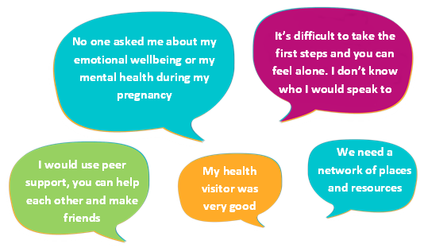

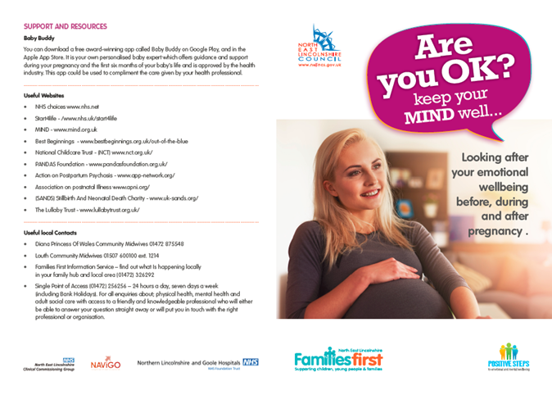Health visitors and midwifes were the two top professionals who asked about the women’s mental health during or after the pregnancy. 36% stated that they felt the experience of PNMH services was very poor and they felt unsupported and did not receive any information. 87% of respondents said that they would be interested in some form of peer support (e.g. small groups, one-to-one support) if this service was available locally in the future.

Both engagement activities have informed the PNMH steering group and will be used to inform the PNMH development fund bid and the future shaping of services and local pathway.

An ‘Are You OK? Keep your mind well…Looking after your emotional wellbeing before, during and after pregnancy’ has been developed to be distributed out to pregnant women to advise women on perinatal mental illnesses.

**Youth Engagement and Participation**

NELC have a voice and influence practitioner who co-ordinates engagement with CYP across the borough. In 2016/17 we have commissioned the team to undertake engagement activities on our behalf and utilised the findings to inform the new service model.

Below highlights a range of engagement events and activities undertaken in partnership with CYP locally.

**Youth Action**

Our local Youth Action group (aged 11 - 21) have been instrumental in shaping campaigns and projects with an aim to improve emotional wellbeing and mental health for CYP and have been shortlisted for a Youth Voice Star award from the British Youth Council for the mental health work they have been involved with.

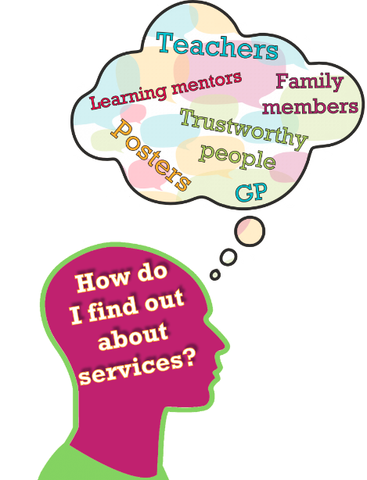Some of the work the group have been involved in includes the following:

* Following the ‘Make your Mark’ campaign, in response to this a Youth Select Committee was formed and reported that there is a need to improve education around mental health, involve young people in the development of services, get the first contact right and reduce stigma relating to mental health.
* Representation on Stairways mental health steering group
* Development of resources for young people (e.g. Are You Ok? Cards etc.)
* Actively promoting information, advice and guidance to peers
* Worked alongside Providers to develop new services (e.g. Kooth)
* 8 young people trained as Youth Mental Health First Aiders (YMHFA)
* Delivering presentations to secondary academy leadership team to encourage YMHFA training for other students
* Held engagement day ‘Project Happy’ to engage with CYP to gather the thoughts, feelings and opinions around the topic of emotional wellbeing and mental health

**Young Reporters & Emotional Wellbeing and Mental Health Short Films**

Young Reporters have written a number of columns which have been published in the Grimsby Telegraph, online and uploaded onto Kooth’s website about CYP and their emotional wellbeing, including topics on, exam stress, self-help, eating disorders and support services available.

Youth Action and Young Reporters have worked with a local television company to create six short films to incorporate emotional wellbeing and mental health as a focus. These short films have been developed in conjunction with the voice and influence practitioner within NELC and NHSe.

The short films centred on the following topics:

* Bullying and the impact on emotional well-being
* Challenging gender stereotypes in mental health
* Promoting self-esteem and self-help
* A young person’s journey of mental health
* Services available to young people
* Challenging stigma
* Acceptance of physical illness and mental health as equal
* Mental health and the impact on young people with a disability

The short films have been premiered to range of individuals, the young people involved in the films, family members, managers, adult mental health and NEL CAMHS. The films were well received and below are some of the quotes from the premiere:

* “Very well done! The films were really powerful and emotional”
* “The videos are effective, especially the bullying one”
* “Brave, strong, true”
* “The person journey (the voice) was very powerful and moving”

Please use the link to view the short films XX.

**Sleep Success Clinics**

NEL have been awarded funding for the ‘Children’s Sleep Charity’ to carry out a sleep project, in which sleep clinics will be offered to parents so that they can gain one-to-one support from a sleep practitioner. These courses have shown to indicate that children get on average an additional 2.5 hours of sleep per night, once parents have complete this course.

20 sleep champions have been trained during the one day accredited course. The training materials equip practitioners to:

* Recognise the signs of sleep deprivation
* Understand the science of sleep
* Apply strategies that can help support a better night’s sleep

Funding has also been allocated to train professionals within NEL, through ‘Sleep Tight’ a two day accredited course which is aimed at Family Support workers, which provides delegates the resources to deliver their own 5 week workshops through a train the trainer programme.

**8. Key Achievements Summary**

|  |  |
| --- | --- |
| **Getting Advice (Coping)** | |
| What we did | * CAMHS have refreshed their website to include self-help material <http://wearecamhslincs.nhs.uk/> * Baby Buddy app is being embedded locally * School nursing text service has been launched and now in operation * The whole school approach is being implemented through schools/academies with action plans in place * Kooth online counselling service is being embedded within schools, academies and primary care settings * Liaison roles have been developed within CAMHs which are supporting primary care and educational settings to understand the local offer for mental health and emotional wellbeing * PNMH resource card to support expectant parents has been developed and is now included within the Bounty Pack * ‘Are you OK?’ reference cards re-printed to include updated self-help resources in NEL * Resilience and Relationships programme and SR4YP training has been cascaded * Engagement undertaken with CYP, parents and professionals for the re-commissioning of the CAMH service * CAMHs specification has been written and is now out for tender for implementation from April 2018 * A series of workshops with key stakeholders has been held to address key issues for NEL and develop action plans |
| **Getting Help** | |
| What we did | * Procured a new online counselling service ‘Kooth’ for emotional wellbeing and mental health issues * Suicide prevention strategy has been re-established and actions plans are being developed * Local response to PNMH Development Fund Bid drafted in anticipation for wave 2 * PNMH Specialist midwife and a bereavement midwife have been recruited and are working to support existing midwives in a liaison and support capacity across four localities * A bereavement support group has been piloted facilitated by Feelings First * CBT approach implemented across schools and youth offending teams |
| **Getting More Help** | |
| What we did | * Eating disorder hub and spoke model has been implemented * Communication and Interactions pathway has been developed and awaiting sign-off |
| **Getting Risk Support** | |
| What we did | * Tier 4 provision has been awarded by NHSe * Maintained the crisis and intensive home treatment service and avoided admissions to Tier 4 services from CAMHs service users |
| **Governance and Workforce** | |
| What we did | * B-EAT eating disorder training has been commissioned and offered out across the children’s workforce * Universal/universal plus training offer was evaluated through a follow up questionnaire to demonstrate the impact on staff confidence and knowledge * PNMH champion training has been undertaken and is being cascaded out to the relevant professionals * Wellbeing Service is providing universal/universal plus training across the children’s workforce and has been reviewed to demonstrate the impact on staff through a follow-up questionnaire * Specialist mental health and emotional wellbeing training is being delivered (e.g. specialist suicide training) * KPIs, experience and outcomes are being monitored across all programmes and services contributing to LTP using OBA scorecard format * PCF is being implemented across the children’s workforce * Embedding the principles of CYPIAPT * School nursing and Liaison and Diversion workers receiving CBT supervision provided through CAMHs |

**Local Transformation Plan**

|  |  |  |
| --- | --- | --- |
| **No.** | **Milestones** | **Completion Date** |
| **Getting Advice (Coping)** | | |
| **1** | **Marketing & Promotion** | |
| 1.1 | Marketing and promote services (e.g. ican) | On-going |
| 1.2 | Update Baby Buddy app to include data from the local area to promote self-care | 17/18 |
| 1.3 | Promote the emotional wellbeing and mental health short films created through social media platforms etc. | 17/18  18/19 |
| 1.4 | Develop resources to support the short films | 17/18 |
| 1.5 | Distribute self-help resources to CYP | On-going |
| 1.6 | Improve IAG for women in the perinatal period and ensure professionals are familiar with pathways for both women and children’s mental health services | 18/19 |
| **2** | **Digital Communication & Support** | |
| 2.1 | Continue School Nursing Text Service and review impact on CYP | On-going |
| 2.2 | Embed online counselling service | On-going |
| 2.3 | Transfer the designated budget to new Provider to maintain or develop online counselling service | 19/20 |
| 2.4 | Develop, implement and review self-care support on the CAMHs website <http://wearecamhslincs.nhs.uk/> | 17/18  18/19 |
| **3** | **Whole School Approach** | |
| 3.1 | Roll out whole school approach to remaining schools across the borough | On-going |
| 3.2 | Ensure all schools involved in WSA have an SEMH policy | On-going |
| 3.3 | Identify additional training to support mental health in schools | 18/19 |
| 3.4 | Identify further mental health champion in all schools/academies | On-going |
| 3.5 | Create a mental health schools champion network | 18/19 |
| 3.6 | Promote services within schools/academies | On-going |
| 3.7 | Ensure schools understand the local offer following the re-procurement | 18/19 |
| **4** | **CAMHs Liaison Role** | |
| 4.1 | Engage with GPs and healthcare professionals to ensure they understand the new delivery model | 18/19 |
| 4.2 | Develop liaison psychiatry for CYP | 17/18 |
| **5** | **Attachment & Parenting Support Pathway** | |
| 5.1 | Complete training to support parenting and attachment pathway | 17/18 |
| 5.2 | Implement parenting and attachment programmes | 18/19 |
| 5.3 | Evaluate and review approaches and further embed parenting and attachment programmes across the system | 19/20  20/21 |
| **6** | **Families First Single Point of Access** | |
| 6.1 | Include specialist CAMHs provision within the Families First Access Point | 17/18 |
| 6.2 | Integrated assessments and jointly owned referrals between CAMHs and Families First Access Point | 18/19 |
| 6.3 | Review arrangements between CAMHs and Families First Access Point to ensure it best meets the model of wider service delivery | 19/20 |
| **Getting Help** | | |
| **7** | **Perinatal Mental Health** |  |
| 7.1 | Complete perinatal mental health peer support evidence review | 17/18 |
| 7.2 | Develop PNMH peer support programme and pilot | 18/19 |
| 7.3 | Review and embed the PNMH peer support programme | 19/20 |
| **8** | **Feelings First Primary Programme** | |
| 8.1 | Deliver the Feelings First primary programme | 17/18 |
| 8.2 | Integrate Feelings First programme into the new CYP MH and emotional wellbeing service | 18/19 |
| 8.3 | Review bereavement pilot group | 17/18 |
| **9** | **Youth Mental Health First Aid** | |
| 9.1 | Pilot ‘Youth Mental Health First Aid’ to a school to student peers | 17/18 |
| 9.2 | Review pilot and recruit further schools to undertake training | 18/19 |
| **10** | **Single Assessment Pathway** | |
| 10.1 | Include appropriate mental health and behavioural assessment in referral documents |  |
| 10.2 | Ensure across Providers a standardised access procedures/protocols – including DNAs/follow ups |  |
| **11** | **Transition Programme** | |
| 11.1 | Implement transition C-Quin | 17/18 |
| 11.2 | Ensure transitions between services are planned and supportive as part of the new delivery model | 18/19 |
| 11.3 | Develop and implement a transition passport | 17/18 |
| 11.4 | Review feedback from CYP and families and measure the impact | 17/18 |
| **12** | **Parental Peer Support** | |
| 12.1 | Develop parent-to-parent support in partnership with the new CYP MH and emotional wellbeing service aligned to the early help offer |  |
| **13** | **CBT Are You Ok?** | |
| 13.1 | Continue to implement the school nursing/youth offending CBT support for CYP with self-harm, low level anxiety and depression | On-going |
| 13.2 | Review and evaluate the CBT support programme for CYP | 18/19 |
| **Getting More Help** | | |
| **14** | **Eating Disorders** | |
| 14.1 | Continue to monitor eating disorder cases to respond any increase in prevalence | On-going |
| 14.2 | Implement an eating disorder awareness training course for secondary school professionals | 17/18 |
| 14.3 | Designated eating disorder budget to new provider of CYP MH and emotional wellbeing service | 18/19 |
| **15** | **Communication and Interaction Pathway** | |
| 15.1 | Develop support options as part of the 0-19 offer for CYP and parents/carers | 18/19 |
| 15.2 | Improve skills of the workforce to provide support for identified localities | 18-20 |
| **16** | **Special Packages of Care/Complex Case Management** | |
| 16.1 | Monitor children who are placed out of area | On-going |
| 16.2 | As part of new service delivery ensure the service provided is accessible for all vulnerable groups | 18/19 – 20/21 |
| 16.3 | Develop additional support for vulnerable CYP (e.g. looked after children, maltreated CYP, asylum seekers) as part of new service delivery and 0-19 phase two/three programme | 18/19 –  20/21 |
| **17** | **Transforming Care** | |
| 17.1 | Consolidation of CYP cohort, register and CETRs processes | 17/18 |
| 17.2 | Ensure continuity with Humber TCP | On-going |
| **18** | **Suicide Prevention** | |
| 18.1 | Engage with the NEL suicide prevention strategy and implement plan | On-going |
| **19** | **Youth Justice/Liaison Diversion** | |
| 19.1 | Improve links across multi-agency services | On-going |
| **Getting Risk Support** | | |
| **20** | **Crisis Care Concordat** | |
| 20.1 | Engage and implement recommendations | On-going |
| **21** | **Section 136** | |
| 21.1 | Continue to explore the Humber model | On-going |
| **22** | **Safeguarding** | |
| 22.1 | Link in with Local Safeguarding Children’s Board | On-going |
| **Governance and Workforce** | | |
| **23** | **Wellbeing Service Training Delivery** | |
| 23.1 | Continue to deliver mental health training offer to the children’s workforce | 17/18 |
| **24** | **PCF Workforce Planning/NHSe Workforce Planning** | |
| 24.1 | Using the THRIVE model identify gaps with the training offer currently available for the children’s workforce from universal to specialist services | 18/19 |
| 24.2 | Audit staff and their level of emotional wellbeing and mental health training within the newly re-structured 0-19 transformation plan and the THRIVE model | 17/18  18/19 |
| 24.3 | Embed the approach of CYP IAPT across the 0-19 workforce | On-going |
| 24.4 | Implement of the schools competency framework across NEL | 18/19 |
| 24.5 | Integrate existing workforce strategies to align to the NHS strategy ‘Stepping Forward to 2020/21: The Mental Health Workforce Plan for England’ | 18/19 |
| **26** | **CYPIAPT** | |
| 26.1 | Following 0-19 transformation plan integrate workforce | 18/19 |
| 26.2 | Continue supervision as part of CYPIAPT | On-going |
| **27** | **Training for Pathways Support** | |
| 27.1 | Cascade out PNMH champions training to wider workforce | 17/18  18/19 |
| 27.2 | Identify additional training to facilitate pathway development (e.g. interactions and communications pathway, parenting and attachment pathway) | On-going |
| **28** | **FiM Programme/Project Management** | |
| 28.1 | Work alongside the 0-19 review to embed Future in Mind | 18/19 |
| **29** | **CBT Supervision** | |
| 29.1 | Maintain CBT supervision arrangements to support the early help model | On-going |
| **30** | **Governance** | |
| 30.1 | Award CAMHs tender to the new Provider | 17/18 |
| 30.2 | Embed THRIVE delivery model across the system | 18/19 – 20/21 |
| 30.3 | Monitor KPI’s, outcomes and activity across all programmes contributing to LTP using the scorecard format | On-going |
| 30.4 | Move towards outcome focused programmes in line with the 0-19 transformation plan | 18/19 |
| 30.5 | Oversee the Future in Mind Strategy through the ‘FiM Strategy Board’ and monitor progress | On-going |
| 30.6 | Explore options to capture additional activity levels from allied services to input into the MHSDS | 18/19 |
| 30.7 | Develop a ‘Future in Mind & Me’ easy read summary for the re-fresh | 17/18 |
| 30.8 | Continue to develop joint working arrangements across STP footprint (e.g. develop a Humber, Coat and Value PNMH pathway and model and define work programme at 18/19 onwards | 17/18 |
| 30.9 | Identify 3rd sector organisations to support the new delivery model and the 0-19 transformation plan | 17/18 |

# Who pays for services?

1. **Future Allocation and Proposed Spend**

|  |  |  |  |  |  |
| --- | --- | --- | --- | --- | --- |
| **Tier** | **Commissioner** | **Services Commissioned** | **14/15 Value** | **15/16 Value** | **16/17 Value** |
| 4 | NHS England | Inpatient beds | £567,752 | £186,456 | £184,874 |
| 3 Plus | NELC | Includes crisis home intervention service | Part of CAMHS block contract below | Part of CAMHS block contract below | Part of CAMHS block contract below |
| 2 | NELC | CAMHs (Tier 2, 3 & 3+) | £2.28 million | £2.28 million | £2.28 million |
| 1 | Variety of different services which support mental health and emotional wellbeing and offer general advice and early signposting into targeted and specialist services. It should be noted that some schools are funding mental health services however values are not known. | | | | |

The following supporting services are also commissioned by NEL CCG these include:

* Early Intervention in Psychosis (14years +)
* Eating Disorders (17.5 years +)
* Autism Pathway (0-18 years)

NEL CCG will be engaged in the delivery of the plan through local governance arrangements like the Children’s Partnership Board, but will support the implementation of the plan as required through its functions as commissioner of a range of stakeholder services as outlined above.

**2017/18 Onwards**

From 2017/18 we have commissioned the new CYP’s emotional wellbeing and mental health service (including CAMHs) which will see the shift of funding being proportioned to prevention and early intervention services and initiatives, as we recognise the need to provide care in the right place at the right time. We are asking Providers to be innovative with the budget and proportion it in line with the THRIVE principles and to support the aspirations set out within Future in Mind and Five Year Forward View to Mental Health.

Our local ambitions are to divert monies away from the specialist provision of care to build emotional resilience in CYP and to provide more early intervention and prevention support to reduce escalation into more specialist services.

**Finance Schedule**

|  |  |  |  |
| --- | --- | --- | --- |
| **Children’s and Young People’s Emotional Wellbeing and Mental Health Services** | | | |
| **Main Sources** | **18/19** | **19/20** | **20/21** |
| Children’s Partnership Agreement | £2,199,800.00 | £2,199,800.00 | £2,199,800.00 |
| CAMHs Commissioning Top Up | £197,000.00 | £197,000.00 | £197,000.00 |
| Prevention and Early Intervention | £64,545.00 | £64,545.00 | £64,545.00 |
| Future in Mind Funding & Eating Disorders | £338,147.00 | £338,147.00 | £338,147.00 |
| Performance Related Incentive Payments | £22,200.00 | £22,200.00 | £22,200.00 |

**Forecast Future in Mind Spend**

|  |  |  |  |  |  |
| --- | --- | --- | --- | --- | --- |
| **Quadrant** | **Activity** | **Approximate Total FiM Allocation** | | | |
| **17/18 - £462,305** | **18/19 - £515,829** | **19/20 - £577,728** | **20/21 -£699,051** |
| **Getting Advice (Coping)** | **Building and promoting resilience within children** | * Marketing & promotion of services to promote self-help & promote anti-stigma * Digital communication & support * Whole School Approach * CAMHS Liaison roles – GPs and schools * Attachment & parenting support pathway development * Families First Single point of access implementation | * Marketing & promotion of services to promote self-help & promote anti-stigma * Integration of digital communication & support within the new CYP MH & Emotional Wellbeing Service * Review the WSA * Review the liaison roles – GPs & Schools * Attachment & parenting support pathway implementation * PNMH peer support model development and pilot * Families First Single point of access embedding | * Marketing & promotion of services to promote self-help & promote anti-stigma * Designated budget for digital communications to new provider of CYP MH and Emotional Wellbeing Service * School/GP model | * Marketing & promotion of services to promote self-help & promote anti-stigma * Designated budget for digital communications to new provider of CYP MH & Emotional Wellbeing Service * School/GP model |
| **Getting Help** | **Focussed short-term evidence based treatments** | * PNMH peer support model evidence review * Feelings First Primary programme * Transition Programme * Peer support model in secondary schools * Single Assessment Pathway development | * Feelings First Primary programme embedded into CYP MH and Emotional Delivery Model * Transition Programme * Parent Peer Support Development * Peer support model in secondary schools review * Single Assessment Pathway implementation | * Attachment & parenting support pathway embedding * PNMH peer support model embedding and impact analysis * Families First Single point of access review * Transition Programme * Parent Peer Support embedding * Peer support model in secondary schools * Single Assessment Pathway review | * Attachment & parenting support pathway embedding * PNMH peer support model embedding * Families First Single point of access * Transition Programme * Parent Peer Support review * Peer support model in secondary schools * Single Assessment Pathway embedding |
| **Getting More Help** | **Focussed long-term evidence based treatments** | * Special packages of care /OOA/LAC Asylum etc. * Communication and Interaction Pathway Development * Eating Disorders – hub and spoke model | * Special packages of care /OOA/LAC Asylum etc. * Communication and Interaction Pathway Embedding * Complex Case Management (Phase two 0-19 strategy) * Designated budget for Eating Disorders to new Provider of CYP MH & Emotional Wellbeing Service | * Special packages of care /OOA/LAC Asylum etc. * Communication and Interaction Pathway Review * Complex Case Management (Phase two 0-19 strategy) * Designated budget for Eating Disorders to new Provider of CYP MH & Emotional Wellbeing Service | * Complex Case Management (Phase two 0-19 strategy) * Designated budget for Eating Disorders to new Provider of CYP MH & Emotional Wellbeing Service |
| **Getting Risk Support** |  | * **Crisis care concordat** * **Safeguarding Section 136** * **Safeguarding** |  |  |  |
| **Workforce & Governance** |  | * Wellbeing Service Training Delivery * PCF/NHSE Workforce Planning (Phase 1) * Procurement model design * CYP IAPT * Training for pathways support * PNMH attachment * FiM Programme/Project Management * CYP MH & Emotional Wellbeing Service Delivery * CBT Supervision | * Wellbeing Service Training Delivery * PCF/NHSE Workforce Planning (Phase 2) * CBT Supervision | * Wellbeing Service Training Delivery * PCF/NHSE Workforce Planning (Phase 3) * CBT Supervision | * CBT Supervision |

1. **Outcome and Performance Monitoring**

**Outcome Based Accountability**

The approach widely used within NELC to monitor a service or projects progress is through Outcome Based Accountability (OBA) as described in 16/17 refresh see page 46.

This approach has been applied to the performance reporting undertaking by the Future in Mind Strategic Group.

**CYP’s Emotional Wellbeing and Mental Health Service (including CAMHs) Specification**

The new specification has been written to align with the OBA approach, in which each of the outcomes for the service is aligned to specific key performance indicators (KPIs), performance measures and performance activity data. This ensures that the service’s outcomes are designed around achieving the best outcomes for CYP locally.

The outcomes of the new specification are centred on the following:

1. Deliver the THRIVE model
2. Deliver the ‘Getting Advice – Coping’ THRIVE quadrant
3. Deliver the ‘Getting Help’ THRIVE quadrant
4. Deliver the ‘Getting More Help’ THRIVE quadrant
5. Deliver the ‘Getting Risk Support’ THRIVE quadrant
6. To capture the voice of the child, young person and their families
7. Mental health and emotional wellbeing support is provided in the right place at the right time
8. Develop effective working relationships with all partners and key organisations
9. Ensure transitions between services are planned and supportive
10. Ensure the service provided is accessible for all vulnerable groups

**Mental Health Services Data Set (MHSDS)**  
NEL CAMHs submit local data to MHSDS as well as bi-monthly commissioning reports to the lead commissioner. This includes patient related outcome measures, OO-CAMHS and CORC. These include goals based questionnaires, CHI Experience of Service Questionnaires and the Outcomes Rating Scale which enables the CYP to self-rate their progress and the Session Rating Scale which allows the person to assess therapeutic alliance and the appropriateness of treatment.

There are a range of other service within NEL which provide direct (CBT principles) and indirect (online counselling) treatment to CYP that would apply to the criteria for submitting data to the MHSDS. However currently these additional services do not submit data to the MHSDS and are monitored through the OBA scorecard approach, which the data is then included within the Local Transformation Plan returns to NHSe.

We are currently exploring options and working alongside NHSe and the Y&H region to create plans to ensure that the additional service’s data feeds into the MHSDS to work towards improved access to services in each year by 2020/21.

**11. Governance**

The transformation plan is being driven by the Future in Mind Strategy Board with links to wider stakeholder forums as detailed in the diagram below. The FiM Board has a direct link to the Health and Wellbeing Board and also the 0-19 commissioning programme.

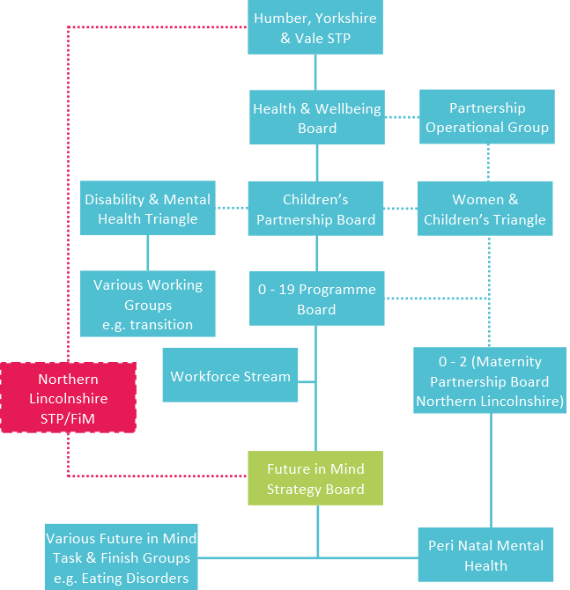

The transformation plan will also align to the local approach for mental health services across the life course to deliver the aspirations outlined in the five year forward view for mental health. There is an ambition between NELC and NELCCG to create a mental health strategy across the life course for NEL. This will ensure that we can move towards a transparent model of support with appropriate care pathways led by needs of the local area, and funding allocated by commissioners based on joint decisions

**Future in Mind Strategy Board**

The Future in Mind strategy board meets on a quarterly basis to discuss the progress made on each of the scorecards which contribute to the vision and aims set out within the LTP plan and to prioritise actions for the following quarter. Below is the membership list to the group which reports into the Governance structure detailed above.

|  |  |  |
| --- | --- | --- |
| **Name** | **Job Role** | **Area of Focus** |
| Lauren King – Co-Chair | Commissioning Lead Women’s & Children’s | Specialist Services |
| Michelle Thompson – Co-Chair | Assistant Director Women’s & Children’s |  |
| Annie Darby | Service Development Manager/ Named Nurse Safeguarding Children & Adults | Perinatal Mental Health |
| Debbie Haines | Learning & Development Manager | Workforce Development |
| Matt Clayton | Young People Support Service Manager | Liaison and Diversion |
| Bob Ross | Head of Children’s Health Provision | Early Help |
| Claire Thompson | Communications & Marketing Advisor | Communications & Marketing |
| Suzanne Bradbury | Educational Psychologist | Social, Emotional, Mental Health (5 – 18 years) |
| Tracey Urquhart | Consultant Lead Psychologist & CAMH Service Manager | CYP IAPT |
| Clare Ward | SEN Service Manager | SEND |
| Jane Fell | Designated Nurse | Looked After Children |
| Ali Cook | Early Intervention | Early Intervention in Psychosis |

**Local Sustainability and Transformation Plans (STP)**

The [Humber, Cost and Vale Transformation plan 2016-2021](http://www.northeastlincolnshireccg.nhs.uk/data/uploads/hcv/humber-coast-and-vale-sustainability-and-transformation-plan.pdf) tells us we have a lot to do to improve mental health services and which is echoed Nationally through the 5 Year Forward View of Mental Health. This document recognises the need to invest in prevention to reduce the prevalence of mental health disorders in children.

**Risk Log**

|  |  |  |  |
| --- | --- | --- | --- |
| **North East Lincolnshire Council/Clinical Commissioning Group** | | | |
| Description of local priority/project | Description of issue of risk to delivery of plan | Mitigating Actions | Date expected |
| **National Priorities and Direction** |  |  |  |
| **0 – 19 Re-structure & impact on FiM workforce** | 0-19 restructure is re-aligning staff to different hub based structure. In the reformation, staff will be lost and trained staff moved to other areas – potential loss of emotional wellbeing and mental health skills to workforce at preventative level | Maintain commissioner representation at 0-19 board, review workforce once 0-19 re-structure is agreed and staff have been re-located, refresh workforce and training plans accordingly. Explore CYP IAPT recruit to train through CAMHs to optimise funding opportunity 17/18 |  |
| **Workforce Training** | Lack of engagement from across the children’s workforce into the workforce planning and training sessions being delivered locally |  |  |
| **Children and Young People’s Mental Health and Emotional Wellbeing Service** | Reduced number of bids or no bids received on the CYP mental health and emotional wellbeing tender |  |  |
| **Section 136** | Delay in the process of Tier 4 provision for Humber impacts on the aspirations to develop a Humber shared place of safety/section 136 | Discussion with adult provider and commissioners in Humber |  |

**12. Supporting Documents**

|  |  |  |
| --- | --- | --- |
| **1.** | **North East Lincolnshire Council and North East Lincolnshire Clinical Commissioning Group Future in Mind: Transformation Plan 2015 - 2020** |  |
| **2.** | **North East Lincolnshire’s Refresh Transformation Plan Children & Young People Mental Health & Emotional Wellbeing October 2016- March 2018** |  |
| **3.** | **Children’s Workforce: Professional Capabilities Framework** |  |
| **4.** | **North East Lincolnshire Council Child & Adolescent Emotional Wellbeing and Mental Health Needs Assessment** |  |
| **5.** | **THRIVE Elaborated** |  |
| **6.** | **Outcome Based Accountability Guidelines** |  |
| **7.** | **Scorecard Presentation – Activity and Impact Statements** |  |
| **8.** | **Children and Young People’s Mental Health and Emotional Wellbeing Service – Service Specification** |  |