Adult services review
Stakeholder update June 2018

We are pleased to announce that following further discussions with providers, we have appointed FutureGov to support the adult service review in North East Lincolnshire (NEL). FutureGov have undertaken several successful projects within NEL in the past and want to build on this success to capacity build within adult services and delivery teams to deliver deep, iterative and continual change within the service.

This project will be led by Davis Ayre and his team.

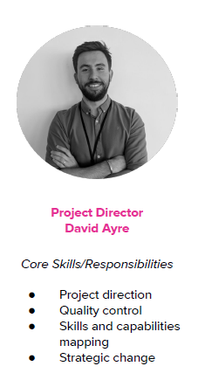

The FutureGov team will be engaging with many services, teams and individuals during the course of the review however if you would like to arrange a meeting with either David or myself, please contact Lezlie Treadgold - l.treadgold@nhs.net.

Who are FutureGov?

We bring together a multidisciplinary team to tackle the complex challenges faced by local government. Over the last 10 years we’ve demonstrated the value of applying a truly integrated team with diverse skill sets to help increase the capacity of government to transform its services around user’s needs, delivering better outcomes and cost savings.

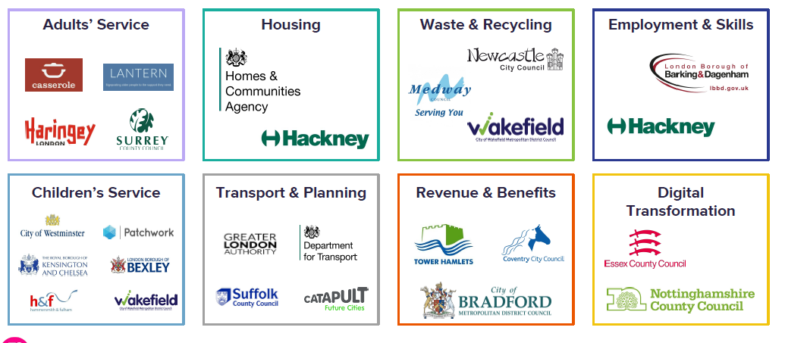

We start with people
Our work is rooted in human centred design, where our starting point is always the people who use services. Deep experience in user research and co-design helps us to make sure we understand the needs of service users and how systems need to change in order to better meet those needs.
We’ll work closely with the adult services team and frontline staff to identify particular areas and scenarios to research.
We then use a combination of ethnographic, observational and other user research methods to understand the experience people in different situations have of council services.
This user-centred approach enables us to cut through departmental and service silos to see what help people really need and when it can be most effective.

Prototyping to validate research
We build on our user research with prototyping future service models. This enables us to test ideas quickly and cheaply and get fast feedback from real users, rather than just speculating about what users need from our solution. Starting with a lower fidelity designs and iteratively moving towards a higher fidelity enables us to test ideas several times along the process, increasing the probability of ideas being successfully adopted into live services and delivering the intended outcomes.

Our prototype approach is based on participatory research. The people we work with - carers, service users, staff - are not passive subjects; they are active participants, who shape the research and our insights.

We’ll use prototyping to work through key areas for redesign in adult services.

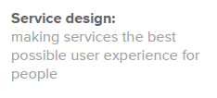

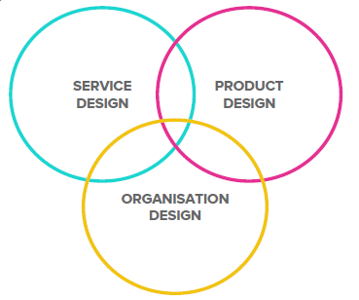
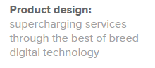

Adult services review project outline
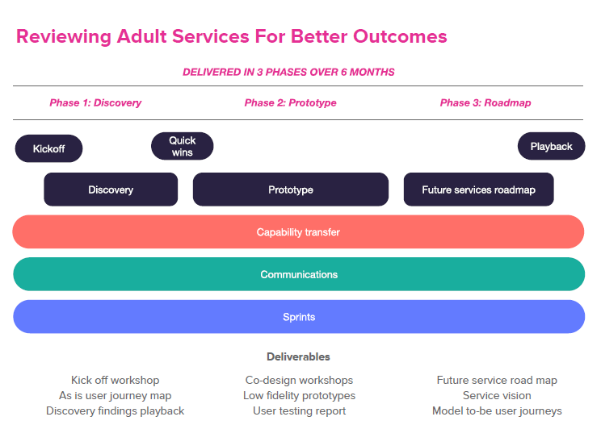

First steps

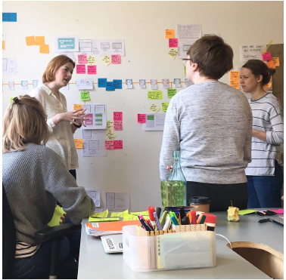
Setup - working with the Adult Services team, FutureGov will identify staff from the council, the CCG, focus and partners to join the project team. This will include colleagues from children’s services, so they can explore the user experience of transitioning between different service areas. They will base themselves alongside colleagues in Adult Services so that the work they do is visible and they’re available for people to talk to and share ideas or ask questions.

Kick off - we’ll kick-off with workshop which will take place mid-July to help flush out different expectations for the project and get us all on the same page. It’s a chance for people to share their ambitions and their concerns and for us to set the plan for the first few weeks together.

Strategy review - FutureGov take time to understand the approach being taken and the short, medium and long-term outcomes for the different parts of Adult Services. This helps inform the discovery and project roadmap.

We look forward to your involvement in the review and will provide updates as the review progresses.

Bev Compton
Director of adult services (DASS)
Project steering board chair

