

**Agenda Item 08**

Report to (Board/Sub-Committee): NEL CCG Partnership Board

Date of Meeting: 13th September 2018

Subject: Integrated Assurance and Quality Report

Presented by: Eddie McCabe Assistant Director – Contracting & Performance, Jan Haxby Director of Quality & Nursing

**STATUS OF THE REPORT**

For Information 

For Discussion ☒

For Approval / Ratification 

|  |  |
| --- | --- |
| **PURPOSE OF REPORT:** | The report advises the Partnership Board of how NELCCG are performing against;   * six domains developed for the performance dashboard and; * three domains developed for quality dashboard.   The dashboards are managed via the Delivery Assurance Committee, the Clinical Governance Committee and the Integrated Governance and Audit Committee.  For more detail on performance and quality the latest integrated assurance report presented to the Delivery Assurance Committee and the quality dashboard report verbally presented to the Clinical Governance Committee can be found via the embedded files in the ‘Appendices / attachments’ section of this cover sheet. |
| **Recommendations:** | The Partnership Board is asked:   * to note judgements made against the domains of the dashboards * for further feedback on ways to improve the report. |
| **Sub Committee Process and Assurance:** | The Delivery Assurance Committee and the Clinical Governance Committee manage and assure the performance and quality contained within these dashboards.  The Delivery Assurance Committee cross reference the performance framework with the CCG Board Assurance framework and Risk Register. This allows the Delivery Assurance Committee to identify any gaps in risk management, however none were identified at this time. |
| ***Implications:*** |  |
| **Risk Assurance Framework Implications:** | The dashboards associated with them are managed via the Delivery Assurance Committee and the Clinical Governance Committee. |
| **Legal Implications:** | None |
| **Equality Impact Assessment implications:** | An Equality Impact Assessment is not required for this report. |
| **Finance Implications:** | There are a number of measures within the Performance Dashboard with a financial implication such as activity and Quality Premium measures, however the detail of these are dealt with separately within the Finance Report. |
| **Quality Implications:** | Quality implications are managed by the Clinical Governance Committee and DAC and are escalated within the main body of this report. |
| **Procurement Decisions/Implications *(Care Contracting Committee):*** | None |
| **Engagement Implications:** | None |
|  |  |
| **Conflicts of Interest** | None |
| **Strategic Objectives**  *Short summary as to how the report links to the CCG’s strategic objectives* | 1. *Sustainable Services*   The performance and quality dashboards contain a number of national and local measures that support this objective. |
| 1. *Empowering People*   The performance and quality dashboards contain a number of national and local measures that support this objective. |
| 1. *Supporting Communities*   The performance and quality dashboards contain a number of national and local measures that support this objective. |
| 1. *Delivering a fit for purpose organisation*   The performance and quality dashboards contain a number of national and local measures that support this objective. |
| **NHS Constitution:** | The Performance and Quality dashboards contain measures from the NHS Constitution and the performance and quality associated with these are managed and assured through the Delivery Assurance Committee and the Clinical Governance Committee. |
| **Report exempt from Public Disclosure** | No |

|  |  |
| --- | --- |
| **Appendices / attachments** |  |

**Integrated Assurance & Quality Report**

**Introduction**

The dashboards below represent an overview of performance and quality for health and social care services across North East Lincolnshire.

The performance dashboard consists of six domains and the quality dashboard three domains that incorporate all areas that North East Lincolnshire Clinical Commissioning Group strive to improve on. A judgement has been made of the status for each domain based on the measures and intelligence underpinning them. These judgements try to balance the current position with the expected outcome at the end of the year and weightings with respect to priority. They also represent the local perspective of performance and quality for North East Lincolnshire rather than the performance against the national definition which, on occasion, covers a broader footprint. It should be noted that those issues that have an impact on the CCGs corporate performance assessment will continue to be scrutinised at the Delivery Assurance Committee. The dashboards reflect performance for the first four months of 2018-19. The Delivery Assurance Committee and Quality Committee, respectively, are asked to make a decision on the final status of the dashboards before reporting to the CCG Partnership Board. Full exception report summaries are also included for Performance (appendix A) detailing performance of indicators that are underperforming, Provider-level Quality Dashboards (appendix B), risk (appendix C) detailing risks rated as 16 or higher and Planned Care performance (appendix D).

**Performance Quality**

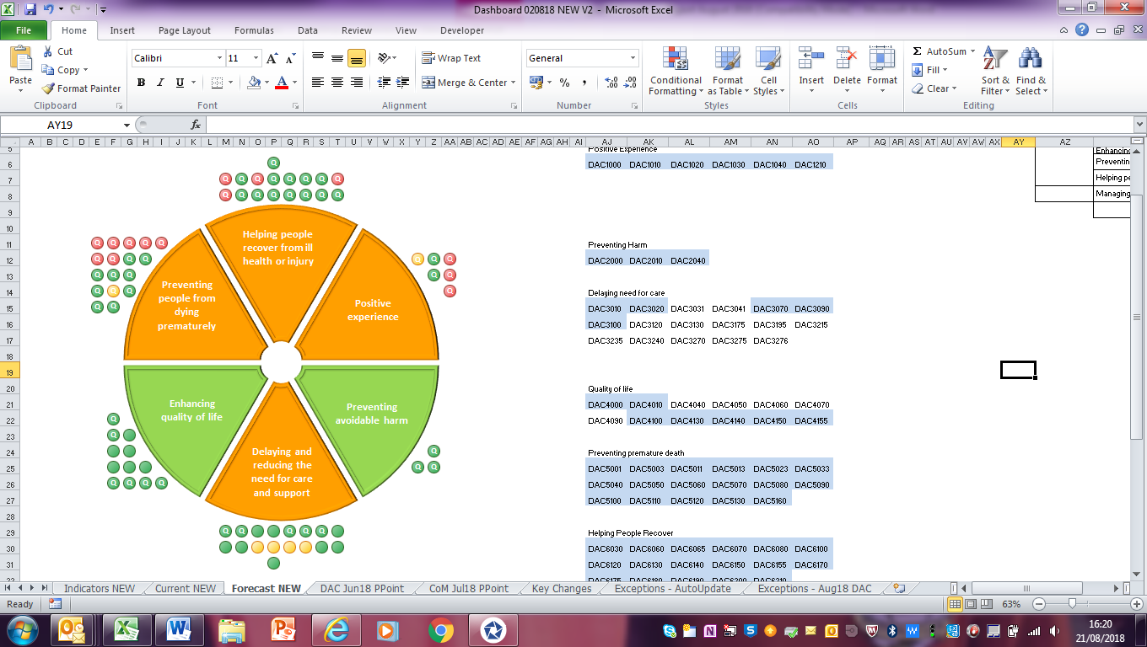 

**Performance Escalation**

**Elective care**

**Expectations**

During the 2018-19 planning process the NHS Operational Plan set out clear expectations with regards to the delivery and management of elective activity (alongside managing the CCG budget, emergency services and other priorities). These expectations were supported nationally by additional funding to support a step increase in activity levels. The requirements associated with this were reflected in NELCCGs 2018/19 commissioning plans which aligned with the level of activity needed to ensure that all waiting lists did not grow beyond March 2018 levels, by March 2019.

CCGs recently received a letter from the NHS England National Director of Operations and Information and NHS North Regional Director highlighting that, if current activity levels are maintained, CCG commissioned trajectories for activity will not be delivered by most Trusts. This significant under-delivery of elective activity against commissioner plans will take concerted collective action to recover in the remainder of the year.

The letter then set out five clear expectations that should be put in place immediately by each CCG.

**Actions Required**

1. Putting basic processes in place everywhere, including:

* A Governing Body level focus and monthly reporting on the state of the waiting list and long waiters, and attention to the importance of delivering elective care performance and activity levels alongside emergency care and finance;
* Certainty that all providers are routinely validating their waiting lists to ensure that we have an accurate view of who is waiting for treatment.

1. Reducing 52 week waits by at least 50%

* Appropriate week by week shared provider/commissioner trajectory should be in place and being met, for reducing the number of 52 week waiters to eliminate these ahead of winter wherever possible.
* Every CCG needs to ensure that it is managing a patient tracking list (PTL) for all long waiters over 40 weeks to ensure that everyone has a date for treatment before they breach 52 weeks.

1. Ensuring patients who are not waiting for inpatient treatment are treated within 18 weeks

* Plans should be agreed with providers with a trajectory to ensure all specialities are treating non-admitted patients within the 18 weeks standard.

1. Delivering the contracted activity volumes

* By early September you should have discussed and received Trust forecasts of their 2018/19 activity and performance commitments to ensure they are back on track to deliver the activity commitments in CCG plans. Where Trusts determine that they will no longer be able to meet this CCGs should work with Trusts to determine how these gaps will be closed through use of capacity in other trusts and/or the independent sector. Any contingency plan for work carried out by other Trusts or the independent sector should be available to mobilise by mid-September.

1. Continuing to manage elective demand

* It is crucially important that we do not lose the recent pathway and referral management gains that have been put in place and continue to innovate service access to make sure that the patients who are referred to hospital outpatients or who are managed through repeated outpatient visits are those for whom that is really the best and only care pathway.

**NELCCGs Performance**

NELCCG are starting the year with relatively poor performance in respect to waiting times and there are capacity challenges in certain service areas to deliver the required level of activity to stabilise or reduce waiting lists. However planned activity levels are being met and both performance and waiting list numbers are improving in the early part of 2018-19.

In respect to planned and delivered levels of activity the table below sets out the position after the first quarter of the year for NELCCG in 2018-19. Total referrals are in line with 2017-18 levels and are 2.7% below the planned level which has accounted for expected growth from demographic changes and the fact that there have been more working days in the first quarter of 2018-19 compared to the 2017-18 and therefore there has been a reduction in referrals in real terms. To add to this NELCCG also have the 5th lowest rate of GP referrals in the country of 207 CCGs.

Despite referral rates being below plan, the level of outpatients has increased and is above plan to the extent of 2.8% and 3.4% for first and follow-up attendances, respectively. Much of the increase in outpatients is being driven by activity in Ophthalmology and Dermatology. Ophthalmology is an area where the CCG has seen significant improvement in waiting times in the early part of 2018-19 and therefore is thought to be associated with the additional capacity for seeing and treating patients by the contract put in place with New Medica in April 2017 and the additional capacity NLAG have realised, in part facilitated by referrals increasing at New Medica. The increase in dermatology appointments is again linked to a new provider (Virgin Care) starting in April 2017 who have improved waiting times significantly in this specialty.

Although elective inpatient and daycase spells are below plan we have seen a small increase in activity from last year. Again procedures in Ophthalmology have seen a significant increase (60%) in 2018-19 whereas the area with the greatest reduction has been gastroenterology and, in particular, a reduction in endoscopy procedures of 14%. Endoscopy, to put in to context, equates to 22% of all daycase spells for NELCCG and has been a particular focus across Northern Lincolnshire to improve gastrointestinal disease pathways which were expected to reduce demand for endoscopy procedures.

|  |  |  |  |  |  |
| --- | --- | --- | --- | --- | --- |
| **Point of delivery** | **2017-18 actuals** | **2018-19 actuals** | **2018-19 plan** | **Year on year change** | **Variance from plan** |
| GP referrals | 6,518 | 6,706 | 6,756 | 2.9% | -0.7% |
| Other referrals | 6,285 | 6,100 | 6,399 | -2.9% | -4.7% |
| Total referrals | 12,803 | 12,806 | 13,155 | 0.0% | -2.7% |
| Outpatient 1st attendances | 12,102 | 12,831 | 12,477 | 6.0% | 2.8% |
| Outpatient FU attendances | 21,287 | 23,419 | 22,642 | 10.0% | 3.4% |
| Total Electives spells | 7,609 | 7,656 | 8,024 | 0.6% | -4.6% |

Waiting times from referral to treatment (RTT) have improved month on month in the first four months of 2018-19 and, although there is still a significant issue locally around RTT performance, NELCCG are ahead of their planned improvement trajectory. Although, on face value, it appears that the number of patients on the waiting list has increased since the end of March 2018, it is actually the introduction of a new cohort of patients waiting for planned inpatient care that was not previously reported against this measure that has caused the increase. This was anticipated and planned for in the CCGs operating plan and therefore we are currently below the planned waiting list numbers in July 2018 due to the reduction seen in the most recent month. The greatest reductions have been seen in Ophthalmology, Neurology, Cardiology and Gastroenterology. Rheumatology and Urology waiting lists are increasing however and NLAG have requested that CCGs work with them to find alternative provision for chronic pain management services. North Lincs and NE Lincs CCGs have been working with current provision for pain management services to discuss options, for patients who wish to do so, to transfer from NLAG and ensuring that there is capacity for all new referrals to be referred elsewhere. Pain Management Solutions, St Hugh’s Hospital and NLAG are now working together to work on solutions for this supported by the CCG with plans to be proposed to the Planned Care Board on 14th September.

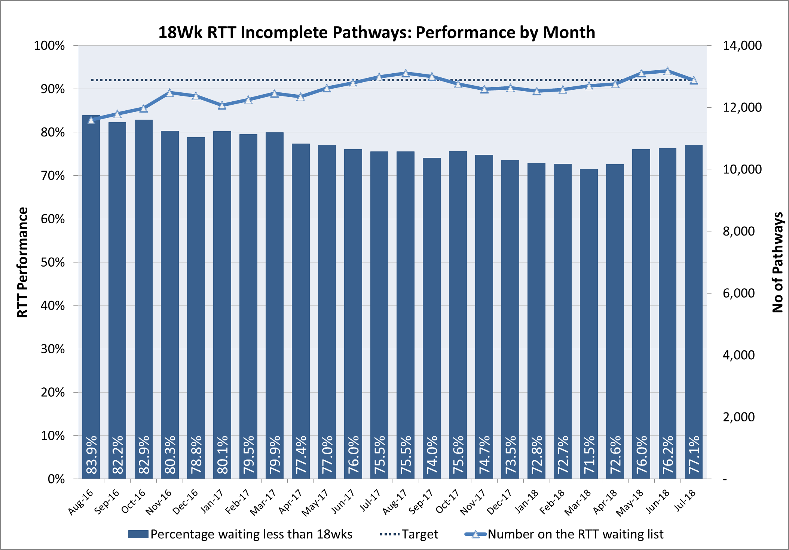

As well as the RTT pathway mentioned above we are also closely monitoring the number of 52 week waiters which peaked at the end of March at 81 patients. Since then we’ve seen a steady reduction down to 75 in July which is slightly above the CCG plan of 70. However NLAG have recently shared their trajectory which profiles the improvement starting to take effect from August onwards and are therefore slightly ahead on their improvement trajectory.

**Quality Escalation**

**Quality Escalation**

The purpose of this report is to highlight the exceptions in Quality and to escalate items from the Clinical Governance Committee to the Board.

1. **Enhanced Quality Surveillance**

One provider across the North East Lincolnshire healthcare system remains to require an enhanced level of quality surveillance. This provider is Northern Lincolnshire and Goole NHS Trust.

1. **Northern Lincolnshire and Goole NHS Trust (NLaG)**

The Trust remains in Special Measures for quality and finance.

The CQC completed an announced comprehensive inspection of the Trust across all three sites in May, the follow-up unannounced visit has been undertaken and the Trust have supplied information to the CQC in accordance with their requests. A formal outcome of the inspection is awaited.

Staffing, waiting times, diagnostics, capacity and demand continue to present significant challenges to the Trust’s ability to provide an acceptable service standard.

We have seen significant progress in the clinical harm review work stream.

1. **Thames Ambulance Service Limited (TASL)**

TASL have moved to routine quality surveillance. We continue to support the provider to improve, we have seen a notable reduction in the number of concerns logged with us and have received assurance that the Provider has policies in place to articulate the Complaints and Incidents processes.

NL and NEL CCG continue to meet on a regular basis to share intelligence.

Regular contract meeting are in place to ensure an oversight mechanism for performance, finance and quality is maintained.

1. **Individual Funding Requests**

Individual Funding Request (IFR) is an application process for healthcare professionals to complete and submit where a treatment or service is not routinely offered by the NHS where they feel their patient would benefit from treatment.

The request is submitted to the CCG IFR process. The administration of the IFR process is completed by a provider called North of England Commissioning Support (NECS) on behalf of the CCG. The IFR outcome decision is made by a local GP panel working on behalf of the CCG.

NELCCG has experienced ‘noise in the system’ concerning the NEL IFR process. The ‘noise’ is predominately coming from IFR referrers (clinicians in primary and secondary care).

We decided to complete an audit of IFR to understand and validate the ‘noise’. The audit was completed in July 2018. The audit identified action which required immediate implementation – which was undertaken in August and plans are in place to share the findings and recommendations with clinical leads.

1. **Infection Prevention and Control – Gram Negative Blood Stream Infections**

The incidence of infection reported to date for this year indicates that if it continues we will not meet the quality premium target for 2018/2019 (66.7% of the target has already been reported YTD). The position YTD is worse than last year (last year we attained the target). We have implemented IPC project work designed to help to reduce the incidence of gram negative blood stream infections. We have contracted a Community Nurse to assist with moving this agenda forwards more quickly. Mechanisms are in place for the Clinical Governance Committee to monitor the Gram Negative Blood Stream Infections position on a regular basis.

1. **Site Visits**

In 2017/18 the Quality Team –led 17 site visits to providers. The majority of which were reactive visits in light of the intelligence received.

This year we plan that site visits will be part of our quality assurance processes and business as usual, to enable a proactive system to be implemented. The number of visits being undertaken will significantly increase to enable patient pathway and themed site visits to complement the quality assurance processes and commissioning cycle.

1. **Clinical Governance Committee**

The Clinical Governance Committee held its first meeting on the 16th of August 2018. The membership is working to establish the Terms of Reference and operations of the Committee.

1. **JTAI** – We are anticipating a joint targeted area inspection between September and March 19 and are working together across agencies to prepare a mock inspection within the next few weeks.

**Appendix A - Performance Exception Summary**

| **Code** | **Indicator** | **Quality Measure?** | **Latest period** | | | | **Year to date** | | | **Year End Forecast** |
| --- | --- | --- | --- | --- | --- | --- | --- | --- | --- | --- |
| **Period** | **Target** | **Value** | **Status** | **Target** | **Value** | **Status** |
| Positive experience | | | | | | | | | | |
| DAC1000 | Total time in A&E: four hours or less | Yes | July 2018 | 88% | 83.97% |  | 87.8% | 86.39% |  |  |
| DAC1020 | Cancelled Operations offered binding date within 28 days | Yes | Q1 2018/19 | 5.34% | 26.42% |  | 5.34% | 26.42% |  |  |
| DAC1040 | Numbers of unjustified mixed sex accommodation breaches | Yes | June 2018 | 0 | 37 |  | 0 | 123 |  |  |
| DAC1210 | Proportion of GP referrals made by e-referrals | Yes | June 2018 | 100% | 54.33% |  | 100% | 54.33% |  |  |
| **Preventing avoidable harm** | | | | | | | | | | |
| No Exceptions | | | | | | | | | | |
| **Delaying and reducing the need for care and support** | | | | | | | | | | |  |  |  |  |  |  |  |  |  |  |
| DAC3175 | Total Elective Spells (Specific Acute) | No | May 2018 | 2813 | 2744 |  | 5386 | 5168 |  |  |
| DAC3195 | Total Non-Elective Spells (Specific Acute) | No | May 2018 | 1437 | 1488 |  | 2811 | 2825 |  |  |
| DAC3215 | Consultant Led First Outpatient Attendances | No | May 2018 | 4294 | 4451 |  | 8158 | 8430 |  |  |
| DAC3235 | Consultant Led Follow-Up Outpatient Attendances | No | May 2018 | 7920 | 8190 |  | 14926 | 15664 |  |  |
| DAC3240 | A&E Attendances (NEL Patients) | No | May 2018 | 5050 | 5193 |  | 9737 | 10044 |  |  |
| **Enhancing quality of life** | | | | | | | | | | |
| DAC4050 | Proportion of adults in contact with secondary mental health services living independently, with or without support | No | May 2018 | 80.00% | 78.36% |  | 80.00% | 77.33% |  |  |
| **Preventing people from dying prematurely** | | | | | | | | | | |
| DAC5001 | ARP Category 1 Mean Response Time – Calls from people with life-threatening illnesses or injuries | Yes | July 2018 | 00:07:00 | 00:07:41 |  | 00:07:00 | 00:07:55 |  |  |
| DAC5003 | ARP Category 1 90th centile response time – Calls from people with life-threatening illnesses or injuries | Yes | July 2018 | 00:15:00 | 00:13:53 |  | 00:15:00 | 00:14:17 |  |  |
| DAC5011 | ARP Category 2 Mean Response Time – Emergency calls | Yes | July 2018 | 00:18:00 | 00:33:17 |  | 00:18:00 | 00:31:47 |  |  |
| DAC5013 | ARP Category 2 90th centile response time – Emergency Calls | Yes | July 2018 | 00:40:00 | 01:10:26 |  | 00:40:00 | 01:07:14 |  |  |
| DAC5023 | ARP Category 3 90th centile response time – Urgent Calls | Yes | July 2018 | 02:00:00 | 03:13:58 |  | 02:00:00 | 02:55:14 |  |  |
| DAC5033 | ARP Category 4 90th centile response time – Less Urgent Calls | Yes | July 2018 | 03:00:00 | 02:29:24 |  | 03:00:00 | 02:20:39 |  |  |
| DAC5040 | Ambulance 30 minute average turnaround time target - DPOW | No | July 2018 | 30 mins | 38.54 mins |  | 30 mins | 38.17 mins |  |  |
| DAC5110 | Cancer 62 Days Referral to Treatment (GP Referral) | Yes | June 2018 | 85% | 60% |  | 85% | 67.69% |  |  |
| **Helping people recover from ill health or injury** | | | | | | | | | | |
| DAC6060 | RTT - Incomplete Patients: % Seen Within 18 Weeks | Yes | July 2018 | 72.4% | 77.09% |  | 70.9% | 75.5% |  |  |
| DAC6070 | RTT – No. waiting on incomplete pathway 52+ wks | Yes | July 2018 | 70 | 75 |  | 235 | 288 |  |  |
| DAC6140 | Proportion of children & young people <18 receiving treatment by NHS funded community services | Yes | Q4 2017/18 | 7.95% | 3.07% |  | No data available in 2018/19 | | |  |
| DAC6200 | Extended access (evening and weekends) at GP services | Yes | July 2018 | 32.1% | 0% |  | 32.1% | 0% |  |  |

**Appendix B – Provider-level Quality Surveillance Ratings**

 