
Agenda Item 08

Report to (Board/Sub-Committee): NEL CCG Partnership Board

Date of Meeting: 14th September 2017

Subject: Integrated Assurance and Quality Report

Presented by: Eddie McCabe Assistant Director – Contracting & Performance, Jan Haxby Director of Quality & Nursing

STATUS OF THE REPORT

For Information
For Discussion 
For Approval / Ratification

PURPOSE OF REPORT: | The report advises the Partnership Board of how NELCCG are performing against;  - six domains developed for the performance dashboard;  - three domains developed for quality dashboard and;  - six domains for risk.  The dashboards are managed via the Delivery Assurance Committee, the Quality Committee and the Integrated Governance and Audit Committee.  A summary of risks with a score of 16 or above is also included.  For more detail on performance, risk and quality the latest integrated assurance report presented to the Delivery Assurance Committee and quality dashboard report presented to the Quality Committee can be found via the embedded files in the ‘Appendices / attachments’ section of this cover sheet.
Recommendations: | The Partnership Board is asked:  - to note judgements made against the domains of the dashboards  - to note the CCG Risk Management framework has been reviewed/refreshed and is shared with the committee on how we manage risks. Risk management is an increasingly important business driver and stakeholders have become much more concerned about risk. Risk may be a driver of strategic decisions, it may be a cause of uncertainty in the organisation or it may simply be embedded in the activities of the organisation. This framework aims to provide strategic direction, guidance and good management practice regarding embedding an integrated risk management approach, ensuring it is central to all CCG business, detailing clear lines of accountability and organisational responsibilities and arrangements.  - to note the Annual risk management reviews took place during June/July with the risk manager and risk assignee, with yet again a positive outcome. The purpose of these sessions are to provide the opportunity for Managers/Assignees to work together to review their risks paying particular attention to the risk ratings/internal controls and look at ways of improving our risk registers. This is also an opportunity to undertake an internal confirm & challenge and monitor static risks, for example if the risk rating of a risk hasn’t changed within the last 12 months, to evaluate whether the risk remains relevant and if so what actions will be taken.  - to note the information on future performance, quality and risk challenges  - to note update information on unplanned care  - to note update information on RTT  - to note CCG IAF rating for NELCCG  - for further feedback on ways to improve the report
Sub Committee Process and Assurance: | The Delivery Assurance Committee, the Quality Committee and the Integrated Governance and Audit Committee manage and assure the performance, quality and risks contained within these dashboards.
Implications:
Risk Assurance Framework Implications: | The dashboards and risks associated with them are managed via the Delivery Assurance Committee, the Quality Committee and the Integrated Governance and Audit Committee.
Legal Implications: | None
Equality Impact Assessment implications: | An Equality Impact Assessment is not required for this report.
Finance Implications: | There are a number of measures within the Performance Dashboard with a financial implication such as activity and Quality Premium measures, however the detail of these are dealt with separately within the Finance Report.
Quality Implications: | Quality implications are managed by the quality committee and escalated within the main body of this report.
Procurement Decisions/Implications (Care Contracting Committee): | None
Engagement Implications: | None
Conflicts of Interest | None
Strategic Objectives  Short summary as to how the report links to the CCG’s strategic objectives | - Sustainable Services  The performance, quality and risk dashboards contain a number of national and local measures that support this objective.
- Empowering People

The performance, quality and risk dashboards contain a number of national and local measures that support this objective.
- Supporting Communities

The performance, quality and risk dashboards contain a number of national and local measures that support this objective.
- Delivering a fit for purpose organisation

The performance, quality and risk dashboards contain a number of national and local measures that support this objective.
NHS Constitution: | The Performance and Quality dashboards contain measures from the NHS Constitution and the performance and risks associated with these are managed and assured through the Delivery Assurance Committee, the Quality Committee and the Integrated Governance and Audit Committee.
Report exempt from Public Disclosure | No

Appendices / attachments | 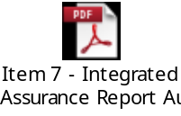

Integrated Assurance & Quality Report

Introduction
The dashboards below represent an overview of performance and quality for health and social care services across North East Lincolnshire.

The performance dashboard consists of six domains and the quality dashboard three domains that incorporate all areas that North East Lincolnshire Clinical Commissioning Group strive to improve on. A judgement has been made of the status for each domain based on the measures and intelligence underpinning them. These judgements try to balance the current position with the expected outcome at the end of the year and weightings with respect to priority. They also represent the local perspective of performance and quality for North East Lincolnshire rather than the performance against the national definition which, on occasion, covers a broader footprint. It should be noted that those issues that have an impact on the CCGs corporate performance assessment will continue to be scrutinised at the Delivery Assurance Committee. The dashboards reflect performance for the four months of 2017-18. The Delivery Assurance Committee and Quality Committee, respectively, are asked to make a decision on the final status of the dashboards before reporting to the CCG Partnership Board. Full exception report summaries are also included for Performance (appendix A) detailing performance of indicators that are underperforming, Provider-level Quality Dashboards (appendix B), risk (appendix C) detailing risks rated as 16 or higher.
Performance
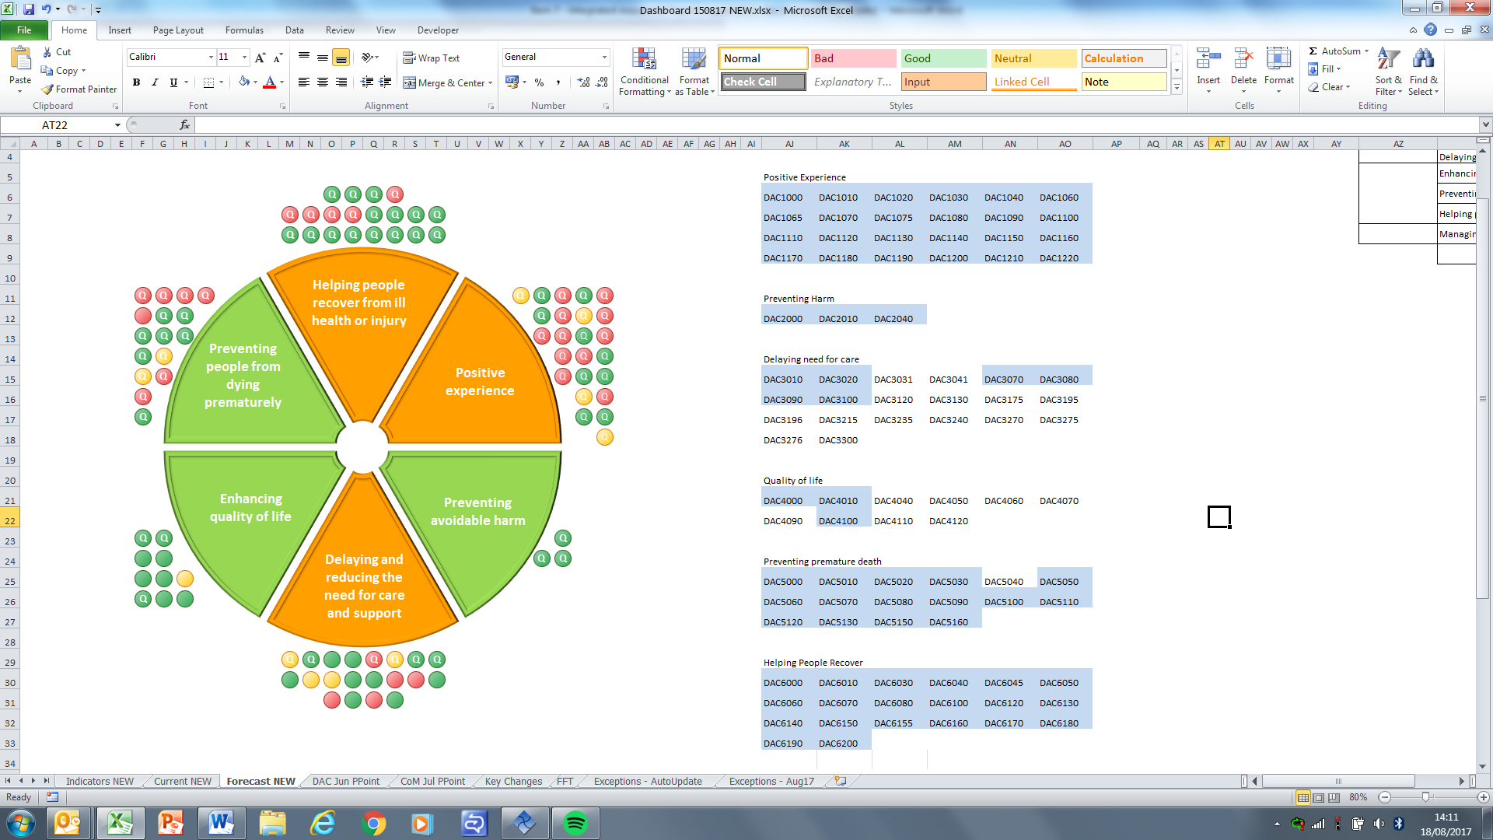
The risk heat maps are separated in to a CCG risk register and the CCGs Board Assurance Framework risks. These heat maps demonstrate the number of risks with a specific risk score. The risk summaries reflect the risk status as at 23rd August 2017.

Risk Register risk profile Board Assurance Framework risk profile
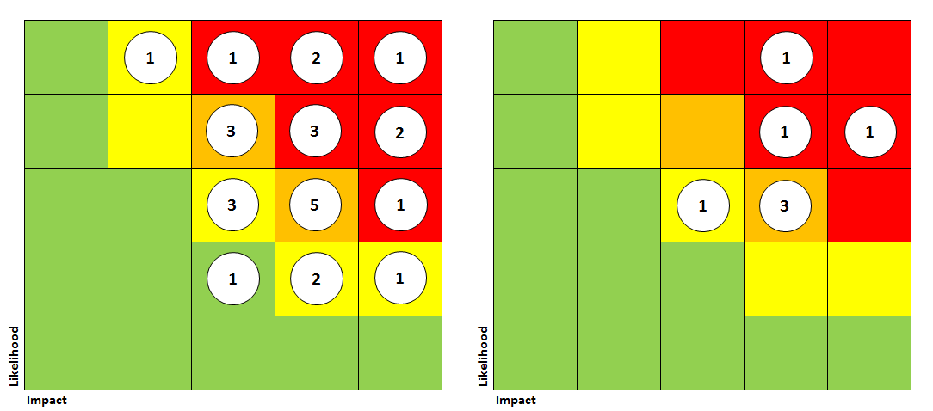

Performance Escalation

Unplanned Care
To update the Partnership Board on unplanned care following initial report in May 2017.

A&E Performance Update
At the end of Q1 (June 2017), the trust A&E position was 83% with DPoW monthly performance in the quarter being 70.3%, 77.9% and 73.1%.

Performance has steadied and improved. In the past 5 weeks to date, DPoW A&E performance is averaging 83% and NLaG overall, 88.18% which is close to the national recovery trajectory of 90% by September. Further, the regular poor performance at weekends has shown improvement with the weekend of 29/30 July being the exception.

Measures stated to address DPoW issues
At the July A&E Delivery Board a specific discussion was held about the issues prevailing at DPoW and measures that would be put in place above and beyond the Delivery Board Improvement Plan. The measures stated were:-

- Continuous Staff Engagement on ED shop floor (Senior team, ACOO, Clinical lead group manager & matron)
- Continuous review of nursing and medical shifts and adjusting/strengthening where required in particular focus on weekend.
- Immediate Escalation of issues affecting ED
- ECIP supporting ED (Dr Kevin Reynard on shop floor this Monday and Wednesday)-Clinical Lead ECC session at DPOW
- Rotation of consultant staff across sites –being discussed
- Identified deputy clinical lead for Emergency Care at DPOW
- Two hourly Board Rounds re- instated
- Identified manager (B7) working alongside shift lead
- Review of Shift Lead role
- Admitting rights for EEC consultants to AMU
- Identified Consultant presence on shop floor
- Facilitated meeting with Ops Centre, shift leads and Ward Managers (ACOO Led on flow & communication)
- Discussion re GP working within A+E as part of team (to be explored)
- Clinical meeting GPs Consultants being planned Sept

Further, a weekly call between NLaG Senior Operational Management and CCG has been established to monitor progress, there has been a positive impact from the measures and a subsequent improvement in performance.

Planned Care
To update the Partnership Board on data validation following initial RTT report in March 2017.

RTT Update – Validation of Records Update
NLaG completed phase 1 at the end of April 2017. External validators produced a report which led to the development of a training programme that will last until the end of September 2017 whereby Team leaders will be given in-depth training to increase their knowledge and competence. RTT coding structure is being reviewed as issues identified show that local codes are being used, this will be linked to the major PAS (Patient Administration System) upgrade planned for November 2017.

NLaG are now focusing on phase 2 of the validation exercise – this will mainly cover the non-active RTT waiting lists – 28,000 records have been identified for validation. This work commenced 10th July and will take approximately 4 months to complete.

An overarching clinical harm process is being implemented and separately managed through the group and is chaired by Dr David Black (NHSE). The clinical harm review will identify people harmed or at risk of harm and any significant incidences. In addition, the Trust has established a clinical harm review process to review 52 week breaches.
NELCCG Improvement Assessment Framework (IAF) Rating
NHS North East Lincolnshire CCG has achieved the overall rating of Good for 2016/17 in the CCG Improvement Assessment Framework (IAF). The ratings are published on the CCG Improvement and Assessment page of the NHS England website and on the My NHS section of the NHS Choices website.

2016/17 Assessment ratings for cancer, mental health and dementia.
Each CCG was provided with a rating for each of the three clinical priority areas. The ratings are described as: ‘outstanding’; ‘good’; ‘requires improvement’; and, ‘inadequate’.

The assessment for NELCCG in each of these three clinical priority areas for 2016/17 was as follows;

NHS North East Lincolnshire CCG
Clinical priority area | Headline rating 2016/17
Cancer | Inadequate
Mental Health | Good
Dementia | Outstanding

Assessments for the other three priority areas (diabetes, learning disabilities and maternity) are expected to follow later in the year.

NELCCG is very pleased with its rating in relation to Mental Health and dementia, but recognises there is more work to do around its cancer performance. To address the specific issues a 62 day cancer recovery plan has been produced and its implementation is being supported by Humber Coast and Vale Cancer Alliance through its planned programmes of work.

Quality Escalation

The purpose of this report is to highlight the exceptions in Quality and to escalate items from the Quality Committee to the Board.

- Service Provider: Northern Lincolnshire and Goole NHS Trust
On enhanced quality surveillance due to finance, performance and quality.

Despite the overall positive trajectory of A and E performance at NLaG, performance at DPoW has seen significant dips in performance over the summer period due to staffing challenges. Commissioning response has been required to ensure Urgent Care Services are in place to support the Trust with managing the activity in the system.

Commissioners are actively engaged working in collaboration with the Trust and peers around specific quality improvement agendas e.g. Clinical Harm Review work. Significant commissioning capacity is being deployed to ensure North East Lincolnshire representation within the governance and oversight arrangements as well as the quality improvement working groups.

- Service Provider: East Midlands Ambulance Service
Surveillance has moved to routine. Commissioners continue to attend and contribute to Contract Meetings. EMAS have entered the Ambulance Response Programme – a national programme to implement new ambulance standards in 4 categories. We are working with the Lead Commissioner and Provider to understand the anticipated impact of ARP.

- Service Provider: HMT St Hugh’s Hospital
The hospital is sustaining a positive improvement in the culture of incident reporting, which was incentivised via last year’s CQUIN. Through the contract meeting the hospital demonstrate response to monthly quality indicators, the recent dashboard has seen an improvement in a number of quality indicators.

Commissioners await the outcome of the CQC’s announced inspection and the St Hugh’s facilitated PLACE (Patient-Led Assessment of the Care Environment) audit in August. The PLACE findings will provide the Trust and stakeholders with a patient perspective of the quality of the care environment at St Hugh’s and will complement the quality improvement agenda the hospital is delivering.

Healthwatch completed an inspection of the service in July. Overall the inspection findings were positive, with areas for improvement in discharge planning and communication. North East Lincolnshire CCG has received a patient journey regarding discharge from St Hugh’s which reflects the findings of Healthwatch. Plans are in place to work with St Hugh’s to triangulate the information and take action to improve practice.

- Service Provider: General Practice and Community Care
Weelsby View Health Centre has received negative media attention this August regarding the poor standard of cleanliness in the buildings toilet facilities. Commissioners and NHS England have since conducted a site visit where the cleanliness of the facilities was determined to be of an adequate standard, on the visit a building occupant also commented on the improvement in cleanliness of the toilet facilities since the media release.

Freshney Green Primary Care Centre’s CQC report was published in August. The report recognises the service for outstanding practice in the review and approval of policy documents, the staff library service and the induction process for new starters. Inspectors identified areas where the service should make improvements. Commissioners intend to engage with Freshney to share their outstanding practice and offer support to help make the improvements identified.

- Service Provider: Hull and East Yorkshire NHS Hospitals Trust
The Trust monthly Quality Report continues to provide commissioners with positive assurance on the organisations oversight and scrutiny of their quality indicators. The Trust is continuing to utilise Safety Thermometer despite the Improvement Academy at the Yorkshire and Humber Academic Health Sciences Network no longer producing the benchmarking data as of April 17. The Trust recognises that the CQC and NHSI expect Trusts to use the dataset as a local improvement tool. Therefore, the Trust will retain the monthly point prevalence audit within the Quality Report.

- Service Provider: Domiciliary Care
The demand for domiciliary care services in North East Lincolnshire has been great over the peak summer period and capacity to meet the demand is struggling. Therefore service users are not always receiving their call time preference. The position is being carefully monitored and responded to by CCG Contract Officers engaging with the Providers.

- Service Provider: Thames Transport Service
An announced site visit has been undertaken by NELCCG Commissioning Lead and the Clinical Nurse for Quality. The focus of the visit was to complete a supportive inspection to assist the Provider with improving quality in their service. The inspection was received well by Thames and Commissioners have committed to conduct further site/crew visits this quarter. Overall the inspection identified specific areas for the service to improve.

Thames commenced another contract from the 1st of September Commissioners anticipate that an increase in calls to the call centre may result in a decline in the quality of service provided to North East Lincolnshire Service Users. Commissioners are monitoring the intelligence received regarding Thames call centre closely and have plans in place to escalate to the Service Provider at the earliest opportunity should quality be affected.

Items for Escalation from the Quality Committee
Members of the NELCCG Quality Committee, which took place on 10/08/2017, identified three items for escalation to the Board, these items are summarised below:

- National Ambition to reduce healthcare associated gram-negative blood stream infections
There is a National ambition to reduce healthcare associated gram-negative blood stream infections by 50% by March 2021. CCG’s and providers are required to work together to achieve this ambition. NHSE require focus, in 2017/18, on E.Coli with a 10% reduction in E.Coli for the year. By September 2017 the CCG is required to submit a joint action plan for how the local economy plans to achieve a 50% reduction in healthcare associated GNBSIs by March 2021. The CCG have appointed Jan Haxby as the Executive Lead to act as the main point of contact, supported by Lydia Golby. The timeframe for creating and submitting a joint strategy is limited. The Quality Committee will have oversight of the action plan and actions will be put in place to regularly monitor delivery.

- The Committee received a proposal to document the Quality Risks to NEL as a population on a Quality Risk Log. The content of which will include the risks escalated to the Quality Committee via the monthly escalation report. The Log would function under the organisations Risk Management framework.

- The Quality Committee Members recognise the significance of the LeDeR programme and note the challenge to taking this programme forward locally.

- The Quality Committee will receive the outcome reports for the deep dive reviews on Medication, Discharge and Pressure Ulcers at the next meeting.

Members of the NELCCG Quality Committee workshop, which took place on 13/07/2017, identified one item for escalation to the board, as summarised below:

- The success of the Noise in the System process (NITS Process) was to be noted and the further development identified by the Committee to refine the process and make it more robust. The Committee recognised the positive contribution of the NITS process in the development of changes in intelligence sharing, action planning and addressing concerns collaboratively with stakeholders. The Committee also recognised how the process has improved the reporting of deep dive concerns to the Quality Committee.

Appendix A - Performance Exception Summary
Code | Indicator | Quality Measure? | Latest period |  |  |  | Year to date |  |  | Year End Forecast
Code | Indicator | Quality Measure? | Period | Target | Value | Status | Target | Value | Status | Year End Forecast
Positive experience
DAC1000 | Total time in A&E: four hours or less | Yes | July 2017 | 85.92% | 83.89% |  | 81.84% | 82.65% | 
DAC1020 | Cancelled Operations offered binding date within 28 days | Yes | Q1 2017/18 | 0.96% | 5.34% |  | 0.96% | 5.34%
DAC1040 | Numbers of unjustified mixed sex accommodation breaches | Yes | June 2017 | 0 | 20 |  | 0 | 20
DAC1065 | Friends & Family - Ambulance - % Who would recommend 'SAT' service | Yes | June 2017 | 96.93% | 92.86% |  | 96.04% | 94.29%
DAC1070 | Friends & Family - Ambulance Response (PTS) | Yes | June 2017 | 0.69% | 0.48% |  | 0.66% | 0.56%
DAC1075 | Friends & Family - Ambulance Response (SAT) | Yes | June 2017 | 0.13% | 0.09% |  | 0.12% | 0.08%
DAC1080 | Friends & Family - AAE % Who would recommend service | Yes | June 2017 | 87.61% | 77.34% |  | 87.3% | 77.38%
DAC1090 | Friends & Family - AAE Response (NLAG) | Yes | June 2017 | 13% | 7.04% |  | 12.66% | 6.43%
DAC1110 | Friends & Family - Inpatient Response (NLAG) | Yes | June 2017 | 26.02% | 15.02% |  | 26.08% | 14.41%
DAC1120 | Friends & Family - Outpatient - % Who would recommend service | Yes | June 2017 | 93.76% | 87.1% |  | 93.71% | 84.21%
DAC1130 | Friends & Family - Outpatient Response | Yes | June 2017 | 6.74% | 0.19% |  | 6.35% | 0.2%
DAC1150 | Friends & Family - Community Response (CPG) | Yes | June 2017 | 3.52% | 1.07% |  | 3.51% | 1.15%
DAC1180 | Friends & Family - Maternity - Combined % Who would recommend | Yes | June 2017 | 96.2% | 95.3% |  | 96.18% | 95.1%
DAC1190 | Friends & Family - Maternity Response (NLAG) Birth | Yes | June 2017 | 24.05% | 17.23% |  | 23.95% | 11.77%
DAC1220 | Overall Experience of Making a GP Appointment | Yes | 2016/17 | 73.26% | 71.53% |  | No data available for 2017/18
Preventing avoidable harm
No exceptions
Delaying and reducing the need for care and support
DAC3010 | Adult and older clients receiving a review as a percentage of those receiving a service. | Yes | July 2017 | 85% | 79.94% |  | 85% | 79.94%
DAC3070 | Delayed transfers of care (delayed days) from hospital per 100,000 population (aged 18+). | Yes | June 2017 | 225.63 | 228.69 |  | 676.89 | 835.06
DAC3080 | Delayed transfers of care (delayed days) from hospital per 100,000 population (aged 18+) which are an NHS responsibility | Yes | June 2017 | 253.39 | 165.74 |  | 613.55 | 694.02
DAC3130 | The proportion of older people aged 65 and over offered reablement services following discharge from hospital. | No | March 2016 | 1.35% | 1.30% |  | No data available for 2017-18
DAC3175 | Total Elective Spells (Specific Acute) | No | June 2017 | 2475 | 2654 |  | 6863 | 7648
DAC3215 | Consultant Led First Outpatient Attendances (Specific Acute) | No | June 2017 | 3712 | 4341 |  | 10294 | 12093
DAC3235 | Consultant Led Follow-Up Outpatient Attendances (Specific Acute) | No | June 2017 | 7333 | 7646 |  | 20332 | 21605
DAC3270 | Total Referrals made for a First Outpatient Appointment (G&A) | No | June 2017 | 4402 | 4425 |  | 12205 | 12821
DAC3276 | Total Other Referrals made for a First Outpatient Appointment (G&A) | No | June 2017 | 1723 | 2215 |  | 4777 | 6301
Enhancing quality of life
DAC4090 | % people who have depression and/or anxiety disorders who receive psychological therapies | No | April 2017 | 1.4% | 1.13% |  | 1.4% | 1.13%
Preventing people from dying prematurely
DAC5000 | Category A (RED1) calls meeting eight minute standard (EMAS) | Yes | June 2017 | 75.00% | 72.53% |  | 75.00% | 72.07%
DAC5010 | Category A (RED2) calls meeting eight minute standard (EMAS) | Yes | June 2017 | 75.00% | 56.38% |  | 75.00% | 57.40%
DAC5020 | Category A calls meeting 19 minute standard (EMAS) | Yes | June 2017 | 95% | 85.02% |  | 95% | 85.57%
DAC5030 | Category A calls meeting 19 minute standard (NELCCG) | Yes | June 2017 | 95% | 85.02% |  | 95% | 86.53%
DAC5040 | Ambulance 30 minute average turnaround time target - DPOW | No | June 2017 | 30 mins | 42 mins |  | 30 mins | 40.51 mins
DAC5110 | Cancer 62 Days Referral to Treatment (GP Referral) | Yes | June 2017 | 81.7% | 69.77% |  | 80% | 74.62%
DAC5120 | Cancer 62 Days Referral to Treatment (Screening Referral) | Yes | June 2017 | 90% | 86.7% |  | 90% | 75.9%
DAC5130 | Cancer 62 Days Referral to Treatment (Consultant Upgrade) | Yes | June 2017 | 90% | 100% |  | 90% | 50%
DAC5150 | Summary Hospital Mortality Index (SHMI) - NLAG | Yes | September 2016 | 100 | 111.37 |  | No data available in 2017/18
Helping people recover from ill health or injury
DAC6040 | RTT - Number of completed admitted RTT pathways | Yes | June 2017 | 859 | 995 |  | 2383 | 2902
DAC6045 | RTT - Number of completed non-admitted RTT pathways | Yes | June 2017 | 2651 | 2627 |  | 7352 | 7707
DAC6050 | RTT - Number of new RTT pathways (clock starts) | Yes | June 2017 | 4402 | 4521 |  | 12206 | 12855
DAC6060 | RTT - Incomplete Patients: % Seen Within 18 Weeks | Yes | June 2017 | 80% | 76.04% |  | 80% | 76.8%
DAC6070 | RTT – No. waiting on incomplete pathway 52+ wks | Yes | June 2017 | 0 | 35 |  | 0 | 137
Appendix B – Provider-level Quality Surveillance Ratings
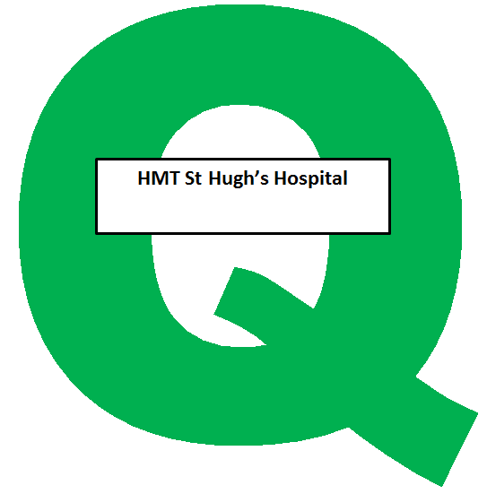
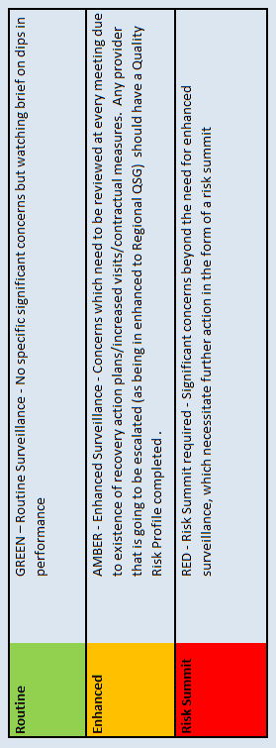

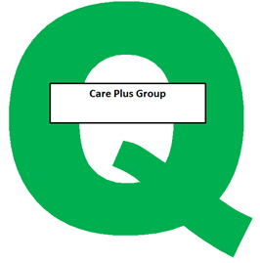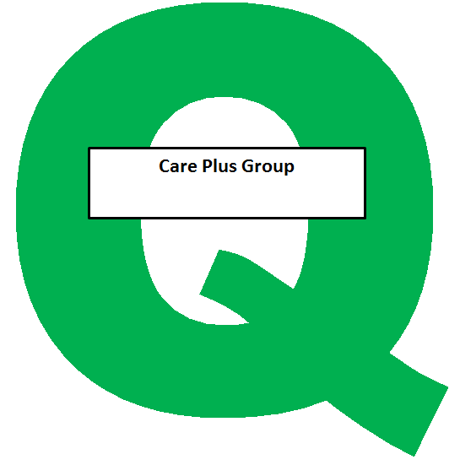
Appendix C – Risk Exception Summary

Section 1 – Board Assurance Framework
The table below reflects risks rated as 15+ (high to significant) on the assurance framework as at 23 August 2017

Component 2: Better Care - How is the CCG faring with its care redesign, performance of constitutional standards, and its outcomes, including in important clinical areas?
Risk Code | Risk Summary | Risk Assignee | Initial Risk Rating | Current Risk rating | Current Risk Trend Icon | Last reviewed date | Control |  | Notes & History Latest Note
CCG-BAF.2002 | Risks in delivery of key annual performance indicators and standards including constitutional standards | Martin Rabbetts | 12 | 20 |  | 11 Aug 2017 | Assurance on controls | Regular reporting in to Partnership Board, Delivery Assurance Committee, CoM and the operational leadership team. | 10/08/17 Martin Rabbetts reviewed this risk, amended the positive assurances and left the rating at the same level as previously.
 |  |  |  |  |  |  | Positive Assurances | July 2017 NHS E have acknowledged the CCG is taking an active leadership role to address the issues in relation to NLaG.  Further assessment of six clinical areas in the CCG Improvement and Assessment Framework demonstrate that NEL are in the top five CCGs in the country, although improvement is required in three.  NHSE's overall assessment of the CCG in the improvement and assessment framework was ‘Good’.  2016/17 Year end position of ASC targets was positive and the Local Account was positive.
 |  |  |  |  |  |  | Gaps in controls | None
 |  |  |  |  |  |  | Gaps in assurances | We recognise that there is significantly increased oversight and assurance mechanisms in place to oversee NLaG performance however gaps will remain until we start to see improvements feeding through.

Risk Code | Risk Summary | Risk Assignee | Initial Risk Rating | Current Risk rating | Current Risk Trend Icon | Last reviewed date | Control |  | Notes & History Latest Note
CCG-BAF.2003 | NLaG Service Sustainability | Helen Kenyon | 20 | 20 |  | 16 Aug 2017 | Assurance on controls | Chief Executive representation from NL & NEL CCGs and NLaG on the system transformation group  CCG representation on all 4 sub groups of the system transformation group  The CCG's Acting Chief Financial Officer represents the CCG on the aligned incentive contract group | 15/08/17 Helen Kenyon advised that the aligned incentive contract has been agreed between NL and NEL CCGs and NLaG to reduce the financial risk to NLaG. New leadership arrangements have been adopted which replace the previous contract management arrangements and the Chief Executives from the 3 organisations are members. The leadership group is called the System Transformation Group and there are 4 sub-groups beneath it (A&E Delivery Board, Planned Care-RTT, Finance and Resources, Quality) which are focusing on the key areas for change within the Trust. There is a System Improvement Board which is chaired by NHS Improvement with the two CCGs and NHS England present to oversee progress on areas identified for improvement from the CQC report and financial special measures.
 |  |  |  |  |  |  | Positive Assurances | System Improvement Board whose membership includes NHS England and NHS Improvement.  NEL CCG received positive feedback in the second quarter of 2017 at its assurance meeting with NHS England  The STP In-hospital Working Group is starting to work more effectively and is addressing issues across providers  The ACP is getting more involved and starting to come up with proposals to divert activity and release pressures
 |  |  |  |  |  |  | Gaps in controls | All of the controls listed have only been established very recently and need time to bed in before their full effectiveness can be evaluated
 |  |  |  |  |  |  | Gaps in assurances | All of the assurances listed have only been established very recently and need time to bed in before their full effectiveness can be evaluated  Lack of consistent leadership presence from NLaG due to a number of time limited interims in place

Risk Code | Risk Summary | Risk Assignee | Initial Risk Rating | Current Risk rating | Current Risk Trend Icon | Last reviewed date | Control |  | Notes & History Latest Note
CCG-BAF.3005 | Instability in partnership finances or services/costs leads to unaffordable consequences for members of the health care system within the current year | Laura Whitton | 12 | 16 |  | 15 Aug 2017 | Assurance on controls | Routine financial reports to partnership board  Delivery Assurance Committee scrutiny of financial plan delivery  QiPP monitoring  Local health community financial monitoring and reporting via the SIB Finance group, ACP finance group | 11/8/17 Laura Whitton advised that the Aligned Incentive contract has now been agreed by all parties (NLAG, NL CCG & NEL CCG). system wide working / resources have started to be put in place to support delivery of mitigating actions, such as roll out of right care.
 |  |  |  |  |  |  | Positive Assurances | SIB (System Improvement Board) assurance process  Medium Term Financial Plan reports to IG&A and board  Internal audit plan is risk -based
 |  |  |  |  |  |  | Gaps in controls | None identified
 |  |  |  |  |  |  | Gaps in assurances | None identified

Section 2 - Risk Register
The table below reflects risks rated as 15+ (high to significant) on the risk register as at 23 August 2017

Risk Code | Risk Summary | Risk Assignee | Original Risk Rating | Current Risk Rating | Current Risk Trend | Last Reviewed Date | Internal Controls | Description of Control | Latest Update
CCG-RR.2005 | RTT Performance | Pauline Bamgbala | 20 | 25 |  | 08 Aug 2017 | CCG-RR.2005a Performance Reporting | Robust performance reporting is produced for the Service Lead to act upon and is monitored at Delivery Assurance Committee with escalation to CoM and Partnership Board. | 08/08/17 Pauline Bamgbala and Jan Haxby further reviewed this risk and amended the risk description to quality issues as well as performance. In line with this a 3rd internal control was also added.
 |  |  |  |  |  |  | CCG-RR.2005c System wide transformation group establised | RTT has been established which will feed into the System Transformation Board and the System Improvement Board. Senior leadership at those meetings with clinically led planning to redesign services for optimum efficiency and effectiveness.  Clinical engagement has been secured from both the Trust and the CCG.  Structured programme approach to be taken using Right Care principles. Initial priority areas identified are respiratory, cardiac and gastro.
 |  |  |  |  |  |  | CCG-RR.2005e Clinical Harm Review Groups | There are two clinical harm review groups (one at NLaG and one external). They both meet on a monthly basis and Jan Haxby is a member of both groups.
CCG-RR.2004 | Failure to achieve Accident and Emergency 4 hour targets | Andy Ombler | 16 | 20 |  | 17 Aug 2017 | CCG-RR.2004b Action Plans | Action plans focussing on all issues with potential impact on 4 hour A&E wait performance. The action plan has been revised to take into account the ECIP findings and recommendations. | 17/08/17 Andy Ombler advised that under the direction of the A&E Delivery Board, a specific set of immediate operational responses/actions for A&E was declared by NLaG. In the subsequent month there have been signs that these are taking effect with average performance rising, improved performance at weekends and faster recovery. These recovery actions are in addition to all of the ongoing Delivery Board Improvement Plan measures.
 |  |  |  |  |  |  | CCG-RR.2004c A&E Delivery Board | A&E delivery board established as part of a national requirement to ensure system wide ownership and delivery against the A&E target required.
CCG-RR.2010 | Infection Prevention and Control | Lydia Golby | 20 | 16 |  | 25 Jul 2017 | CCG-RR.2010a Quality Committee | Quality Committee have been briefed on the current risk and monitor the action plan following the gap analysis. | 25/07/17 A management review of this risk was carried out with Jan Haxby and Lydia Golby. The description of the risk was reworked to explain the statutory function carried by the CCG.
 |  |  |  |  |  |  | CCG-RR.2010b Quality Team Meeting | The Quality Team meetings review the IPC gap analysis action plan.
CCG-RR.2003 | On-going failure to meet Clinical Handover time targets for EMAS patient delivery at DPoW A&E | Andy Ombler | 8 | 15 |  | 17 Aug 2017 | CCG-RR.2003a CCG | Performance is monitored by the CCG and reported to the A&E Delivery Board. Monitoring only. | 17/08/17 Andy Ombler advised there is no change to this position at this time.

Risk Code | Risk Summary | Risk Assignee | Original Risk Rating | Current Risk Rating | Current Risk Trend | Last Reviewed Date | Internal Controls | Description of Control | Latest Update
CCG-RR.3016 | Mental Health SilverLink Computer System (Non-Disclosure Applies) | John Mitchell | 15 | 20 |  | 31 Jul 2017 | CCG-RR.3016a NAViGO Project Team. Project Plan in place which is overseen by the Programme Manager | A NAViGO project team with a CCG representative (Associate Director IT) is to be established | 31 – July 2017 – Risk Management review took place with Helen Kenyon and John Mitchell. The risk was reviewed and increased I5 x L4 = 20, this is due to the risk now being focused on care delivery and the fact the if NAVIGO doesn’t have a suitable IT system, the CCG may need to procure a new MH Provider which will more than likely jeopardise the ACP and go against the strategic direction for a single system. Target risk increased to make it more feasible I4 x L2 = 8. Existing internal controls tweaked and additional internal control added.
 |  |  |  |  |  |  | CCG-RR.3016b Veeam back up of data | Veeam backup of data and servers at 3am every day
 |  |  |  |  |  |  | CCG-RR.3016c Real time replication | The SilverLink databases are replicated in real time from Care Plus Group primary datacentre to Care Plus Group secondary datacentre.
 |  |  |  |  |  |  | CCG-RR.3016d Programme Manager | Programme Manager now in place. This is funded by CCG, his role is to manage the project and the implementation of procurement.
CCG-RR.3003 | Adult ADHD Pathway breakdown | Leigh Holton | 20 | 16 |  | 26 Jul 2017 | CCG-RR.3003a Council of Members (CoM) | Quarterly report to CoM | 26/7/17 Bev Compton and Leigh Holton carried out a management review of this risk and considered the risk description and internal controls which had minor adjustments made to them. Leigh advised that in the last month there has been a further discussion to CoM and a new course of action has been agreed exploring a new larger footprint option. We are setting up discussions with Humber CCGs, Lincolnshire CCGs and should these be ineffective we will also look at the Humber Coast and Vale footprint. We are optimistic that this will now begin to progress as each of the above have recognised a need to address the issue on a wider basis. Hull have also experienced similar difficulties elsewhere within the patch.
 |  |  |  |  |  |  | CCG-RR.3003b PALs monitoring logs | Monitoring through logs of concerns via PALs
CCG-RR.3015 | Supported Living and Extra Care Housing - Housing Benefit Review | Sarah Moody | 16 | 16 |  | 15 Aug 2017 | CCG-RR.3015a Joint Housing Strategy Meeting | Representatives from NELC and the CCG are members of this meeting | 15/08/17 Sarah Moody advised that nothing has changed from the report on 11.7.17 except that the CCG have conveyed the main issues, challenges and barriers to progress to the Council and there is now a much clearer understanding within the Council and a real willingness to resolve the issues jointly.
 |  |  |  |  |  |  | CCG-RR.3015c Refresh of extra care housing strategy | The CCG is currently undertaking a refresh with an updated evidence base
 |  |  |  |  |  |  | CCG-RR.3015d Transitional planning for CCG/NELC Union | Extra care housing delivery will be a strategic priority for the CCG/NELC union.
 |  |  |  |  |  |  | CCG-RR.3015e Commitment from HCA to ensure the scheme is affordable by the allocation of a funding grant | The regional team HCA are very supportive and are under spent in North East Lincolnshire so this is a priority for them

Risk Code | Risk Summary | Risk Assignee | Original Risk Rating | Current Risk Rating | Current Risk Trend | Last Reviewed Date | Internal Controls | Description of Control | Latest Update
CCG-RR.4004 | The new DoLS requirements are unable to cope with the increasing number of requests for authorisation | Bruce Bradshaw | 16 | 20 |  | 07 Apr 2017 | CCG-RR.4004a Monitoring of activity at DAC and Safeguarding Board | The risks are monitored as part of the strategic plan and reviewed on a regular basis by the Chair and Deputy Chair of the Safeguarding Adults Board. | 06/04/17 Bruce Bradshaw reviewed the risk and has agreed that it should continue to remain at the present level. This is because of the need to consider Deprivations in non-standard settings, the availability of assessors for routine DoLS and the continued financial pressures. Mitigating factors will include reviewing actions against the recent ADASS proposals and the need to plan for any legislative changes as a result of the Law Commission Report
 |  |  |  |  |  |  | CCG-RR.4004b Strategic Mental Capacity Group | The Group monitors strategic change and works jointly with the CCG and providers
CCG-RR.4017 | Establishment of the Accountable Care Partnership in North East Lincolnshire | Helen Kenyon | 25 | 20 |  | 18 Aug 2017 | CCG-RR.4017a ACP Shadow Board | The CCG is a member of the board. Regular meetings take place to discuss the development of the ACP | 17/8/17 Helen Kenyon advised the ACP has identified 3 service priorities for action and has recently added a 4th, and to ensure progress is made against each of the areas increased reporting arrangements were agreed at the last ACP meeting.  It was also agreed that the commissioner (CCG & Council) will produce a more formal statement of what we expect the ACP to be able to demonstrate as part of its assurance of sufficient progress. A meeting has been established to pull together the high level progress requirements & timeline for the commissioner to send to the ACP.
 |  |  |  |  |  |  | CCG-RR.4017b ACP Workplan in place | Work plan in place to provide timelines and oversight on progress of the ACP
 |  |  |  |  |  |  | CCG-RR.4017c Programme Manager appointed | A Programme Manager has been appointed to support overall delivery of the programme
CCG-RR.4007 | eMBED IT Core Contract Delivery | John Mitchell | 25 | 15 |  | 04 Aug 2017 | CCG-RR.4007a Contract in place | Contract, detailing service spec and SLA in place. Currently meeting contractual IT KPIs. | 04/08/17 John Mitchell advised that eMBED have stated that Minor works projects are excluded from KPIs – this needs further thought. A new control has been added to this risk (CCG-RR.4007e Local primary care strategy group).
 |  |  |  |  |  |  | CCG-RR.4007b Contract Management Arrangements in place | Regular monthly contract monitoring meeting in place with the CCG and eMBED. Attendees are John Mitchell and Eddie McCabe and Julie Wilson attends as required
 |  |  |  |  |  |  | CCG-RR.4007c Programme and Project Plans | Programme controls in place, used to manage the Project and Programmes. eMBED able to provide tracking tool.  The CCG has taken steps to monitor programme delivery on a monthly basis via the Strategy Board.
 |  |  |  |  |  |  | CCG-RR.4007d Risk Management in Place | Part of programme management of controls and is also picked up by the Strategy group.
 |  |  |  |  |  |  | CCG-RR.4007e Local Primary Care Strategy Group | A locally focused strategic group has been formed to provide a gateway for approving use of project days and monitoring progress on delivery. This control is scored at partially effective as the group is currently in its initiation phase.

