Integrated Assurance Report

Introduction

The dashboards below represent an overview of performance and risk for health and social care services across North East Lincolnshire. The dashboards consist of seven domains that incorporate all areas that North East Lincolnshire Care Trust Plus strive to improve on.

A judgement has been made of the status for each domain based on the performance measures and risks underpinning them. These judgements try to balance the current position with the expected outcome at the end of the year and weightings with respect to priority. An additional domain has been added to the performance dashboard that concentrates on those indicators where accountability is likely to transfer out of the CCG. The Delivery Assurance Committee is asked to make a decision on the final status of the dashboard before reporting to the CCG Governing Body. The performance exception section updates on the failing performance around breastfeeding initiation and at 6-8 weeks. A full exception report summary is also included in appendix A detailing performance of indicators that are underperforming.

Performance Dashboard Risk Dashboard
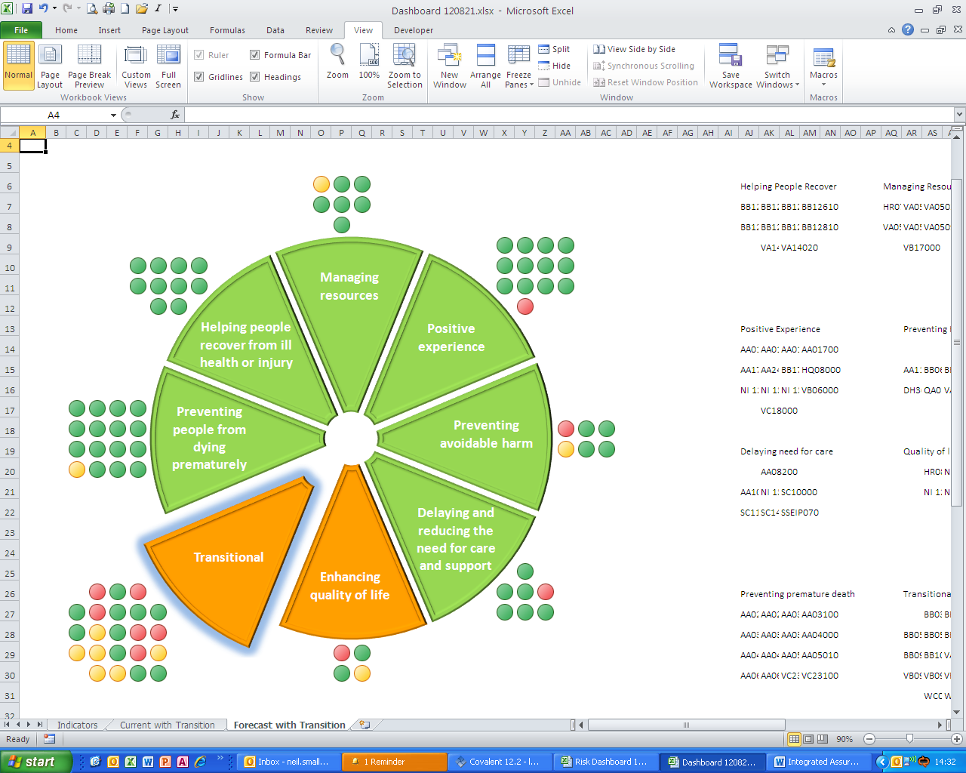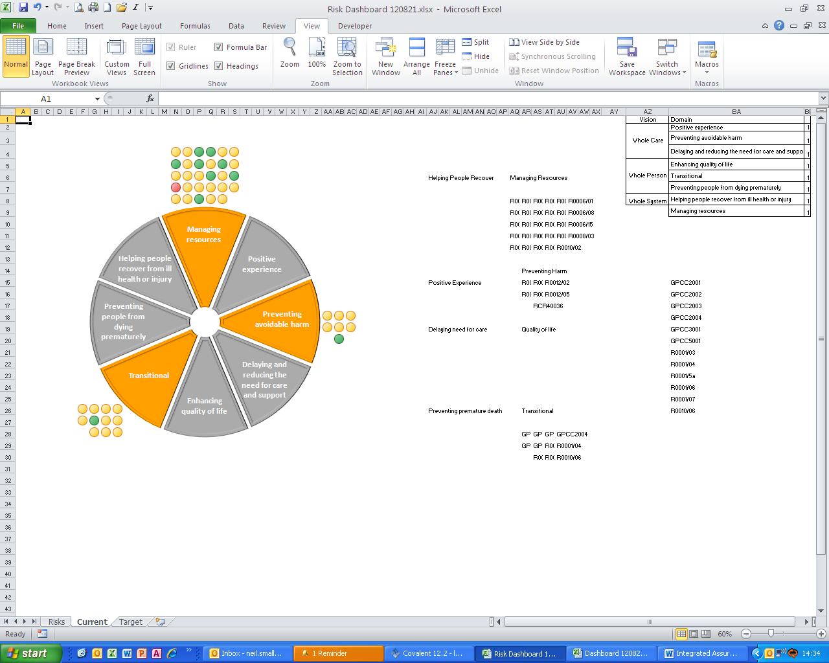
Performance Exception

Recent decline in rates of breastfeeding initiation and at 6 to 8 weeks

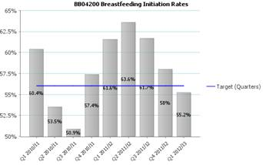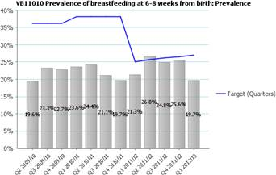

The issue of the decline in breast feeding initiation and 6-8 weeks has been raised with acting head of midwifery and head of health visiting on a number of occasions. Neither can identify reasons for the recent decline. However anecdotal feedback seems to be that midwives are more busy and not able to spend the time necessary with women who are struggling to breastfeed when there are more pressing activities e.g. women giving birth etc. My understanding is that staffing levels in maternity remain an issue with more women choosing to give birth at DPoW, not necessarily from the NEL area, putting pressure on existing services. Another contributory reason could be the change of head of midwifery over this period of time though the appointed acting head of midwifery is positive and work very well with public health and wouldn’t explain the decline at 6-8 weeks. There is a long standing culture of women not breast feeding in NEL and still needs on going work though this does not explain this recent decline because of the previous increases.

There has been a range of support put into place over the last year or so with more staff having been trained in breast feeding management both within maternity and health visiting. There are active volunteer breast feeding peer supporters who are working on the maternity wards but they are volunteers and therefore are only available at certain times. Monies for short term funded paid breast feeding peer supporters through NELC has meant that these paid breast feeding peer supporters , who have just been recruited, will be starting soon and be able to provide a service over a 7 day period however they are part time and short term funded. All this preparation has led to NEL being ready for the stage 1 assessment from UNICEF Baby Friendly Initiative in the autumn (postponed from July as the assessors weren’t available). However there are still identified gaps with some GPs/ Drs (community and hospital) not considering or supporting women to continue breast feeding if they required prescribed medication (rather than reviewing compatibility of prescribed medication and breast feeding)

Although we have data for initiation and at 6-8 weeks, we can also get the breastfeeding status at 10-14 day handover, which is helpful and robust. Though women are asked about feeding status at each contact, one of the issues is that we are unable to identify when the drop off in breast feeding actually occurs. We suspect, based on national evidence, in the first few days but we don’t have the data to support this. NLaG are unable to pull this information off their systems consistently when asked. They have audited notes for three months on status of breast feeding at the three day contact (telephone contact mainly) but the data was of poor quality so couldn’t be used. They explored pulling data at the new-born blood spot contact (5-8 days) but were unable to do this. Therefore if we want to understand when the drop off actually occur ,so more support can be given to women at this point, we might have to have a more formal approach for additional data collection.

Therefore there does not appear to be any direct explanation for the decline seen however a meeting of the heads of maternity, health visiting and infant feeding lead in the hospital and the infant feeding coordinator, peer support coordinator will take place shortly to explore these reasons and how they can work towards increasing uptake for the future.
Appendix A - Performance Exception Summary

Code | Indicator | Latest period |  |  |  | 2012/13 year to date |  |  | Year End Forecast Position
Code | Indicator | Period | Target | Value | Status | Target | Value | Status | Year End Forecast Position
Positive experience
VC18000 | The number of carers receiving a 'carer's break' or a specific carers' service or advice and information as a percentage of clients receiving community based services. | July 2012 |  | 13% |  |  | 13%
Preventing avoidable harm
AA11000 | Diabetic Retinopathy Screening | Q1 2012/13 | 95% | 87% |  | 95% | 87%
DH30100 | MRSA Blood Stream Infections | July 2012 | 0 | 0 |  | 0 | 1
Delaying and reducing the need for care and support
SC10000 | C72 Perm. Admissions (65+) | July 2012 |  | 179.83 |  |  | 179.83
Enhancing quality of life
HR08000 | Health visitor numbers | July 2012 | 31.7 | 25.75 |  | 31.7 | 25.75
NI 13000 | Social Care Clients receiving Self Directed Support | July 2012 |  | 43.32% |  |  | 43.32%
Preventing people from dying prematurely
AA06000 | Category A calls meeting 19 minute standard (EMAS) | July 2012 | 95% | 94.1% |  | 95% | 94.7%
Helping people recover from ill health or injury
No Exceptions
Managing resources
HR07000 | Numbers waiting on an incomplete referral to treatment pathway | June 2012 | 5,700 | 5,962 |  | 5,700 | 5,962

Code | Indicator | Latest period |  |  |  | 2012/13 year to date |  |  | Year End Forecast Position
Code | Indicator | Period | Target | Value | Status | Target | Value | Status | Year End Forecast Position
Transitional
BB03101 | Number of drug users leaving treatment free from drugs | June 2012 | 39 | 24 |  | 39 | 24
BB04300 | Smoking During Pregnancy | Q1 2012/13 | 22.3% | 22.7% |  | 22.3% | 22.7%
BB05500 | Teenage conception rates per 1,000 females aged 15-17 | Q3 2010/11 | 31.4 | 60 |  | No data available for 2012-13
BB10400 | Cardiovascular disease mortality rate per 100,000 under 75 | 2010/11 | 72.5 | 81.7 |  | No data available for 2012-13
VB01010 | All age all-cause mortality - males | 2010/11 | 667 | 724 |  | No data available for 2012-13
VB01020 | All age all-cause mortality - females | 2010/11 | 450 | 481 |  | No data available for 2012-13
VB09010 | Childhood obesity rate: Year R | 2010/11 | 10% | 10.65% |  | No data available for 2012-13
VB09030 | Childhood obesity rate: Year 6 | 2010/11 | 16% | 18.9% |  | No data available for 2012-13
VB11010 | Prevalence of breastfeeding at 6-8 weeks from birth: Prevalence | Q1 2012/13 | 27% | 19.7% |  | 27% | 19.7%
VB18000 | Access to primary dental services | July 2012 | 103,044 | 102,157 |  | 103,044 | 102,157
WC01001 | Health inequalities (slope index): Males | 2010/11 |  | 11.1 |  | No data available for 2012-13
WC01002 | Health inequalities (slope index): Females | 2010/11 |  | 8.7 |  | No data available for 2012-13

