
North East Lincolnshire CCG

Attachment 12

Report to: | NEL CCG Partnership Board
Presented by: | Zena Robertson, Assistant Chief Operating Officer
Date of Meeting: | 10th January 2013
Subject: | Integrated Assurance Report
Status: | OPEN CLOSED
Agenda Section: | STRATEGY COMMISSIONING OPERATIONAL ISSUES

OBJECT OF REPORT
The report advises the Governing Body of how NELCCG are performing against the eight domains developed for the dashboard with respect to its performance measures and risks.

There is currently work on-going to develop the dashboard to reflect progressing vision of the CCG. This is being managed via the Delivery Assurance Committee.

Further intelligence relating to the CCGs financial and workforce performance has been taken in to account under ‘Managing Resources’.

For more detail on performance and risk the latest integrated assurance report presented to the Delivery Assurance Committee can be found via the following embedded file:


STRATEGY
The structure of the performance and risk dashboards that are managed through the Delivery Assurance Committee reflect the following eight domains.

• Positive experience
• Preventing avoidable harm
• Delaying and reducing the need for care and support
• Enhancing quality of life
• Preventing people from dying prematurely
• Helping people recover from ill health or injury
• Managing resources
• Transition

IMPLICATIONS
Whilst it has been identified that the organisation is performing well overall, the Delivery Assurance Committee continues to focus on specific areas where improvement is to be pursued. This links in to an assessment of how the organisation is likely to perform in key external judgements. It is apparent that the CTP needs to continue to focus on its Public Health targets but, despite a number of indicators underachieving, there is continued improvement in many areas.

RECOMMENDATIONS (R) AND ACTIONS (A) FOR AGREEMENT

The Governing Body is asked:
• to note judgements made against the eight domains
• for further feedback on ways to improve the dashboard

 |  | Yes/No | Comments
 | Does the document take account of and meet the requirements of the following:
i) | Mental Capacity Act | NA
ii) | CCG Equality Impact Assessment | NA
iii) | Human Rights Act 1998 | NA
iv) | Health and Safety at Work Act 1974 | NA
v) | Freedom of Information Act 2000 / Data Protection Act 1998 | NA
iv) | Does the report have regard of the principles and values of the NHS Constitution?  www.dh.gov.uk/en/Publicationsandstatistics/Publications/PublicationsPolicyAndGuidance/DH_113613 | Yes

Integrated Assurance Report

Introduction

The dashboards below represent an overview of performance and risk for health and social care services across North East Lincolnshire. The dashboards consist of seven domains that incorporate all areas that North East Lincolnshire Care Trust Plus strive to improve on.

A judgement has been made of the status for each domain based on the performance measures and risks underpinning them. These judgements try to balance the current position with the expected outcome at the end of the year and weightings with respect to priority. An additional domain has been added to the performance dashboard that concentrates on those indicators where accountability is likely to transfer out of the CCG. The Delivery Assurance Committee is asked to make a decision on the final status of the dashboard before reporting to the CCG Governing Body. A full exception report summary is also included in appendix A detailing performance of indicators that are underperforming.

Performance Dashboard Risk Dashboard
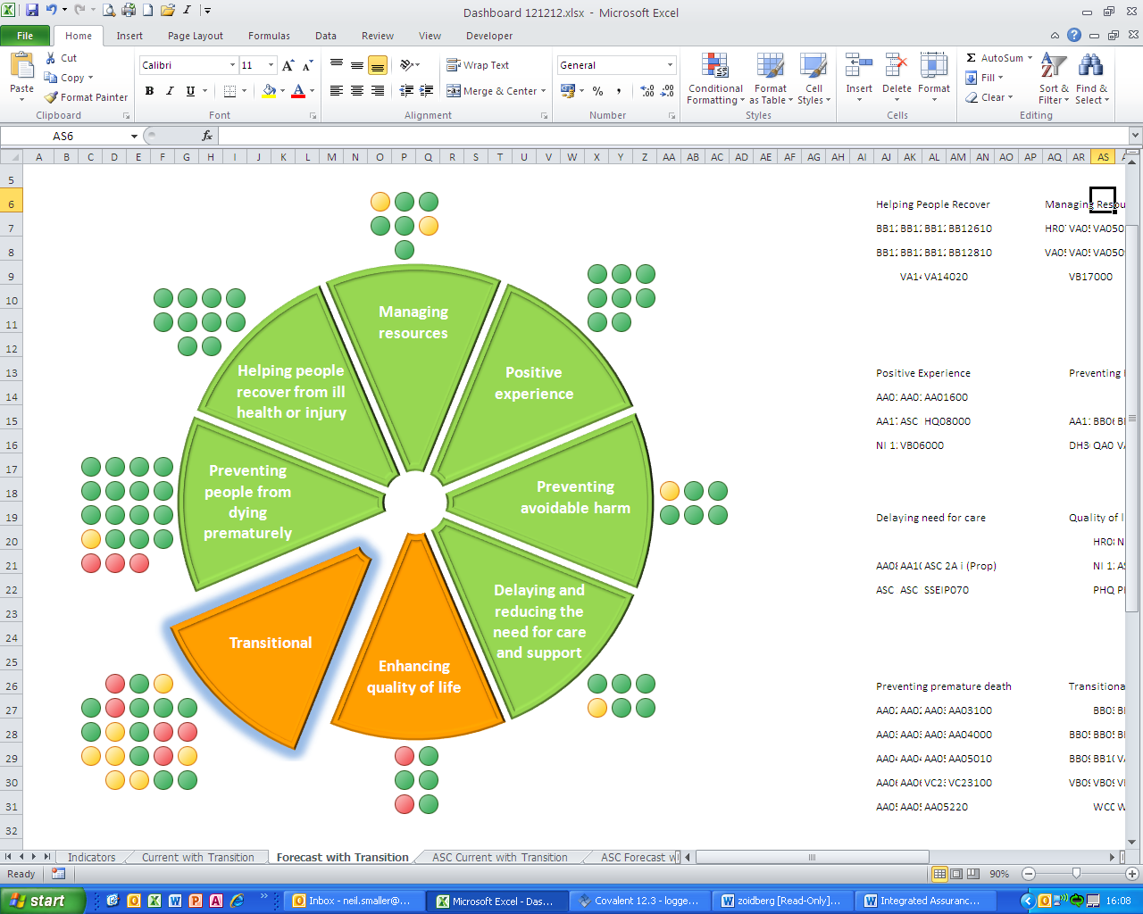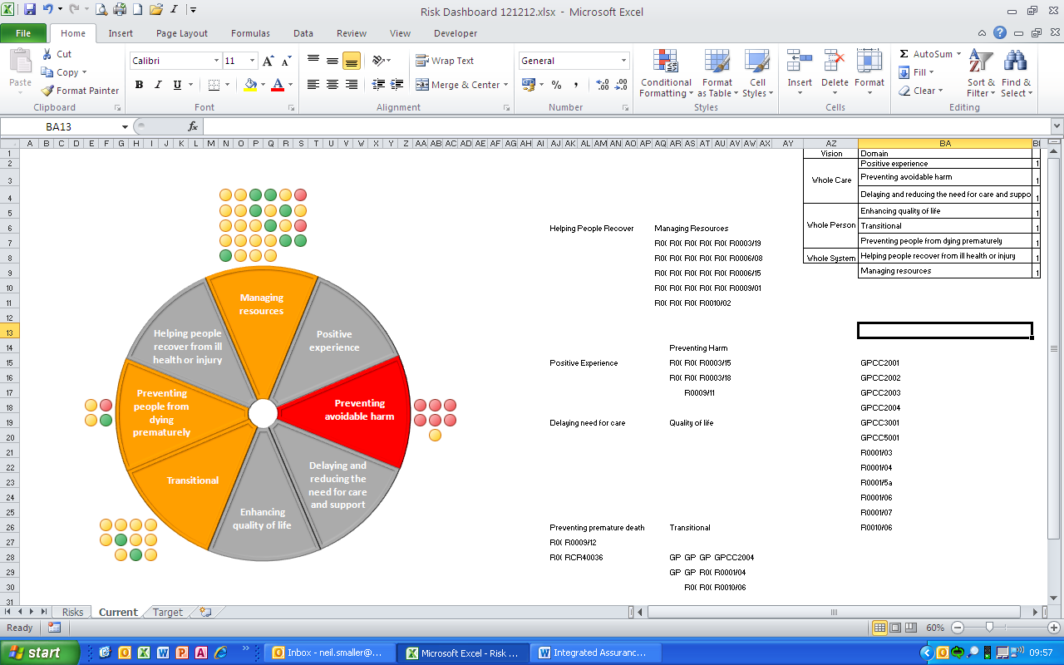

Appendix A - Performance Exception Summary

Code | Indicator | Latest period |  |  |  | 2012/13 year to date |  |  | Year End Forecast Position
Code | Indicator | Period | Target | Value | Status | Target | Value | Status | Year End Forecast Position
Positive experience
No Exceptions

Preventing avoidable harm
AA11000 | Diabetic Retinopathy Screening | Q2 2012/13 | 95% | 93.4% |  | 95% | 93.4%
Delaying and reducing the need for care and support
ASC 2A ii (Prop) | Permanent admissions 65+ to residential and nursing care homes, per 100,000 population | November 2012 | No target set | 459.48 |  | No target set | 459.48
Enhancing quality of life
HR08000 | Health visitor numbers | November 2012 | 32.7 | 27.96 |  | 32.7 | 27.96
PHQ1310 | % people who have depression and/or anxiety disorders who receive psychological therapies | Q2 2012/13 | 3.5% | 2.7% |  | 7.0% | 5.6%
Preventing people from dying prematurely
AA05200 | Ambulance average total turnaround time - DPOW | October 2012 | 25 mins | 40.3 mins |  | 25 mins | 40.3 mins
AA05210 | Ambulance average clinical handover time - DPOW | October 2012 | 15 mins | 25.53 mins |  | 15 mins | 25.53 mins
AA05220 | Ambulance average post-handover time - DPOW | October 2012 | 10 mins | 14.59 mins |  | 10 mins | 14.59 mins
AA06000 | Category A calls meeting 19 minute standard (EMAS) | October 2012 | 95% | 94.4% |  | 95% | 94.5%
Helping people recover from ill health or injury
No Exceptions

Managing resources
HR07000 | Numbers waiting on an incomplete referral to treatment pathway | October 2012 | 5,700 | 6,248 |  | 5,700 | 6,248
VA05090 | Non-Elective Activity | October 2012 | 1,239 | 1,418 |  | 8,279 | 8,812
Transitional
BB03101 | Number of drug users leaving treatment free from drugs | October 2012 | 93 | 60 |  | 93 | 60
BB04300 | Smoking During Pregnancy | Q2 2012/13 | 21.7% | 23.6% |  | 22.3% | 23.2%
BB05500 | Teenage conception rates per 1,000 females aged 15-17 | Q4 2010/11 | 31.3 | 56.1 |  | No data available for 2012-13
BB10400 | Cardiovascular disease mortality rate per 100,000 under 75 | 2010/11 | 72.5 | 81.7 |  | No data available for 2012-13
VB01010 | All age all-cause mortality - males | 2010/11 | 667 | 724 |  | No data available for 2012-13
VB01020 | All age all-cause mortality - females | 2010/11 | 450 | 481 |  | No data available for 2012-13
VB09010 | Childhood obesity rate: Year R | 2010/11 | 10% | 10.65% |  | No data available for 2012-13
VB09030 | Childhood obesity rate: Year 6 | 2010/11 | 16% | 18.9% |  | No data available for 2012-13
VB11010 | Prevalence of breastfeeding at 6-8 weeks from birth: Prevalence | Q2 2012/13 | 27.4% | 23.2% |  | 27% | 19.7%
VB18000 | Access to primary dental services | October 2012 | 103,115 | 102,695 |  | 103,115 | 102,695
WC01001 | Health inequalities (slope index): Males | 2010/11 | No target set | 11.1 |  | No data available for 2012-13
WC01002 | Health inequalities (slope index): Females | 2010/11 | No target set | 8.7 |  | No data available for 2012-13

