
North East Lincolnshire CCG

Attachment 08

Report to: | NEL CCG Partnership Board
Presented by: | Cathy Kennedy, Deputy Chief Executive
Date of Meeting: | 12 September 2013
Subject: | Integrated Assurance Report
Status: | OPEN CLOSED
Agenda Section: | STRATEGY COMMISSIONING OPERATIONAL ISSUES

OBJECT OF REPORT
The report advises the Partnership Board of how NELCCG are performing against the seven domains developed for the dashboard with respect to its performance measures and risks.

There is currently work on-going to develop the dashboard to reflect progressing vision of the CCG as well as those areas identified in 2013-14 outcomes frameworks. This is being managed via the Delivery Assurance Committee. The most recent development incorporate the additional national measures from the 2013-14 NHS Outcomes Framework and CCG Assurance Framework as well as a key identifier in the performance dashboard that categorises whether the measures are quality focused or not.

Further intelligence relating to the CCGs financial and workforce performance has been taken in to account under ‘Managing Resources’.

For more detail on performance and risk the latest integrated assurance report presented to the Delivery Assurance Committee can be found via the following embedded file:


STRATEGY
The structure of the performance and risk dashboards that are managed through the Delivery Assurance Committee reflect the following seven domains.

• Positive experience
• Preventing avoidable harm
• Delaying and reducing the need for care and support
• Enhancing quality of life
• Preventing people from dying prematurely
• Helping people recover from ill health or injury
• Managing resources
Although the current domains for risk align to those used in the performance dashboard, it is not felt that they are relevant for the CCG risk register. Therefore the next report will map the risk register to the six domains set out in the CCG Assurance Framework as listed below.

- Clinically led and quality focused
- Community Engagement
- Delivering local priorities within budget
- Constitutional and governance arrangements
- Collaborative arrangements with partners
- Leadership

IMPLICATIONS
Whilst it has been identified that the organisation is performing well overall, the Delivery Assurance Committee continues to focus on specific areas where improvement is to be pursued. This links in to an assessment of how the organisation is likely to perform in key external judgements. It is apparent that the CCG needs to continue to focus on some specific areas but, despite a number of indicators underachieving, there is continued improvement in many areas.

RECOMMENDATIONS (R) AND ACTIONS (A) FOR AGREEMENT

The Partnership Board is asked:
• to note judgements made against the domains of the dashboards
• to note the information on the Quality Premium in the performance escalation
• for views on addressing the underachievement of the performance exceptions
• for further feedback on ways to improve the report

 |  | Yes/No | Comments
 | Does the document take account of and meet the requirements of the following:
i) | Mental Capacity Act | NA
ii) | CCG Equality Impact Assessment | NA
iii) | Human Rights Act 1998 | NA
iv) | Health and Safety at Work Act 1974 | NA
v) | Freedom of Information Act 2000 / Data Protection Act 1998 | NA
iv) | Does the report have regard of the principles and values of the NHS Constitution?  www.dh.gov.uk/en/Publicationsandstatistics/Publications/PublicationsPolicyAndGuidance/DH_113613 | Yes

Integrated Assurance Report

Introduction

The dashboards below represent an overview of performance and risk for health and social care services across North East Lincolnshire. The dashboards consist of seven domains that incorporate all areas that North East Lincolnshire Clinical Commissioning Group strive to improve on.

A judgement has been made of the status for each domain based on the performance measures and risks underpinning them. These judgements try to balance the current position with the expected outcome at the end of the year and weightings with respect to priority. The Delivery Assurance Committee is asked to make a decision on the final status of the dashboard before reporting to the CCG Partnership Board. A full exception report summary is also included in appendix A detailing performance of indicators that are underperforming.

Performance Dashboard Risk Dashboard
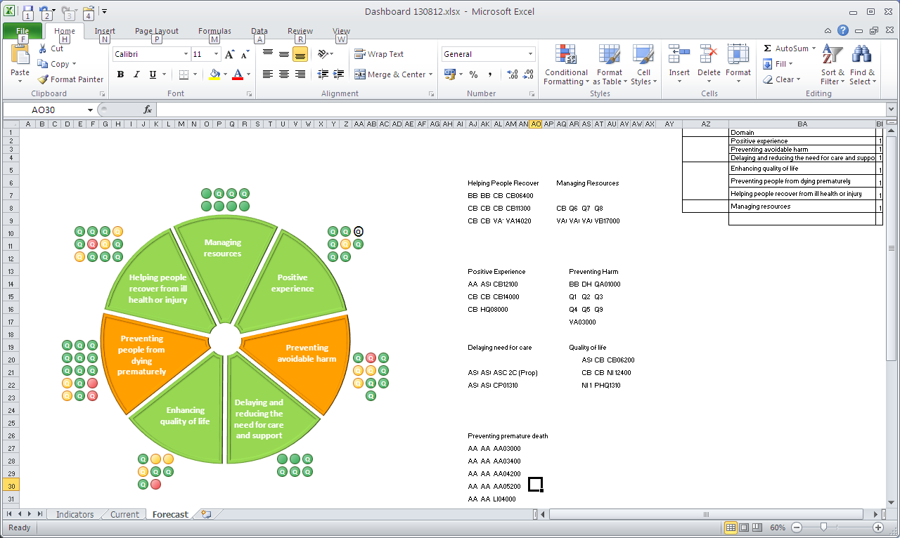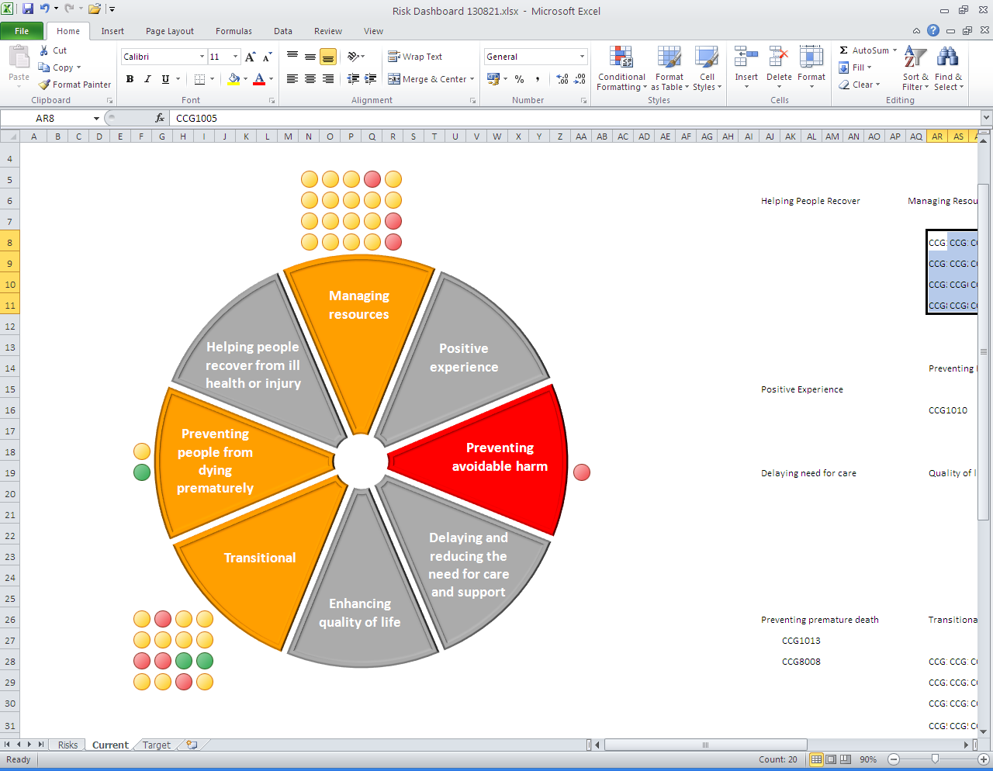
Please note the white circles on the dashboards denote measures where performance is currently not available.
Please note the letter Q indicates a quality measure. These indicators focus on safety, experience and effectiveness and are present in the NHS England Quality Dashboard and the Quality domain of the CCG Assurance Framework.
Performance Escalation

CCG Quality Premium

The Quality Premium is intended to reward clinical commissioning groups (CCGs) for improvements in the quality of the services that they commission and for associated improvements in health outcomes and reducing inequalities.
It is paid to CCGs in 2014/15 to reflect the quality of the health services commissioned by them in 2013/14 and will be based on four national measures and three local measures.
The four national measures, all of which are based on measures in the NHS Outcomes Framework, are:
- reducing potential years of lives lost through amenable mortality (12.5% of quality premium): the overarching objective for Domain 1 of the NHS Outcomes Framework;
- reducing avoidable emergency admissions (25% of quality premium): a composite measure drawn from four measures in Domains 2 and 3 of the NHS Outcomes Framework;
- ensuring roll-out of the Friends and Family Test and improving patient experience of hospital services (12.5% of quality premium), based on one of the overarching objectives for Domain 4 of the NHS Outcomes Framework;
- preventing healthcare associated infections (12.5% of quality premium), based on one of the objectives for Domain 5 of the NHS Outcomes Framework.

The three local priorities are:
- Technology-enable care: Non face-to-face outpatient follow-up appointments (12.5% of quality premium)
- End of life care : Proportion of people dying at home (including care homes) (12.5% of quality premium)
- Community preventative support: Increasing the availability of community based preventative support solutions (12.5% of quality premium)

A CCG will have its quality premium reduced if the providers from whom it commissions services do not meet four patient rights or pledges set out in the NHS Constitution (25% reduction for each).
The total amount payable will be £5 per patient, based on the same formula as running costs (NELCCG Population = 163,846).
The quality premium payment is in addition to a CCG’s main financial allocation and running costs allowance.
The regulations have set out the purposes for which the CCG is able to spend the quality premium payment. Under the regulations, CCGs must use the funding awarded to them under the quality premium in ways that improve quality of care or health outcomes and/or reduce health inequalities.
CCGs will have to publish details of how they spend quality premium payments, so that they are accountable to the public and their local community.
NHS England will reserve the right not to make any quality premium payments to a CCG in cases of serious quality failure, i.e. where the Care Quality Commission judges that a provider is in serious breach of its registration requirements.
A CCG can only earn a quality premium if it has improved quality or achieved high standards of quality as assessed by the measures set out above. Subject to regulations, a CCG will not, however, receive a quality premium if it has failed to manage within its total resources envelope or has exceeded the agreed level of surplus drawdown, based on the principle that effective use of public resources should be seen as an integral part of securing high-quality services. NHS England may also withhold or reduce a quality premium payment if a CCG does not meet requirements in relation to financial propriety.

NELCCG Quality Premium Scenario Analysis

The following summary demonstrates the range between the likely best scenario and the likely worst scenario in relation to North East Lincolnshire CCGs Quality Premium achievement. A best and worst case scenario has not been included as this scenarios outcome would lead to the CCG receiving either the total £819,230 available or no payment under the premium scheme. The following two scenarios assume that the CCG manages within its total resources for 2013-14 and that there are no serious quality failures.
Measure |  | Quality Premium Value |  | Better Case |  | Worse Case
 |  |  |  | Achieved | Value | Achieved | Value
National Measures | Potential years of life lost | 12.5% | £102,403.75 | N | £0.00 | N | £0.00
National Measures | Avoidable emergency admissions | 25.0% | £204,807.50 | Y | £204,807.50 | N | £0.00
National Measures | Friends and family test | 12.5% | £102,403.75 | N | £0.00 | N | £0.00
National Measures | Infection control | 12.5% | £102,403.75 | N | £0.00 | N | £0.00
Local Priorities | Non face to face outpatient follow-ups | 12.5% | £102,403.75 | Y | £102,403.75 | Y | £102,403.75
Local Priorities | Proportion of people dying at home | 12.5% | £102,403.75 | Y | £102,403.75 | N | £0.00
Local Priorities | Community based preventative support | 12.5% | £102,403.75 | Y | £102,403.75 | Y | £102,403.75
Total before NHS Constitution deductions |  |  | £819,230.00 |  | £512,018.75 |  | £204,807.50
Constitution Rights and Pledges | Referral to treatment times | 25.0% |  | Y | £0.00 | Y | £0.00
Constitution Rights and Pledges | A&E four hour wait | 25.0% |  | Y | £0.00 | N | -£51,201.88
Constitution Rights and Pledges | Cancer waiting times | 25.0% |  | Y | £0.00 | Y | £0.00
Constitution Rights and Pledges | Ambulance Response Times | 25.0% |  | Y | £0.00 | N | -£51,201.88
Adjustment for failure |  |  |  |  | £0.00 |  | -£102,403.75
QUALITY PREMIUM TOTAL |  |  |  |  | £512,018.75 |  | £102,403.75

The above range from £102k to £512k shows the limited confidence we can have in the CCGs achievement at this time however the DAC will continue to monitor the measures included within the premium and assess the likely financial reward against this.
Appendix A - Performance Exception Summary

Code | Indicator | Quality Measure? | Latest period |  |  |  | 2013/14 year to date |  |  | Year End Forecast Position
Code | Indicator | Quality Measure? | Period | Target | Value | Status | Target | Value | Status | Year End Forecast Position
Positive experience
CB13000 | Friends and family test | Yes | June 2013 | 78.7% | 63% |  | 78.7% | 72%
Preventing avoidable harm
DH30100 | MRSA Blood Stream Infections | Yes | July 2013 | 0 | 0 |  | 0 | 2 | 
Q1 | Unclosed Serious Incidents | Yes | June 2013 | No | Yes |  | No | Yes
Q2 | Never events | Yes | June 2013 | No | Yes |  | No | Yes
Q4 | Quality compliance risk by Monitor | Yes | June 2013 | No | Yes |  | No | Yes
Delaying and reducing the need for care and support
No Exceptions
Enhancing quality of life
CB06100 | Unplanned hospitalisation for chronic ambulatory care sensitive conditions (adults) | No | 2011/12 | 753.1 | 824.5 |  | No data available for 2013-14
CB06200 | Unplanned hospitalisation for asthma, diabetes and epilepsy in under 19s | No | 2011/12 | 247.2 | 289.3 |  | No data available for 2013-14
CB08000 | Health-related quality of life for people with long-term conditions | Yes | 2012/13 | 0.73 | 0.7 |  | No data available for 2013-14
PHQ1310 | % people who have depression and/or anxiety disorders who receive psychological therapies | No | Q1 2013/14 | 3.5% | 2.8% |  | 3.5% | 2.8%
Preventing people from dying prematurely
AA05001 | Category A (RED1) calls meeting eight minute standard (EMAS) | Yes | June 2013 | 75.0% | 77.6% |  | 75.0% | 74.5%
AA05200 | Ambulance average total turnaround time - DPOW | No | June 2013 | 25 mins | 40.59 mins |  | 25 mins | 40.59 mins
AA06000 | Category A calls meeting 19 minute standard (EMAS) | Yes | June 2013 | 95% | 94.4% |  | 95% | 94%
LIO4000 | SHMI | Yes | Q3 2012/13 | 100.0 | 115 |  | No data available for 2013-14
Helping people recover from ill health or injury
CB06400 | Emergency admissions for children with Lower Respiratory Tract Infections (LRTI) | Yes | 2011/12 | 260.9 | 331.8 |  | No data available for 2013-14
CB11100 | Total health gain assessed by patients i. Hip replacement | Yes | 2011/12 | 0.43 | 0.36 |  | No data available for 2013-14
CB11200 | Total health gain assessed by patients ii. Knee replacement | Yes | 2011/12 | 0.32 | 0.3 |  | No data available for 2013-14
CB11400 | Total health gain assessed by patients iv. Varicose veins | Yes | 2011/12 | 0.1 | 0.06 |  | No data available for 2013-14
Managing resources
No Exceptions

Please note the status of the measures in bold are currently determined by the CCG relative position compared to the other 210 CCGs. Where NEL is in the bottom quartile the measures is given a red rating and where it is below top quartile it is amber. Future monitoring of these measures will be based on improvement from this baseline.

