
North East Lincolnshire CCG

Attachment 8a)

Report to: | NEL CCG Partnership Board
Presented by: | Tracey McErlain-Burns
Date of Meeting: | 9 May 2013
Subject: | Clinical Quality / Governance Review
Status: | OPEN
Agenda Section: | STRATEGY

OBJECT OF REPORT

The embedded report with seven (7) appendices has been written by Tracey McErlain-Burns.
It has been presented to, and discussed with the Delivery Assurance meeting and a verbal update on the considerations of that meeting will be included in the presentation to the Governing Body.

In headline terms, the review was commissioned by Dr Melton and Mrs Cathy Kennedy. Twenty-three individuals have participated in the review which has concluded that the arrangements currently in place to engage with clinicians, across the service triangles to provide assurance on the quality, safety and effectiveness of the commissioned services are not as robust or understood as they should be, and have been in the past.

The review finds that the absence of a forum for clinical debate and peer review leaves some individuals feeling vulnerable. Further, the lack of clarity regarding the governance framework, partly associated with NHS transition results in the majority being unable to describe where the soft and hard intelligence comes together to inform the big picture about the quality, safety and effectiveness of services commissioned by the CCG.

On a scale of 0-10 participants place their scores to the left of the scale when describing the current arrangements for the provision of assurance, whereas those who could score previous arrangements placed the score to the right. This indicates a perceived negative shift.



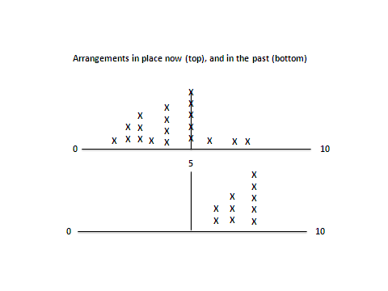

Three recommendations are made. The three are interdependent. These are; that a time limited committee should be established under the leadership of a clinician who is a member of the Council of Members to monitor the quality of services and drive improvement; that a wall chart should be used to address much of the confusion (the analogy being the London underground map) and monthly team brief should include outputs from all corporate meetings. It was not within the scope of the remit for the review for the report author to determine who should lead the implementation of the recommendations that should be determined by the Governing Body if the recommendations are accepted.

The appendices are designed as a package to enable implementation of the recommendations. The final appendix (7) provides the response to feedback on the circulated draft.

STRATEGY
The review and subsequent, timely implementation of the recommendations will support achievement of the corporate strategic objectives, particularly the focus on quality and safety.
Further the remit and responsibilities of the committee (health and social care quality governance committee) enable the CCG to strengthen its proactive approach to the findings of Robert Francis QC following the Mid Staffs Inquiry.

IMPLICATIONS
The financial implications have not been quantified but will presumably include sessional payments to the clinical lead and the cost of the development of the wall chart and production of posters both of which will require graphic designers.

RECOMMENDATIONS (R) AND ACTIONS (A) FOR AGREEMENT
The Partnership Board is asked to:
- Receive the report (copy embedded)
- Note the findings
- Discuss the report
- Support the recommendations
- Assign responsibility for enacting the recommendations
- Provide approval in principle for the funding described above
- Provide feedback to Tracey McErlain-Burns

Agreed?

 |  | Yes/No | Comments
 | Does the document take account of and meet the requirements of the following:
i) | Mental Capacity Act | N/A | Whist a N/A response to the assessment against the requirements on the left has been cited, there is an implied expectation that by monitoring quality and driving improvement the provision of assurance will include meeting these fundamental standards and legal duties. Indeed the committee recommended to the Governing Body will seek explicit assurance that these duties are being addressed when signing off care pathways etc.
ii) | CCG Equality Impact Assessment | N/A
iii) | Human Rights Act 1998 | N/A
iv) | Health and Safety at Work Act 1974 | YES | By addressing gaps in communication
v) | Freedom of Information Act 2000 / Data Protection Act 1998 | YES | Implied rather than explicit
iv) | Does the report have regard of the principles and values of the NHS Constitution?  www.dh.gov.uk/en/Publicationsandstatistics/Publications/PublicationsPolicyAndGuidance/DH_113613 | YES

