
North East Lincolnshire CCG

Attachment 10

Report to: | NEL CCG Partnership Board
Presented by: | Cathy Kennedy, Deputy Chief Executive
Date of Meeting: | 9th Mary 2013
Subject: | Integrated Assurance Report
Status: | OPEN CLOSED
Agenda Section: | STRATEGY COMMISSIONING OPERATIONAL ISSUES

OBJECT OF REPORT
The report advises the Partnership Board of how NELCCG are performing against the seven domains developed for the dashboard with respect to its performance measures and risks.

There is currently work on-going to develop the dashboard to reflect progressing vision of the CCG as well as those areas identified in 2013-14 outcomes frameworks. This is being managed via the Delivery Assurance Committee.

Further intelligence relating to the CCGs financial and workforce performance has been taken in to account under ‘Managing Resources’.

For more detail on performance and risk the latest integrated assurance report presented to the Delivery Assurance Committee can be found via the following embedded file:


STRATEGY
The structure of the performance and risk dashboards that are managed through the Delivery Assurance Committee reflect the following seven domains.

• Positive experience
• Preventing avoidable harm
• Delaying and reducing the need for care and support
• Enhancing quality of life
• Preventing people from dying prematurely
• Helping people recover from ill health or injury
• Managing resources

IMPLICATIONS
Whilst it has been identified that the organisation is performing well overall, the Delivery Assurance Committee continues to focus on specific areas where improvement is to be pursued. This links in to an assessment of how the organisation is likely to perform in key external judgements. It is apparent that the CCG needs to continue to focus on Public Health targets in partnership with the local authority but, despite a number of indicators underachieving, there is continued improvement in many areas.

RECOMMENDATIONS (R) AND ACTIONS (A) FOR AGREEMENT

The Partnership Board is asked:
• to note judgements made against the seven domains
• for views on addressing the issues highlighted in the performance escalation
• for views on addressing the underachievement of the performance exceptions
• for further feedback on ways to improve the dashboard

 |  | Yes/No | Comments
 | Does the document take account of and meet the requirements of the following:
i) | Mental Capacity Act | NA
ii) | CCG Equality Impact Assessment | NA
iii) | Human Rights Act 1998 | NA
iv) | Health and Safety at Work Act 1974 | NA
v) | Freedom of Information Act 2000 / Data Protection Act 1998 | NA
iv) | Does the report have regard of the principles and values of the NHS Constitution?  www.dh.gov.uk/en/Publicationsandstatistics/Publications/PublicationsPolicyAndGuidance/DH_113613 | Yes

Integrated Assurance Report

Introduction

The dashboards below represent an overview of performance and risk for health and social care services across North East Lincolnshire. The dashboards consist of seven domains that incorporate all areas that North East Lincolnshire Clinical Commissioning Group strive to improve on.

A judgement has been made of the status for each domain based on the performance measures and risks underpinning them. These judgements try to balance the current position with the expected outcome at the end of the year and weightings with respect to priority. The Delivery Assurance Committee is asked to make a decision on the final status of the dashboard before reporting to the CCG Governing Body. A full exception report summary is also included in appendix A detailing performance of indicators that are underperforming.

Performance Dashboard Risk Dashboard
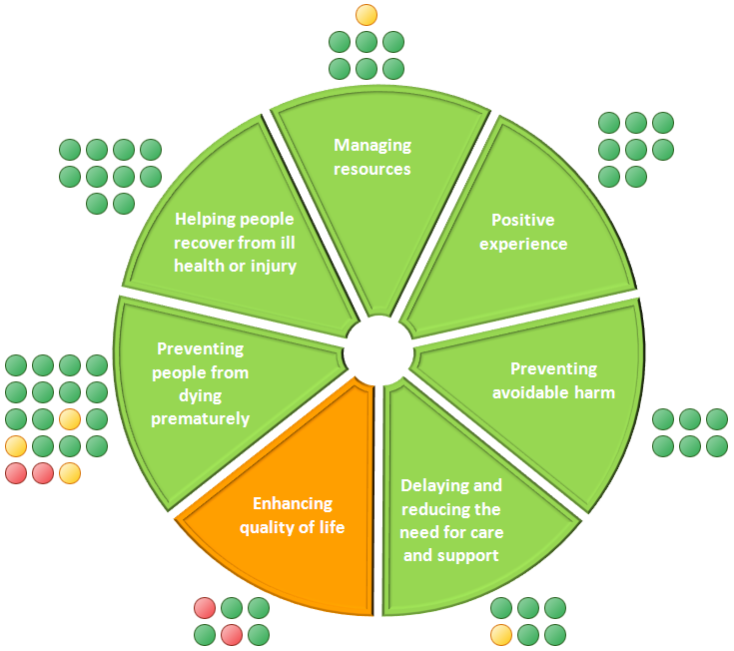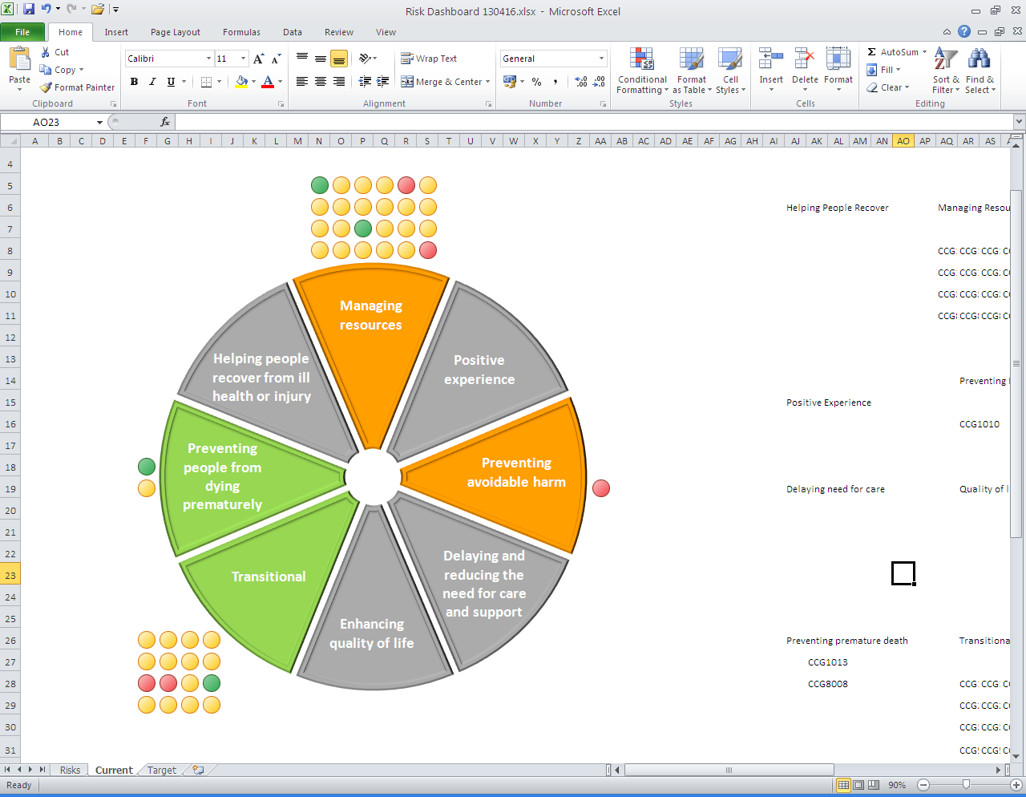
Performance Escalation

Patient flows through acute emergency services: the impact on performance

There is no simple relationship between 4 hour wait performance and the number of A&E attendees on any given day or other period considered.

Intuitively it might be expected that, the more patients there are in A&E in a day, the higher the likelihood of more patients having to wait longer than 4 hours, however this is not born out in the data. It is the patients that require admission to a medical ward and the bed capacity for these admissions that is more closely linked to 4 hour wait performance. If you also include the discharge of patients that then creates available beds then it is the flow of patients through this system and the issues that impact on this flow that then impact on 4 hour wait performance.

The largest proportion of A&E attendees in any period, are those with a simple diagnosis who are readily discharged from A&E and this group are rarely subject to waits in A&E exceeding 4 hours. The patients who are admitted to a medical ward (or the smaller group admitted to a surgical ward) are significantly more likely to have waited more than 4 hours when the conditions causing delays are present.

The coded cause of these delays is either waiting for a bed or a delay in being seen. When beds are available for required admissions, flow is not affected even at times of high attendance and the data shows that there are many days with very high attendance activity with very few waits exceeding 4 hours. Where 4 hour wait performance drops below 95% for an extended period of a few days, there will be a combination of factors present impacting on flow, very often involving unplanned capacity reductions ward closures due to D&V. Where high numbers of attendees require admission, bed occupancy is high and ward closures combine, the ability to recover back to manageable patient flows can be impaired for days and sometimes weeks. Short term difficulties are usually averaged out allowing for compliance with the 95% limit to be achieved over a year however sustained problems can impact on the quarter and the overall annual performance.

Whilst delayed transfer of care bed days are a permanent feature in the patient flow, they do vary significantly and the data for the year to date shows the impact of the above pressures in the system affecting performance in a period with sustained stability and reduction in the delayed transfers of care bed day level. A further issue for scrutiny is the unplanned absence of one or more senior clinical staff as this could be a significant factor in any period of below compliance performance.

In the last year, the 4 hour target was met at DPoW, a period which naturally included spells where performance was under the limit for periods but which have been averaged out over the year. The resilience to react to the combination of key factors described is therefore key to maintaining high performance and work continues to ensure escalation plans with all involved parties are in place. A significant dip in performance has been seen in the first half of April which demonstrates that lessons must continue to be learned and further improvements made.

There is a related issue of performance for ambulance handover times at DPoW A&E and it is clear that this suffers greatly when the flow through A&E is restricted, either due to the issues described above or by the occurrence of multiple ambulance arrivals over a short period.

The charts below demonstrate the deteriorating performance of both the A&E 4 hour wait and ambulance turnaround time measures due to the compounding issues highlighted above.

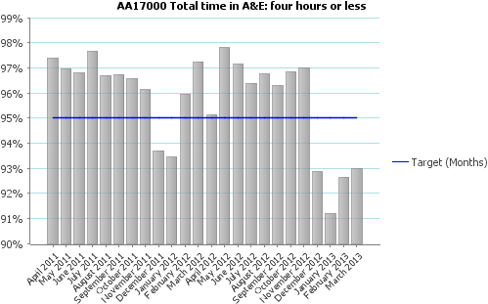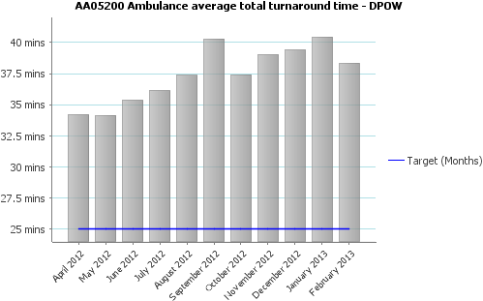
Appendix A - Performance Exception Summary

Code | Indicator | Latest period |  |  |  | 2012/13 year to date |  |  | Year End Forecast Position
Code | Indicator | Period | Target | Value | Status | Target | Value | Status | Year End Forecast Position
Positive experience
No Exceptions
Preventing avoidable harm
No Exceptions
Delaying and reducing the need for care and support
ASC 2A ii (Prop) | Permanent admissions 65+ to residential and nursing care homes, per 100,000 population | March 2013 | 459.70 | 733.75 |  | 459.70 | 733.75
Enhancing quality of life
HR08000 | Health visitor numbers | Feb 2013 | 33.5 | 28.03 |  | 33.5 | 28.03
PHQ1310 | % people who have depression and/or anxiety disorders who receive psychological therapies | Q3 2012/13 | 3.5% | 2.2% |  | 10.5% | 7.8%
Preventing people from dying prematurely
AA05000 | Category A calls meeting eight minute standard (EMAS) | Feb 2013 | 75.0% | 75.8% |  | 75.0% | 73.8%
AA05200 | Ambulance average total turnaround time - DPOW | Feb 2013 | 25 mins | 38.34 mins |  | 25 mins | 38.34 mins
AA05210 | Ambulance average clinical handover time - DPOW | Feb 2013 | 15 mins | 25.38 mins |  | 15 mins | 25.38 mins
AA05220 | Ambulance average post-handover time - DPOW | Feb 2013 | 10 mins | 13.13 mins |  | 10 mins | 13.13 mins
AA06000 | Category A calls meeting 19 minute standard (EMAS) | Feb 2013 | 95% | 94% |  | 95% | 93.6%
Helping people recover from ill health or injury
No Exceptions
Managing resources
HR07000 | Numbers waiting on an incomplete referral to treatment pathway | Feb 2013 | 5,700 | 5,956 |  | 5,700 | 5,956

