North East Lincolnshire CCG

Attachment 05

Report to: | NEL CCG Partnership Board
Presented by: | Cathy Kennedy
Date of Meeting: | 13th March 2014
Subject: | Operational and Strategic plans
Status: | OPEN CLOSED
Agenda Section: | STRATEGY COMMISSIONING OPERATIONAL ISSUES

OBJECT OF REPORT
To present draft outline operational and strategic plans for North East Lincolnshire CCG

STRATEGY
As part of the requirements laid out in the NHS national Planning Guidance, Everyone Counts: Planning for Patients 2014/15-2018/19 the CCG is developing two year operational plans and five year strategic plans which set out aspirations for each of those time periods.

Five year strategic plans

The vision and direction of travel we have set out for the next five years in North East Lincolnshire, working with commissioning partners, local providers, stakeholders and local people is ambitious in its scope and enables local health and social care services to meet the needs of people in the area within the resources available.

A key element of this vision is to enable local people to manage their own health and wellbeing more effectively and to engage with their communities to deliver solutions based on self care and self-responsibility.

Our vision can be described in the diagram below which is drawn from our system wide transformation programme, Healthy Lives, Healthy Futures.

Our vision and direction of travel has been shared and developed with the local Health and Wellbeing Board as well as all the commissioner and provider stakeholders who comprise the Healthy Lives, Healthy Futures Programme Board.

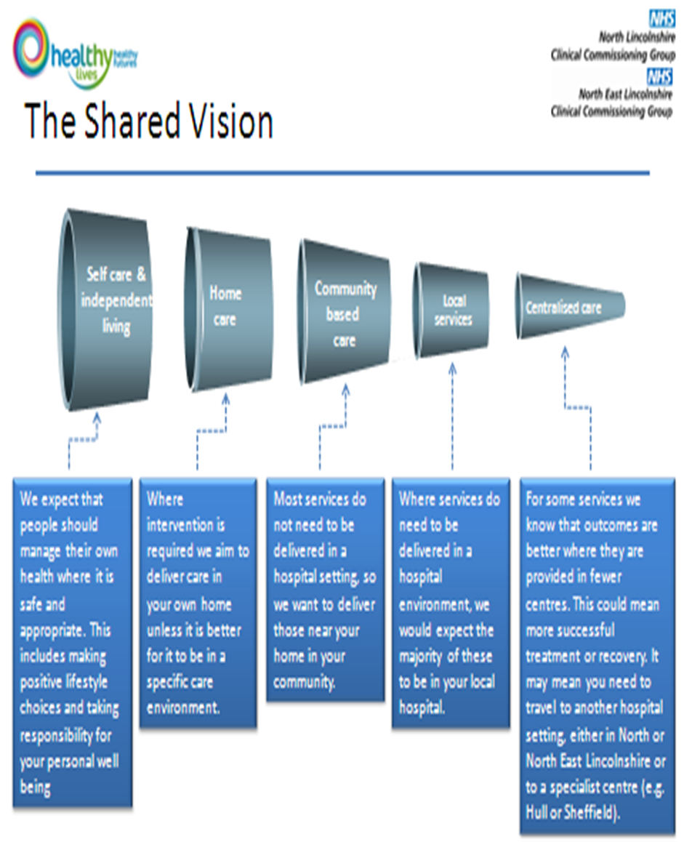

Five year strategic plans are required to consist of high level finance and performance trajectories coupled with a clear vision for the outcomes the CCG aspires to achieve for its local population by March 2019. These should be set out in relation to key lines of enquiry and a Strategic Plan on a Page (Appendix One), which is also cross referenced to the six characteristics of high quality, sustainable health and care systems as described below:

- Citizen inclusion and empowerment
- Wider primary care, provided at scale
- A modern model of integrated care
- Access to the highest quality urgent and emergency care
- A step-change in the productivity of elective care
- Specialised services concentrated in centres of excellence

Draft strategic plans will be submitted on 4th April 2014 and final strategic plans will be submitted on 20th June 2014.

Operational plans

Two year operational plans consisting of finance and activity templates setting out trajectories for key identified performance indicators are required to be submitted by 4th April 2014

Key messages for these submissions include:

Improvement trajectories for

- Potential years of life lost from conditions considered amenable to healthcare
- Health related quality of life for people with long-term conditions
- Avoidable emergency admissions
- Proportion of older people living independently at home following discharge from hospital
- Patient experience of inpatient care
- Patient experience of (i) GP services, (ii) GP Out of Hours
- Hospital deaths attributable to problems in care.
- Numbers of people accessing psychological therapies
Our key local priority in relation to attracting the available quality premium relates to End of Life Care and sets target of 52% (up from 50%) of people dying in their usual place of residence.

The CCG is on target to make a surplus of £6m (3%) in 2013/14,. Over the next 2 years the CCG plans to reduce its in year surplus by £2m a year so that by 2015/16 the surplus will be £2m (1%). This funding (£2m non recurrent in both 2014/15 and 2015/16) is to be used to create a Healthy Lives Healthy Futures Transformation Fund. The CCG will have a contingency equivalent to 0.5% of allocation each year, the contingency will be used non recurrently in each year to fund pressures that arise in year with use of the contingency funding having to be agreed by the Partnership Board. The total of the reserves and contingency funding in each of the 2 years meets the level of assessed risk. Risk will be monitored closely in year and reported routinely to the Delivery Assurance Committee, with escalation to the Board as required.

Year One Plan on a Page

In addition to these requirements the CCG has worked up an operational Plan on a Page for 2014/15 in order to articulate the progress we intend to make in year one of this plan (Appendix Two).
Each of the initiatives outlined in the operational Plan on a Page has further planning work underpinning its delivery and clear business plans outlining quality and efficiency gains associated with it.
This first year plan lays the foundation upon which the overall strategic ambitions will be achieved.

IMPLICATIONS
These plans provide a roadmap for the operational and strategic delivery of improved health outcomes for the local population of North East Lincolnshire in line with priorities developed since the inception of the CCG according to assessment of need.

The indicators and submissions meet the requirements for the next stage of the NHS England planning round and form the basis of information required for the final submission of NELCCG’s five year strategic plan in June 2014.

They align with the ambition and vision articulated by the Healthy Lives, Healthy Futures programme and articulate progress towards quality improvement and financial sustainability for the local health and social care economy.

RECOMMENDATIONS (R) AND ACTIONS (A) FOR AGREEMENT

Recommendation: To endorse strategic direction of travel for the CCG and to approve priorities for action (Plan on a Page) for 2014/15
Agreed?

 |  | Yes/No | Comments
 | Does the document take account of and meet the requirements of the following:
i) | Mental Capacity Act | Y
ii) | CCG Equality Impact Assessment | Y | Each initiative which contributes to delivery of the overall strategy has been or will be subject to an Equality Impact Assessment which includes consideration of compliance with the Human Rights Act
iii) | Human Rights Act 1998 | Y | As above
iv) | Health and Safety at Work Act 1974 | Y
v) | Freedom of Information Act 2000 / Data Protection Act 1998 | Y
iv) | Does the report have regard of the principles and values of the NHS Constitution?  www.dh.gov.uk/en/Publicationsandstatistics/Publications/PublicationsPolicyAndGuidance/DH_113613 | Y

Appendix One
The system vision for North East Lincolnshire, consisting of all local commissioners and providers
Delivering to the people of North East Lincolnshire the best possible independent healthy living through
joined up solutions

Note – aside from ECH, targets quoted are Year 1. 5 Year targets are in development. All interventions are supported by robust and comprehensive business cases
Enhancement of multi-disciplinary team to provide care for people in the last stage of life, enabling 2% more people to die in their place of residence

Increase level of referrals into community prevention initiatives to 10.4%
Support to voluntary and community sector to strengthen infrastructure and develop community based preventative interventions
Enhance community based interventions for long term conditions, beginning with COPD
Deliver effective transition to payment by results
Develop ExtraCare Housing – 60 units during 2015, 300 units by 2018

Continue implementation of the care homes Quality Framework to incentivise best practice and manage out substandard care

Deliver integrated solution across providers for primary and intermediate care

Introduce an integrated single point of access for North East Lincolnshire
20% efficiency gains in elective care through variety of initiatives
Reshape urgent and specialist care to align with HLHF strategic aims

Ensure best possible experience at the end of life, resulting in an additional 2% of people dying in their usual place of residence
Ensure optimal prevention of ill health through community based prevention initiatives
Reduce acute hospital admissions for exacerbations of long term conditions

Achieve parity of esteem for physical and mental health

Ensure best possible housing solutions to support health and wellbeing
Optimal market activity for residential care homes and domiciliary care

Deliver 24/7 integrated solution for primary and intermediate care

Measured using the following success criteria
- All organisations within the health economy report a financial balance in 18/19
- Meeting key quality standards
- Delivery of the system objectives
- Delivery of the “shift to the left” articulated in Healthy Lives, Healthy Futures
- System delivers against local need
Governance
- Healthy Lives, Healthy Futures programme incorporating local health and social care stakeholders, staff and public
- Chief Executive forum overseeing strategic direction and implementation of all local plans and initiatives
- Local organisations’ Boards
System values and principles
- We place quality at the heart of all we do
- Make best practice common practice consistently across North East Lincolnshire
- Respect the diversity of individuals and communities and tackle inequalities in care
- Listen to and act on what our staff and service users tell us
Reconfigure specialist, elective and urgent care to maintain high quality and generate requisite efficiencies

4
6
5
1
3
3
3
2

Place quality at the heart of all we do
Listen to & act on what our staff, service users say
Nurture relationships by valuing & empowering the public, our staff & partners to enable them to actively contribute and care for themselves
Become the leading CCG in the country to be first adopters of innovation from elsewhere
Our Values-Quality,
Consistency,
Innovation

Be open, honest, inclusive & accountable in all we do
Make best practice common practice consistently across North East Lincolnshire
Respect the diversity of individuals & communities and tackle inequalities in care
Consistent model of GP care, reducing variation in use of the hospital
Commission accessible, responsive, quality care
Local Priority
End of Life – 52% of people to die in their usual place of residence
Transforming care
Headline initiatives
Increased prevention: increase level of referrals into community prevention initiatives to 10.4%
Develop 24/7 resilience across the area: Pilot programme for 24/7 care
Focus on people with complex needs: Enhance care for top 10% resource users via the NHS IQ initiative

Enhancement of multi-disciplinary team to provide care for people in the last stage of life, enabling 2% more people to die in their place of residence
Better management of long term conditions and chronic disease to achieve a radical shift from unplanned to planned care
Deliver improvements in quality and safety across all of our providers
Reducing dependency on services through self-care and community based care

Effective management of the transition to PBR for mental health
Improving patient experience for patients with long term conditions through use of technology, reducing travel and reducing follow ups

Develop Extra Care Housing – 60 units by 2015, 300 units by 2018
Introduce a consolidated Single Point of Access service to streamline pathways and reduce pressure on community, social and secondary care
Reduce hospital admissions for COPD patients stemming from exacerbations of their condition through enhanced community based service
Optimising market activity for residential care homes and domiciliary care

Redevelop Community Nursing for Adults and Children to optimise admission avoidance
Treating and caring for people in a safe environment and protecting them from avoidable harm
Helping people to recover from episodes of ill health or following injury
Preventing People from dying prematurely
Outcomes

Enhancing quality of life for people with long term conditions
Ensuring people have a positive experience of care

Deliver Healthy Lives, Healthy Futures for North East Lincolnshire in partnership with all key stakeholders.

Delivering to the people of North East Lincolnshire the best possible independent healthy living through
Our Vision
Delivering to the people of North East Lincolnshire the best possible independent healthy living through
joined up solutions

