

**North East Lincolnshire CCG**

Attachment 08

|  |  |
| --- | --- |
|  |  |
| **Report to:** | NEL CCG Partnership Board |
| **Presented by:** | Lisa Hilder/Laura Whitton |
| **Date of Meeting:** | 8th May 2014 |
| **Subject:** | Overview of NELCCG five year strategic plan and medium term financial plan |
| **Status:** | OPEN  CLOSED |
| **Agenda Section:** | STRATEGY  COMMISSIONING OPERATIONAL ISSUES |

|  |  |
| --- | --- |
| **OBJECT OF REPORT** |  |
| To brief the Partnership Board on the 2014/15 -2018/19 strategic plan and medium term financial plan | |

|  |  |
| --- | --- |
| **STRATEGY** |  |
| The CCG five year strategic plan and medium term financial plan sets out the context and aspiration for strategic development of health and social care services in North East Lincolnshire alongside the financial resource available to deliver the required outcomes | |

|  |  |
| --- | --- |
| **IMPLICATIONS** |  |
| The strategic plan and the medium term financial plan set out the direction of travel for the CCG for the next five years to March 2019. | |

|  |  |  |  |
| --- | --- | --- | --- |
| **RECOMMENDATIONS (R) AND ACTIONS (A) FOR AGREEMENT** | | | |
| The Partnership Board is asked to note and approve the direction of travel and agree the strategic approach to commissioning outlined | | |  |
|  |  |  | |

|  |  | **Yes/No** | **Comments** |
| --- | --- | --- | --- |
|  | Does the document take account of and meet the requirements of the following: |  |  |
| i) | Mental Capacity Act | Y |  |
| ii) | CCG Equality Impact Assessment | Y |  |
| iii) | Human Rights Act 1998 | Y |  |
| iv) | Health and Safety at Work Act 1974 | Y |  |
| v) | Freedom of Information Act 2000 / Data Protection Act 1998 | Y |  |
| iv) | Does the report have regard of the principles and values of the NHS Constitution?  [www.dh.gov.uk/en/Publicationsandstatistics/Publications/PublicationsPolicyAndGuidance/DH_113613](http://www.dh.gov.uk/en/Publicationsandstatistics/Publications/PublicationsPolicyAndGuidance/DH_113613) | Y |  |



**NELCCG Five Year Strategic Plan**

The Strategic plan for North East Lincolnshire CCG sets out the direction of travel for service design, development and commissioning for the next five years and is fully compliant with the national requirements mandated by NHS England in Everyone Counts: Planning for Patients 2014/15 – 2018/19.

These requirements include five year finance, activity and performance targets which demonstrate that the CCG has clear plans to deliver high quality care which improves outcomes for patients and which is affordable within current and assumed levels of financial allocations.

NELCCG’s five year strategic plan incorporates actions to deliver across each of the five outcome domains (figure 1) of the NHS England outcomes framework and demonstrates the six characteristics of High Quality, Sustainable Health and Care Systems (figure 2).

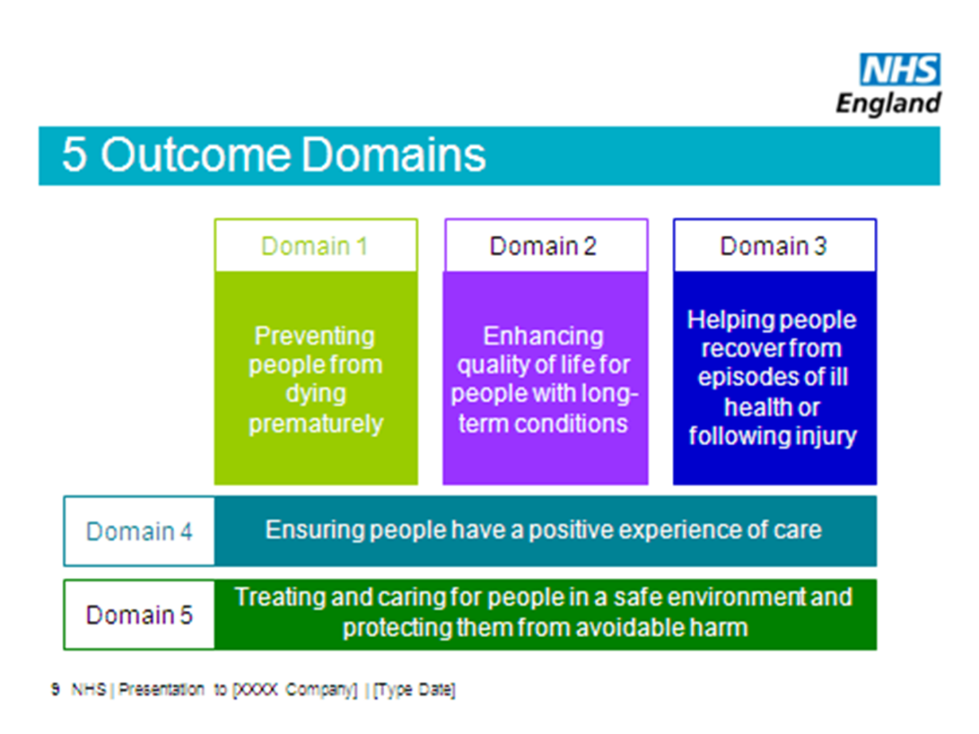

*Figure 1*

The 6 characteristics of high quality, sustainable health and care systems in 5 years time are:

1. Citizen inclusion and empowerment
2. Wider primary care, provided at scale
3. A modern model of integrated care
4. Access to the highest quality urgent and emergency care
5. A step-change in the productivity of elective care
6. Specialised services concentrated in centres of excellence

*Figure 2*

**Strategic Plan on a Page**

The five year Strategic Plan on a Page (next page) describes key aims, objectives, initiatives and outcomes for the North East Lincolnshire CCG and “unit of planning” (in this instance the corresponding NEL unitary authority area). The red indicators correspond with the six characteristics of high quality, sustainable health and care systems.

Our strategic aims, as set out in our constitution and identified in the Strategic Plan on a Page are defined as below

|  |  |  |
| --- | --- | --- |
| **Empowering People** | **Supporting Communities** | **Delivering sustainable services** |
| **Aim** | | |
| By 2019 individuals and groups in North East Lincolnshire are equal and active partners in managing their health and care | By 2019, people are managing their health and care effectively at home and the health inequalities between our most affluent and least affluent wards have narrowed | By 2019 the health and care economy is delivering care which is of consistently high quality and is financially sustainable in the long term |

Also described on the Plan on a Page are the high level measures of success, the underpinning values and principles and the governance mechanisms that will allow the local system to measure and demonstrate successful delivery of the objectives.

This Plan on a Page aligns with the strategic direction of travel set out within Healthy Lives, Healthy Futures which describes the “shift to the left” in relation to moving the emphasis of health and care towards self-care and independent living and out-of-hospital care. Whilst working closely with commissioners and providers across Northern Lincolnshire, the NELCCG Strategic Plan is designed to be responsive to localised health and social care needs.

**Key building blocks of the strategic plan**

In order to deliver the outcomes identified and create the framework within which to redesign local health and care services, the following elements will feature prominently in our work.

* Cultural shift towards self-care and self-responsibility
* Making best use of innovation and embracing opportunities to innovate
* Utilising technology effectively
* Recognising contextual factors – demographics, integrated care, geographical location, workforce issues, national economic drivers
* Maintaining gains in delivery of urgent care and delivering sustainability through shifts in delivery of planned care
* Influencing and responding to changes in direct commissioning – specialised, primary care, public health england

**Integrated Care and the Better Care Fund**

The CCG Strategic Plan recognises the unique nature of commissioning arrangements in North East Lincolnshire and the opportunities this affords in terms of delivering seamless care solutions between health and social care. A key part of this delivery will be the establishment of an integrated Single Point of Access which will be an enabler for more integrated care solutions into the future

The priorities framework described in the CCG’s Adult Social Care strategy reflects the range of care solutions which will meet local need into the medium term and beyond.



Medium Term Financial Plan

Planned expenditure by allocation type over the next 5 years

Planned programme cost expenditure over the next 5 years

Overview

The CCG made a surplus of £6m (3%) in 2013/14. Over the next 3 years the CCG plans to reduce its in year surplus by £4m so that by 2016/17 the surplus will be £2m (1%). The surplus is then planned to be maintained at 1%.

The total of the reserves & contingency in each of the years exceeds the level of assessed risk. Risk will be monitored closely in year and reported routinely to the Delivery Assurance Committee.

Overview on QIPP schemes and risk to delivery

NHS QIPP requirement of £3.5m per annum

NELC outcome review savings requirement (cash reduction) of £7m in total (£2m in 2014/15 & £5m in 2015/16) Adult Social Care total savings requirement of £8.1m (£7m cash reduction plus £1.1m efficiencies to manage demand and other pressures)

Plans are well developed for the first 2 years of the plan and schemes will be monitored routinely at the CCGs Delivery & Assurance Committee.

Work is on-going to develop the detailed QIPP plans for 2016/17 – 2018/19 and this will be done alongside the Healthy Lives Healthy Futures Programme.

The main risks to delivery of QIPP schemes:-

• Inability to draw down 2014/15 surplus as planned, leading to delays in transformation programme

• Maintaining the financial stability of all providers during the transformation, which will involve significant change across the whole system and involve a number of providers

Non-recurrent expenditure

Non recurrent funding is to be used to support;-

• Provider sustainability; whilst the transformational changes are taking place

• Healthy Lives Healthy Futures Transformation Fund; double running costs whilst QIPP schemes being rolled out &/or one off costs associated with implementation

• Pump priming of schemes to support ASC/integrated working ahead of 2015/16

• CHC Legacy risk share

**Conclusion**

The five year strategic plan and the medium term financial plan reflect the overall shift to the left for health and care services in line with the Healthy Lives, Healthy Futures vision and the strategic aims for North East Lincolnshire CCG

The Partnership Board is asked to note and approve the direction of travel and agree the strategic approach to commissioning outlined here.