Integrated Assurance Report

Introduction

The dashboards below represent an overview of performance and risk for health and social care services across North East Lincolnshire.

The performance dashboard consists of seven domains that incorporate all areas that North East Lincolnshire Clinical Commissioning Group strive to improve on. A judgement has been made of the status for each domain based on the performance measures underpinning them. These judgements try to balance the current position with the expected outcome at the end of the year and weightings with respect to priority. They also represent the local perspective of performance for North East Lincolnshire rather than the performance against the national definition which, on occasion, covers a broader footprint. It should be noted that those issues that have an impact on the CCGs corporate performance assessment will continue to be scrutinised at the Delivery Assurance Committee. The Delivery Assurance Committee is asked to make a decision on the final status of the dashboard before reporting to the CCG Partnership Board. The risk dashboards are separated in to a CCG risk register and the CCGs Board Assurance Framework risks. These dashboards demonstrate the number of risks with a specific risk score. The performance dashboard reflects performance for the first four months of 2015-16 and the risk summaries reflect risk status as at 18th August 2015. Full exception report summaries are also included for Performance (appendix A) detailing performance of indicators that are underperforming and risk (appendix B) detailing risks rated as 16 or higher.

Performance Dashboard
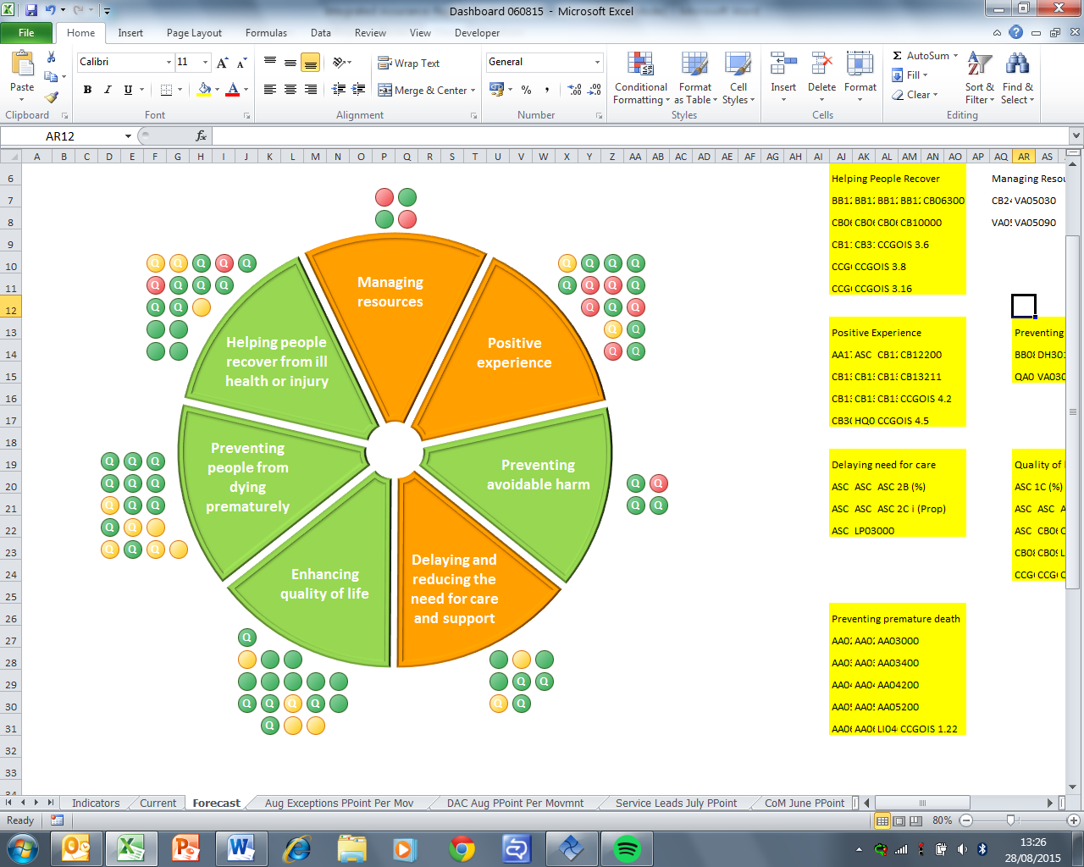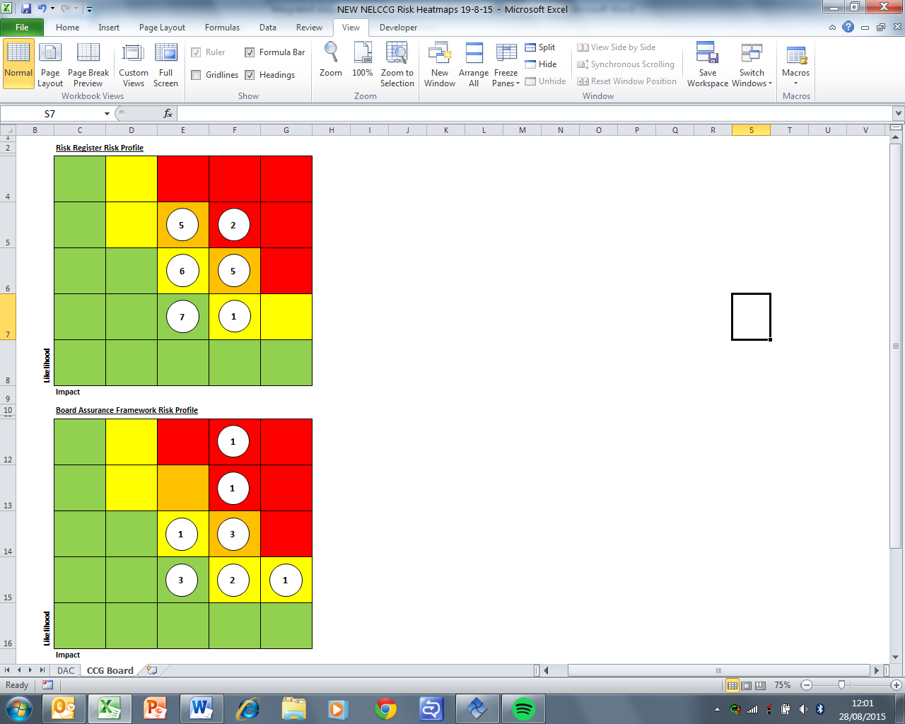

Please note the letter Q indicates a quality measure. These indicators focus on safety, experience and effectiveness and are present in the NHS England Quality Dashboard and the Quality domain of the CCG Assurance Framework.
Escalation

Performance Highlight

CCG Benchmarking analysis

The summary below demonstrates how the CCG performance against the domain ‘Preventing Avoidable Harm’ as a comparison against the other 210 CCGs within in England. The closer the yellow point is to the outside of the circle the better North East Lincolnshire CCGs relative performance. The two areas of greatest concern from this would be ‘ASC people who feel safe’ and ‘MRSA Blood Stream Infections’. The former looks at those people receiving an Adult Social Care service and whether they feel safe in general. When looked at in juxtaposition to the ‘ASC services that have made them feel safe’ which focuses on how those same people feel about the specific services they receive we can see that the CCG has relatively high performance so clearly the services put in place are having a positive impact on the individuals opinion of how safe they feel.

With respect to MRSA, a post infection review has been undertaken on each of the four cases this relates to and for each case it was not felt that healthcare services could have taken any steps to have prevented the incidence.

It should also be noted that there are two further measures where the CCG performance is in the best quartile. These being ‘Incidence of Clostridium Difficile’ and ‘Proportion on Care Programme Approach discharged from inpatient care who are followed up within seven days’.

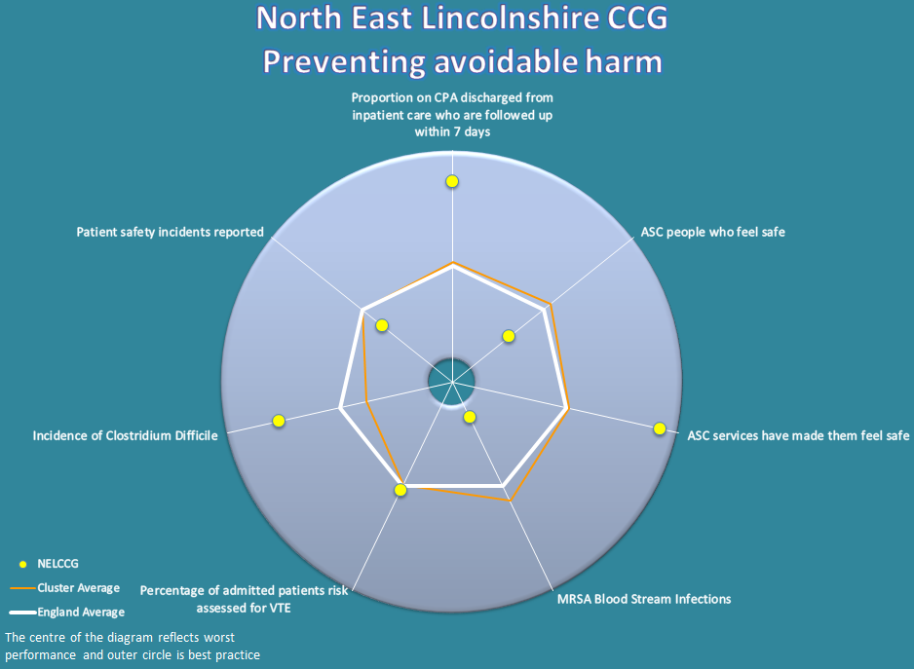

Appendix A - Performance Exception Summary
Code | Indicator | Quality Measure? | Latest period |  |  |  | 2015/16 year to date |  |  | Year End Forecast
Code | Indicator | Quality Measure? | Period | Target | Value | Status | Target | Value | Status | Year End Forecast
Positive experience
AA17000 | Total time in A&E: four hours or less | Yes | July 2015 | 95% | 96.4% |  | 95% | 95.2%
CB13210 | Friends & Family - AAE % Who would recommend service | Yes | June 2015 | 87.5% | 85.15% |  | 87.5% | 79.6% | 
CB13201 | Friends & Family - AAE Response (NLAG) | Yes | June 2015 | 14.8% | 11.15% |  | 14.8% | 12.81%
CB13203 | Friends & Family - Inpatient Response (NLAG) | Yes | June 2015 | 26.3% | 20.22% |  | 26.3% | 20.36%
CB13205 | Friends & Family - Maternity Response Birth (NLAG) | Yes | June 2015 | 23.61% | 10.73% |  | 23.47% | 9.44%
CCGOIS 4.2 | Patient experience of hospital care | Yes | 2013/14 | 78.63 | 76.1 |  | No data available for 2015-16
HQ08000 | Numbers of unjustified mixed sex accommodation breaches | Yes | 2015/16 | 0 | 4 |  | 0 | 4
Preventing avoidable harm
DH30100 | MRSA Blood Stream Infections | Yes | July 2015 | 0 | 0 |  | 0 | 2
Delaying and reducing the need for care and support
ASC 2A ii (Prop) | Permanent admissions 65+ to residential and nursing care homes, per 100,000 population | No | June 2015 | 147.90 | 179.13 |  | 147.90 | 179.13
ASC LOC1 (%) | Adult and older clients receiving a review as a percentage of those receiving a service. | Yes | June 2015 | 29.26% | 22.11% |  | 29.26% | 22.11%
Enhancing quality of life
ASC 1E (%) | Proportion of adults with learning disabilities in paid employment | No | June 2015 | 11.00% | 3.36% |  | 11.00% | 3.36%
CCGOIS 2.9 | Access to community mental health services by people from Black and Minority Ethnic (BME) groups | No | 2013/14 | 2035.9 | 1430.3 |  | No data available for 2015-16
CCGOIS 2.10 | Access to psychological therapies services by people from Black and Minority Ethnic (BME) groups | No | 2013/14 | 719.4 | 286.1 |  | No data available for 2015-16
LP02000 | Deaths that occur at home (inc. care homes) | Yes | Q3 2014/15 | 50.5% | 48.9% |  | No data available for 2015-16
Preventing people from dying prematurely
AA04100 | Cancer 62 Days Referral to Treatment (Screening Referral) | Yes | June 2015 | 90% | 100% |  | 90% | 100%
AA05002 | Cat A (RED2) calls meeting eight minute standard (EMAS) | Yes | July 2015 | 75.00% | 70.33% |  | 75.00% | 74.49%
AA05200 | Ambulance average total turnaround time – DPOW | No | July 2015 | 30 mins | 33.18 mins |  | 30 mins | 32.73 mins
AA06000 | Cat A calls meeting 19 minute standard (EMAS) | Yes | July 2015 | 95% | 91.8% |  | 95% | 94.05%
CCGOIS 1.22 | The rate of people admitted with a primary diagnosis of hip fracture per 100,000 CCG population | No | December 2014 | 431.5 | 469.2 |  | No data available for 2015-16
LIO4000 | Summary Hospital Mortality Index (SHMI) – NLAG | Yes | December 2014 | 100 | 109.8 |  | No data available for 2015-16
Helping people recover from ill health or injury
BB12300 | 18 week referral to treatment times - admitted | Yes | June 2015 | 90% | 87.3% |  | 90% | 84.4%
BB12400 | 18 week referral to treatment times - non-admitted | Yes | June 2015 | 95% | 95% |  | 95% | 94.3%
BB12830 | RTT - Number waiting over 52 wks | Yes | June 2015 | 0 | 1 |  | 0 | 1
CB06301 | Total Emergency admissions for acute conditions that should not usually require hospital admission | Yes | June 2015 | 159 | 179 |  | 509 | 607
CCGOIS 3.6 | People who have had an acute stroke who receive thrombolysis | No | 2013/14 | 11.6% | 7.1% |  | No data available for 2015-16
Managing resources
CB24000 | A&E Attendances | No | June 2015 | 4,371 | 4,784 |  | 13,213 | 14,105
VA05090 | Non-Elective Activity | No | June 2015 | 1,577 | 1,278 |  | 4,736 | 3,926
Appendix B - Risk Exception Summary

The table below reflects risks rated as 16+ (high to significant) on the risk register as at 18 August 2015

No. | Risk | Current risk rating | Risk Lead | Internal Controls | Latest update
1 | CCG3012  18 week RTT performance | 16 | Debbee Walker | Commissioning action plan is in place which is reported through Delivery Assurance Committee for progress.  Updates fed into internal Groups for information/further discussion and action: Service Leads, Council Of Members, System Resilience Group.  Clinically led collaborative meeting with Providers to discuss service delivery concerns/ improvements.  Financial penalties imposed on Providers for non-achievement of Key Performance Indicators. | Debbee Walker - risk reviewed and updated 18 August 2015  M03 return illustrated that NELCCG achieved the incomplete 18 week standard, but failed to achieve the admitted and non-admitted standards.  Admitted performance improved in month, however non-admitted performance declined.  Nationally, admitted and non-admitted targets are going to be abolished and only incomplete performance standards will remain which the CCG currently achieves. Therefore the admitted and non-admitted standards will no longer be a risk to the CCGs assurance framework.
2 | CCG1004  On-going failure to meet Clinical Handover time targets for EMAS patient delivery at DPoW A&E | 16 | Andy Ombler | Moving from monitoring only to action planning  Performance is monitored by the Urgent Care Board. | Andy Ombler - risk reviewed and updated 13 July 2015  Handover performance has stabilised however has not reduced to the required target of 30mins ( April to June: 00:32:55, 00:32:13, 00:33:04 )  Performance at DPoW remains better than the average each month at all hospitals in the EMAS contract. A new handover process is being introduced in the next 6 months ( estimated ) that replaces previous initiatives on handover timing and this, along with plans to reduce conveyance and therefore arrivals activity, are the focus for continued improvement of handover performance. It is also likely that acute KPIs will be introduced that penalise extended clinical handovers.

The table below reflects risks rated as 15+ (high to significant) on the assurance framework as at 18 August 2015
No. | Risk | Current risk rating | Risk Lead | Internal Controls | Latest Update
1 | CCGAF3003  Risk that Healthy Lives, Healthy Futures will not deliver the quality and financial sustainability outcomes in the requisite timeframe | 16 | Lisa Hilder | Further work on reviewing and refreshing the financial gap has been commissioned by the Programme Board to be delivered by PWC (13 October 2014)  HLHF Programme Board  Governance framework provided by HLHF programme board, engagement core group and assurance sub group in place.  The HLHF Programme Board reviews progress monthly towards financial and clinical sustainability goals for Northern Lincolnshire. The Programme Board reviews the programme risk log on a monthly basis and has also established an assurance sub group to identify key areas of concern and recommend remedial action. With regards to financial sustainability the Executive group of the Programme board meets weekly virtually and receives ongoing reports and assurance on the updated financial position. | Lisa Hilder - risk reviewed and updated 17 August 2015  Clinical workshops have identified key workstreams:  Planned care  Unplanned care  Women and children  Long term conditions  These are being grouped into in hospital and out of hospital care, with initial focus on out of hospital care. The programme Board have received an outline strategy for service redesign which is currently being refined. Further communications and engagement where relevant to support outline changes will take place during the latter part of 2015/16
2 | CCGAF3008  Risk that the CCG could face financial challenges (i.e. Fail to deliver a balanced budget or there is a funding gap) and therefore does not achieve statutory financial obligations. Particular issue at this time due to NELC (social care) funding pressures, local NHS community financial challenges, and acute provider deficit | 16 | Cathy Kennedy | Within the CCG the Integrated Governance and Audit Committee assures management of financial risk  Regular meetings for Executive Directors for CCG/LA to monitor position.  HLHF programme arrangements include Memorandum of Understanding including a collective risk management approach | Cathy Kennedy - risk reviewed and updated 10 August 2015 and internal controls updated

