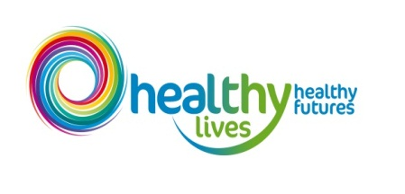Healthy Lives, Healthy Futures Monthly Report
Attachment 13 a
North East Lincolnshire Partnership Board – May, 2015
This report presents information which is drawn from the HLHF reporting process, which is currently under development. Information contained within the report to the partnership board (and the presentation of information) will be updated as the process is refined.
- Programme Progress Report

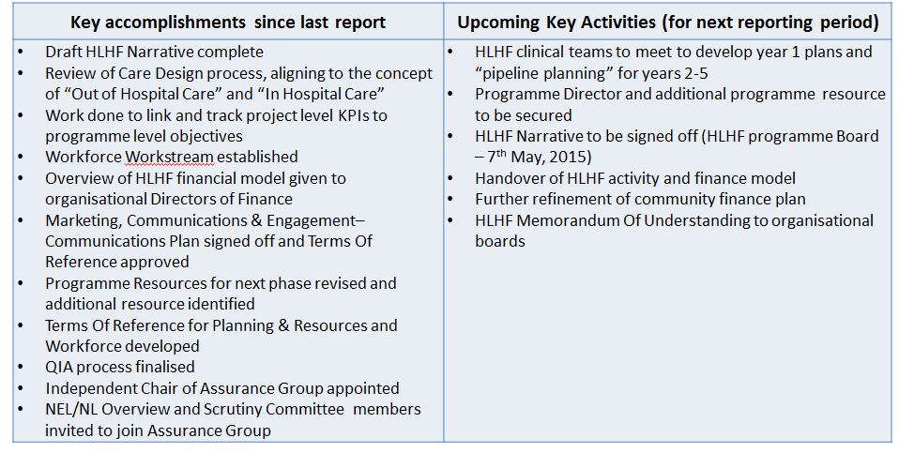
- Programme Overview

The table below shows the total number of schemes due to be implemented in 2015/16 that are being tracked by the HLHF programme. The programme board are currently working on “pipeline planning” for years 2-5.

Total Number of HLHF schemes | NEL CCG Lead organisation | NL CCG lead organisation | NLaG lead organisation | Jointly led
51 | 10 | 11 | 29 | 1

All HLHF schemes are monitored on a gateway system via the HLHF scheme tracker to indicate project progress. A breakdown of the gateway system and the number of schemes currently sitting in each gateway for all HLHF schemes can be seen below:
Gateway Key
Gateway | 0 | 1 | 2 | 3 | 4 | 5
Project Stage | Idea Generation | Project Scoping | Project Development | Project Implementation | Benefits Realisation | Project Closure

- North East Lincolnshire Transformational Schemes

The table below describes the current North East Lincolnshire schemes being tracked by the Healthy Lives, Healthy Futures programme and the project gateway in which they currently sit. Gateway deadlines are currently being defined and each report will assess actual progress against planned gateway completion dates – current data indicates that all NEL schemes are on track.
Scheme | Planned Gateway | Actual Gateway | Update/Comments
Assisted Living Centre (Grimsby) | 3 | 3 | On track
End of Life / Palliative Care | 4 | 4 | On track
Extensivist Team (Advanced Community Care - ACC) | 3 | 3 | On track
Extra Care Housing | 3 | 3 | On track
Frequent Service Users | 4 | 4 | On track
GP Front ending A&E - extension include ambulance arrivals | 1 | 1 | On track
Home from Home (Grimsby) | 3 | 3 | On track
Mobile GPs - pilot | 4 | 4 | On track
Single Point of Access (Grimsby) | 3 | 3 | On track
Support to Care homes (including GP alignment & MDT options) | 1 | 1 | On track
Dermatology | 1 | 1 | On track
Frail and Elderly Assessment Unit (Grimsby) | 0 | 0 | On track
Outpatients | 0 | 0 | On track

- Quality

Work is currently on-going to define programme level Key Performance Indicators and quality targets. These KPIs will be monitored on weekly basis via the HLHF operational group and exceptions escalated to the appropriate senior leads from relevant organisations. This report will define the month on month performance of key quality indicators and provide brief trend analysis.
- Financial Summary

Financial progress against individual scheme targets will be monitored through existing contracting/provider management processes and fed into the HLHF Programme Management Office for collation and aggregation. The overall impact of activity changes can then be assessed against the health and social care community finance gap – £104m by 2019. This assessment of progress against both the yearly and 5 year financial targets will be a key element of the HLHF reporting dashboard (under development).
The graphic below shows the total projected health and social care community financial gap by 2019, split by provider cost improvement (assessed and agreed), HLHF transformation work and the residual gap:
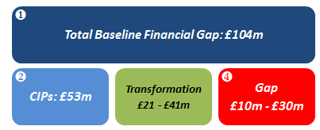
The Graph below indicates a gap of approximately £96m after accounting for the impact of work planned in 2015/16. However £53m of this will be covered by Cost Improvement Plans, which will be profiled into the graph. This leaves a residual gap of approximately £43m.
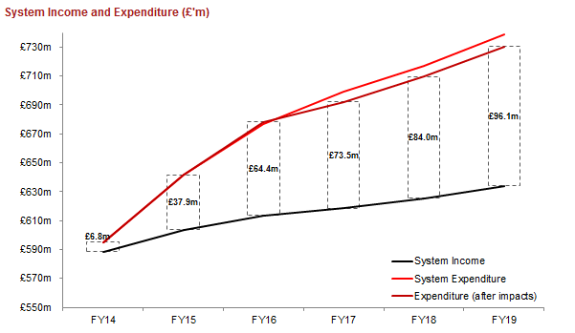

- Programme Risk Summary

Below is a summary of the HLHF programme risks that score 15 or above on the risk matrix. There is a full HLHF risk register that is monitored by the HLHF Programme Board.
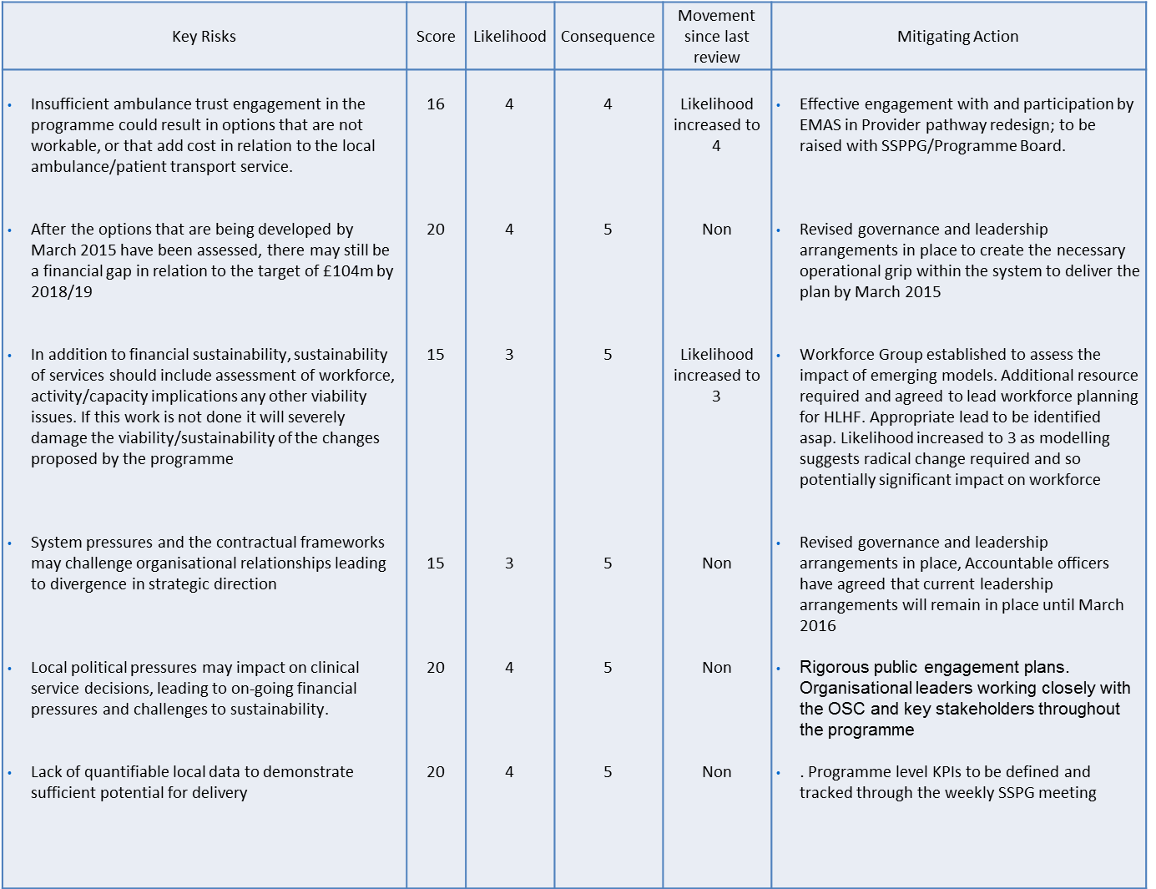
- Programme Timeline
