
North East Lincolnshire CCG

Attachment 12

Report to: | NEL CCG Partnership Board
Presented by: | Cathy Kennedy, Deputy Chief Executive
Date of Meeting: | 15th January 2015
Subject: | Integrated Assurance Report
Status: | OPEN CLOSED
Agenda Section: | STRATEGY COMMISSIONING OPERATIONAL ISSUES

OBJECT OF REPORT
The report advises the Partnership Board of how NELCCG are performing against the seven domains developed for the dashboard with respect to its performance measures and six domains for risk.

The development of the dashboards is being managed via the Delivery Assurance Committee. The most recent development sets out the risk summaries using a heat map of scores rather than the wheel used for performance. A summary of risks with a score of 15 or above is also included.

Further intelligence relating to the CCGs financial and workforce performance has been taken in to account under ‘Managing Resources’.

For more detail on performance and risk the latest integrated assurance report presented to the Delivery Assurance Committee can be found via the following embedded file:


STRATEGY
The structure of the performance dashboard reflects the following seven domains.

- Positive experience
- Preventing avoidable harm
- Delaying and reducing the need for care and support
- Enhancing quality of life
- Preventing people from dying prematurely
- Helping people recover from ill health or injury
- Managing resources

The structure of the risk dashboard reflects the following six domains.

- Clinically led and quality focused
- Community Engagement
- Delivering local priorities within budget
- Constitutional and governance arrangements
- Collaborative arrangements with partners
- Leadership

IMPLICATIONS
Whilst it has been identified that the organisation is performing well overall, the Delivery Assurance Committee continues to focus on specific areas where improvement is to be pursued. This links in to an assessment of how the organisation is likely to perform in key external judgements. It is apparent that the CCG needs to continue to focus on some specific areas but, despite a number of indicators underachieving, there is continued improvement in many areas.

RECOMMENDATIONS (R) AND ACTIONS (A) FOR AGREEMENT

The Partnership Board is asked:
• to note judgements made against the domains of the dashboards
• to note the information on the Adult Social Care Performance
- to note the information on better payment practice
• for views on activity increases contract cost pressures
• for views on A&E four hour wait performance
• for further feedback on ways to improve the report

 |  | Yes/No | Comments
 | Does the document take account of and meet the requirements of the following:
i) | Mental Capacity Act | NA
ii) | CCG Equality Impact Assessment | NA
iii) | Human Rights Act 1998 | NA
iv) | Health and Safety at Work Act 1974 | NA
v) | Freedom of Information Act 2000 / Data Protection Act 1998 | NA
iv) | Does the report have regard of the principles and values of the NHS Constitution?  www.dh.gov.uk/en/Publicationsandstatistics/Publications/PublicationsPolicyAndGuidance/DH_113613 | Yes

Integrated Assurance Report

Introduction

The dashboards below represent an overview of performance and risk for health and social care services across North East Lincolnshire.

The performance dashboard consists of seven domains that incorporate all areas that North East Lincolnshire Clinical Commissioning Group strive to improve on. A judgement has been made of the status for each domain based on the performance measures underpinning them. These judgements try to balance the current position with the expected outcome at the end of the year and weightings with respect to priority. They also represent the local perspective of performance for North East Lincolnshire rather than the performance against the national definition which, on occasion, covers a broader footprint. It should be noted that those issues that have an impact on the CCGs corporate performance assessment will continue to be scrutinised at the Delivery Assurance Committee. The Delivery Assurance Committee is asked to make a decision on the final status of the dashboard before reporting to the CCG Partnership Board. The risk dashboards are separated in to a CCG risk register and the CCGs Board Assurance Framework risks. These dashboards demonstrate the number of risks with a specific risk score. The performance dashboard reflects performance for the period April to November 2014 and the risk summaries reflect risk status as at 10th December 2014. Full exception report summaries are also included for Performance (appendix A) detailing performance of indicators that are underperforming and risk (appendix B) detailing risks rated as 15 or higher.

Performance Dashboard
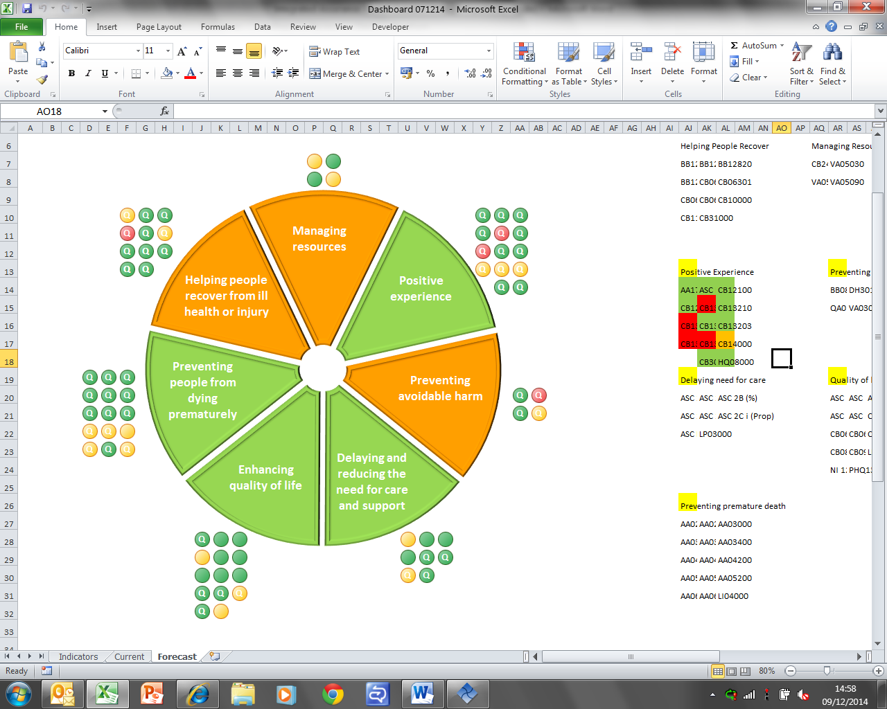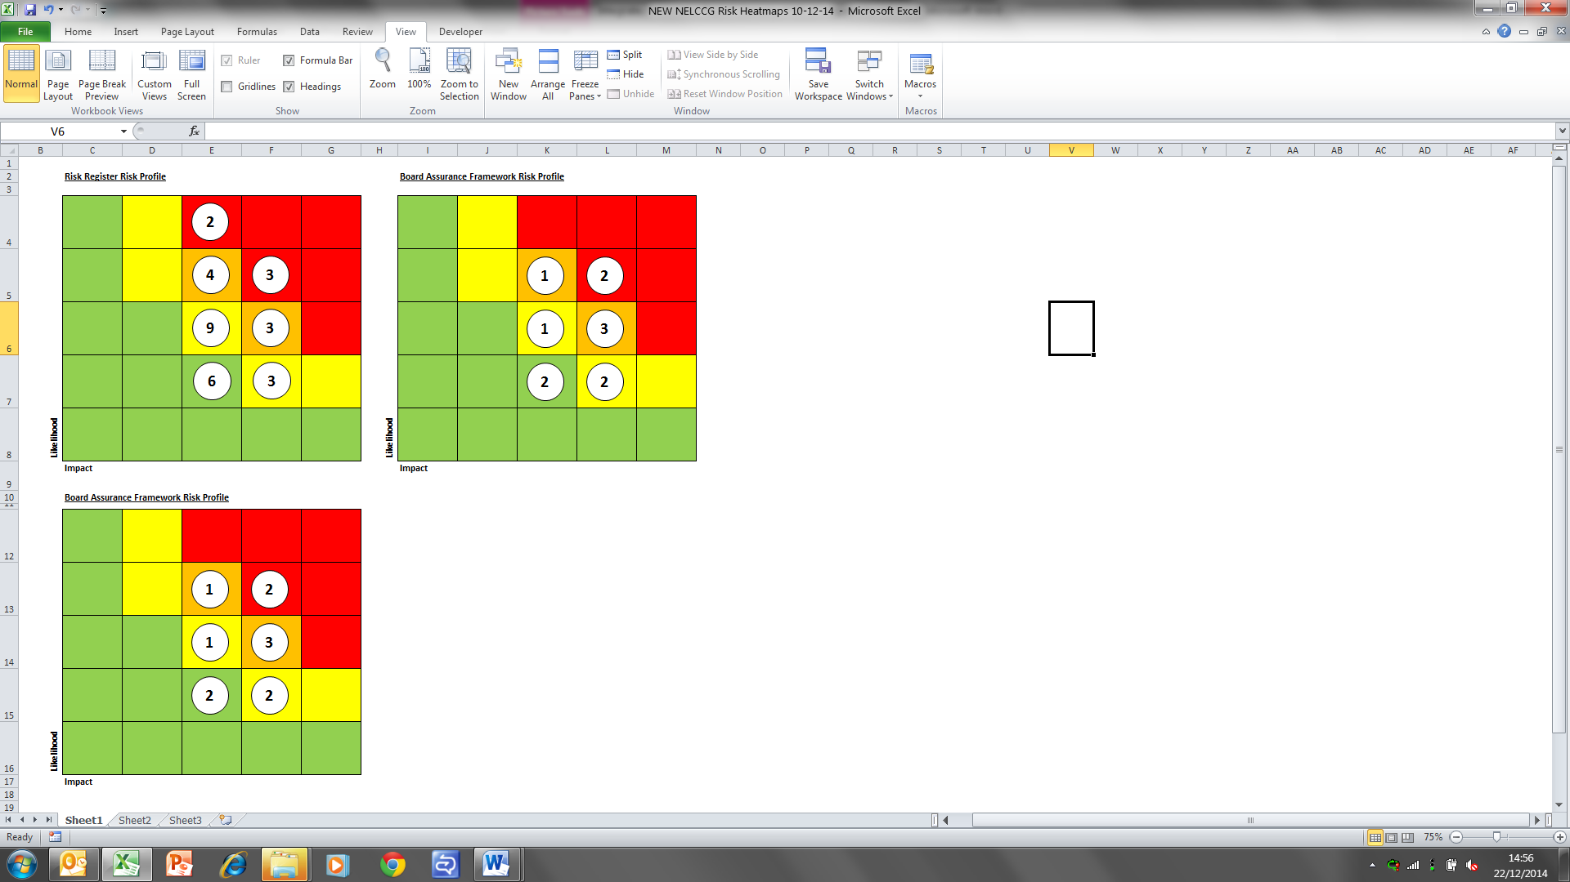

Please note the letter Q indicates a quality measure. These indicators focus on safety, experience and effectiveness and are present in the NHS England Quality Dashboard and the Quality domain of the CCG Assurance Framework.
Escalation

Performance Highlight

Adult Social Care performance
The diagram below represents North East Lincolnshire CCG’s benchmarked performance for each of the performance measures from the Adult Social Care Outcomes Framework (ASCOF) in 2013-14. Each of the dots represents a measure from the ASCOF and the closer the dot is to the outer ring the better NELCGG’s performance is against its peers.

It should be noted that whilst the ‘Offered reablement’ measure looks to be an issue in the context of the CCG having a very low readmission rate this is not a concern and is expected to be associated with the method of counting.

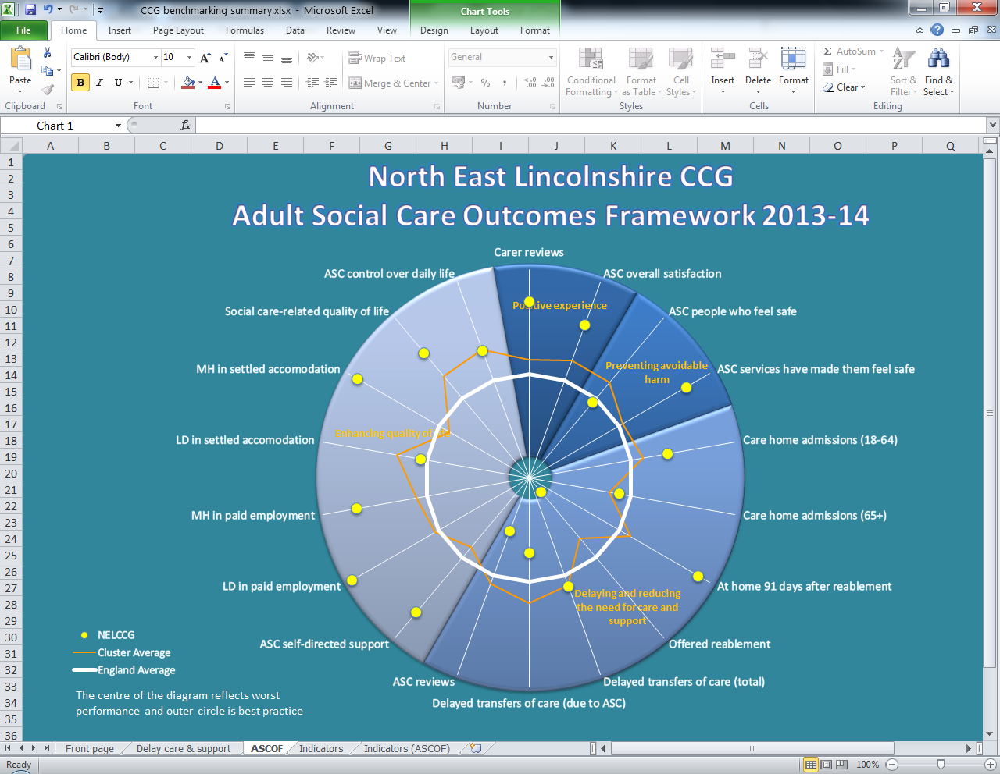

Better Payment Practice
There are 2 parts to the Better Payment Practice Code at NELCCG.
- Invoices that are processed through Oracle for both NHS & Non-NHS invoices. This accounts for the highest value of invoice payments.
- Invoices for Adult Social Care processed via Focus through NE Lincs Council payment systems. This accounts for the highest quantity of invoice payments.

The NELC invoices paid within target has steadily risen following some issues with some suppliers in May, June & July. Following discussions and changes in working practices at Focus, this now looks to have been resolved.
NE Lincs CCG will continue to converse with Focus to monitor the situation for any future issues.

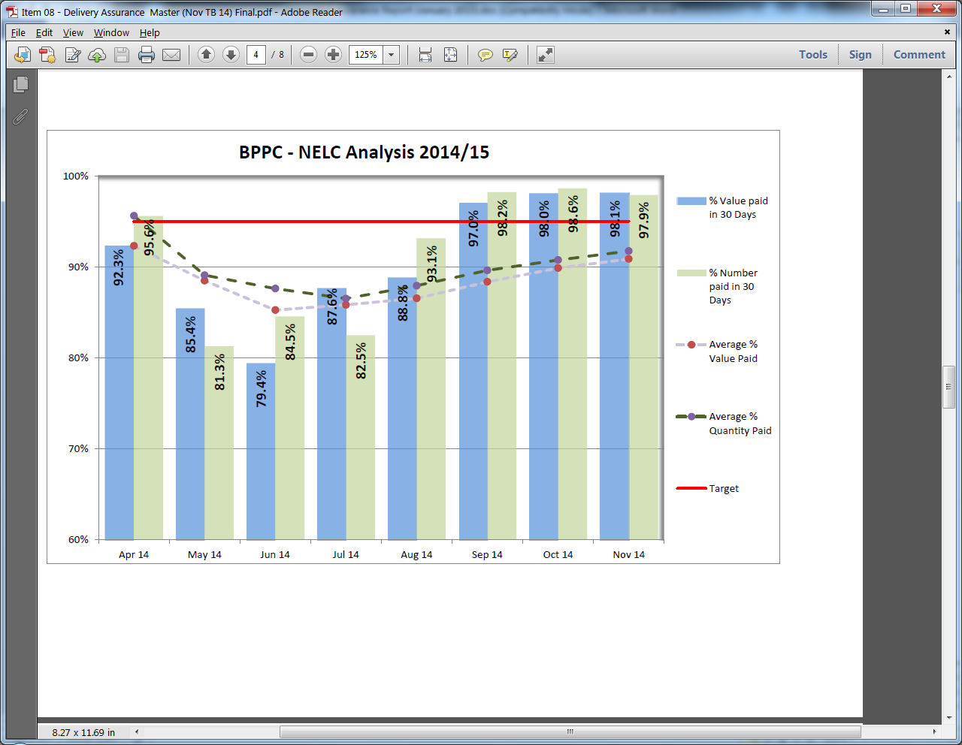

In more recent months payment timescales have improved significantly. If payments made continue at the current rate, NELC are on course to reach the 95% target by the end of the financial year.
Performance Exception

Contract cost pressures
NELCCG has seen significant increases in certain areas of activity in 2014-15 over and above that of previous years. The table below reflects the increase across different areas of activity. Whilst it is expected that some of the rise in planned care activity can be attributed to the additional work being delivered to improve waiting times, the majority of the rise is associated with a greater conversion rate from referral to receiving treatment. Although the CCG is working with Northern Lincolnshire and Goole NHS Foundation Trust to understand what is driving this change and, specifically, whether it is continuous growth that we should expect to continue or a step change and therefore no additional growth should be expected.

Activity Type | Activity Increase | Cost Increase
A&E attendances | 2.5% | 7.7%
Emergency admissions | 6.8% | 3.8%
Elective inpatient and daycase | 13.4% | 7.0%
Imaging diagnostics | 14.4% | 21.0%
Excluded Drugs, Devices, Procedures | 110.7% | 18.1%

Due to the significance of the increases and the fact that, without intervention, much of it is anticipated to continue in to future years this has been escalated to the CCG Partnership Board because of the impact it will have on the future financial sustainability of the health and social care system in North East Lincolnshire.

A&E four hour wait
Over the first six months of 2014-15 Northern Lincolnshire and Goole NHS Foundation Trust consistently delivered on the NHS constitutional standard with over 96% of people spending less than four hours in A&E (target, 95%). Over the last three months to December performance has deteriorated to just below 93% in quarter 3 with December’s performance down at 90.2%. At the end of December the year to date position is now at 95.1% and clearly if the current level of performance continues then the 95% will not be achieved across 2014-15.

The current issues driving this poor performance are believed to be a combination additional demand on both the A&E department and hospital beds with a greater proportion of people attending A&E requiring admission. There is additional pressure on the hospital from surrounding hospital trusts that are under significant pressure and looking to transfer patients in to NLAG.

With this increasing pressure on beds there will inevitably be a knock on effect to planned care and the need to cancel the less urgent appointments which will in turn create pressures on other performance areas such as 18 week wait. NLAG hadn’t seen cancellations above the normal levels until the last two weeks where there has been a notable increase.

The chart below demonstrates the current year to date performance of NLAG against the other hospital trusts across England.
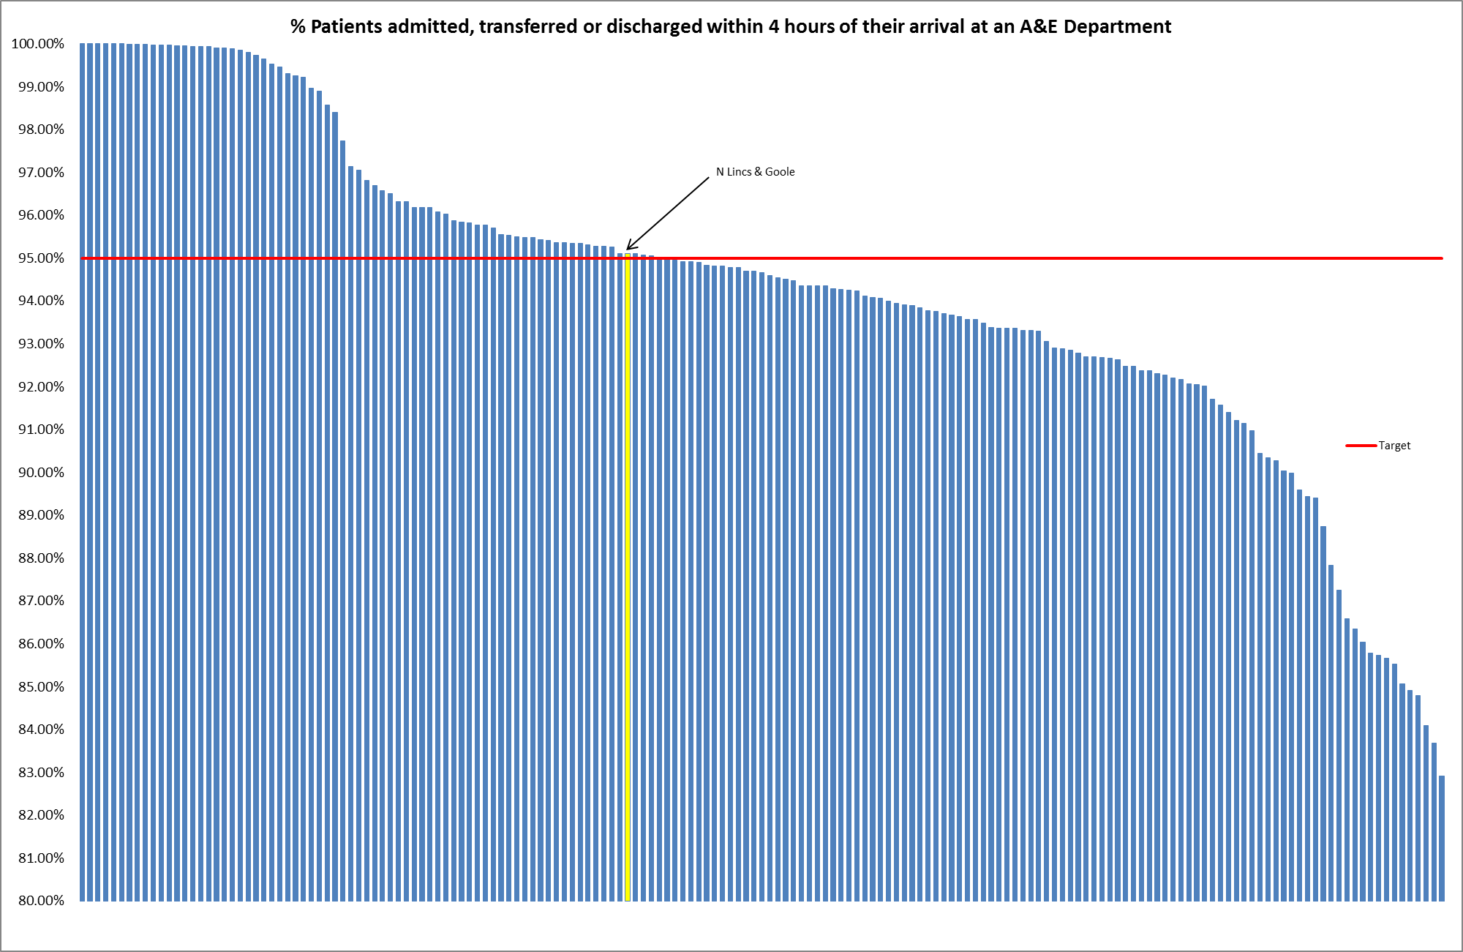
Appendix A - Performance Exception Summary
Code | Indicator | Quality Measure? | Latest period |  |  |  | 2014/15 year to date |  |  | Year End Forecast
Code | Indicator | Quality Measure? | Period | Target | Value | Status | Target | Value | Status | Year End Forecast
Positive experience
CB13002 | Friends and family test – Employee Score | Yes | 2013/14 | 64 | 48.33 |  | No data available for 2014-15
CB13201 | Friends & Family - AAE Response (NLAG) | Yes | October 2014 | 15% | 12.4% |  | 15% | 8.81%
CB13216 | Friends & Family - Maternity - Combined % Who would recommend | Yes | October 2014 | 97% | 95% |  | 97% | 95.03%
CB13205 | Friends & Family - Maternity Response Birth (NLAG) | Yes | October 2014 | 25% | 25.1% |  | 25% | 22.78%
CB14000 | Patient experience of hospital care | Yes | 2013/14 | 78.63 | 75 |  | No data available for 2014-15
Preventing avoidable harm
DH30100 | MRSA Blood Stream Infections | Yes | November 2014 | 0 | 1 |  | 0 | 1
VA03000 | Incidence of Clostridium Difficile | Yes | November 2014 | 2 | 2 |  | 14 | 22
Delaying and reducing the need for care and support
ASC 2A i (Prop) | Permanent admissions 18-64 to residential and nursing care homes, per 100,000 population | No | November 2014 | 6.26 | 8.40 |  | 6.26 | 8.40
ASC LOC1 (%) | Adult and older clients receiving a review as a percentage of those receiving a service. | Yes | November 2014 | 66.56% | 56.41% |  | 65.26% | 56.41%
Enhancing quality of life
ASC 1G (%) | Proportion of adults with learning disabilities who live in their own home or with their family |  | November 2014 | 79.90% | 75.97% |  | 79.90% | 75.97%
LP02000 | Deaths that occur at home (inc. care homes) | Yes | Q4 2013/14 | 50.0% | 49.5% |  | No data available for 2014-15
PHQ1310 | % people who have depression and/or anxiety disorders who receive psychological therapies | No | Q2 2014/15 | 2.5% | 2.7% |  | 5.0% | 5.2%
Preventing people from dying prematurely
AA05001 | Cat A (RED1) calls meeting eight minute standard (EMAS) | Yes | November 2014 | 75.0% | 73.0% |  | 75.0% | 73.2%
AA05002 | Cat A (RED2) calls meeting eight minute standard (EMAS) | Yes | November 2014 | 75.0% | 71.5% |  | 75.0% | 73.6%
AA05200 | Ambulance average total turnaround time – DPOW | No | November 2014 | 30 mins | 29.44 mins |  | 30 mins | 30.08 mins
AA06000 | Cat A calls meeting 19 minute standard (EMAS) | Yes | November 2014 | 95% | 93.8% |  | 95% | 94.5%
LIO4000 | Summary Hospital Mortality Index (SHMI) – NLAG | Yes | Q4 2013/14 | 100 | 107.7 |  | No data available for 2014-15
Helping people recover from ill health or injury
BB12300 | 18 week referral to treatment times - admitted | Yes | October 2014 | 90% | 87.2% |  | 90% | 88.9%
BB12830 | RTT - Number waiting over 52 wks | Yes | October 2014 | 0 | 0 |  | 0 | 1
CB06301 | Total Emergency admissions for acute conditions that should not usually require hospital admission | Yes | October 2014 | 173 | 215 |  | 1178 | 1294
Managing resources
CB24000 | A&E Attendances | No | October 2014 | 4,106 | 4,408 |  | 27,193 | 30,508
VA05090 | Non-Elective Activity | No | October 2014 | 4,106 | 4,408 |  | 27,193 | 30,508

Appendix B - Risk Exception Summary

The table below reflects risks rated as 15+ (high to significant) on the risk register as at 10 December 2014
Risk | Risk rating | Risk Lead | Control measures in place
Risk Register
18 week RTT performance | 16 | Debbee Walker | Debbee Walker - risk reviewed and updated 2 December 2014  Risk remains high. Additional activity has been undertaken during October and November.  Backlog of patients have begun to decline as a result of the additional activity NLGFT has been undertaking, which we have been informed will continue until backlogs are fully cleared.  NELCCG are more assured that performance will achieve respective targets by 1 December 2014.
NHS Continuing Healthcare and Funded Nursing Care | 16 | Ros Davey | Ros Davey - risk reviewed and updated 7 November 2014  Performance and governance framework under development with NELCCG – target date for completion 31 January 2015. Team is virtually fully recruited, however not yet fully functioning- target date 31 January 2015. Operating protocols in draft format, for finalisation 25 November 2014, however will then require formal acceptance by CCG.
GPIT Funding | 15 | John Mitchell | John Mitchell – risk reviewed 19 November 2014 and no further changes noted since update below  There is a gap in the GPIT funding in both Hull and NEL, a bid has been made to the transition fund to bridge the gap for the next years, but savings will have to be found within those 2 years
None GP (Clinical) systems | 15 | John Mitchell | John Mitchell – risk reviewed and updated 19 November 2014  IMT Service Development and Project Manager has been assigned to lead this work on behalf of Northern Lincolnshire. It is expected that the order will be placed in December
Failure to achieve Accident and Emergency 4 hour targets | 16 | Andy Ombler | Andy Ombler - risk reviewed and updated 12 December 2014  Volatility continues to be a feature of A&E performance. November showed an improvement on October with the month ending on 95.5%. December has started with a significant problem over a weekend with low performance for 3 consecutive days meaning that it is very unlikely that the 95% target can be met for December. In contrast to last year, a key feature so far in December has been the closure of acute and intermediate care beds due to D&V outbreaks.
Board Assurance Framework
Risk that Healthy Lives, Healthy Futures will not deliver the quality and financial sustainability outcomes in the requisite timeframe | 16 | Lisa Hilder | Lisa Hilder - risk reviewed and updated 8 December 2014  The consultation on Hyper Acute Stroke and ENT concluded on 26 September 2014. The recommendations from the report to maintain HAS at SGH and to consolidate ENT inpatient services at DPOW were accepted by the programme board and the respective CCGS and will now move to implementation. The focus for the consultation has been on service redesign for quality rather than financial efficiencies. Current modelling suggests circa 50% progress towards the overall financial goals. This work has been assisted by some additional modelling capacity from PWC which has produced the “single version of the truth” (SVT) Further workstreams targeting service redesign for financial efficiencies are underway for future phases of the programme, the first of which will be constructed in the coming 3-6 months.  PWC have been retained to assist with this modelling work and a service visioning workshop is planned for January 2015
Risk that the CCG could face financial challenges (i.e. Fail to deliver a balanced budget or there is a funding gap) and therefore does not achieve statutory financial obligations Particular issue at this time due to uncertainties in NHS transition/allocations and NELC (social care) funding pressures and NHS service sustainability | 16 | Cathy Kennedy | Cathy Kennedy - risk reviewed 7 November 2014 and no changes noted since last update below:  The HLHF programme has not fully identified solutions to the financial sustainability risks. Risk likelihood has therefore increased from 2 to 4.

