
North East Lincolnshire CCG

Attachment 07

Report to: | NEL CCG Partnership Board
Presented by: | Cathy Kennedy, Deputy Chief Executive
Date of Meeting: | 12th May 2016
Subject: | Integrated Assurance Report
Status: | OPEN CLOSED
Agenda Section: | STRATEGY COMMISSIONING OPERATIONAL ISSUES

OBJECT OF REPORT
The report advises the Partnership Board of how NELCCG are performing against the six domains developed for the dashboard with respect to its performance measures and six domains for risk.

The development of the dashboards is being managed via the Delivery Assurance Committee. The most recent development sets out the risk summaries using a heat map of scores rather than the wheel used for performance. A summary of risks with a score of 16 or above is also included.

For more detail on performance and risk the latest integrated assurance report presented to the Delivery Assurance Committee can be found via the following embedded file:

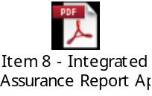

STRATEGY
The structure of the performance dashboard reflects the following six domains.

- Positive experience
- Preventing avoidable harm
- Delaying and reducing the need for care and support
- Enhancing quality of life
- Preventing people from dying prematurely
- Helping people recover from ill health or injury

The structure of the risk dashboard reflects the following six domains.

- Clinically led and quality focused
- Community Engagement
- Delivering local priorities within budget
- Constitutional and governance arrangements
- Collaborative arrangements with partners
- Leadership
IMPLICATIONS
Whilst it has been identified that the organisation is performing well overall, the Delivery Assurance Committee, Quality Committee and the Integrated Governance and Audit Committee continue to focus on specific areas where improvement is to be pursued. This links in to an assessment of how the organisation is likely to perform in key external judgements. It is apparent that the CCG needs to continue to focus on some specific areas but there is continued improvement in many areas.

RECOMMENDATIONS (R) AND ACTIONS (A) FOR AGREEMENT

The Partnership Board is asked:
- to note judgements made against the domains of the dashboards
- to note the information on future performance and risk challenges
- to note information escalated on Mental Health and QIPP
- for further feedback on ways to improve the report

 |  | Yes/No | Comments
 | Does the document take account of and meet the requirements of the following:
i) | Mental Capacity Act | NA
ii) | CCG Equality Impact Assessment | NA
iii) | Human Rights Act 1998 | NA
iv) | Health and Safety at Work Act 1974 | NA
v) | Freedom of Information Act 2000 / Data Protection Act 1998 | NA
iv) | Does the report have regard of the principles and values of the NHS Constitution?  www.dh.gov.uk/en/Publicationsandstatistics/Publications/PublicationsPolicyAndGuidance/DH_113613 | Yes

Integrated Assurance Report

Introduction

The dashboards below represent an overview of performance and risk for health and social care services across North East Lincolnshire.

The performance dashboard consists of six domains that incorporate all areas that North East Lincolnshire Clinical Commissioning Group strive to improve on. A judgement has been made of the status for each domain based on the performance measures underpinning them. These judgements try to balance the current position with the expected outcome at the end of the year and weightings with respect to priority. They also represent the local perspective of performance for North East Lincolnshire rather than the performance against the national definition which, on occasion, covers a broader footprint. It should be noted that those issues that have an impact on the CCGs corporate performance assessment will continue to be scrutinised at the Delivery Assurance Committee. The Delivery Assurance Committee is asked to make a decision on the final status of the dashboard before reporting to the CCG Partnership Board. The risk dashboards are separated in to a CCG risk register and the CCGs Board Assurance Framework risks. These dashboards demonstrate the number of risks with a specific risk score. The performance dashboard reflects performance for the twelve months of 2015-16 and the risk summaries reflect risk status as at 18th April 2016. Full exception report summaries are also included for Performance (appendix A) detailing performance of indicators that are underperforming and risk (appendix B) detailing risks rated as 16 or higher.

Performance Dashboard
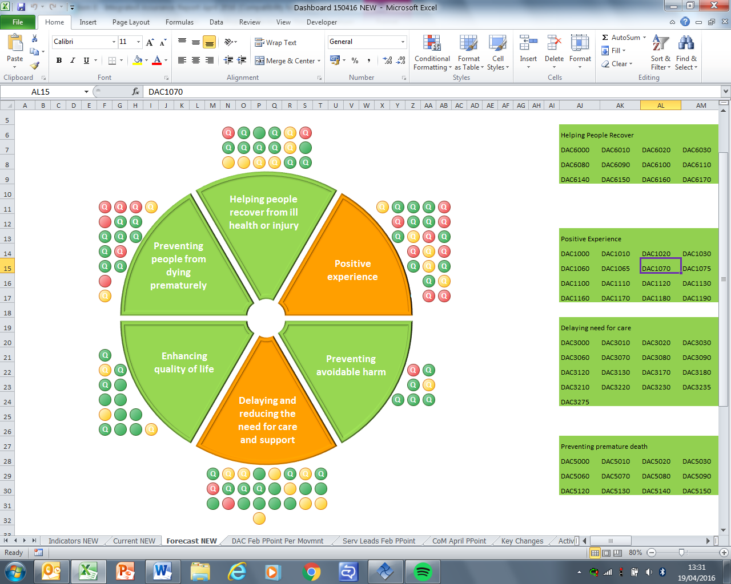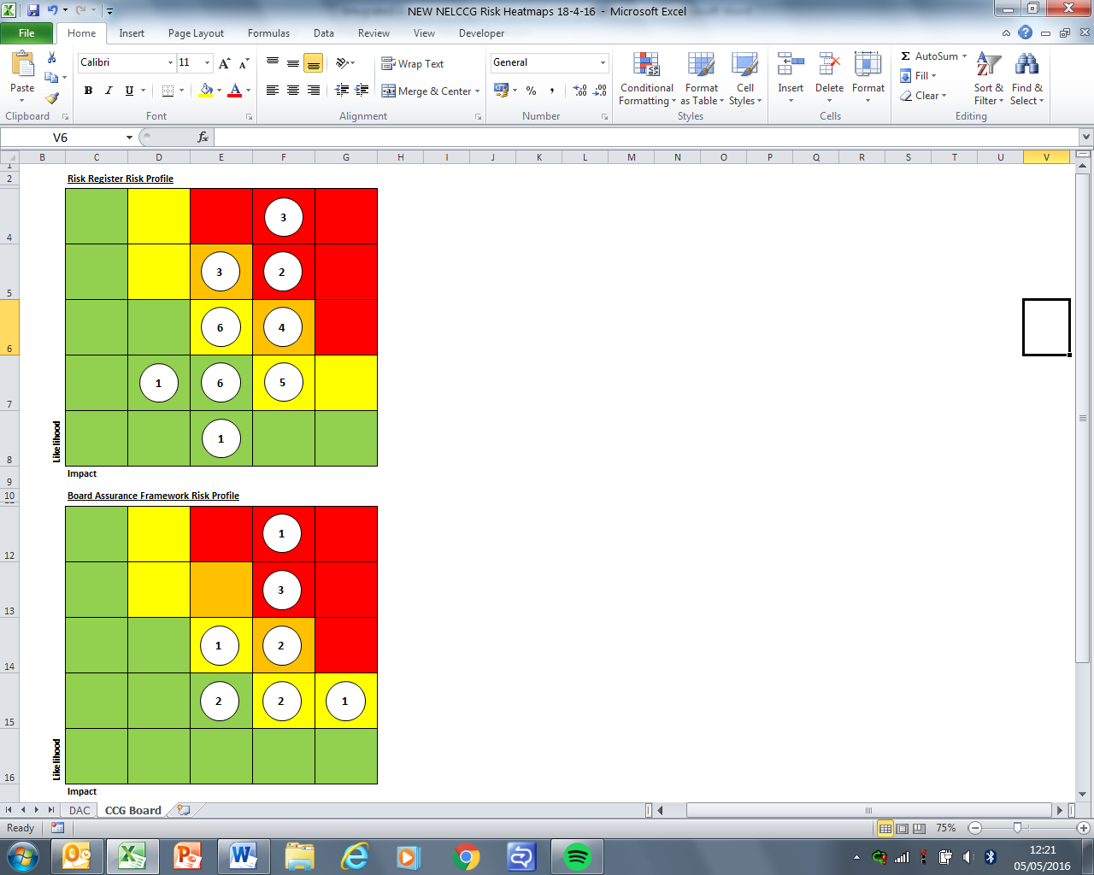
Please note the letter Q indicates a quality measure within the performance dashboard.

Escalation

Performance Highlight

Mental Health Performance

In January 2016 the Board received information on a number of Mental Health measures that were underperforming at that time. Since then we have seen an improvement in many of these measures and the information below shows an update on these with any actions taken;

- Proportion of adults in contact with secondary mental health services living independently, with or without support - There has been an increase in numbers of people recorded as on CPA which has contributed to the fall in performance, so data cleaning is being implemented to ensure a more accurate baseline. There has also been some confusion around the definition of this measure from all levels including the frontline staff responsible for the recording and we are working with all staff to address this. This measure is used to offer guard around perverse incentives and is not seen as a critical measure.
- Proportion of adults in contact with secondary mental health services in paid employment - This is a target locally set, and like the measure above is affected by the increase in numbers recorded as on CPA. Employment is acknowledged to improve mental health and Navigo have employment support to support these outcomes. We are looking to benchmark our performance against others to gain a sense of whether the service is optimal for NEL and ascertain whether local or wider low levels of employment issues are at play.
- % people who have depression and/or anxiety disorders who receive psychological therapies - Performance has improved on this measure and we are now above the target at quarter 3 2015/16.
- IAPT recovery rate - This measure is down by 0.9%, a marginal amount. Recovery is measured using a pre-post assessment methodology, Navigo identified a significant number of people were just 1 point short of the ‘recovery’ cut-off mark. Initiatives are in place to address this, and thus far appear to show encouraging results. The IAPT agenda is very well monitored and reported at every step. Where an IAPT service does well in one measure it will show a lower level in another. Looking nationally the NHS England team identify there is no ‘perfect storm’.
- IAPT - Average number of treatment sessions - This is an indicative measure trying to illustrate people in treatment rather than ‘processed’ for activity. The average number of treatments is nearer 4 than the national average of 5. This could indicate an efficient system if accompanied by good recovery rates, but here is suspected to be influenced by the inclusion of long-term conditions work. The long-term conditions work sees people who experience depression or anxiety and who have long term condition such as COPD. Evidence shows that people with long term conditions & depression or anxiety often do not recover optimally or often experience multiple hospital admissions meaning they often don’t complete the full ‘course of treatment’.
- Readmissions to mental health services within 30 days of discharge - This measure is one of the measures we are looking into in more depth (170.3 against England average of 100). The National Data set criteria allow some curious anomalies such as a person admitted to general hospital from the ward returns is counted as a readmission whereas we would view is as the same spell. Community Treatment Orders also count. Even with these anomalies accounted for the measure is still high. The model of care is orientated to shorter time as an inpatient and the lower length of stay is evidenced, this carries with it more risk of readmission. Navigo argue that they are more risk-taking than other organisations, however looking regionally it appears to indicate that they are taking about the same level of risk as others. The difference could be perceptual and requires more exploration and as such Navigo have agreed to explore this in more depth and report back to us.

- NEW Mental Health Mandate measure of 50% of people experiencing first episode of psychosis to access treatment within two weeks - This new standard is under fortnightly monitoring through NHS England. The standard is in 2 parts;
- Access - which through the EIP standard implementation group, we have no concerns around and;
- Delivery NICE compliant treatments - The deficit was CBTp (specific form of CBT for psychosis). There is a national shortage of these skills in the UK, and NHSE have procured specific training. The NEL Team have successfully recruited a CBTp qualified part-time member of staff, however this will not enable sufficient capacity for expected level of need, so the training plan is still essential. The NHSE assurance monitoring will continue to show ‘partially assured’ as it requires a financial envelope for EIP to be agreed. This is wrapped up in the contract negotiations with Navigo.
Escalation

Approach to evaluating QIPP (Quality, Innovation, Productivity and Prevention) schemes in 2016-17

The challenge of assessing the impact of QIPP schemes is getting bigger as services become more integrated and schemes focus in on people with more complex needs and similar cohorts of service users. In previous years the emphasis has been heavily weighted towards whether there is a notable impact in terms of activity and/or finance monitoring, particularly in those services where the cost to the CCG flexes with activity changes.

Reliance on this approach alone is not only narrow in focus but will also be more problematic in future. If you are to consider an individual with Chronic Obstructive Pulmonary Disease (COPD) who happens to be resident at a care home; although working together as an integrated system, the CCG plans to have numerous different arrangements in place that will not have previously been available. Amongst other things, many of these will look to reduce the number of emergency admissions for this cohort. With respect to this individual the ‘support to care homes’, ‘enhanced primary care service for COPD’ and ‘out of hospital urgent and emergency care system’ are just some of the CCGs plans that, either collectively or individually, have the potential to prevent this person being admitted to hospital.

In light of the above the data the CCG can access does not enable it to accurately attribute any impact realised to a particular scheme, however some schemes could be grouped together to judge their collective impact. In addition to this the assessment of these services would be narrowly focused on data alone. In coming months the CCG plans to broaden its intelligence gathering to the experience of service users, clinicians/practitioners on the ground and partner organisations to further understand the success of the schemes. The CCG are considering the best way to facilitate this and would welcome the Partnership Boards view.

Appendix A - Performance Exception Summary
Code | Indicator | Quality Measure? | Latest period |  |  |  | 2015/16 year to date |  |  | Year End Forecast
Code | Indicator | Quality Measure? | Period | Target | Value | Status | Target | Value | Status | Year End Forecast
Positive experience
DAC1000 | Total time in A&E: four hours or less | Yes | March 2016 | 95% | 90.45% |  | 95% | 93.04%
DAC1040 | Numbers of unjustified mixed sex accommodation breaches | Yes | February 2016 | 0 | 0 |  | 0 | 29 | 
DAC1050 | The number of carers whose needs were assessed or reviewed by the council in a year who received a specific carer's service, or advice and information in the same year as a percentage of people receiving a community based service in the year. | Yes | February 2016 | 47% | 38.54% |  | 47% | 38.54%
DAC1070 | Friends & Family - Ambulance Response (PTS) | Yes | February 2016 | 0.64% | 0.19% |  | 0.48% | 0.37%
DAC1080 | Friends & Family - AAE % Who would recommend service | Yes | February 2016 | 84.9% | 85.01% |  | 87.66% | 84.6%
DAC1090 | Friends & Family - AAE Response (NLAG) | Yes | February 2016 | 13.34% | 17.26% |  | 13.92% | 12.64%
DAC1110 | Friends & Family - Inpatient Response (NLAG) | Yes | February 2016 | 24.91% | 20.16% |  | 25.76% | 20.59%
DAC1120 | Friends & Family - Outpatient - % Who would recommend service | Yes | February 2016 | 92.76% | 91.49% |  | 92.34% | 90.49%
DAC1130 | Friends & Family - Outpatient Response | Yes | February 2016 | 6.42% | 0.15% |  | 6.08% | 0.56%
DAC1150 | Friends & Family - Community Response (CPG) | Yes | February 2016 | 3.61% | 0.4% |  | 3.42% | 1.05%
DAC1180 | Friends & Family - Maternity - Combined % Who would recommend | Yes | February 2016 | 95.47% | 94.94% |  | 95.58% | 93.05%
DAC1190 | Friends & Family - Maternity Response (NLAG) Birth | Yes | February 2016 | 24.63% | 52.63% |  | 22.85% | 14.03%
DAC1200 | Friends and family test - Employee score | Yes | Q2 2015/16 | 78.96% | 49.65% |  | 77.89% | 50%
Preventing avoidable harm
DAC2000 | MRSA Blood Stream Infections | Yes | March 2016 | 0 | 0 |  | 0 | 2
DAC2030 | Patient safety incidents reported | Yes | H2 2014/15 | 30 | 35.82 |  | No data available for 2015-16
Delaying and reducing the need for care and support
DAC3010 | Adult and older clients receiving a review as a percentage of those receiving a service. | Yes | February 2016 | 77.92% | 75.51% |  | 73.12% | 75.51%
DAC3020 | Outcome of short-term services: sequel to service | Yes | March 2015 | 68.06% | 67.71% |  | No data available for 2015-16
DAC3040 | Permanent admissions 65+ to residential and nursing care homes, per 100,000 population | No | February 2016 | 542.3 | 586.32 |  | 542.3 | 586.32
DAC3060 | Delayed transfers of care from hospital which are attributable to adult social care per 100,000 population | Yes | January 2016 | 2 | 3.19 |  | 2 | 1.36
DAC3080 | Delayed transfers of care (delayed days) from hospital per 100,000 population (aged 18+) which are an NHS responsibility | Yes | January 2016 | 232.06 | 275.7 |  | 1748.01 | 1944.22
DAC3130 | The proportion of older people aged 65 and over offered reablement services following discharge from hospital. | No | March 2015 | 1.35% | 1.21% |  | No data available for 2015-16
DAC3200 | Non-Elective Activity (General & Acute) | No | February 2016 | 1172 | 1196 |  | 13058 | 14085
DAC3240 | A&E Attendances (NEL Patients) | No | February 2016 | 3898 | 4494 |  | 49424 | 51589
DAC3270 | Total referrals in general and acute specialties | No | February 2016 | 3834 | 4261 |  | 44320 | 45160
DAC3275 | Total referrals all specialties | No | Q3 2015/16 | 13239 | 12843 |  | 39391 | 39837
Enhancing quality of life
DAC4010 | Proportion of Carers who receive self-directed support | Yes | February 2016 | 75% | 52.66% |  | 75% | 52.66%
DAC4070 | Proportion of adults with learning disabilities in paid employment | No | February 2016 | 5% | 1.62% |  | 5% | 1.62%
DAC4130 | End of life care – Percentage of all deaths that occur at home (including care homes) | Yes | Q2 2015/16 | 52% | 48.39% |  | 52% | 48.39%
Preventing people from dying prematurely
DAC5000 | Category A (RED1) calls meeting eight minute standard (EMAS) | Yes | March 2016 | 75.00% | 64.10% |  | 75.00% | 69.12%
DAC5010 | Category A (RED2) calls meeting eight minute standard (EMAS) | Yes | March 2016 | 75.00% | 47.00% |  | 75.00% | 60.82%
DAC5020 | Category A calls meeting 19 minute standard (EMAS) | Yes | March 2016 | 95% | 79.36% |  | 95% | 87.38%
DAC5030 | Category A calls meeting 19 minute standard (NELCCG) | Yes | March 2016 | 95% | 88.53% |  | 95% | 91.92%
DAC5040 | Ambulance 30 minute average turnaround time target - DPOW | No | March 2016 | 30 mins | 38.29 mins |  | 30 mins | 35.04 mins
DAC5110 | Cancer 62 Days Referral to Treatment (GP Referral) | Yes | February 2016 | 85% | 85.29% |  | 85% | 81.25%
DAC5140 | The rate of people admitted with a primary diagnosis of hip fracture per 100,000 CCG population | No | September 2015 | 446.7 | 584 |  | 446.7 | 584
DAC5150 | Summary Hospital Mortality Index (SHMI) - NLAG | Yes | September 2015 | 100 | 107.6 |  | 100 | 107.6
Helping people recover from ill health or injury
DAC6000 | Total Emergency admissions for acute conditions that should not usually require hospital admission | Yes | February 2016 | 180 | 231 |  | 1911 | 2271
DAC6060 | RTT - Incomplete Patients: % Seen Within 18 Weeks | Yes | February 2016 | 92% | 89.86% |  | 92% | 89.86%
DAC6070 | RTT - Number waiting on an incomplete pathway over 52 wks | Yes | February 2016 | 0 | 0 |  | 0 | 1
DAC6130 | IAPT - No. of ended referrals that received a course of treatment against the number of ended referrals | No | Q3 2015/16 | 1% | 1.67% |  | 1% | 1.48%
DAC6140 | IAPT - Average number of treatment sessions | No | Q3 2015/16 | 5 | 4.67 |  | 5 | 4.45
DAC6150 | Readmissions to mental health services within 30 days of discharge | No | Q2 2015/16 | 100.0 | 192.3 |  | 100.0 | 192.3
DAC6160 | Winterbourne - Numbers of admissions to in-patient beds for mental and/or behavioural healthcare who have either learning disabilities and/or autistic spectrum disorder (including Asperger’s syndrome). | Yes | March 2016 | 0 | 0 |  | 0 | 1
DAC6170 | Winterbourne - Total number of patients in in-patient beds for mental and/or behavioural healthcare who have either learning disabilities and/or autistic spectrum disorder (including Asperger’s syndrome) | Yes | March 2016 | 0 | 1 |  | 0 | 1
Appendix B - Risk Exception Summary

The table below reflects risks rated as 15+ (high to significant) on the risk register as at 18 April 2016
Code & Title | Assigned To |  | Internal Controls | Current Risk Rating | Latest Note
CCG2001 Failure to achieve Accident and Emergency 4 hour targets | Andy Ombler |  | Commissioning weekly monitoring of performance. The System Resilience Group, with Commissioner & Provider membership, has a primary purpose in the monitoring and resilience of the A&E 4 hour performance. Action Plans focussing on all issues with potential impact on 4 hour A&E wait performance. | 20 | Andy Ombler - Risk reviewed and updated 15/04/2016 - A&E performance has still not stabilised at the required level. The end of Q4 and the start of Q1 continue remains characterised by variable performance under the continuing bed capacity pressures that have characterised the system since end of December. The 95% level is achieved regularly however performance can vary by 30% between adjacent days where admission demand causes queuing in A&E and waits for admission. Seasonal pressures are expected to reduce in line with annual patterns however the SRG must now endeavour to ensure all parts of the system can respond to cyclical patters of winter pressure demands based on predictability of Q4 pressures.
CCG2002 On-going failure to meet Clinical Handover time for EMAS patient delivery at DPoW | Andy Ombler |  | Moving from monitoring only to action planning  Performance is monitored by the System Resilience Group. | 20 | Andy Ombler - risk reviewed and updated 15/04/2016 - The position remains as per March update. Performance continues to be impacted in line with the pressures experienced in DPoW A&E. The new “arrival screens” have not yet been evaluated as we wait for the imminent March handover data which is the first full month of data under the new handover timing system.
CCG4006 The new Safeguarding Adults arrangements are unable to cope with increasing no. of referrals | Bruce Bradshaw |  | Safeguarding Adults Operational Group, Safeguarding Adults Leadership Group and via formal contract monitoring arrangements between NELCCG and focus.  The risks are monitored as part of the strategic plan and reviewed on a regular basis by the Chair and Deputy Chair of the Safeguarding Adults Board | 20 | Bruce Bradshaw - Risk Reviewed 15/04/2016 - Work continuing to identify possible DoLS cases in supported living and pressures of funding out of hours assessments continue to put pressure on the system. Risk rating remains the same
CG3005 Failure to meet residential and domiciliary care admission targets |  | Joe Warner | Activity is monitored by the Delivery and Assurance Committee.  Expenditure scrutiny and control through the risk and quality panel  Internal controls within focus CIC are key however to creating the right culture and risk management approaches. | 16 | Joe Warner reviewed this risk on 11 April and advised that there is no change at this time.
CCG3008 Adult ADHD Pathway breakdown and remodelling |  | Leigh Holton | Mitigations: multiagency ADHD workgroup generated a new model of service, Shared Care guidance being developed, regular reports to Council of Members (CoM), monitoring through logs of concerns reaching PALS | 16 | Leigh Holton reviewed this risk on 11 April and advised that the model remains agreed in principle, requires funding to implement, and continues seeking resource.

The table below reflects risks rated as 15+ (high to significant) on the assurance framework as at 18 April 2016

Code & Title | Assigned To | Internal Controls | Current Risk Rating | Latest Note
CCGAF3002 Financial challenges | Cathy Kennedy | The IG&A committee assures management of financial risk  Regular meetings for Executive Directors for CCG/LA to monitor position.  HLHF programme arrangements include Memorandum of Understanding including a collective risk management approach | 20 | Cathy Kennedy reviewed this risk on 12 April and advised that no changes are required.  Risk updated 1/12/2015 as follows:-  Risk description updated – Risk that the CCG could face financial challenges (i.e. Fail to deliver a balanced budget or there is a funding gap) & therefore does not achieve statutory financial obligations. Particular issue due to NELC (social care) funding pressures, implementation of living wage, local NHS community financial challenges, & acute provider deficit
CCGAF2002 Summary Hospital Mortality Indicator (SHMI) Organisational Risk | Jan Haxby | Northern Lincolnshire Mortality Stakeholder Group continues to oversee the release of information into the public domain and to oversee the delivery of the Communication Protocol to support both organisations to communicate when SHMI data or other mortality data/information is published  Progress monitored via the NL&G Contract management Board and NELCCG Quality Committee. | 16 | Jan Haxby reviewed and updated this risk on 8 March.  A workshop with GPs that’s focused on mortality and improving SHMI took place at the end of February which raised awareness across GPs and generated discussion around the strategic plans in place (risk remains at 16)
CCGAF3001 Instability in partnership finances or services/costs leads to unaffordable consequences for members of the health care system | Cathy Kennedy | NELC flagging that their 3 year financial plan has an unresolved gap which may require additional savings in ASC to be identified - regular meetings for Executive Directors for CCG/LA in place to monitor position.  Efficiency plans established for £9million savings, approved by CCG and NELC in principle. Delivery and risks being monitored jointly at Partnership Operational Group, reported to QiPP monitoring (and hence DAC) as and when required. | 16 | Cathy Kennedy reviewed this risk on 12 April and advised that no changes are required.  Risk updated 08/01/2016 as follows:-  Risk description updated - Instability in partnership finances or services/costs leads to unaffordable consequences for the CCG and/or the wider NEL health and care system eg Living Wage impact has not yet got an identified funding source  Risk rating increased to 16
CCGAF4001 Risk that Healthy Lives, Healthy Futures will not deliver the quality & financial sustainability outcomes in the requisite timeframe | Julie Wilson | PWC have provided assistance to programme in assuring plans & identifying remaining gaps. They also provided (March 2015) a modelling tool to assist planning future service redesign.  HLHF Programme Board oversees the programme’s activity, including a weekly operational group which ensures pace and accountability for programme work  Governance framework provided by HLHF programme board, engagement core group and assurance sub group in place.  The Programme Board reviews the programme risk log on a monthly basis. | 16 | Julie Wilson reviewed this risk on 14 April and updated as follows:  The current HLHF programme arrangements are being reviewed, in light of a decision by the Accountable Officers to move towards an Accountable Care approach. This risk remains at this current time, but will need to be updated when the decision regarding the revised arrangements has been made (HLHF meeting on 14/04/16 to discuss).

