Integrated Assurance Report

Introduction

The dashboards below represent an overview of performance and risk for health and social care services across North East Lincolnshire.

The performance dashboard consists of six domains that incorporate all areas that North East Lincolnshire Clinical Commissioning Group strive to improve on. A judgement has been made of the status for each domain based on the performance measures underpinning them. These judgements try to balance the current position with the expected outcome at the end of the year and weightings with respect to priority. They also represent the local perspective of performance for North East Lincolnshire rather than the performance against the national definition which, on occasion, covers a broader footprint. It should be noted that those issues that have an impact on the CCGs corporate performance assessment will continue to be scrutinised at the Delivery Assurance Committee. The Delivery Assurance Committee is asked to make a decision on the final status of the dashboard before reporting to the CCG Partnership Board. The risk dashboards are separated in to a CCG risk register and the CCGs Board Assurance Framework risks. These dashboards demonstrate the number of risks with a specific risk score. The performance dashboard reflects performance for the first eight months of 2015-16 and the risk summaries reflect risk status as at 27th November 2015. Full exception report summaries are also included for Performance (appendix A) detailing performance of indicators that are underperforming and risk (appendix B) detailing risks rated as 16 or higher.

Performance Dashboard
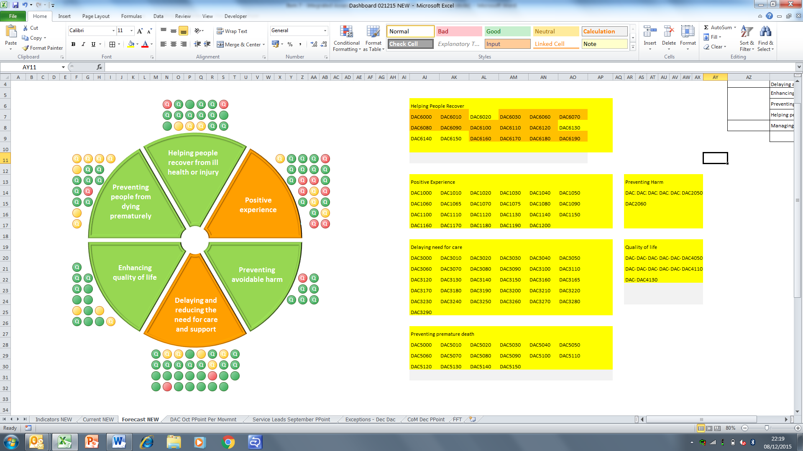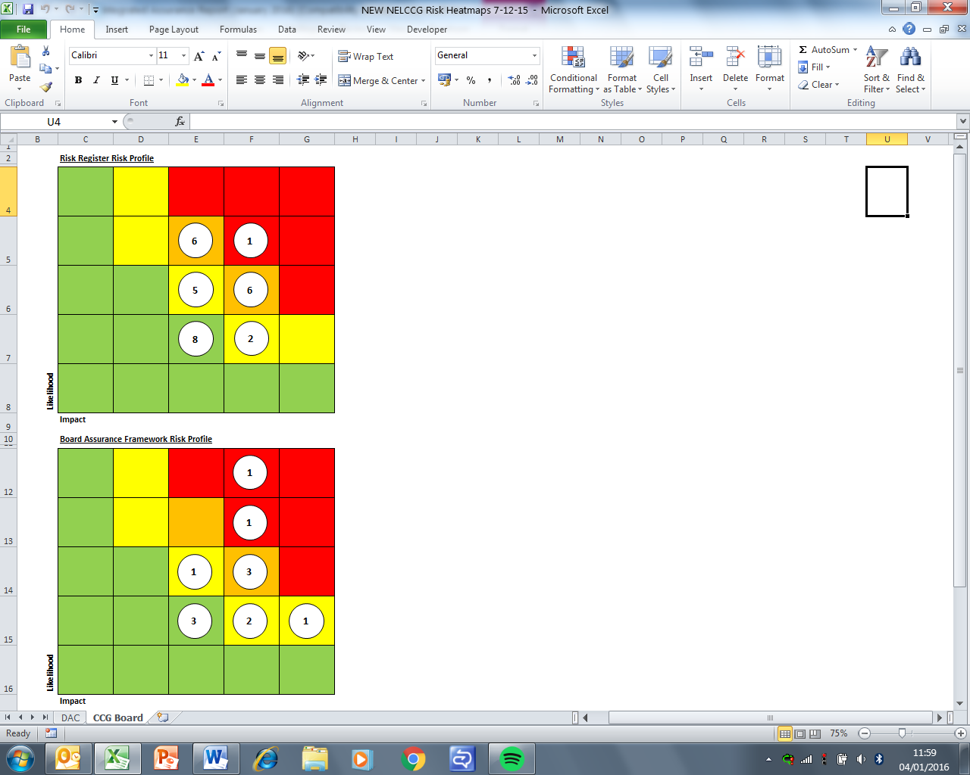

Please note the letter Q indicates a quality measure. These indicators focus on safety, experience and effectiveness and are present in the NHS England Quality Dashboard and the Quality domain of the CCG Assurance Framework.
Escalation

Performance Highlight

Adult Social Care Local Account
The local account was introduced by the Government and is a document about social care in North East Lincolnshire.
It provides an opportunity to tell local people about how services are performing, what has been spent and how the organisation is delivering value for money, and whether future plans make sense to the public.

NELCCG’s 2014/15 Local Account was recently subject to a supportive assessment by the Yorkshire and Humber regional customer group and the Yorkshire and Humber regional standards and performance network.

The general feedback received was extremely positive and some of these comments included;

- Listened to peoples comments and responded to them
- Well presented with a good explanation overall
- Fantastic use of pictures throughout
- Like the use of the pound on age 22/23 to demonstrate where and how the money was spent
- Good use of customer case studies throughout
- Easy to read and understand and there is an explanation of any words in the appendices
- Excellent use of feedback from the last local account supportive assessment
- Demonstrates openness and transparency in performance throughout
- Clearly shows the types of services on offer for the citizens of North East Lincolnshire and the pathway to access to services.
- The document is clearly focused on the delivery of integrated services and joint commissioning for better outcomes.
- It is evident that a range of stakeholders have been involved in the development of the local account.

There were some suggestions on what can be done to improve NELCCG’s local account and these will be factored into the final published document and also in future publications. The suggestions for improvement are;

- It is a really long document. Not sure if it could be condensed somehow.
- The future challenges and priorities are scattered throughout the document, it would maybe benefit from seeing these in one place along with an improvement plan or direction of travel.
- The quality of services in NEL is not clear and how CQC rate services.
- Whilst a good section on how the money is spent it doesn’t provide a view on the future pressures that may be placed on the budget.
- It not clear on the external view of services provided by NEL or whether there has been any external challenge.

Mental Health performance
The table below shows a list of the Mental Health measures contained within the Integrated Assurance Dashboard that are currently failing to achieve the aspirations set. These measures are monitored and managed by regular contract meetings and as such the CCG will be seeking assurances on these measures from the provider and any subsequent feedback or actions taken will be brought back to the next Delivery Assurance Committee meeting.

Code | Indicator | 2015/16 year to date
Code | Indicator | Period | Target | Value | Status
DAC4050 | Proportion of adults in contact with secondary mental health services living independently, with or without support | September 2015 | 78.00% | 66.59% | 
DAC4060 | Proportion of adults in contact with secondary mental health services in paid employment | September 2015 | 9.00% | 6.90%
DAC4090 | % people who have depression and/or anxiety disorders who receive psychological therapies | Q2 2015/16 | 7.5% | 7.44% | 
DAC6120 | IAPT recovery rate | Q2 2015/16 | 50% | 40.27%
DAC6140 | IAPT - Average number of treatment sessions | Q2 2015/16 | 6.3 | 4.33
DAC6150 | Readmissions to mental health services within 30 days of discharge | Q1 2015/16 | 100.0 | 170.3

Appendix A - Performance Exception Summary
Code | Indicator | Quality Measure? | Latest period |  |  |  | 2015/16 year to date |  |  | Year End Forecast
Code | Indicator | Quality Measure? | Period | Target | Value | Status | Target | Value | Status | Year End Forecast
Positive experience
DAC1000 | Total time in A&E: four hours or less | Yes | October 2015 | 95% | 93.6% |  | 95% | 94.8%
DAC1040 | Numbers of unjustified mixed sex accommodation breaches | Yes | October 2015 | 0 | 0 |  | 0 | 4
DAC1080 | Friends & Family - AAE % Who would recommend service | Yes | September 2015 | 87.85% | 87.25% |  | 88.1% | 84.71%
DAC1090 | Friends & Family - AAE Response (NLAG) | Yes | September 2015 | 14.12% | 13.08% |  | 14.81% | 13.1%
DAC1110 | Friends & Family - Inpatient Response (NLAG) | Yes | September 2015 | 25.14% | 22.6% |  | 27.03% | 20.26%
DAC1120 | Friends & Family - Outpatient - % Who would recommend service | Yes | September 2015 | 92.26% | 88.59% |  | 92.2% | 89.12%
DAC1130 | Friends & Family - Outpatient Response | Yes | September 2015 | 6.7% | 0.57% |  | 5.86% | 0.71%
DAC1150 | Friends & Family - Community Response (CPG) | Yes | September 2015 | 3.34% | 4.85% |  | 3.55% | 1.68%
DAC1180 | Friends & Family - Maternity - Combined % Who would recommend | Yes | September 2015 | 95.15% | 90.13% |  | 95.64% | 91.27%
DAC1190 | Friends & Family - Maternity Response (NLAG) Birth | Yes | September 2015 | 22.66% | 12.68% |  | 22.79% | 10.51%
DAC1200 | Friends and family test - Employee score | Yes | Q2 2015/16 | 78.96% | 49.65% |  | 77.89% | 50%
Preventing avoidable harm
DAC2000 | MRSA Blood Stream Infections | Yes | November 2015 | 0 | 0 |  | 0 | 2
Delaying and reducing the need for care and support
DAC3010 | Adult and older clients receiving a review as a percentage of those receiving a service. | Yes | November 2015 | 66.56% | 54.85% |  | 66.56% | 54.85%
DAC3020 | Outcome of short-term services: sequel to service | Yes | March 2015 | 68.06% | 67.71% |  | No data available for 2015-16
DAC3040 | Permanent admissions 65+ to residential and nursing care homes, per 100,000 population | No | November 2015 | 394.4 | 478.83 |  | 394.4 | 478.83
DAC3060 | Delayed transfers of care from hospital which are attributable to adult social care per 100,000 population | Yes | September 2015 | 1.6 | 0.8 |  | 1.6 | 1.59
DAC3130 | The proportion of older people aged 65 and over offered reablement services following discharge from hospital. | No | March 2015 | 1.35% | 1.21% |  | No data available for 2015-16
DAC3200 | Non-Elective Activity (General & Acute) | No | October 2015 | 1695 | 1376 |  | 11253 | 9261
DAC3240 | A&E Attendances (NEL Patients) | No | September 2015 | 4711 | 4713 |  | 22185 | 28474
Enhancing quality of life
DAC4070 | Proportion of adults with learning disabilities in paid employment | No | November 2015 | 5% | 3.57% |  | 5% | 3.57%
DAC4090 | % people who have depression and/or anxiety disorders who receive psychological therapies | No | Q2 2015/16 | 3.75% | 2.45% |  | 7.5% | 5.97%
DAC4130 | End of life care – Percentage of all deaths that occur at home (including care homes) | Yes | Q1 2015/16 | 52% | 48.26% |  | 52% | 48.26%
Preventing people from dying prematurely
DAC5000 | Category A (RED1) calls meeting eight minute standard (EMAS) | Yes | November 2015 | 75.00% | 65.61% |  | 75.00% | 71.92%
DAC5010 | Category A (RED2) calls meeting eight minute standard (EMAS) | Yes | November 2015 | 75.00% | 56.88% |  | 75.00% | 67.39%
DAC5020 | Category A calls meeting 19 minute standard (EMAS) | Yes | November 2015 | 95% | 85.34% |  | 95% | 90.46%
DAC5030 | Category A calls meeting 19 minute standard (NELCCG) | Yes | November 2015 | 95% | 90.6% |  | 95% | 92.36%
DAC5040 | Ambulance 30 minute average turnaround time target - DPOW | No | November 2015 | 30 mins | 35.06 mins |  | 30 mins | 33.59 mins
DAC5110 | Cancer 62 Days Referral to Treatment (GP Referral) | Yes | October 2015 | 85% | 78.79% |  | 85% | 80.71%
DAC5140 | The rate of people admitted with a primary diagnosis of hip fracture per 100,000 CCG population | No | March 2015 | 436.4 | 508.3 |  | No data available for 2015-16
DAC5150 | Summary Hospital Mortality Index (SHMI) - NLAG | Yes | March 2015 | 100 | 110.99 |  | No data available for 2015-16
Helping people recover from ill health or injury
DAC6000 | Total Emergency admissions for acute conditions that should not usually require hospital admission | Yes | October 2015 | 169 | 211 |  | 1151 | 1408
DAC6070 | RTT - Number waiting on an incomplete pathway over 52 wks | Yes | October 2015 | 0 | 0 |  | 0 | 1
DAC6150 | Readmissions to mental health services within 30 days of discharge | No | Q4 2014/15 | 100.0 | 154.2 |  | No data available
DAC6160 | Winterbourne - Numbers of admissions to in-patient beds for mental and/or behavioural healthcare who have either learning disabilities and/or autistic spectrum disorder (including Asperger’s syndrome). | Yes | November 2015 | 0 | 1 |  | 0 | 1
DAC6170 | Winterbourne - Total number of patients in in-patient beds for mental and/or behavioural healthcare who have either learning disabilities and/or autistic spectrum disorder (including Asperger’s syndrome) | Yes | November 2015 | 0 | 1 |  | 0 | 1
Appendix B - Risk Exception Summary

The table below reflects risks rated as 15+ (high to significant) on the risk register as at 27 November 2015
No. | Risk | Current risk rating | Risk Lead | Internal Controls | Latest update
1 | CCG2002  On-going failure to meet Clinical Handover time targets for EMAS patient delivery at DPoW A&E | 16 | Andy Ombler | Moving from monitoring only to action planning  Performance is monitored by the Urgent Care Board. | Andy Ombler - risk reviewed and updated 16 October 2015 as follows:  Performance for September improved from August and on average remains better than the overall contract average. The key measures to support handover improvement remain as described in the August update and these remain in progress for deployment with progress being reported through the NEL SRG  August update:  Handover performance remains around 3 minutes above the target at DPoW though slightly below the average all hospitals in the EMAS contract.  The planned new arrival screen initiative remains scheduled for October. This will change the way all handover timings are recorded with a dual “sign-off” process required at each stage and will enable handover performance discussions to be based on an agreed methodology.

The table below reflects risks rated as 15+ (high to significant) on the assurance framework as at 27 November 2015

No. | Risk | Current risk rating | Risk Lead | Internal Controls | Latest Update
1 | CCGAF3003  Risk that Healthy Lives, Healthy Futures will not deliver the quality and financial sustainability outcomes in the requisite timeframe | 16 | Lisa Hilder | Further work on reviewing and refreshing the financial gap has been commissioned by the Programme Board to be delivered by PWC (13 October 2014).  HLHF Programme Board  Governance framework provided by HLHF programme board, engagement core group and assurance sub group in place.  The HLHF Programme Board reviews progress monthly towards financial and clinical sustainability goals for Northern Lincolnshire. The Programme Board reviews the programme risk log on a monthly basis and has also established an assurance sub group to identify key areas of concern and recommend remedial action. With regards to financial sustainability the Executive group of the Programme board meets weekly virtually and receives ongoing reports and assurance on the updated financial position. | Lisa Hilder - risk reviewed and updated 8 October 2015 and no changes noted since the last update as at 17 August 2015:  Clinical workshops have identified key workstreams:  Planned care  Unplanned care  Women and children  Long term conditions  These are being grouped into in hospital and out of hospital care, with initial focus on out of hospital care. The programme Board have received an outline strategy for service redesign which is currently being refined. Further communications and engagement where relevant to support outline changes will take place during the latter part of 2015/16
2 | CCGAF3002  Risk CCG could face financial challenges & therefore does not achieve statutory financial obligations. Particular issue due to NELC (social care) funding pressures, local NHS community financial challenges, & acute provider deficit | 20 | Cathy Kennedy | Within the CCG the Integrated Governance and Audit Committee assures management of financial risk  Regular meetings for Executive Directors for CCG/LA to monitor position.  HLHF programme arrangements include Memorandum of Understanding including a collective risk management approach | Cathy Kennedy - risk reviewed and updated 7 October 2015 and no changes noted

