
Agenda Item 07

Report to (Board/Sub-Committee): NEL CCG Partnership Board

Date of Meeting: 14th July 2016

Subject: Integrated Assurance and Quality Report

Presented by: Cathy Kennedy, Deputy Chief Executive/Jan Haxby Director of Quality & Nursing

STATUS OF THE REPORT

For Information
For Discussion 
For Approval / Ratification

PURPOSE OF REPORT: | The report advises the Partnership Board of how NELCCG are performing against;  - six domains developed for the performance dashboard;  - three domains developed for quality dashboard and;  - six domains for risk.  The dashboards are managed via the Delivery Assurance Committee, the Quality Committee and the Integrated Governance and Audit Committee.  A summary of risks with a score of 16 or above is also included.  For more detail on performance and risk the latest integrated assurance report presented to the Delivery Assurance Committee can be found via the embedded file in the ‘Appendices / attachments’ section of this cover sheet.
Recommendations: | The Partnership Board is asked:  - to note judgements made against the domains of the dashboards  - to note the information on future performance, quality and risk challenges  - to note information on assessment rating of CCG Assurance Framework  - for further feedback on ways to improve the report
Sub Committee Process and Assurance: | The Delivery Assurance Committee, the Quality Committee and the Integrated Governance and Audit Committee manage and assure the performance, quality and risks contained within these dashboards.
Implications:
Risk Assurance Framework Implications: | The dashboards and risks associated with them are managed via the Delivery Assurance Committee, the Quality Committee and the Integrated Governance and Audit Committee.
Legal Implications: | None
Equality Impact Assessment implications: | An Equality Impact Assessment is not required for this report.
Finance Implications: | There are a number of measures within the Performance Dashboard with a financial implication such as activity and Quality Premium measures, however the detail of these are dealt with separately within the Finance Report.
Quality Implications: | Quality implications are managed by the quality committee and escalated within the main body of this report.
Procurement Decisions/Implications (Care Contracting Committee): | None
Engagement Implications: | None
Conflicts of Interest | None
Strategic Objectives  Short summary as to how the report links to the CCG’s strategic objectives | - Sustainable Services  The performance, quality and risk dashboards contain a number of national and local measures that support this objective.
- Empowering People

The performance, quality and risk dashboards contain a number of national and local measures that support this objective.
- Supporting Communities

The performance, quality and risk dashboards contain a number of national and local measures that support this objective.
- Delivering a fit for purpose organisation

The performance, quality and risk dashboards contain a number of national and local measures that support this objective.
NHS Constitution: | The Performance and Quality dashboards contain measures from the NHS Constitution and the performance and risks associated with these are managed and assured through the Delivery Assurance Committee, the Quality Committee and the Integrated Governance and Audit Committee.
Report exempt from Public Disclosure | No

Appendices / attachments | 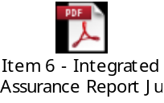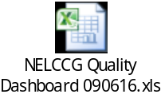

Integrated Assurance & Quality Report

Introduction
The dashboards below represent an overview of performance and quality for health and social care services across North East Lincolnshire.

The performance dashboard consists of six domains and the quality dashboard three domains that incorporate all areas that North East Lincolnshire Clinical Commissioning Group strive to improve on. A judgement has been made of the status for each domain based on the measures and intelligence underpinning them. These judgements try to balance the current position with the expected outcome at the end of the year and weightings with respect to priority. They also represent the local perspective of performance and quality for North East Lincolnshire rather than the performance against the national definition which, on occasion, covers a broader footprint. It should be noted that those issues that have an impact on the CCGs corporate performance assessment will continue to be scrutinised at the Delivery Assurance Committee. The dashboards reflect performance for the first two months of 2016-17. The Delivery Assurance Committee and Quality Committee, respectively, are asked to make a decision on the final status of the dashboards before reporting to the CCG Partnership Board. Full exception report summaries are also included for Performance (appendix A) detailing performance of indicators that are underperforming and risk (appendix B) detailing risks rated as 16 or higher.
Performance Quality
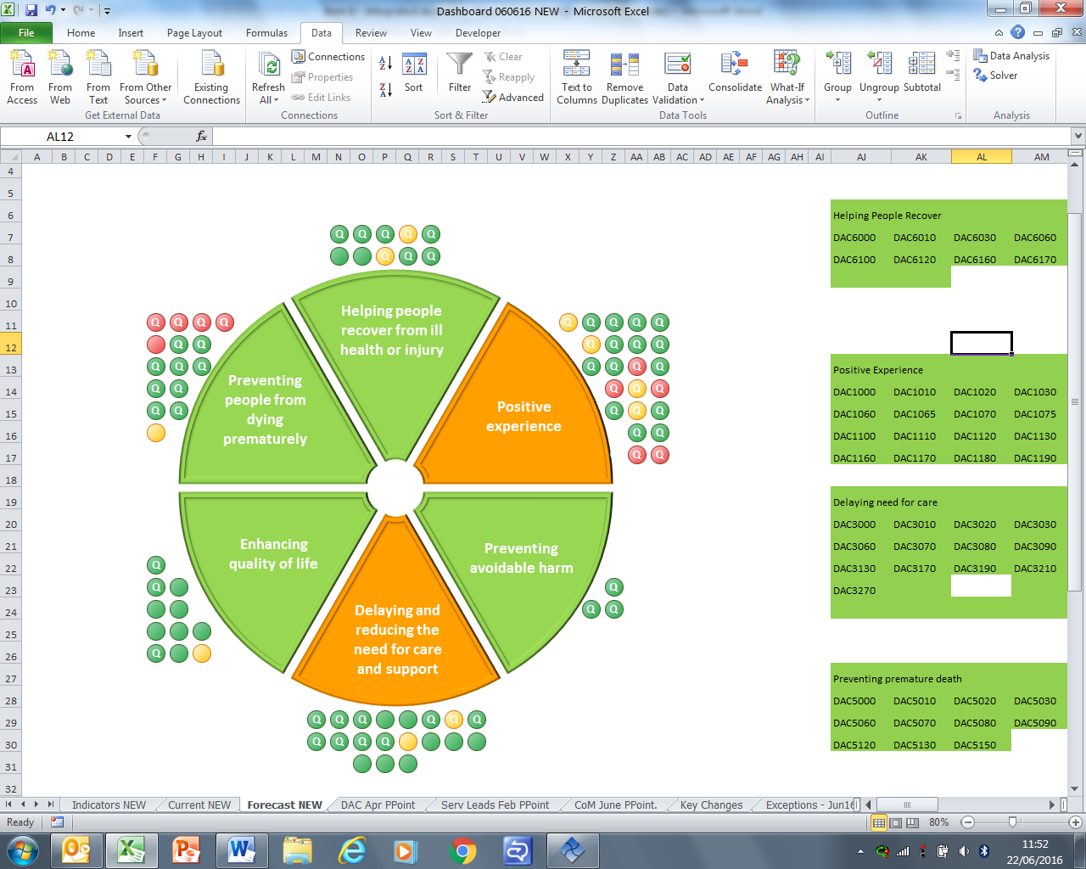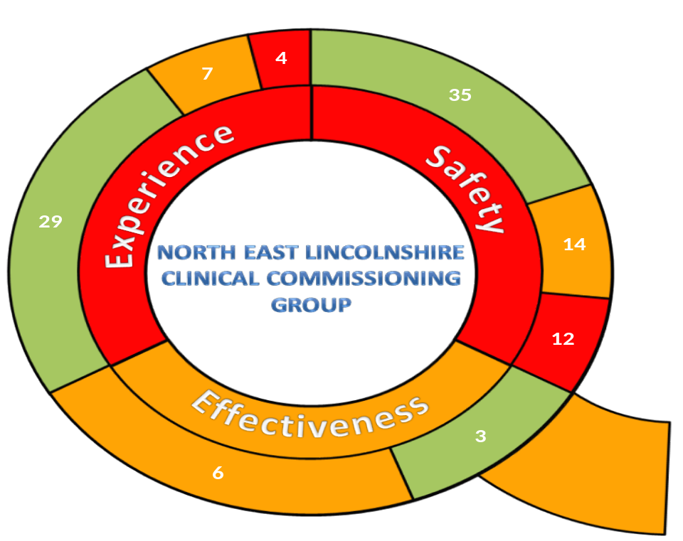
Please note the letter Q indicates a quality measure within the performance dashboard.

The risk heat maps are separated in to a CCG risk register and the CCGs Board Assurance Framework risks. These heat maps demonstrate the number of risks with a specific risk score. The risk summaries reflect the risk status as at 15th June 2016.

Risk Register risk profile Board Assurance Framework risk profile
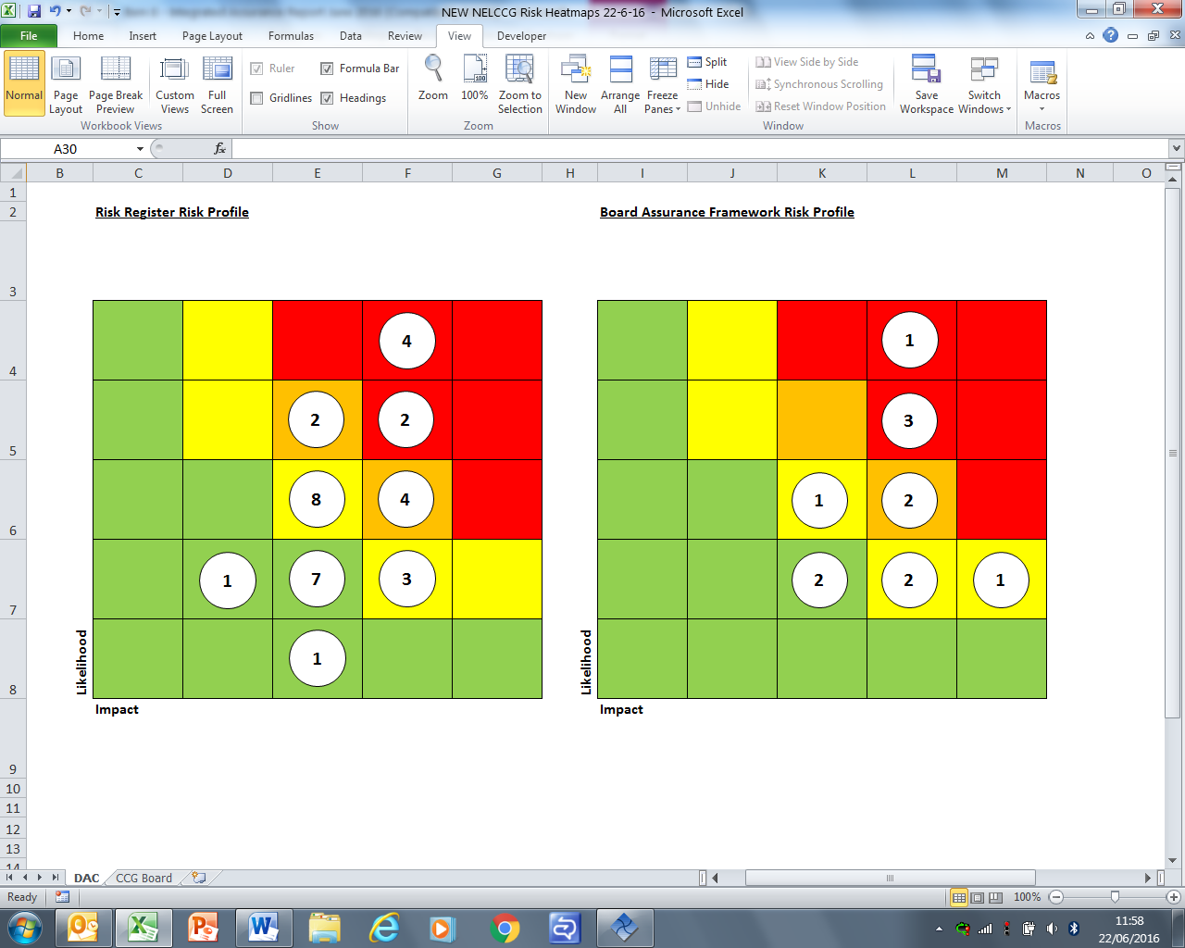

Escalation

CCG Assurance Framework assessment rating

North East Lincolnshire CCG (NELCCG) was subject to its annual review of the CCG Assurance Framework by NHS England in April 2016.

Following this review in June 2016 we received our indicative assurance ratings from NHS England for 2015/16 and these are as follows;

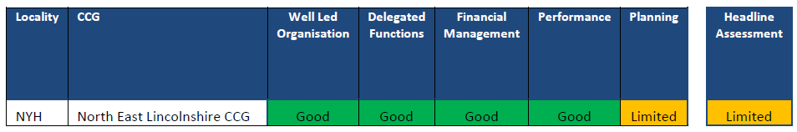

The above gives NELCCG an overall assurance rating for 2015/16 as ‘Limited’, though this is still subject to national confirmation.

At the annual review NHS England noted some of NELCCG’s achievements and accomplishments over the past year. In particular;

- progression of the partnership agreement with the Local Authority
- the model for Joint Strategic Commissioning outcomes for North East Lincolnshire
- Accountable Care Organisation and Strategic Commissioner development
- change in management of financial plans
- improved transparency and
- foundations NELCCG have established for cultural and transformational change.

NELCCG’s performance and quality was also discussed and NHS England noted how we are aiming to address the constitutional standards for IAPT, EIP, and dementia and also the progress made for Children and Young People. It was also set out how we are addressing the quality and safety concerns at North Lincolnshire and Goole Hospitals.

NELCCG received an indicative assurance rating of ‘limited’ in terms of planning. This domain has a number of elements to it, only one of which was found to be less than ‘good’. This rating was therefore solely due to our progress on the Healthy Lives Healthy Futures Programme, and the fact that full solutions to the financial and service challenges had yet to be identified. However it should be noted that this was our position in April 2016 and since then progress has been made to address this, with the agreement of new system arrangements and Accountable Care approaches.

It should be noted as a positive that NELCCG received an indicative assurance rating of ‘Good’ across 4 of the 5 domains, however the headline assessment shows as ‘limited’. NELCCG understands that the majority of other CCG’s will have the same ‘Headline Assessment’ assurance rating as ourselves.
Quality Escalation

The 3 sections below headed as safety, Effectiveness and Experience, escalates and highlights key issues to be noted within the attached Quality Dashboard (Excel document attached on page 2), or concerns from the Quality Committee and Quality Team at the CCG.

Safety

The majority of Safety Indicators rated as Red, contributing to create the overall Red status of the Quality Domain (as seen on Page 3), are within the following Providers; NL&G and EMAS.

Key points to note include:-

- EMAS received a CQC Safety rating of Inadequate (CQC, 2016). CQC have taken enforcement action (Section 29 Warning Notice) in light of the concerns regarding; safe staffing levels; sickness rates; response times and clinical handover delays.
- EMAS not meeting Call Response performance targets. EMAS reports that they will not achieve National Performance Standards during 2016/17. NL&G – Themes and trends identified through analysis of intelligence received through the NELCCG Incident Application, PALS/ASKUS and the portal has identified significant concern regarding discharge from NL&G services.
- NL&G – Themes and trends in Serious Incidents (SI) – there has been a trend of four Maternity SI reports not achieving assurance following review. Lack of assurance due to both clinical and SI process challenges/concerns.
- NL&G – SHMI, The Trust’s current official SHMI position is reducing (Oct 14 - Sep 15) is 107.6, the HED SHMI (Dec 14 - Nov 15) using provisional data is 106.9. The out of hospital HED SHMI in North East Lincolnshire is gradually increasing.
- NLG CQC concerns - overall rating is ‘Requires Improvement’. Key points are as follows:
- middle grade staffing in ED across both sites
- weekend staffing cover
- process for cancelling Ophthalmology appointments
- application of leadership and governance arrangements consistently applied across all sites
- implementation of learning from SI’s
- provision of LD training
- NAViGO – received requires improvement rating for the Safety Domain (CQC, 2016), notice for improvement in Sharps Safety. All other domains were rated Good.
- St Hughs CQC Action Plan is progressing positively with CCG support.

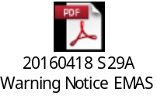

Action being taken in respect of the key points above:-

Points 1 & 2 are inter-related, interconnected and inter-dependent. A Jointly Commissioned Independent Strategic Demand and Capacity Review has been established with Commissioners and EMAS committing to the implementation of the outcome of the review which will be implemented on a phased basis over three years commencing 2016/17 through to 2018/19. There are a number of objectives for the review which include the delivery of a clinically and financially safe and sustainable service. The review will align with local Sustainability and Transformation Plans whilst also recognising and being adapted to the changing urgent and emergency care network.

Commissioners have agreed a regional performance trajectory which reflects an improvement on 2015/16 figures. A Performance trajectory for each County has been drafted and will be monitored via the EMAS County Commissioning Meeting once received.
Performance regarding clinical handover is improving and any breaches will be charged to EMAS following validation of the data.

Point 3, a deep dive into intelligence regarding the Maternity Services at NL&G is under way. A ‘Maternity Focus’ Meeting has been undertaken with Commissioners, Service Leads, Performance, Public Health and the Quality Team to share intelligence regarding this service, share concerns and determine action. A similar deep dive approach is being taken to explore issues in respect of patient discharges and we are currently at the stage of gathering data and soft intelligence which will generate further investigation. In both cases we will compile a report of issues and actions taken which will be shared with commissioners and the service providers. The report will be escalated to the SI group and the Quality Committee for a decision about further action and/or escalation. The process of deep dives to clarify, address and escalate concerns will be documented to ensure the process is clear.

The Quality Committee, at its June meeting, discussed risk and the way risk is managed within the CCG and felt that the process for reporting and managing risk, particularly low-level risk should be clearer. The work described above will address this.

Point 4, HED SHMI: We are working closely with NLG to understand why the out-of-hospital SHMI is rising and the significance of this increase. We have been able to attribute an increase in HED SHMI with a change in local protocol of the Haven (palliative/end of life) team when they started working directly at hospital ward level prioritising getting patients discharged within 24/48 hrs notification. This correlates with a sharp increase in HED SHMI from October to December 2015. In addition there has been work undertaken to better understand the coding of patients which determines if patients are included in HED SHMI.

Point 5, With regards to NLG CQC concerns: The Trust is in the final stages of developing the CQC action plan; the plan has been devised in conjunction with Commissioners and will focus on implementing the actions agreed at the NL&G Quality Summit. Members of the NL&G Executive Contract Board (ECB) have agreed that the CQC action plan will be monitored by Commissioners at the NL&G ECB; the action plan will then be submitted to NL&G Quality Contract Review (QCR) for information and review.

Point 7, With regards to St Hughs: CQC highlighted their concerns regarding the processes for managing patient safety, specifically the lack of robust systems and processes in place to manage incidents (including serious incidents). Staff at St Hugh’s hospital have actively engaged with commissioners to progress the CQC action plan, the plan is monitored via the contract management process.

The Board is asked to note a delay in the process of managing an SI attempted homicide on May 19th 2016. The delay is because NHS England have their own 72hr report for attempted/ homicide which NAViGO has completed and returned. However NHS England are not able to make a decision around who would lead on this investigation (NHSE or NAViGO) as the SI has to be discussed by the IIP (independent investigation panel who makes the decision regarding homicide SIs) and who do not next meet until 11 July. The CCG have concerns that the IIP will have had the NHS England Homicide 72hr report from NAViGO for some 5 weeks before a decision can be made as to whether an independent team will take over the investigation or NAViGO can carry on with it. We are escalating our concerns re the delay within NHSE.

Effectiveness
The CCG needs to do further work to identify measures of quality effectiveness and actions required by the CCG. These will be reflected in the Quality Dashboard. This work will make improvements to our systems and processes for ensuring that the whole commissioning process is supported by clinically effective information and evidence based monitoring.

Key points to note include:-
- Compliance with NICE guidance: where data is available – NLG and HEY – providers achieved Amber and is considered to be an acceptable level of compliance.

- Friends and family test: there is poor uptake of the FFT across with regards to patients and staff experience from NLG, HEY and EMAS.
- Number of complaints: data in respect of complaints suggests that all providers are good.
- With regards to CQC ratings re Effectiveness: NLG, EMAS and St Hughs requires improvement and HEY Inadequate. Navigo and CPG were rated Good.

Actions being taken:
Point 4, with regards to CQC overall compliance position at HEY. The Trust has devised a new Quality Improvement Plan for 16/17; the new plan incorporates a number of projects that have been revised and updated to consolidate the improvement work from 2015/16 and include new objectives. This is closely monitored by commissioners and providers at contract meetings. CQC recently completed a mock visit, initial feedback was mixed with some on-going concerns around governance processes. We await the final feedback.

All providers, except for Care Plus Group, currently have an amber rating for effectiveness. We are not confident that we currently have the intelligence to indicate the quality in this area of service. Appendix B of the Quality Dashboard shows that we currently utilise a small number of indicators to reflect the level of quality in this domain –with gaps in the intelligence collected from providers, one of which being compliance with NICE guidance.

A Critical Analysis Report, commended by the Quality Committee, was completed by the CCG Quality team which raised 3 key points for action;
- The CCG should enhance clarity of its process for escalation
- The CCG should review and refine the current intelligence monitoring and gathering system
- The CCG should consider including the 5 identified themes from the report (Monitoring, Incentivising performance, and enhancing safety, effectiveness and experience) in all stages of commissioning.

The Quality Team has already responded to this though actions described on page 7 regarding deep dives and our approach to perceived risk or concerns. This work will continue.

Experience
The CCG needs to do further work to identify measures of quality experience and actions required to support our systems and processes for commissioning, with patient experience and feedback.

Areas of key concern in this domain are clearly seen in Appendix B as with NL&G and HEY, both subject to a red rating in this domain.

Key points to note include:-
- There are three Red rated and three Amber experience quality indicators for NL&G.
- Of which the Staff FFT, only 33% of staff whom completed the survey would recommend the hospital to friends and family, is extremely significant – also there were low response rates for staff FFT (499).
- The ‘Maternity Focus’ deep dive also brought to light that the significant increase in complaints in Women’s and Children’s Services, 2015 Annual Total = 5 and the Year to Date total is already more than double this at 12.
- Intelligence received into NELCCG has also identified a theme and increased trend of reporting of concerns regarding NL&G discharges.
- There is one Red rated and three Amber rated experience quality indicators for HEY.
- The Red rating has been applied due to the CQC (2015) Inadequate rating for responsive.
- The Staff FFT, 56% of staff whom completed the survey would recommend the hospital to friends and family.

Action being taken:-
Points 1 & 2 in respect of FFT results are monitored through the quality contract monitoring processes with both NLG and HEY. Both Trusts have additional ways of receiving feedback from patients.
The CCG is ensuring it pulls together feedback received about patient experience through the PALS or Complaints route or through the CCG Portal as part of its deep dive exercises.

However we consider there is more work to do to improve uptake of FFT across all providers and to make clear what actions are taken by providers in response to FFT and other mechanisms for obtaining patient experience and feedback.

Key point to note
Members are asked to note that the quality indicators in the CCG’s quality dashboard has been revised, this is to ensure that the CCG remains in line with national and local best practice (including statutory and mandatory requirements) and this also reflects the new NELCCG quality model. As a result of this update, some of the CCG’s providers do not currently report/publish this data; this is reflected as ‘data currently unavailable’ in the report. The Quality Team is working with each provider to ensure that this data is provided going forward; this is being managed via the contract management process.

Members are also asked to note that the RAG grading process has been revised, see figure 1 below. The RAG rating is based on a national definition that the CCG is seeking to adopt and which forms part of the new NELCCG Quality Strategy.

Figure 1:
RAG Grading Key
Red | - There are significant issues with the delivery and/or outcome of this service, and/or;  - These issues require a multi-disciplinary approach to improve the outcome indicator, and/or;  - Corrective action is required in order to meet the required outcome of this quality indicator
Amber | - Quality indicators display an area/areas of concern at Provider level but are being actioned through the Provider’s internal processes, and/or;  - Action is being/has been taken to resolve the problem, or a decision made by the CCG to monitor the situation via appropriate routes, and/or;  - The Provider’s quality indicators display deviation from the CCG’s quality tolerances; however, at Provider level, tolerances fall within accepted limits.
Green | - All quality indicators fall within the agreed tolerances

Appendix A - Performance Exception Summary
Code | Indicator | Quality Measure? | Latest period |  |  |  | 2016/17 year to date |  |  | Year End Forecast
Code | Indicator | Quality Measure? | Period | Target | Value | Status | Target | Value | Status | Year End Forecast
Positive experience
DAC1000 | Total time in A&E: four hours or less | Yes | May 2016 | 95% | 93.2% |  | 95% | 91.63%
DAC1020 | Cancelled Operations offered binding date within 28 days | Yes | Q4 2015/16 | 0% | 2.25% |  | No data available for 2016-17
DAC1050 | The number of carers whose needs were assessed or reviewed by the council in a year who received a specific carer's service, or advice and information in the same year as a percentage of people receiving a community based service in the year. | Yes | May 2016 | 10% | 8.88% |  | 10% | 8.88%
DAC1090 | Friends & Family - AAE Response (NLAG) | Yes | April 2016 | 12.88% | 8.94% |  | 12.88% | 8.94%
DAC1110 | Friends & Family - Inpatient Response (NLAG) | Yes | April 2016 | 25.35% | 19.28% |  | 25.35% | 19.28%
DAC1120 | Friends & Family - Outpatient - % Who would recommend service | Yes | April 2016 | 92.75% | 72.34% |  | 92.75% | 72.34%
DAC1130 | Friends & Family - Outpatient Response | Yes | April 2016 | 6.37% | 0.15% |  | 6.37% | 0.15%
DAC1150 | Friends & Family - Community Response (CPG) | Yes | April 2016 | 3.7% | 0.53% |  | 3.7% | 0.53%
DAC1190 | Friends & Family - Maternity Response (NLAG) Birth | Yes | April 2016 | 23.77% | 19.77% |  | 23.77% | 19.77%
DAC1200 | Friends and family test - Employee score | Yes | Q4 2015/16 | 78.67% | 53.91% |  | No data available for 2016-17
Preventing avoidable harm
No exceptions
Delaying and reducing the need for care and support
DAC3060 | Delayed transfers of care from hospital which are attributable to adult social care per 100,000 population | Yes | April 2016 | 1.96 | 3.19 |  | 2 | 3.19
DAC3130 | The proportion of older people aged 65 and over offered reablement services following discharge from hospital. | No | March 2015 | 1.35% | 1.21% |  | No data available for 2016-17
Enhancing quality of life
DAC4130 | End of life care – Percentage of all deaths that occur at home (including care homes) | Yes | Q2 2015/16 | 52% | 48.39% |  | No data available in 2016-17
Preventing people from dying prematurely
DAC5000 | Category A (RED1) calls meeting eight minute standard (EMAS) | Yes | May 2016 | 75.00% | 67.31% |  | 75.00% | 66.83%
DAC5010 | Category A (RED2) calls meeting eight minute standard (EMAS) | Yes | May 2016 | 75.00% | 59.81% |  | 75.00% | 58.55%
DAC5020 | Category A calls meeting 19 minute standard (EMAS) | Yes | May 2016 | 95% | 87.23% |  | 95% | 86.95%
DAC5030 | Category A calls meeting 19 minute standard (NELCCG) | Yes | May 2016 | 95% | 93.87% |  | 95% | 91.51%
DAC5040 | Ambulance 30 minute average turnaround time target - DPOW | No | May 2016 | 30 mins | 32.03 mins |  | 30 mins | 34.57 mins
DAC5150 | Summary Hospital Mortality Index (SHMI) - NLAG | Yes | September 2015 | 100 | 107.6 |  | No data available in 2016-17
Helping people recover from ill health or injury
DAC6060 | RTT - Incomplete Patients: % Seen Within 18 Weeks | Yes | May 2016 | 92% | 87.82% |  | 92% | 87.82%

Appendix B – Provider-level Quality Dashboards
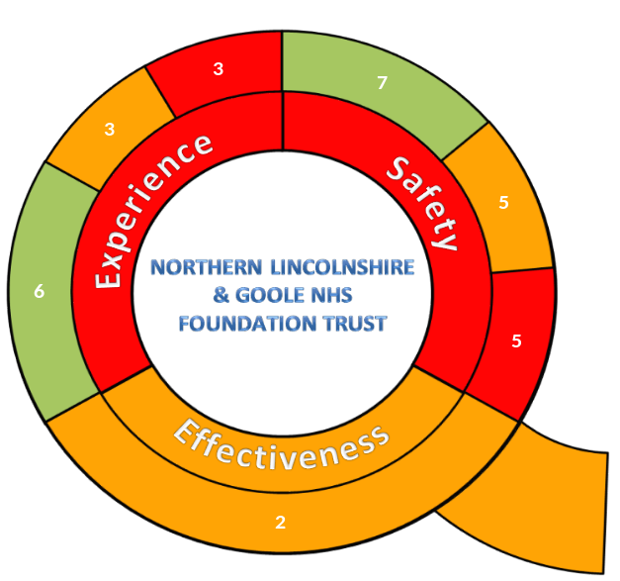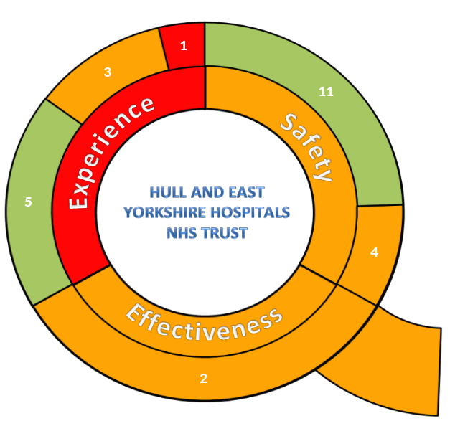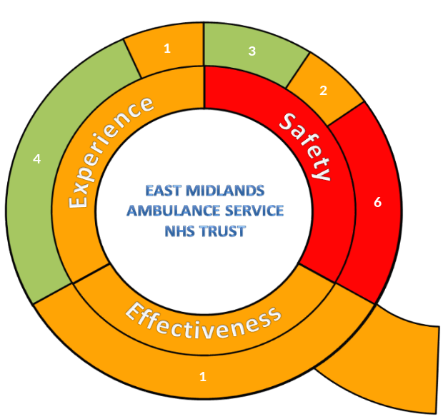
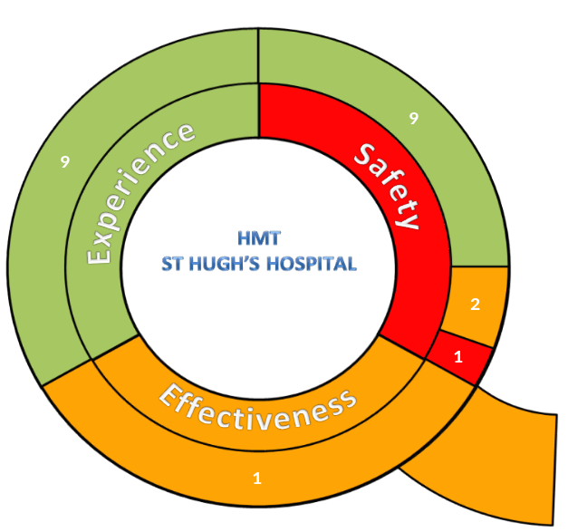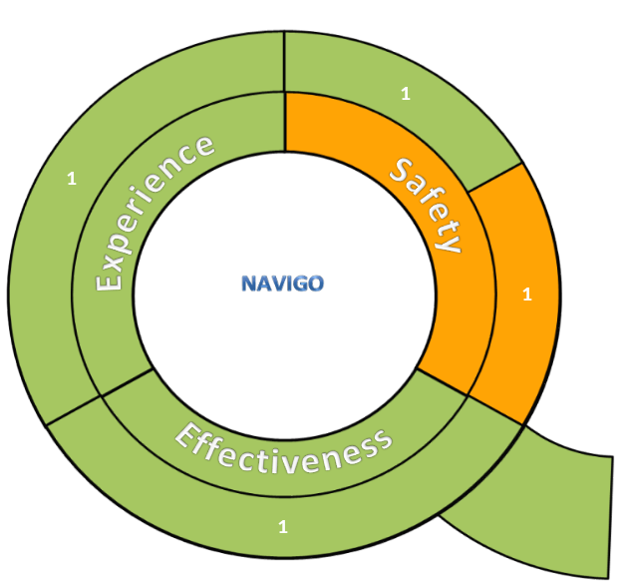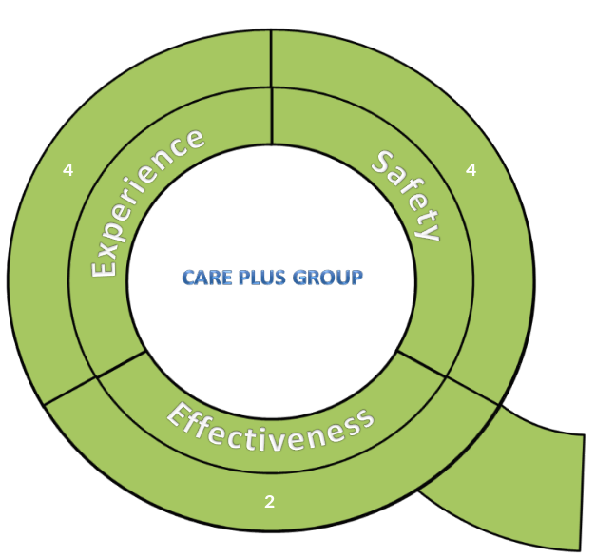

Appendix C – Risk Exception Summary

The table below reflects risks rated as 15+ (high to significant) on the risk register as at 15 June 2016

Code & Title | Assigned To | Internal Controls | Current Residual Risk Rating | Latest Note
CCG2001 Failure to achieve Accident and Emergency 4 hour targets | Andy Ombler | Commissioning weekly monitoring of performance. The System Resilience Group, with Commissioner & Provider membership, has a primary purpose in the monitoring and resilience of the A&E 4 hour performance. Action Plans focussing on all issues with potential impact on 4 hour A&E wait performance. | 20 | Andy Ombler reviewed the risk and updated on 13/05/2016:  A&E performance has still not stabilised at the required level. The end of Q4 and the start of Q1 remain characterised by variable performance under the continuing bed capacity pressures that have characterised the system since end of December.  Performance has not improved in line with expectations of seasonal patterns and an NLaG action plan for improvement has been forwarded and will be considered at the May SRG.  Ratings remain the same.
CCG2002 On-going failure to meet Clinical Handover time targets for EMAS patient delivery at DPoW A&E | Andy Ombler | Moving from monitoring only to action planning  Performance is monitored by the System Resilience Group. | 20 | Andy Ombler reviewed and updated the risk on 13/05/2016  In line with degraded A&E performance, handover performance remains under target. The new “arrival screens” impact has not yet delivered improvement though there should now be agreement on timing data principles and the underlying flow pressures are assumed to be on a larger scale to than timing recording issues. As with A&E performance, an NLaG action plan for improvement has been produced and will be considered at the May SRG. Ratings remain the same
CCG2009 NELCCG Response to the Francis report & recommendations made by East Coast Audit Consortium - Report Reference 140708 (June 2014) | Lydia  Golby | The Francis Report is an active and open project with the Quality Team. The project reports into the Quality Committee where it is monitored and challenged accordingly.  The actions needed to implement the recommendations are open and in progress and are being monitored and challenged by the Quality Committee. | 20 | Lydia Golby - new risk identified:-  Review of the 290 recommendations in the Francis Report. A gap analysis against the 89 identified as pertinent to the CCG has been undertaken. Level of compliancy has been assessed and those which are noncompliant/partial compliant have been given a risk sore to aid the prioritisation of action against the recommendations. A Gap analysis against the Audit Consortium Recommendations has been undertaken and compliancy has been ascertained – a risk score has been applied to all non-compliant/partial compliant recommendations to aid prioritisation. The next steps are to review the high risk recommendations, identify a lead and the action needed to rectify the non-compliancy and implement the action.

CCG4006 The new Safeguarding Adults arrangements are unable to cope with the increasing number of referrals | Bruce Bradshaw | Safeguarding Adults Operational Group, Safeguarding Adults Leadership Group and via formal contract monitoring arrangements between NELCCG and focus.  The risks are monitored as part of the strategic plan and reviewed on a regular basis by the Chair and Deputy Chair of the Safeguarding Adults Board | 20 | Bruce Bradshaw reviewed this risk on 11 May as follows:  Additional funding has been agreed to recruit further staff to the Safeguarding DoLS team. Secured with full year effect this will allow for slippage to continue to fund out of hours assessments whist new staff are recruited/trained.  There continues to be pressure on none Focus BIA’s time from their employing organisation. This compromises the support of none Focus BIAs to the duty Rota. A separate piece of work needs to be explored to look at why other organisations can be supported to deliver elements of the duty rota system
CG3005 Failure to meet residential and domiciliary care admission targets | Joe Warner | Activity is monitored by the Delivery and Assurance Committee.  Expenditure scrutiny and control through the risk and quality panel  Internal controls within focus CIC are key however to creating the right culture and risk management approaches. | 16 | Joe Warner reviewed this risk on 6 May and advised there is no change to this, will need to see how things develop in the first quarter.  Latest update 05/02/2016 as follows:-  The risk rating remains the same, we are continuing with the same measures, which are having some affect but not enough to alter the expected overspend sufficiently.
CCG3008 Adult ADHD Pathway breakdown and | Leigh Holton | Mitigations: multiagency ADHD workgroup generated a new model of service, Shared Care guidance being developed, regular reports to Council of Members (CoM), monitoring through logs of concerns reaching PALS | 16 | Leigh Holton reviewed this risk on 6th May 2016 and advised that the model remains agreed in principle, requires funding to implement, and continues seeking resource. This continues to look unlikely. Providers Open Door and Navigo continue to express concern, no new concerns logged with PALS this month.

The table below reflects risks rated as 15+ (high to significant) on the assurance framework as at 15 June 2016

Code & Title | Assigned To | Internal Controls | Current Residual Risk Rating | Latest Note
CCGAF3002 Financial challenges | Cathy Kennedy | The IG&A committee assures management of financial risk.  Regular Meetings for CCG/LA to monitor position.  HLHF programme arrangements include Memorandum of Understanding including a collective risk management approach | 20 | Cathy Kennedy reviewed this risk on 5 May and advised that no changes are required.
CCGAF2002 Summary Hospital Mortality Indicator (SHMI) Organisational Risk | Jan Haxby | Stakeholder Group oversees delivery primary care & prevention focused plan. A joint Communication Protocol supports both CCG and NLG to communicate when SHMI data or other mortality data/information is published. Progress monitored via the NL&G Contract management Board and NELCCG Quality Committee. Multiagency End of Life strategy with delivery board and subgroups. NLG have a strategic mortality group (MPAC) including attendees from CCG & community care services. | 16 | Jan Haxby updated this risk on 11th May.  The CCG are now working much closer with the NLG Mortality Lead and agreeing a way forward to develop a joint Mortality Strategy during 2016, wich will align our plans to reduce mortality.
CCGAF3001 Instability in partnership finances or services/costs leading to unaffordable consequences for members of system | Cathy Kennedy | NELC flagging their 3 year financial plan has unresolved gap which may require additional savings in ASC to be identified - regular meetings for CCG/LA in place to monitor position.  Efficiency plans established for £9million savings, approved by CCG & NELC in principle. Delivery & risks being monitored jointly at Partnership Operational Group, reported to QiPP monitoring and DAC as and when required. | 16 | Cathy Kennedy reviewed this risk on 5 May and advised that no changes are required..  Risk updated 08/01/2016 as follows:-  Risk description updated - Instability in partnership finances or services/costs leads to unaffordable consequences for the CCG and/or the wider NEL health and care system eg Living Wage impact has not yet got an identified funding source  Risk rating increased to 16
CCGAF4001 Risk HLHF will not deliver the quality & financial sustainability outcomes in the requisite timeframe | Julie  Wilson | PWC provided assistance to programme in assuring plans & identifying remaining gaps. PWC provided (Mar 2015) a modelling tool for planning future service redesign. HLHF Programme Board oversees programme’s activity, including a weekly op group which ensures pace & accountability for programme work. Governance framework provided by HLHF programme board, engagement core group & assurance sub group in place. Programme risk log reviewed monthly. | 16 | Julie Wilson reviewed this risk on 11 May and advised this risk remains. The revised programme arrangements have been agreed by local Accountable Officers and the move towards an Accountable Care approach will occur during 2016/17. Further work on addressing the residual financial gap identified through the HLHF arrangements continues.

