

**Agenda Item 04**

Report to: Governing Body

Date of Meeting: 9 November 2017

Subject: Taking on delegated responsibility for the commissioning of core general

practice services

Presented by: Julie Wilson – Assistant Director of Strategy and Primary Care

Laura Whitton – Interim Chief Finance Officer

**STATUS OF THE REPORT**

For Information √

|  |  |
| --- | --- |
| **PURPOSE OF REPORT:** | This report has been prepared to provide the Governing Body with information relating to application to NHS England by the CCG in respect of taking on fully delegated commissioning of general practice services from April 2018. |
| **Recommendations:** | The Governing Body is asked to note the contents of the report. |
| **Sub Committee Process and Assurance:** | N/A |
| ***Implications:*** |  |
| **Risk Assurance Framework Implications:** | There are a number of risks associated with assuming delegated responsibility for commissioning of general practice core services, as set out within the attached paper. These would be managed through the CCG’s risk management framework, should the CCG be approved by NHS England to take on this responsibility. |
| **Legal Implications:** | N/A |
| **Equality Impact Assessment implications:** | An Equality Impact Analysis / Assessment is not required for this report. |
| **Finance Implications:** | The full budget associated with the NEL core general practice contracts would be transferred to the CCG. The financial risk and benefits associated with the budget transfer are detailed in this paper. |
| **Quality Implications:** | N/A |
| **Procurement Decisions/Implications *(Care Contracting Committee):*** | N/A |

|  |  |
| --- | --- |
| **Engagement Implications:** | N/A |
|  |  |
| **Conflicts of Interest** | The CCG would be required to update the constitution if the application to take on delegated responsibility for commissioning of general practice core services is approved. |
| **Strategic Objectives**  *Short summary as to how the report links to the CCG’s strategic objectives* | 1. *Sustainable Services*   N/A |
| *2. Empowering People*  N/A |
| *3. Supporting Communities*  N/A |
| *4. Delivering a fit for purpose organisation*  Taking on delegated responsibility for general practice core service commissioning would provide the CCG with full ownership of the primary care agenda and support place-based commissioning. |
| **NHS Constitution:** | *Does the report and its recommendations comply with the requirements of the NHS constitution? Yes* |
| **Report exempt from Public Disclosure** | No |

|  |  |
| --- | --- |
| **Appendices / attachments** | NHS England 2017 CCG delegated commissioning checklist application |

**Background (NHS England statement)**

‘NHS England’s Board has committed to support the majority of CCGs to assume delegated responsibilities for the commissioning of primary medical services [general practice] from 1 April 2018. Giving CCGs more control over general practice is part of a wider strategy to support the development of place-based commissioning and a key enabler of the development of new care models.

The delegated commissioning model is delivering a number of benefits for CCGs and local populations. It is critical to local sustainability and transformation planning (STP), supporting the development of more coherent commissioning plans for healthcare systems and giving CCGs greater ability to transform primary care services. CCGs have also reported that delegated commissioning is giving them greater insight into practice performance issues, greater opportunities to develop a more sustainable primary care workforce and is helping to strengthen relationships between CCGs and practices.’

There are 3 levels of co-commissioning with NHS England:

* Level 1: Greater involvement – CCG is more involved and aware of NHS England decisions
* Level 2: Joint Co-Commissioning Committee – Formal joint committee for decision-making with NHS England and CCG representatives (NHS England retain right of veto)
* Level 3: Fully Delegated – CCG has responsibility for commissioning of primary medical services.

**CCG arrangements:**

The offer from NHS England was first made in 2014/15. At that time NEL CCG elected to move to Level 2 joint arrangements. Since then, the CCG has considered whether to move to Level 3 each year. Further details of this timeline are shown in Appendix 2. This year the deadline for submission is shorter than in previous years, and the CCG was only notified during week commencing 2nd October 2017 that the deadline for submission of applications for 2018 was 1st November 2017. This meant there was insufficient time to ask for a decision at the Council of Members (CoM) meeting in October, so a virtual decision had to be made before the end of October 2017. The CoM were asked to vote on the decision with a deadline of 27th October 2017, resulting in agreement to apply for fully delegated responsibility.

Given the deadline, it was also not possible to allow time for formal ratification by the Governing Body, as required within the process. Chair’s Action was then taken to ratify the CoM decision, and the formal application was submitted to NHS England on 1st November 2017.

**Benefits and Risks of full delegated responsibilities**

The main benefits and risks of remaining at Level 2 or moving to Level 3 are set out at Appendix 1, and were described to the Joint Co-Commissioning Committee and CoM as part of the decision making process. Previously the Committee had two main concerns:

* Lack of clarity regarding the level of support to be provided by NHS England to CCGs to help manage the associated workload;
* Lack of clarity regarding the extent to which NHS England might support CCGs in managing the additional financial risk associated with taking on full responsibility.

The CCG met with representatives from NHS England - Yorkshire and the Humber to discuss these two main concerns and it was clarified that:

* Support from NHS England in terms of commissioning / contracting, finance and quality would remain as it is now; i.e. the CCG staff would not feel any change in terms of the workload associated with core contract management. The only exception to this would be if a procurement of a general practice list was required, in which case the CCG team would be expected to take the lead. This has occurred very infrequently and is therefore unlikely to have a significant impact.
* Existing legal / financial costs would be indemnified by NHS England. However, any increases in costs would be the responsibility of the CCG from the date at which they assume full responsibility for general practice commissioning. There is a contingency (as reported within the finance report), which would also be transferred to the CCG but this may not always cover the full costs of any increases. The CCG would therefore need to incorporate increases in costs associated with general practice commissioning, e.g. notional rent increases, into its financial planning. Local CCGs could agree to risk sharing arrangements for some costs, to provide greater flexibility.

The letter from NHS England providing assurance regarding support to be provided, and indemnity against previous contractual issue legal costs is embedded below:



**Risk Mitigation**

* Workload and Resources:

As stated above discussions are on-going with NHS England and the support in terms of commissioning / contracting, finance and quality would remain the same.

* Real and perceived conflict of interest:

Robust governance and conflict of interest protocols/policies will be in place. A move to delegated commissioning will not affect a GP’s role in commissioning other care, e.g. urgent, community, mental health.

* Financial

The CCG is better placed to manage and prioritise this risk through its local operating plan and commissioning intentions in order to achieve its strategic planning goals. In assessing the financial risk/benefits associated with moving to delegated commissioning, the CCG has reviewed the last two years (15/16 and 16/17) primary care spend against the allocation. This is detailed in the table below. For each year, a significant underspend was reported and the CCG is not aware of any factors that will cause this position to change.



**Financial Information**

The table below details the indicative budget that will be delegated to the CCG from NHS England as from 1st April 2018 if the application is successful.

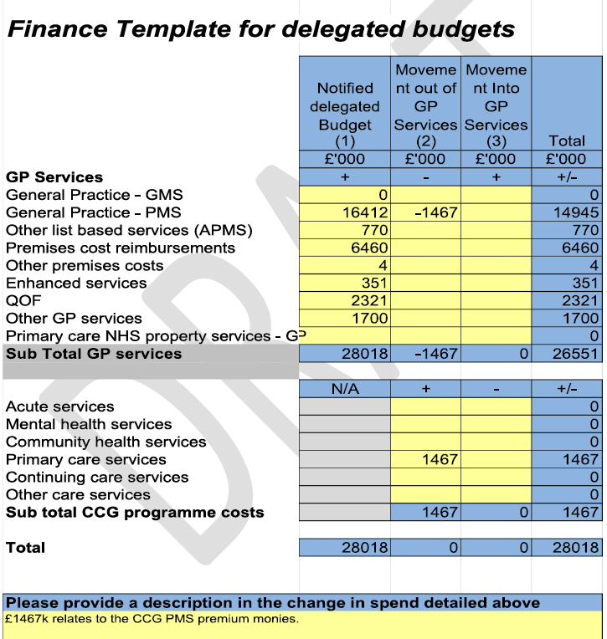

**Governance Arrangements**

As part of the requirements to move to fully delegated commissioning arrangements, the CCG will have to establish a Primary Care Commissioning Committee in order for NHS England to effectively discharge the functions associated with primary care commissioning.

The committee will be established from 1st April 2018 in accordance with the provisions below to enable the members to make collective decisions on the review, planning and procurement of primary medical care services in North East Lincolnshire, under delegated authority from NHS England. A draft Terms of Reference has been produced to be ratified upon establishment of the Committee.

Statutory duties set out in Chapter A2 of the NHS Act and including:

1. Management of conflicts of interest (section 14O);
2. Duty to promote the NHS Constitution (section 14P);
3. Duty to exercise its functions effectively, efficiently and economically (section 14Q);
4. Duty as to improvement in quality of services (section 14R);
5. Duty in relation to quality of primary medical care services (section 14S);
6. Duties as to reducing inequalities (section 14T);
7. Duty to promote the involvement of each patient (section 14U);
8. Duty as to patient choice (section 14V);
9. Duty as to promoting integration (section 14Z1);
10. Public involvement and consultation (section 14Z2)

The Committee shall consist of:

1. Lay member from NEL CCG governing body
2. NELC member (or chair) of the Health and Wellbeing board
3. NELC Director of Public Health who shall also be a Health and Wellbeing board representative
4. GP chair of the Council of Members in NEL CCG
5. GP vice chair of the Council of Members in NEL CCG
6. NEL CCG Chief Finance Officer

Whilst national guidance states that GPs should be encouraged to be members of the Committee, they must not be in the majority, which is the case with the proposed membership.

**Managing Conflicts of interest**

All Committee Members must adhere to the CCG’s Constitution and Standards of Business Conduct / Conflicts of Interest policies, together with NHS England statutory guidance on managing conflicts of interest.

NHS England will shortly be releasing Mandatory and Statutory training for all employees/ members (CoM), Governing Body members its committees/subcommittees.   The training will be broken down into three modules and individuals will be assigned accordingly to the appropriate modules for their roles/responsibilities.

1. Fundamental  (everyone)
2. Decision making roles (particular relating to commissioning cycle – procurement/service redesign/contract monitoring)

(Board Members/CCC members/Contract Team/Service Leads –OLT)

1. Advance (this module has clear guidance re Primary Care Commissioning Committees - (CCG Senior Staff/Board Members/Primary Care Commissioning Committee members/All Committee Chairs.

**Next Steps**

The CCG will be informed of the outcome of the application process in December and will update the Governing Body as appropriate following this decision.



|  |  |
| --- | --- |
| Remain as Level 2 – Joint Commissioning | Assume Level 3 – Fully Delegated |
| Benefits:   * Shared reputational risk within the health system * Clearer management of Conflicts of Interest due to membership of a Joint decision-making committee * Opportunity for partnership working and better communications/understanding * Agreement of aligned single local strategy for primary care – with better potential to feed ‘upwards’ to inform national NHSE view * Practice performance contractual issues dealt with by NHS England * Local resource and effort focussed on strategic change * Risks from financial and allocation ‘business rules’ imposed on NHS primary care funds stays with NHS England. * CCG HQ staff not in the (potentially) confusing position of being ‘performance regulator’ and ‘developer’ for member practices * Opportunity for practice contracts to be simplified into two – ‘core’ (with NHSE) and ‘all other’ (with CCG) | Benefits:   * Full resource is allocated and managed by the CCG * Raises profile as lead commissioning organisation * Full ownership of the primary care agenda by the CCG and supports place-based commissioning * Full control of strategic direction and decisions at local level * Enables a single NHS contract framework with each practice (and opportunity to include NELC contracts) * Supports the CCG having greater flexibility to develop new GP provider models (if desired) and five year forward view agenda * Potential to benefit from primary care budget underspends (unpredictable budget which can overspend too) * Easier for staff and stakeholders to understand the commissioning arrangements * Less fragmentation of commissioning arrangements for local practices * Greater flexibility in respect of management of premises funding and ability to align with CCG strategy for improved utilisation. |
| Downside/risks   * Reputational risk to CCG of not taking on fully delegated, when this is expectation of direction of travel * CCG not in full control of decisions – the Joint Committee will decide * CCG not fully sighted on all aspects of general practice commissioning, and less direct influence to enact commissioning changes in line with strategic direction * No potential to benefit from primary care budget underspends (unpredictable – can overspend too) * Confused and fragmented contracting arrangements for general practices | Downside/risks   * Full reputational risk lies with CCG * More problematic management of conflicts of interest, although these can be mitigated through policy and process * Practice performance contractual issues can incur significant legal costs that have to be funded for CCG *and* Practice * CCG HQ staff are in the (potentially) confusing position of being ‘performance manager’ and ‘developer/supporter’ for member practices * Risks from financial business rules and allocation changes due to being ‘above target funding’ rests with CCG * Risks from financial pressures pertaining to increases in rents and rates on primary care premises rests with CCG * Potential risk of additional workload on CCG officers, although NHS England have advised that support will remain as is under Level 2 arrangements. |

**Appendix 2 - Local Process and Timeline**

|  |  |  |
| --- | --- | --- |
| **Discussion / Committee Paper** | **Date** | **Outcome** |
| CCG decided to move to Level 2 | 2014/15 | Joint Co-Commissioning Committee established from 1st April 2015 onwards |
| Joint Co-Commissioning Committee | 01/09/2015 | Recommendation to Partnership Board not to take on delegated responsibility from 1st April 2016.  Concerns regarding risks, mainly financial – associated with significant contractual issue (now resolved and a very unusual occurrence) |
| Partnership Board | 10/09/2015 | Accepted recommendation of Co-Commissioning Committee not to move to fully delegated from 1st April 2016. |
| Joint Co-Commissioning Committee | 18/10/2016 | Recommendation to Council of Members not to take on delegated responsibility unless sufficient assurance from NHS England re: support to help deliver workload and support to help manage potential financial risks.  This was taken forward to the CoM this time, as recognised that decision would require change to constitution and therefore needed CoM approval. This was also in line with other CCGs’ approaches and NHS E advice. |
| Council of Members | 01/12/2016 | Council of Members decided not to move to fully delegated from 1st April 2017 |
| Partnership Board |  | No formal paper sent to Partnership Board, as no decision to ratify.  However, joint Co-Commissioning Committee minutes are shared with Partnership Board. |
| Joint Co-Commissioning Committee | 03/10/2017 | Committee considered additional information provided by NHSE, providing reassurance regarding support from staff and financial issues (pertaining to on-going contractual issues).  Committee recommended to CoM that CCG takes on fully delegated responsibility from 1st April 2018 |
| Council of Members – virtual decision | 27/10/2017 | Virtual vote over preceding two weeks. Result is that CCG should move to take on fully delegated responsibilities from 1st April 2018 |
| Ratification required from Governing Body – Agreed Chairs Action | 30/10/2017 | Timeline from NHS England for applications this year is shorter than previous year. **Deadline for submission is 1st November 2017**  Plans were in place originally, based on previous year’s timescales, to take discussion and decisions to:  Co-Commissioning Committee 03/10/2017  CoM 02/11/2017 with  Governing Body virtual ratification during November 2017  When virtual paper sent to CoM request for Chair’s Action on behalf of Governing Body, as insufficient time from closing of vote by CoM to deadline for submission to NHS England. |