Attachment 20
North East Lincolnshire CCG

Report to: NEL CCG Joint Co-Commissioning Committee

Presented by: Heather Marsh – Head of Localities, NHS England

Date of Meeting: 28 April 2016

Subject: APMS & PMS Uplift paper

Status: OPEN CLOSED

Complies with latest CCG Strategy for Primary Medical Services, if not, please give a brief reason why:

OBJECT OF REPORT:

This report is to update the committee on matters pertaining to the APMS/PMS uplift for 2016-17.

STRATEGY:

N/A

IMPLICATIONS:

None to report

RECOMMENDATIONS (R) AND ACTIONS (A) FOR AGREEMENT:

To receive and note the update.

 |  | Yes/ No | Comments
 | Does the document take account of and meet the requirements of the following:
i) | Mental Capacity Act | Yes
ii) | CCG Equality Impact Assessment | Yes
iii) | Human Rights Act 1998 | Yes
iv) | Health and Safety at Work Act 1974 | Yes
v) | Freedom of Information Act 2000 / Data Protection Act 1998 | Yes
iv) | Does the report have regard of the principles and values of the  NHS Constitution?  www.dh.gov.uk/en/Publicationsandstatistics/Publications/Publica tionsPolicyAndGuidance/DH_113613 | Yes

APMS/PMS Uplift 2016-17
Introduction
Each year the Doctors and Dentists Review Body (DDRB) advises Government on rates of pay for Doctors and Dentists.
2016/2017 DDRB Recommendation
The DDRB recommended an uplift of 1% for GMS practices
To deliver an equitable and consistent approach to uplifting PMS and APMS contracts commissioners (NHS England teams or CCGs under delegation agreement) the same increase will apply. It is important to note that the APMS uplift will only apply to practices where an uplift is stipulated in their contractual agreements.

In summary, GP practices will receive increases in core funding as set out in table 1.
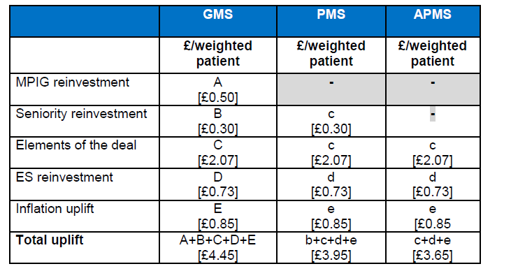

Recommendation
The Committee is asked to note the uplift to APMS/PMS contracts in accordance with the recommendations of the DDRB.

