 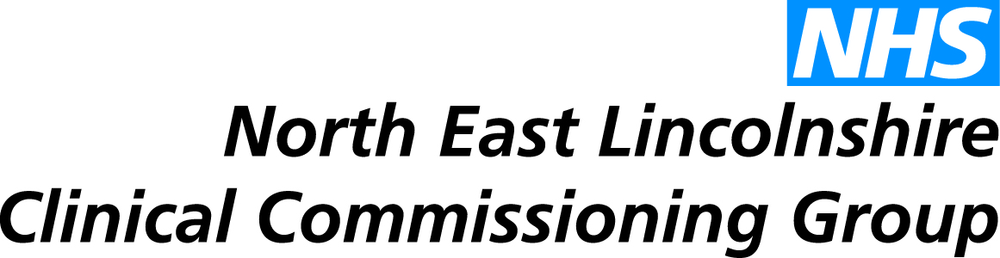

**Briefing Paper - Recruitment Drive in The Netherlands**

The team had a well organised and positive trip to The Netherlands - with success in terms of recruitment which will be realised within 2-3 years.

We saw six GPs/potential GPs (two in Dutch GP training, one considering GP training in UK, one may consider UK GP training and two experienced GPs wishing a new challenge). Two will visit NEL in the next 3 months; two wish to visit in the next 6 months.

None were ready yet to consider formal applications, interviews or exams, however we believe we’ll get 2 or 3 GPs in the next two years from this initial effort.

3 other key points are considered when evaluating the trip:

1. NL&G (Northern Lincolnshire & Goole NHS Trust) joined us on the visit - they had productive visits from three probable new consultants. NL&G now are visiting European countries regularly with a dedicated team of staff. The team determined that we are going to have to match their dedication, professionalism, resources and patience to see rewards. They gave us good ideas, and good contacts.

2. We met representatives from 3 (of the 8) Dutch medical schools to explore both student primary care placements in the UK and possible Dutch VTS links - their medical schools cover UG & PG. Our Dutch colleagues were very positive. We should build on this to sow seeds for future GP trainees or future GP principals.

3. There were some nerves from candidates and the team about sitting exams and the new hoops to jump on two levels: 1) Dutch GP training is similar to ours - three years and lots of exams, tests, checks & balances. 2) Experienced GPs have similarly very good annual checks and balances - these are high quality colleagues coming from Europe’s best health care system.

It is strongly suggested we aim to return to Holland in the Autumn with a recruitment stall at the Dutch GPs conference - where 50% of all GPs attend.

