Attachment

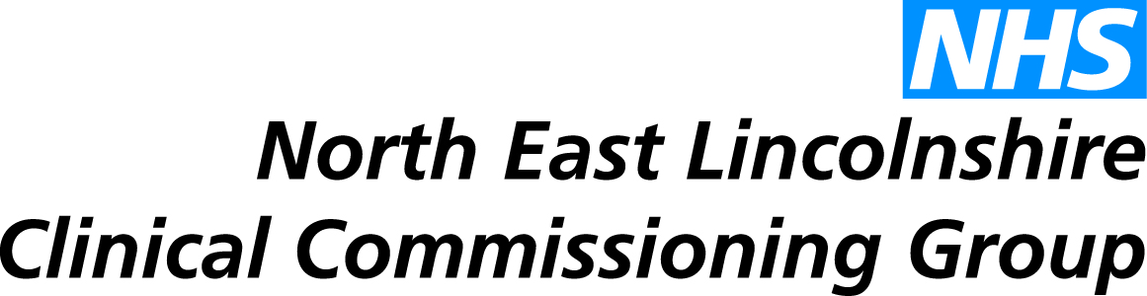
Report to: | NEL CCG Joint Co-Commissioning Committee
Presented by: | Debbee Walker, Service Manager
Date of Meeting: | 29th October 2015
Subject: | Match National Recruitment Office (NRO) Bursary Funding – Dutch Recruits
Status: | OPEN CLOSED
 | Complies with latest CCG Strategy for Primary Medical Services, if not, please give a brief reason why:

OBJECT OF REPORT:
This report has been prepared to detail the CCGs strategy to match bursary funding in relation to potential Dutch GP recruits to endorse the approach/principles, and agree that final decision will get appropriate authorisation within the CCG governance structure.

STRATEGY:
The proposal contained within this report is consistent with the primary care strategy presented to the Committee at the meeting on 23rd April 2015.

IMPLICATIONS:
General Practice faces many and varied workforce challenges; with an increasing workload, GPs retiring earlier, the reduced popularity of General Practice as a career choice and the huge retirement risk due to the high number of experienced GPs and nurses aged over 55. North East Lincolnshire CCG is working with a number of partners to explore opportunities to stabilise, and reshape the workforce model of Primary Care.

One of these schemes has resulted in a recruitment drive in The Netherlands to attract Dutch GPs to come and work in NEL. This initiative resulted in a well organised and positive trip to The Netherlands in June 2015 with success in terms of recruitment of 5 GPs which will be realised within 2-3 years.

As part of the recruitment package, the CCG propose to match National Recruitment Office (NRO) bursary funding for each candidate during their training phase, the length of which will be determined by their result of the MCQ clinical knowledge test as part of the national Induction and Refresher (I&R) scheme. If anyone does exceptionally well (Band 5) they can apply to be on the performers list and be inducted into the local I&R scheme – 2 weeks maximum - and then enter paid employment.

For those who do well at MCQ (Band 4 or 3 result), they’ll need to do a simulated surgery at RCGP London. If they pass they’ll need a three month induction in an approved educational practice (Band 4 result) or six months (Band 3 result) – both with on-going assessment, 360 appraisal etc.

Doctors on the I&R scheme will receive a bursary of £2300 per month full time equivalent, on a monthly pro rata basis. The CCG propose to match this funding (£2300 per month) to make the package more attractive to candidates, providing a salary of £4600 during their training phase.

We anticipate that the first candidate is likely to commence the NRO process at the end of 2016 at the earliest.

RECOMMENDATIONS (R) AND ACTIONS (A) FOR AGREEMENT:

The Joint Co-Commissioning Committee is asked to endorse the approach/principles, and agree that the final decision will get appropriate authorisation within the CCG governance structure.

 |  | Yes/  No | Comments
 | Does the document take account of and meet the requirements of the following:
i) | Mental Capacity Act | N | n/a
ii) | CCG Equality Impact Assessment | N | n/a
iii) | Human Rights Act 1998 | N | n/a
iv) | Health and Safety at Work Act 1974 | N | n/a
v) | Freedom of Information Act 2000 / Data Protection Act 1998 | Y
iv) | Does the report have regard of the principles and values of the NHS Constitution?  www.dh.gov.uk/en/Publicationsandstatistics/Publications/PublicationsPolicyAndGuidance/DH_113613 | Y

