Keeping the Door Open – Easier-to-access routine family health services for the future in North East Lincolnshire
‘You Said – We Did’ - Engagement outcomes, actions and progress (updated February 2019)
In April 2016, NHS England published the ‘General Practice Forward View’, committing an extra £2.4 billion a year to improve patient care and access and invest in new ways of providing primary care over seven days a week in England.
Given the pressures faced by GP services, it is impractical and unaffordable to provide GP services from each individual practice continuously seven days a week in North East Lincolnshire. However, North East Lincolnshire Clinical Commissioning Group (NELCCG) want to look at ways of making it easier and more flexible for people of all ages in the area to access GP services for routine (non-urgent) advice or treatment.
From September to November 2016, the CCG carried out public engagement to ascertain the views and experiences of local people to contribute to designing a new service specification for extended access to GP practice services. This included gaining an understanding of whether patients want to access services during the evening or at the weekend and would attend a different practice to do so, see another healthcare professional instead of a GP when appropriate, and use technology such as Skype, ‘apps’ and online symptom checkers for advice and appointments.
The purpose of the ‘Keeping the Door Open’ survey was to gain views and opinions of North East Lincolnshire residents on how to make GP Services more accessible. It was also to inform the development of NELCCG Primary Care Strategy and respond to the NHS 5 Year Forward View as the Department of Health has told the local NHS that they would like to see GP services offered to local residents over 7 days.
The Survey
Initially a group of Accord members discussed Primary Care at the Annual Accord Meeting in early September 2016 and their thoughts and opinions informed the final version of the survey and provided helpful insight into how best to pose questions, present the survey and reach patient groups.
Public engagement then took place in the form of electronic and paper surveys with 134 responses returned.
The survey and information leaflet was sent out to stakeholder contacts representing a wide range of stakeholders groups including those with protected characteristics under the Equality Act. It was sent to Accord members and promoted at GP practices using posters, newsletters and social media.
Other engagement opportunities
Since this activity took place, we have spoken to patients at Patient Participation Group forums, public and patient engagement events and published feedback reports and through our Accord newsletters. We have continued this dialogue with people in North East Lincolnshire in the Our Place Our Future survey in 2017/18, and have developed a You Said, We Did report for that too.
In October last year, Extended Access to GP services was launched across England. In North East Lincolnshire, patients can access both pre-bookable and on the day appointments with a GP, nurse or other health professional on weekday evenings, Saturday, and Sunday. Groups of practices have come together to form federations and this is one of the services they offer. There are three federations within North East Lincolnshire. Patients can find out about these appointments on their practice website and can choose to attend these if they wish. Sometimes these appointments will take place at another GP practice in their Federation but patients have the choice of whether to access these or get an appointment at their own surgery during regular opening hours.
This document explains how the outcomes from this engagement informed the design of GP Extended Access and the wider planning around developing GP services.
You Said | We Did | We are working on
Just over half of respondents were generally satisfied with current opening hours and felt able to book a routine appointment at their convenience.  The most popular time for attending a routine GP appointment was during the week between 8am & 6pm (core hours). Older people and people who had retired favoured these times  There was support for having the opportunity to access routine appointments in the evenings and at weekends – especially amongst working age people. | Extended Access was launched in October 2018. Extended Access is in addition to the core opening hours of GP practices.  Practices must continue to provide the core hours that are convenient for these patients  Extended Access means that patients now can book appointments on weekday evenings and on Saturdays and Sunday giving some working people more flexibility. | We are currently refreshing our primary care strategy and this will include a range of initiatives that are aimed at improving access to general practice services; this covers workforce initiatives, training, new methods of accessing advice. More detail can be found throughout the remainder of this document.
Patients who reported difficulty accessing appointments in core opening hours said the main reasons were ‘No appointments available when I need them’ followed by ‘Fitting in around work commitments’ | We have brought in a number of measures to support GP practices to ensure patient access the care that is right for them, which in some cases means speaking to another health care professional. This will also help to keep the GP appointments free for the patients who need to see a GP. | A number of local GP practices have started to offer online consultation via their websites. This allows patients to request support through an online consultation form, which is reviewed by a healthcare professional in the practice who will ensure that each patient receives the right response for their needs. This does not always mean a trip to see somebody at the surgery and can save time for the patient and the professional.
The way in which practices want their patient to book appointments is difficult for some people.  - Getting through on telephone  - Unease about reception staff asking personal questions and making decisions about the type of appointments the patient requires | We know that the booking systems at some practices do not work for all patients. Patient Participation Groups work with their practices to share patient experience and ideas to improve services; including booking systems | We have trained 126 Care Navigators across all practices – Care Navigators offers the patient ‘choice not triage’ to access the most appropriate service first which isn’t always the GP. Care Navigators do not make clinical decisions.  We are developing systems to enable GP practices to send patients SMS/text messages about appointment times and other important information. This system also enables patients to reply back to some of the messages they receive from their surgery (such as to confirm or cancel their attendance at an appointment)
Securing an appointment at suitable time can be very challenging for certain groups of people, such as, working people, people with disabilities, carers, single parents and those people with no support. | We want to make accessing the right care at the right time in the right place | We are now working to increase rates of booking appointments, ordering prescriptions and accessing records online.
People were not very enthusiastic about appointments before 8am | We have no plans to introduce routine GP appointments before 8am
Saturdays were favoured more over Sundays for routine appointments. | Extended Access appointments are available on Saturdays and Sundays – we are monitoring the use of the service to ensure we match resources to the demand.  Generally, there are more appointments available on Saturdays than there are on Sundays.
The most important consideration for 47% respondents when booking a routine, non-urgent health care appointment was ‘seeing the health professional of my choice’. People said there were benefits for their care in seeing someone who knew them and their medical history. | We know that seeing a health professional of choice is important to some patients especially those with long-term conditions who are more comfortable being seen by practice staff who know them. We have undertaken training to enhance the skills of nurses who can support patients with specific health conditions.  The federations are working together to deliver care for patients with long term conditions; this should mean that those patients receive their care from the same team (working across those practices) most of the time and get used to the same team members.
We asked if people would travel to another GP centre for a more convenient routine, non-urgent appointment with a suitably qualified health professional  - 57% said they would be willing to do this  Reasons given for not wanting to travel included extra travel costs and travel time incurred for patients who are feeling unwell, who do not drive or who are unable to drive due to medical conditions. | Extended Access now provides this flexibility for patients who want to access the service. Each federation has considered accessibility when deciding which GP Centres to operate their services from  Patients can still be seen within their own practice during core opening hours if they do not wish to travel to a different centre.
Although some patients prefer to see their own GP, it was generally accepted that this was not always possible and they would be prepared to see an alternative GP at a different practice as long as their medical records were available; for a routine appointment | Extended Access gives people more choice of when they have their routine appointment – the trade-off is that they may not see their own GP as practices are working together within federations to offer this service. | We have been working across the Humber region to integrate the two main GP computer systems that are used locally. This means doctors can now see information about their patients even if they have been treated somewhere else, for example, by an Out of Hours GP, a hospice doctor or a service in the community. After a successful pilot, this integration has now been rolled out across North East Lincolnshire and the rest of the Humber region. This is a first in the UK and has been welcomed by local clinicians.
43% said they would not be willing to travel to another GP Centre | Patients will not be given appointments at another GP centre if they do not want it.  Extended Access is about giving patients more choice.
We asked people who said they would be willing to travel to another GP centre for an appointment how long they thought was reasonable for them to go.  - 90% said they would travel up to 30 minutes to a routine appointment  - 10% said they would travel over 30minutes | There are three federations of GP practices working together to provide Extended Access. Most patients will have less than 30 minute travel to time to get to an extended access appointment in North East Lincolnshire.
We asked people if they would be willing to see a different professional, who is suitably qualified, instead of their GP?  - 88% said they would | The Extended Access appointments on offer in NEL are for a range of professionals, including nurses and GPs. We are working with practices to enhance the service offer for patients to include other qualified professional to deal with routine appointments, where clinically appropriate
Some people who had experience of seeing another professional rather than their GP spoke of their positive experiences and suggested more should be done to promote the breadth of expertise there is within a GP practice | Our plans for Primary Care include broadening the range of professionals who can support GPs. Many practices use Advanced Nurse Practitioners, Nurses and HealthCare Assistants and some also have Clinical Pharmacists.  … | We want to encourage more patients to tell us about their experiences of care. These ‘patient stories’ can help us to promote the range of services and expertise that patients can access now in their local GP centre. Please contact us at nelccg.askus@nhs.net or telephone 0300 3000 500
We asked the people who said they would be willing to travel to another GP centre to see a suitably qualified health professional for a routine appointments how long they thought was reasonable for them to go  - 83% said up to 30 minutes  - 17% said over 30 minutes | Extended access does now give people more flexibility and other health professionals working as part of a wider Primary Care team provide some of these appointments.
Respondents were asked who would they would rather speak to if they wanted advice about any medications or medical aids – most people said ‘a pharmacist’ , next was ‘GP’ followed by ‘other allied health professional’ | We have provided support and training to practices to upskill their staff and bring in other health and care professionals to improve on the range of services and support for their patients. Some practices now have Clinical Pharmacists who carry out medication reviews and advice, and patients can still access their community pharmacy for advice, where appropriate.
We did receive some feedback to suggest people felt that the Single Point of Access (SPA) in North East Lincolnshire and the national NHS 111 service did not enable access to qualified professionals, and was more of a signposting service. | We think it is very important to set the record straight here…  The SPA offers a single telephone contact point for local people to access a broad range of services, 24 hours a day, and 7 days a week. A range of qualified health proffessionals work at the SPA along with trained call handlers. The SPA is for all enquiries about:  - physical health (incl urgent care advice, access to the GP Out of Hours service)  - mental health;  - adult social care  - safeguarding adults concerns  NHS111 is a national free helpline with trained advisors – North East Lincolnshire patients who call 111 will be transferred to the local SPA service where appropriate to receive advice and support. | 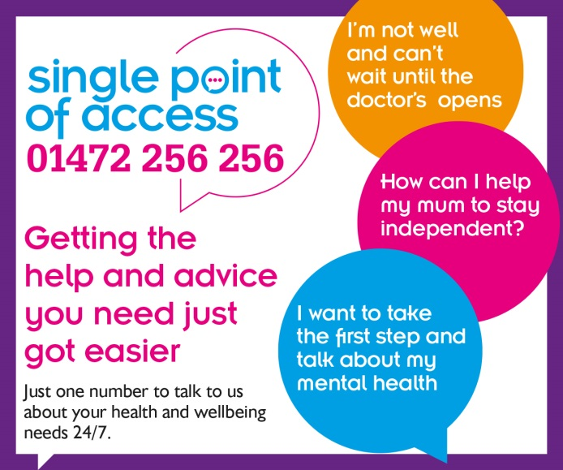
The majority of respondents were happy with the ways they could access advice at their GP practice, the most common methods used now were given as face to face, followed by Practice website and telephone appointments.  We asked people how they would like to access advice there was strong interest in technology, such as, Instant messaging/Live chat, Video/Skype appointments, Email, Symptom checker and Online access to medical records | We understand that technology brings a range of opportunities for the NHS to improve access to information and advice for patients and carers and enhance the quality of care. Providing these options for patients can free up more time in GP practices for those patients who do need to see a GP or Health professional in person.  We already have 3 practices that are offering online consultation, and others are due to go live with this.  We are also rolling out a new SMS messaging system which will enable practices to send patients SMS/text messages about appointment times and other important information. This system also enables patients to reply back to some of the messages they receive from their surgery (such as to confirm or cancel their attendance at an appointment) | . Our plans for 2019 include:  - The NHS App is coming to North East Lincolnshire - The NHS App provides a simple and secure way for patients aged 13 or over to access a range of healthcare services on their smartphone or tablet. The NHS App is being gradually rolled out across England now and we expect all surgeries to be connected by 1 July 2019.  - We have rolled out an NHS approved app to support patients with COPD and this is available from your clinician. We are currently looking at apps available for other conditions (e.g. diabetes) and how these can support patients.  - We will be rolling out a Health App Library which contains apps that have been assessed and evaluated. Health professionals will be able to signpost patients to the App store.

