

**Agenda Item 06**

Report to (Board/Sub-Committee): NEL CCG Partnership Board

Date of Meeting: 8th November 2018

Subject: Integrated Assurance and Quality Report

Presented by: Jan Haxby Director of Quality & Nursing

**STATUS OF THE REPORT**

For Information 

For Discussion ☒

For Approval / Ratification 

|  |  |
| --- | --- |
| **PURPOSE OF REPORT:** | The report advises the Partnership Board of how NELCCG are performing against;   * six domains developed for the performance dashboard and; * three domains developed for quality dashboard.   The dashboards are managed via the Delivery Assurance Committee, the Clinical Governance Committee and the Integrated Governance and Audit Committee.  For more detail on performance and quality the latest integrated assurance report presented to the Delivery Assurance Committee and the quality dashboard report verbally presented to the Clinical Governance Committee can be found via the embedded files in the ‘Appendices / attachments’ section of this cover sheet. |
| **Recommendations:** | The Partnership Board is asked:   * to note judgements made against the domains of the dashboards * for further feedback on ways to improve the report. * to note information on NELCCG Quarter 2 Assurance Meeting |
| **Sub Committee Process and Assurance:** | The Delivery Assurance Committee and the Clinical Governance Committee manage and assure the performance and quality contained within these dashboards.  The Delivery Assurance Committee cross reference the performance framework with the CCG Board Assurance framework and Risk Register. This allows the Delivery Assurance Committee to identify any gaps in risk management, however none were identified at this time. |
| ***Implications:*** |  |
| **Risk Assurance Framework Implications:** | The dashboards associated with them are managed via the Delivery Assurance Committee and the Clinical Governance Committee. |
| **Legal Implications:** | None |
| **Equality Impact Assessment implications:** | An Equality Impact Assessment is not required for this report. |
| **Finance Implications:** | There are a number of measures within the Performance Dashboard with a financial implication such as activity and Quality Premium measures, however the detail of these are dealt with separately within the Finance Report. |
| **Quality Implications:** | Quality implications are managed by the Clinical Governance Committee and DAC and are escalated within the main body of this report. |
| **Procurement Decisions/Implications *(Care Contracting Committee):*** | None |
| **Engagement Implications:** | None |
|  |  |
| **Conflicts of Interest** | None |
| **Strategic Objectives**  *Short summary as to how the report links to the CCG’s strategic objectives* | 1. *Sustainable Services*   The performance and quality dashboards contain a number of national and local measures that support this objective. |
| 1. *Empowering People*   The performance and quality dashboards contain a number of national and local measures that support this objective. |
| 1. *Supporting Communities*   The performance and quality dashboards contain a number of national and local measures that support this objective. |
| 1. *Delivering a fit for purpose organisation*   The performance and quality dashboards contain a number of national and local measures that support this objective. |
| **NHS Constitution:** | The Performance and Quality dashboards contain measures from the NHS Constitution and the performance and quality associated with these are managed and assured through the Delivery Assurance Committee and the Clinical Governance Committee. |
| **Report exempt from Public Disclosure** | No |

|  |  |
| --- | --- |
| **Appendices / attachments** |  |

**Integrated Assurance & Quality Report**

**Introduction**

The dashboards below represent an overview of performance and quality for health and social care services across North East Lincolnshire.

The performance dashboard consists of six domains and the quality dashboard three domains that incorporate all areas that North East Lincolnshire Clinical Commissioning Group strive to improve on. A judgement has been made of the status for each domain based on the measures and intelligence underpinning them. These judgements try to balance the current position with the expected outcome at the end of the year and weightings with respect to priority. They also represent the local perspective of performance and quality for North East Lincolnshire rather than the performance against the national definition which, on occasion, covers a broader footprint. It should be noted that those issues that have an impact on the CCGs corporate performance assessment will continue to be scrutinised at the Delivery Assurance Committee. The dashboards reflect performance for the first six months of 2018-19. The Delivery Assurance Committee and Quality Committee, respectively, are asked to make a decision on the final status of the dashboards before reporting to the CCG Partnership Board. Full exception report summaries are also included for Performance (appendix A) detailing performance of indicators that are underperforming and Provider-level Quality Dashboards (appendix B).

**Performance Quality**

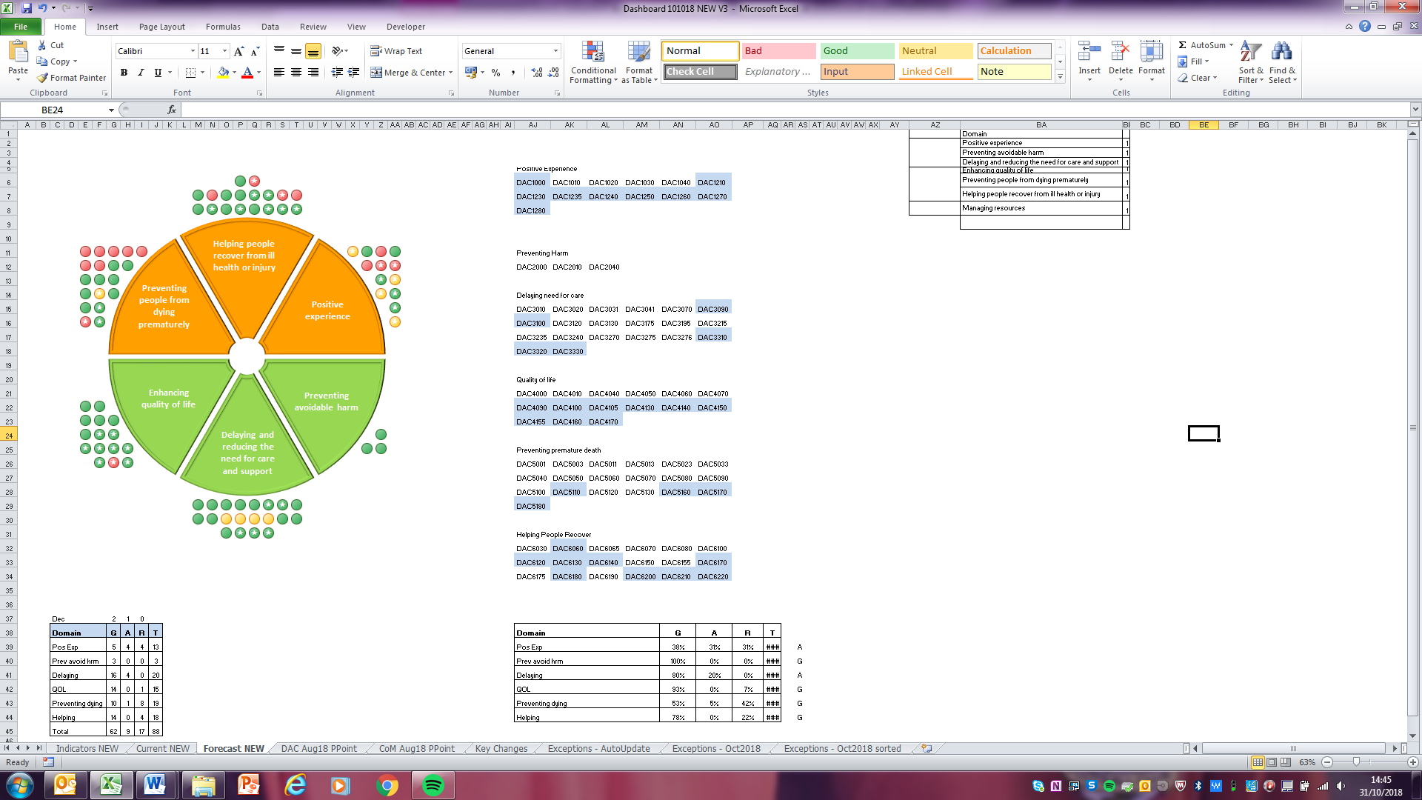 

***Please note the star symbol indicates a measure from the CCG Improvement and Assessment Framework (CCG IAF). These indicators focus Better Health, Better Care, Sustainability and Leadership.***

**Performance Escalation**

**NELCCG Quarter 2 Assurance Meeting**

NELCCG is subject to quarterly assurance meetings with NHS England where one of the points raised is our performance against the Improvement and Assessment Framework (IAF). The table below shows our performance for March 2018 against the latest performance on those key measures identified as a particular challenge in 2017/18 for NELCCG along with those key measures as likely to be a particular challenge in 2018/19.



**Additional comments on performance**

* A&E 4 hr wait
  + A&E Delivery Board performance was 90.1% in September (90% target)
  + Performance is above the national average in September
  + 3.3% better YTD compared to 17-18
  + NELCCG performance was 89.2% (does not include Goole)
* Reduced super-stranded bed days rate in 2018-19 and in-line with national ambition
* DToC (beds) The table above reflects August vs March performance, whereas the actual 2018/19 year to date DToC levels have reduced by 18% and are below the BCF plan, it is also worth noting that this measure is within the Best Quartile Nationally.
* RTT
* % within 18 weeks performance has improved by 3.7% from Mar to Sep 18
* In real terms the waiting list has reduced by 3% over that period (accounting for introduction of planned IP waiting list)
* There are currently 77 patients currently waiting over 52wks for treatment, this, again, is an improvement from March but is now behind the trajectory set (majority continue to be at NLaG under ENT and general surgery).
* Cancer rate for 62 days was 79.6% in August; an improvement over the last two months and above the national average but still below the 85% target
* IAPT currently 4.1% access, 51.7% recovery and meeting waiting times targets
* TCP inpatients – showing flow of people towards discharge. We remain on trajectory even though there has been an admission.

**Quality Escalation**

**Quality Escalation**

The purpose of this report is to highlight the exceptions in Quality and to escalate items from the Clinical Governance Committee to the Board.

1. **Enhanced Quality Surveillance**

One provider across the North East Lincolnshire healthcare system remains to require an enhanced level of quality surveillance. This provider is Northern Lincolnshire and Goole NHS Trust.

1. **Northern Lincolnshire and Goole NHS Trust (NLaG)**

The Trust remains in Special Measures for quality and finance. A separate agenda item regarding the CQC report is available.

We are working closely with the Trust to implement agreed backlog guidance to oversee RTT breaches of 52 weeks waiting and 62 day cancer breaches. This process was agreed at the Planned Care Board and will report into the Quality Review meeting (QRM).

The Clinical Harm review work that commenced in April 2017 is now complete and the Chair of the Clinical Harm Review group is writing a final report to summarise the learning.

1. **Individual Funding Requests (IFR)**

We are progressing actions to improve the IFR processes in North East Lincolnshire and we are working with colleagues across the Humber Coast and Vale to try to align our systems. We are also linking with colleagues in Lincolnshire to ensure the Commissioning agencies surrounding our local Trust review their systems in line with the feedback we have had from secondary care.

1. **Infection Prevention and Control – Gram Negative Blood Stream Infections**

The General Practice Quality Scheme is underway; a section of the scheme concentrates on improvement activity in gram negative blood stream infections and sepsis. The next phase of the project work being undertaken by the CCG is to mobilise support to the care and nursing homes to improve hydration, hygiene and continence care delivery. It is anticipated that this work will also contribute positively to the support to care homes agenda on minimising hospital attendances. The Quality Team and the Support to Care Homes Lead are working together to progress this initiative at pace.

1. **Site Visits**

Site visits to NLaG continue to be undertaken on a monthly basis and complement the agenda structure for the Quality Review Meeting (Contract Quality Meeting held between commissioners and the Trust).

1. **East Midlands Ambulance Service (EMAS)**

We are not satisfied that all the learning from NEL incidents reported concerning perceived/actual delay in response times to 999 calls made from General Practice has been ascertained for all parties involved in the incidents. Therefore we raised this with EMAS and proposed call review audit of those cases reported to us to be undertaken with commissioners to review the occurrences together. We anticipate learning both for EMAS and Primary Care. Our challenge has been received well and action has been agreed to support learning and progress actions together.

EMAS are undertaking work to support minimising seasonal emergency service demand management by creating promotional posters for care and nursing homes.

Innovative schemes for recruiting qualified paramedics are progressing.

The service has recognised a need to review transfers made from Louth Urgent Care Centre to A&E’s, due to the demand a shuttle crew has had to be mobilised between Louth UCC and NLaG A&E. Actions are being mobilised to review this position with the commissioners of the service.

1. **Sharing Lessons Learnt**

We have revised our ‘Risky Matters’ bulletin, a mechanism for sharing learning from incidents with primary care, to become a ‘Quality Matters’ bulletin. The content of which includes learning from local post infection reviews, incidents, customer care, safeguarding and medications enquiries. Also included is direction to new NICE guidance and newly published best practice standards. The new bulletin was launched in September and has been shared with all NELCCG commissioned providers.

1. **Humber Infectious Disease Outbreak Exercise**

Public Health facilitated an infectious disease outbreak exercise, which we contributed to and found to be an extremely helpful exercise. A report is being complied to enable learning to be consolidated and inform local actions. Actions are already in progress locally to facilitate local outbreak exercises and formalise the patient group direction (PGD) procedure for approving PGD’s in a limited timeframe (A PGD is a written instruction for the administration of medication by a named registered professional without a prescription).

**Appendix A - Performance Exception Summary**

| **Code** | **Indicator** | **CCG IAF** | **Latest period** | | | | **Year to date** | | | **Year End Forecast** |
| --- | --- | --- | --- | --- | --- | --- | --- | --- | --- | --- |
| **Period** | **Target** | **Value** | **Status** | **Target** | **Value** | **Status** |
| Positive experience | | | | | | | | | | |
| DAC1000 | Total time in A&E: four hours or less | No | September 2018 | 90% | 89.17% |  | 89% | 86.94% |  |  |
| DAC1020 | Cancelled Operations offered binding date within 28 days | No | Q1 2018/19 | 5.34% | 26.42% |  | 5.34% | 26.42% |  |  |
| DAC1040 | Numbers of unjustified mixed sex accommodation breaches | No | August 2018 | 0 | 49 |  | 0 | 210 |  |  |
| DAC1210 | Proportion of GP referrals made by e-referrals | Yes | July 2018 | 100% | 66.31% |  | 100% | 66.31% |  |  |
| DAC1220 | Overall Experience of Making a GP Appointment | No | 2017/18 | 74.58% | 65.17% |  | No data available in 2018/19 | | |  |
| DAC1230 | Provision of high quality care: hospital (121a) | Yes | Q4 2017/18 | 58 | 55 |  | No data available in 2018/19 | | |  |
| DAC1240 | Provision of high quality care: adult social care (121c) | Yes | Q4 2017/18 | 62 | 61 |  | No data available in 2018/19 | | |  |
| DAC1250 | Patient experience of GP services (128b) | Yes | 2016/17 | 85.1% | 82.23% |  | No data available in 2018/19 | | |  |
| DAC1280 | Cancer patient experience (122d) | Yes | 2015/16 | 8.73 | 8.69 |  | No data available in 2018/19 | | |  |
| **Preventing avoidable harm** | | | | | | | | | | |
| No exceptions | | | | | | | | | | |
| **Delaying and reducing the need for care and support** | | | | | | | | | | |  |  | | |  | |  |  |  |  |  |  |  |
| DAC3175 | Total Elective Spells (Specific Acute) | No | July 2018 | 2662 | 2690 |  | 10686 | 10319 |  |  |
| DAC3195 | Total Non-Elective Spells (Specific Acute) | No | July 2018 | 1468 | 1574 |  | 5710 | 5716 |  |  |
| DAC3215 | Consultant Led First Outpatient Attendances (Specific Acute) | No | July 2018 | 4208 | 4454 |  | 16685 | 17303 |  |  |
| DAC3235 | Consultant Led Follow-Up Outpatient Attendances (Specific Acute) | No | July 2018 | 7584 | 7641 |  | 30226 | 31112 |  |  |
| DAC3240 | A&E Attendances (NEL Patients) | No | July 2018 | 5265 | 5562 |  | 20098 | 20995 |  |  |
| **Enhancing quality of life** | | | | | | | | | | |
| DAC4050 | Proportion of adults in contact with secondary mental health services living independently, with or without support | No | July 2018 | 80.00% | 74.85% |  | 80.00% | 76.71% |  |  |
| DAC4160 | The proportion of carers with a long term condition who feel supported to manage their condition (108a) | Yes | 2016/17 | 60.95% | 57.28% |  | No data available in 2018/19 | | |  |  | | |  | |
| **Preventing people from dying prematurely** | | | | | | | | | | |
| DAC5001 | ARP Category 1 Mean Response Time – Calls from people with life-threatening illnesses or injuries | No | August 2018 | 00:07:00 | 00:07:34 |  | 00:07:00 | 00:07:50 |  |  |
| DAC5003 | ARP Category 1 90th centile response time – Calls from people with life-threatening illnesses or injuries | No | August 2018 | 00:15:00 | 00:13:48 |  | 00:15:00 | 00:14:11 |  |  |
| DAC5011 | ARP Category 2 Mean Response Time – Emergency calls | No | August 2018 | 00:18:00 | 00:31:29 |  | 00:18:00 | 00:31:43 |  |  |
| DAC5013 | ARP Category 2 90th centile response time – Emergency Calls | No | August 2018 | 00:40:00 | 01:06:53 |  | 00:40:00 | 01:07:09 |  |  |
| DAC5023 | ARP Category 3 90th centile response time – Urgent Calls | No | August 2018 | 02:00:00 | 03:02:22 |  | 02:00:00 | 02:56:40 |  |  |
| DAC5033 | ARP Category 4 90th centile response time – Less Urgent Calls | No | August 2018 | 03:00:00 | 02:47:18 |  | 03:00:00 | 02:25:59 |  |  |
| DAC5040 | Ambulance 30 minute average turnaround time target - DPOW | No | August 2018 | 30 mins | 36.21 mins |  | 30 mins | 37.78 mins |  |  |
| DAC5110 | Cancer 62 Days Referral to Treatment (GP Referral) | No | August 2018 | 85% | 79.63% |  | 85% | 71.74% |  |  |
| DAC5170 | Maternal smoking at delivery (125d) | Yes | Q3 2017/18 | 14.71% | 21.33% |  | No data available in 2018/19 | | |  |
| **Helping people recover from ill health or injury** | | | | | | | | | | |
| DAC6060 | RTT - Incomplete Patients: % Seen Within 18 Weeks | Yes | September 2018 | 73.4% | 75.19% |  | 70.9% | 75.58% |  |  |
| DAC6070 | RTT – No. waiting on incomplete pathway 52+ wks | No | September 2018 | 60 | 77 |  | 235 | 439 |  |  |
| DAC6140 | Proportion of children & young people <18 receiving treatment by NHS funded community services | Yes | Q1 2018/19 | 12.77% | 11.29% |  | 12.77% | 11.29% |  |  |
| DAC6150 | The proportion of CYP with ED (routine cases) that wait 4 weeks or less from referral to start of NICE-approved treatment. | No | Q1 2018/19 | 95% | 50% |  | 95% | 50% |  |  |  | |
| DAC6200 | Extended access (evening and weekends) at GP services | Yes | September 2018 | 55.6% | 0% |  | 32.1% | 0% |  |  |

**Appendix B – Provider-level Quality Surveillance Ratings**

 