

**Agenda Item 08**

Report to (Board/Sub-Committee): Partnership Board meeting

Date of Meeting: 9th November 2017

Subject: Winter and Integrated Urgent Care (IUC)

Presented by: Helen Kenyon Deputy Chief Executive

**STATUS OF THE REPORT**

For Information 

For Discussion X

For Approval / Ratification 

|  |  |
| --- | --- |
| **PURPOSE OF REPORT:** | To make the Partnership Board aware of the National expectation of how the system will manage and continue to deliver services over the winter period. A Winter plan has been produced to try and ensure continued service delivery to the required standards over winter and this report requirements it has to deliver against, the resources required and the risks associated with the winter plan for 2017. It also outlines the winter reporting and escalation processes being put in place.  To make the Board aware of the new nationally mandated Interrelated Urgent Care Service Specification IUCSS, and to provide an overview of the proposed approach to ensure delivery within the required timescales.  To highlight the link between the work required to support continued delivery over the winter and the implementation of the requirements within the IUCSS |
| **Recommendations:** | To note the information about the issues raised in the report |
| **Sub Committee Process and Assurance:** | Delivery against the winter plan requirements will be overseen by the Delivery Assurance Committee within the CCG, and on a system wide basis delivery will be driven by the A&E Delivery Board.  The work associated with the IUCSS will be overseen by the Care Contracting Committee (CCC) and where required the quality committee.  It is likely that the CCG will need to use one of the NHS New model contracts to deliver the requirements of the IUCSS, and the Department of Health has recently published a model alliance contract for use. |
| ***Implications:*** |  |
| **Risk Assurance Framework Implications:** | *Please demonstrate that there is an effective system in place to identify and manage risks.*  The A&E Delivery Board has increased the frequency of its meetings to fortnightly over the winter period to ensure ongoing whole system oversight of the plans implementation, any risks that arise over the winter that need to be addressed and the actions required to mitigate against the risks. |
| **Legal Implications:** | *Summarise key legal issues / legislation relevant to the report.*  If the CCG does not follow the correct process as part its implementation of the IUCSS there is a risk of a legal challenge from providers who feel they have missed the opportunity to be involved in service delivery |
| **Equality Impact Assessment implications:** | *An Equality Impact Analysis / Assessment is not required for this report. Yes/ No -* ***No***  If Yes:  *An Equality Impact Analysis / Assessment has been completed in accordance with CCG policy.* ***Yes /******No***   * *There are no actions arising from the analysis / assessment* * *There are actions arising for the analysis / assessment which are included in section in the enclosed report* |
| **Finance Implications:** | *Summarise key financial issues relevant to the report.*  There are known costs to delivering the winter plan, a risk assessed financial plan has been submitted as part of the winter plan process and we are currently awaiting confirmation from the DH/NHSI/E, that this funding is going to be made available. Costs are already being incurred against the plan, and these costs are being captured a system level to ensure that reimbursement can take place once the funding is received. Should funding not be received then the system will need to determine how best to manage the pressure across the system.  It is not yet known whether there will be an increased cost associated with delivery of the IUCSS. This is currently being assessed as the new system will require specific elements of the current system to come together and deliver differently. The assumption at a national level is that the new service will be able to be managed within the current cost of service delivery plus any additional national money being made available within the various 5 year forward view plans (Mental Health, Primary Care etc). |
| **Quality Implications:** | *Summarise key quality issues relevant to the report.*  A quality impact assessment was undertaken as part of the development of the winter plan.  It the winter plan is not delivered then the quality of patient care will be affected. |
| **Procurement Decisions/Implications *(Care Contracting Committee):*** | *Include the proposed /chosen procurement route to market.*  There are no procurement decisions required for the Winter plan.  The CCG will need to determine the most appropriate route to deliver the IUCSS, which could be via a procurement or working with the existing providers under an alliance type contract. Work to determine the most appropriate route will be overseen by the CCC. |
| **Engagement Implications:** | *please state any past engagement activities and any future engagement activities (distinguish between public and stakeholder engagement).*  As part of the winter plan there is a proactive and reactive communications plan which includes within it public engagement based around the “Choose Well” national campaign. |
|  |  |
| **Conflicts of Interest** | *Have all conflicts and potential conflicts of interest been appropriately declared and entered in registers which are publicly available? Yes /No.* **Yes**  There is a potential contract of interest for all practicing GPs as it is likely that the IUCSS will result in changes to the way that all GPS in the area have to work.  This will need to managed in accordance with our conflicts of Interest ploicy as we go through the process over the coming months  *Please state ay conflicts that need to be brought to the attention of the meeting.* |
| **Strategic Objectives**  *Short summary as to how the report links to the CCG’s strategic objectives* | 1. *Sustainable Services*   The Winter plan will be a key component to delivering against the CCGs & councils A&E performance & DTOC requirements.  The IUCSS sets out the model for sustainable service delivery for Urgent care in the future |
| *2. Empowering People*  *N/a* |
| *3. Supporting Communities*  *N/a* |
| *4. Delivering a fit for purpose organisation* |
| **NHS Constitution:** | *Does the report and its recommendations comply with the requirements of the NHS constitution? Yes*  *If Yes, please summarise key issues*  Providing timely and safe services to patients and delivery against the 4 hour wait standard. |
| **Report exempt from Public Disclosure** | No |

|  |  |
| --- | --- |
| **Appendices / attachments** | Attach winter plan & Escalation plan |

**Winter Plan & Escalation**

**Introduction**

At the September 2017 Partnership Board an update on the CCGs production of its winter plan for 2017 was presented, with an expectation of sign off by the A&E delivery Board on the 21st September.

The 1st submission that was made was not approved by the system regulators NHSE/I due to the fact that it was not a single plan for delivery across our A&E Delivery Board footprint i.e. North & North East Lincolnshire.

At the same time at a national level all areas were ranked in order of the level of risk to delivery against the A&E 4 hour standard. Our A&E delivery Board was assessed as being level 4 – a system at high risk of failure to deliver, and therefore required more oversight. This assessment was based on the overall pressures known to be in the system, i.e. 2 organisations in special measures and failure to deliver against the 4 hour target during the year to September.

The system has therefore been given revised A&E target to deliver over the winter period of 90% in both Quarter 3 and Quarter 4**. It must therefore be noted that it is not the constitutional standard target of 95% that the system will be monitored against over the remainder of the year.**

As a result a lot of work was undertaken by the system to both revise the governance arrangements to be put in place to oversee delivery of the plan, and also to produce a new single system wide winter plan which focused on the key activities required across the system to ensure a consistent approach across North and North East Lincolnshire.

**Winter Plan**

The revised winter plan focuses on a small number of high impact interventions within one of three work areas:

1. Pre – Hospital; Integrated Urgent Care

This work stream includes all of the Primary Care and Community service elements that combine in an integrated urgent care system. Its constituent elements that provide for demand management in terms of providing the right care in an appropriate setting and directly impacting on A&E attendees.

1. In Hospital

This work stream includes all of the front door streaming initiatives aimed at reducing crowding in A&E and avoiding admissions and on direct access for GP referrals and A&E to specialities handover. It also includes initiatives to improve flow and bed capacity management in the hospital for those who are admitted.

1. Discharge and onward care

This work stream includes all of the measures that reduce DToCs, improving flow and bed capacity management. It incorporates the measures in the national 8 High Impact Change model for reducing DToCs. Whilst DToCs remain a statutory measure, this work stream includes the key principle of a system wide focus on discharging quickly those who are medically optimised and a shift of their remaining care and assessment needs out of hospital.

The combined impact of all of the interventions within these workstreams has been assessed as creating on average an 94 beds worth of capacity within the hospitals every day to enable them to operate with a bed occupancy rate of nearer the recommended average of 85%, without escalation beds being opened in acute care.

The cost of delivering this has been assesses to be £968K.

In addition to the winter plan workstream areas 3 system escalation & surge activities have been identified to reduce / alleviate pressures in the hospital:

* Escalation beds will be opened across the system.

There is the potential to open 28 escalation beds across the trust plus North and North east Lincolnshire can spot purchase beds for those patients requiring step down support during periods of pressure.

* Elective activity will be reviewed and appropriately planned dependent upon pressures, with pre-planning in place for known pressure points (e.g. post Christmas and New Year).
* Elective Pacing

In recognition of heightened periods of pressure locally and nationally NLAG is planning to reduce routine elective activity and routine outpatients for the first two weeks of January. The detail will be worked through with the clinical leads by specialty, cognisant of the fact that no delays should occur to create any potential for clinical harm.

The estimated cost of having to enact the escalation and surge activities has been assessed as £2,846K.

**The winter Plan in total to deliver could therefore cost the system £3,814K**

**Governance**

To ensure robust management of winter it has been agreed that the A&E delivery Board increase the frequency it meets to fortnightly. The Chair of the A&E Delivery Board will transfer to the NLG Chief Executive to reflect a more operational role for the A&E delivery Board over the winter and to enable to CCG Chief Clinical Officer to be more involved direct clinical management of patients across the system, but with a specific focus on non-elective admitted patients to improve earlier discharge.

In addition an executive sub-group of the A&E Delivery Board will be established to operationally lead & manage the system over the winter, membership of the sub group will comprise of Senior Executives from the two CCGs and a senior executive from the acute trust working with senior Clinical leads from across the 3 organisations, and supported by operational staff from across the system. The NELCCG Executive lead will act as the key meet regularly to ensure delivery of the winter plan, and robust management of winter. This will provide an integrated approach and rapid escalation and action as required.

**Escalation**

Over the winter period the system is required to report daily its OPEL (Operational Performance Escalation Level ). 1 being everything is working well, no real system pressures, through to 4 being a where the system is under extreme pressure even after all of the mitigating actions available have been taken.

In order to manage this situation on a daily basis and to try and maintain the system at an OPEL level 1 or 2, over the winter an escalation and reporting process has been developed, This is attached to the paper for information, but it must be noted that even at an OPEL level 2 the demands on the system in terms of action required and assurance to NHSI/E is considerable.

**Risks**

There are therefore a number of risks that will need to be managed over the winter period:

1. The cost associated with delivering the plan, if the centre do not provide the funding to cover the costs associated with the plan, the system will have to manage it within existing envelopes
2. The level of human resource including senior leadership capacity within the CCG is significant and during times of extreme pressure could result in the system having to stop doing other things to manage the situation.
3. There could be a negative an impact on the Referral to Treatment Time (RTT) target, when the system is already in the bottom quartile of performance in this area.
4. Despite best endeavours there is still a risk that the system may not deliver the required quarterly performance 90% target.

**Integrated Urgent Care Service Specification (IUCSS)**

At the end of August NHS England published the IUCSS as a policy document. It is a nationally mandated Service Specification and as such must be implemented by commissioners.

The service specification is for the provision of an integrated 24/7 urgent care access, clinical advice and treatment service, which incorporates NHS 111 call-handling and former GP out-of-hours services. As such it will complete the 111 journey that started with at scale telephone access via 111 and will now also deliver the necessary clinical advice, directly book face to face urgent services and deliver GPOOH in one contracted service. 111. online will also become available where people will be able to carry out all of the same functions as calling 111.

The “offer” to patients from the IUCSS is:

* Access to urgent care via NHS111, either a free to call telephone number or online
* Triage by a health professional
* Consultation with a clinician using a Clinical Decision Support System or an agreed clinical protocol to complete the episode on the telephone where possible
* Direct booking post clinical assessment into a face to face service where necessary
* Electronic prescription; and
* Self help information delivered to the patient

Because of the technical & call handling response time requirements, this specification will have an impact on our local SPA service as it will not be able to deliver to the requirements on a 24/7 basis. However the specification is also helpful to our local service as there is a much greater requirement for clinical consultation via a consult and complete model. This will mean that patients will receive a complete episode of care concluding with either: advice, a prescription, or an appointment for further assessment or treatment. Our Health triage is already clinically led and already links into the 111 service, we are therefore working with 111 and our local providers who operate the spa to become part of the Clinical Assessment Service.

**The Model for Integrated Urgent & Emergency Care**

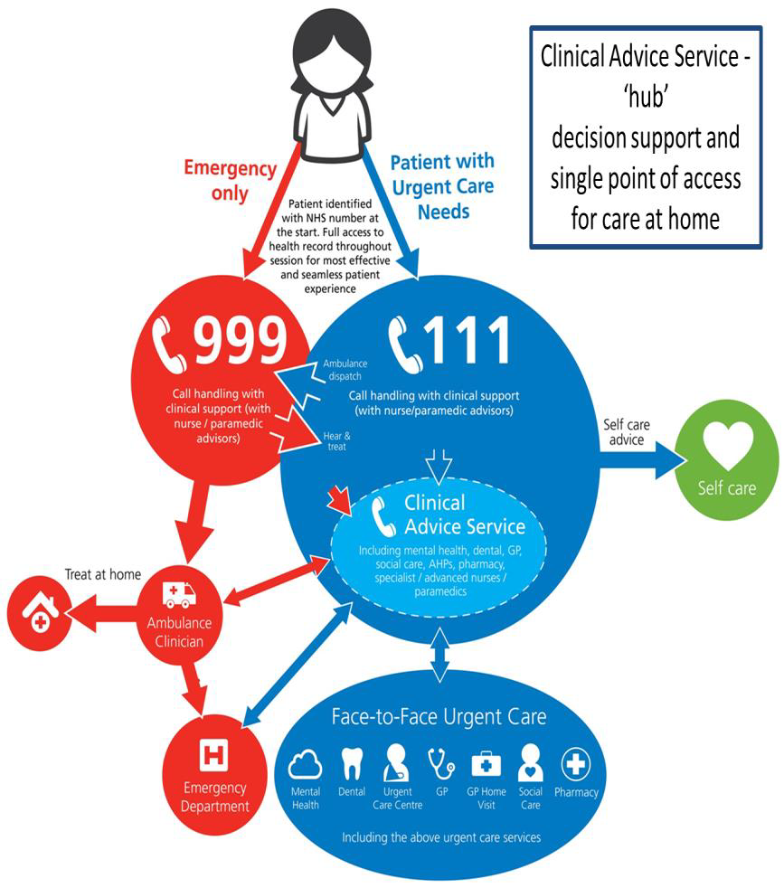

By 30th September the CCG was required to develop lead commissioner arrangements where they are not already in place. NELCCG is already part of a collaborative commissioner arrangement with the other 23 CCGs across Yorkshire and the Humber for the contracting of 111 and 999, and these will be strengthened over the coming months to better reflect the developing STP arrangements.

There is also a requirement within the specification to develop a collaborative provider arrangement to enable all of the required providers to work together to deliver the specification requirements. These collaborative arrangements will be governed by an alliance contract or a lead provider contract.

The CCG has been working with local providers around the development of an accountable care partnership (ACP) and one of the priorities for the ACP is Urgent Care. The CCG and ACP are now working through the requirements and implications of the IUCSS and developing an implementation plan.

The national requirement is for the IUCSS to be delivered by 31st March 2019, and the CCG is currently working through the key milestones that will need to be delivered to ensure compliance with this overall timescale.

Many of the activities that are being progressed as part of the winter plan will contribute towards delivery of the IUCSS, including increased clinical call handling within the SPA, GP streaming, and enhanced rapid response community services to support hospital avoidance.

**Recommendation**

The Board are asked to note the work that is being taken forward in relation to winter planning to ensure continued service delivery over the winter; & the work being undertaken to understand the implications of and actions required by the CCG and system to ensure delivery of IUCSS by 31st March 2019.