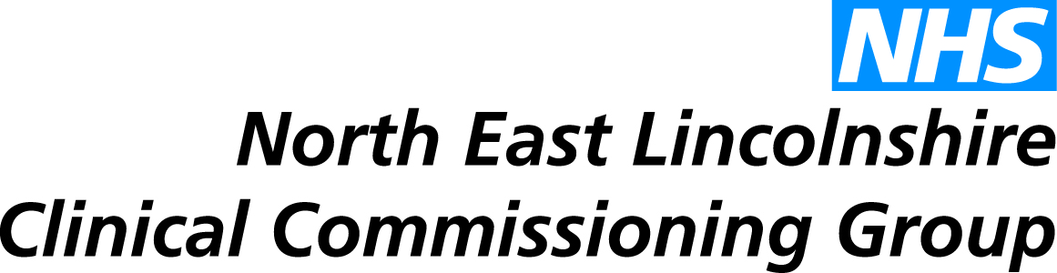
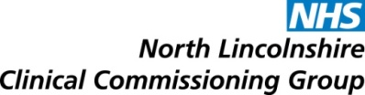
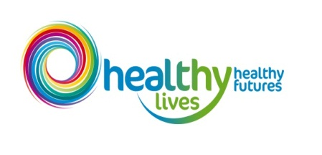
Healthy Lives, Healthy Futures Monthly Report
This report presents information which is drawn from the HLHF reporting process, which is currently under development. Information contained within the report to the board (and the presentation of information) will be updated as the process is refined.
- Programme Progress Report

Key Accomplishments since last report | Upcoming Activities
- Clinical MOU signed off  - Estates Workshop – Mapping Underway  - Approach agreed to support workforce workstream  - Review of HLHF governance by PMO  - Process agreed to align quality lead to Planning and Resource Group work  - Draft narrative slides produced for public audience  - HLHF system wide workshop 3rd September  - Finance/contracting “lock in” session to agree community finance position and action required post September | - Work to refine out of hospital service models and align with in hospital model  - Out of hospital “proof of concepts” to go live Oct/Nov  - Refresh community finance plan  - Review of HLHF risk management process  - Define key HLHF objectives and indicators in terms of quality and sustainability  - Refine marketing comms and engagement dashboard  - Work to develop HLHF brand, website and messaging  - Develop workforce and OD plans

- Programme Overview

The table below shows the total number of schemes due to be implemented in 2015/16 that are being tracked by the HLHF programme. The programme board are currently working on “pipeline planning” for years 2-5.

Total Number of HLHF schemes | NEL CCG Lead organisation | NL CCG lead organisation | NLaG lead organisation | Jointly led
40 | 8 | 9 | 22 | 1

All HLHF schemes are monitored on a gateway system via the HLHF scheme tracker to indicate project progress. A breakdown of the gateway system and the number of schemes currently sitting in each gateway for all HLHF schemes can be seen below:
Gateway Status (No of Projects in each Gateway)

- North East Lincolnshire Transformational Schemes

The table below describes the current North East Lincolnshire schemes being tracked by the Healthy Lives, Healthy Futures programme and the project gateway in which they currently sit. Gateway deadlines are currently being defined and each report will assess actual progress against planned gateway completion dates – current data indicates that all NEL schemes are on track.

Scheme | Actual Gateway | Update/Comments
Advanced Community Care | 4 | On track
End of Life / Palliative Care | 4 | On track
Extra Care Housing | 4 | On track
Frequent Service Users | 4 | On track
GP Front ending | 4 | On track
Home from Home (Grimsby) | 4 | On track
Single Point of Access (Grimsby) | 4 | On track
Support to Care homes (including GP alignment & MDT options) | 3 | On track

- Quality

Work is currently on-going to define programme level Key Performance Indicators and quality targets. These KPIs will be monitored via the HLHF operational group and exceptions escalated to the appropriate senior leads from relevant organisations. This report will define the month on month performance of key quality indicators and provide brief trend analysis.
An updated version of the Integrated Quality Outcomes Framework has been developed with draft KPIs and all programme level KPIs will be mapped against this. Clinical leaders from all organisations within Northern Lincolnshire now need to review this and agree the critical success factors required to define the success of the HLHF programme, in terms of positive impact on quality of services and outcomes for local people.
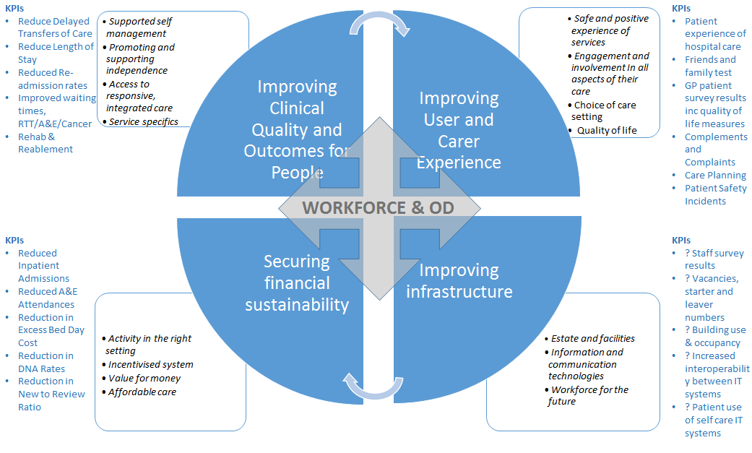
The framework draws on the following four key national frameworks: DH (2014) Adult social care outcomes framework 2015/16; DH (2014) NHS Outcomes Framework 2015; DH (2013) Public Health Outcomes Framework 2013/16; Policy Innovation Research Unit (PIRU) (2014) Integrated care and support Pioneers: Indicators for measuring the quality of integrated care Final report.

- Financial Summary

Work is currently underway to provide a refreshed community finance plan and position against the overall financial gap of £104m by 2019. A “lock in” meeting is to be held on 9th Sept to facilitate this and set out the key elements of the financial timeline over the next few months.
Following the dissemination of letters to all trusts by Monitor requesting that they find additional savings to those planned for the year 15/16, there is a requirement for NLaG to submit their financial plan to Monitor by 31st December 2015. It has been agreed that this should be set in the context of the community finance plan and the work of the HLHF finance group between now and December will support that approach.

- Programme Risk Summary

PMO have reviewed the risk register and identified the need to change the way that programme risks are managed in order to create ownership by those responsible for delivery of mitigating actions. Over the coming weeks, the PMO will work with risk sponsors/workstream leads to:
- Review the risk owners for each risk
- Review each risk and ensure that mitigating actions are relevant and appropriate
- Remove any duplication of risks
- Amend the risk register to reflect risk scores after mitigation has occurred

The risk register is therefore currently under review but the process that will be used is outlined below:
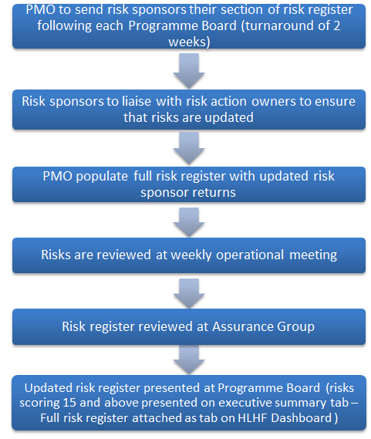

- Programme Timeline

