
Agenda Item 09

Report to (Board/Sub-Committee): NEL CCG Partnership Board

Date of Meeting: 10th November 2016

Subject: Integrated Assurance and Quality Report

Presented by: Cathy Kennedy, Deputy Chief Executive/Jan Haxby Director of Quality & Nursing

STATUS OF THE REPORT

For Information
For Discussion 
For Approval / Ratification

PURPOSE OF REPORT: | The report advises the Partnership Board of how NELCCG are performing against;  - six domains developed for the performance dashboard;  - three domains developed for quality dashboard and;  - six domains for risk.  The dashboards are managed via the Delivery Assurance Committee, the Quality Committee and the Integrated Governance and Audit Committee.  A summary of risks with a score of 16 or above is also included.  For more detail on performance, risk and quality the latest integrated assurance report presented to the Delivery Assurance Committee and quality dashboard report presented to the Quality Committee can be found via the embedded files in the ‘Appendices / attachments’ section of this cover sheet.
Recommendations: | The Partnership Board is asked:  - to note judgements made against the domains of the dashboards  - to note the information on future performance, quality and risk challenges  - to note information on CCG Improvement and Assessment Framework and note on further work being done on A&E improvement.  - for further feedback on ways to improve the report
Sub Committee Process and Assurance: | The Delivery Assurance Committee, the Quality Committee and the Integrated Governance and Audit Committee manage and assure the performance, quality and risks contained within these dashboards.
Implications:
Risk Assurance Framework Implications: | The dashboards and risks associated with them are managed via the Delivery Assurance Committee, the Quality Committee and the Integrated Governance and Audit Committee.
Legal Implications: | None
Equality Impact Assessment implications: | An Equality Impact Assessment is not required for this report.
Finance Implications: | There are a number of measures within the Performance Dashboard with a financial implication such as activity and Quality Premium measures, however the detail of these are dealt with separately within the Finance Report.
Quality Implications: | Quality implications are managed by the quality committee and escalated within the main body of this report.
Procurement Decisions/Implications (Care Contracting Committee): | None
Engagement Implications: | None
Conflicts of Interest | None
Strategic Objectives  Short summary as to how the report links to the CCG’s strategic objectives | - Sustainable Services  The performance, quality and risk dashboards contain a number of national and local measures that support this objective.
- Empowering People

The performance, quality and risk dashboards contain a number of national and local measures that support this objective.
- Supporting Communities

The performance, quality and risk dashboards contain a number of national and local measures that support this objective.
- Delivering a fit for purpose organisation

The performance, quality and risk dashboards contain a number of national and local measures that support this objective.
NHS Constitution: | The Performance and Quality dashboards contain measures from the NHS Constitution and the performance and risks associated with these are managed and assured through the Delivery Assurance Committee, the Quality Committee and the Integrated Governance and Audit Committee.
Report exempt from Public Disclosure | No

Appendices / attachments | 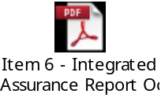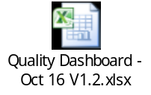

Integrated Assurance & Quality Report

Introduction
The dashboards below represent an overview of performance and quality for health and social care services across North East Lincolnshire.

The performance dashboard consists of six domains and the quality dashboard three domains that incorporate all areas that North East Lincolnshire Clinical Commissioning Group strive to improve on. A judgement has been made of the status for each domain based on the measures and intelligence underpinning them. These judgements try to balance the current position with the expected outcome at the end of the year and weightings with respect to priority. They also represent the local perspective of performance and quality for North East Lincolnshire rather than the performance against the national definition which, on occasion, covers a broader footprint. It should be noted that those issues that have an impact on the CCGs corporate performance assessment will continue to be scrutinised at the Delivery Assurance Committee. The dashboards reflect performance for the first four months of 2016-17. The Delivery Assurance Committee and Quality Committee, respectively, are asked to make a decision on the final status of the dashboards before reporting to the CCG Partnership Board. Full exception report summaries are also included for Performance (appendix A) detailing performance of indicators that are underperforming and risk (appendix B) detailing risks rated as 16 or higher.
Performance Quality
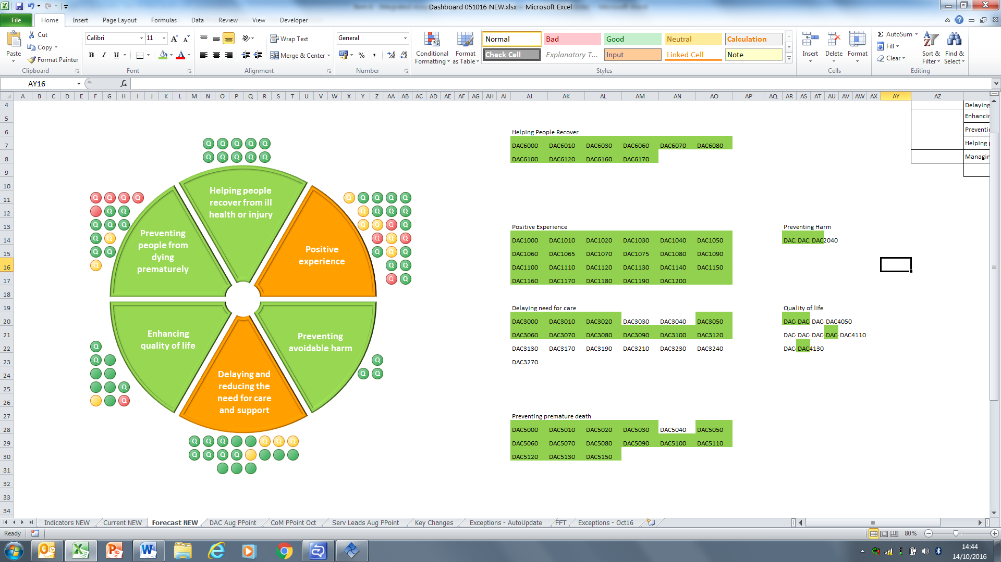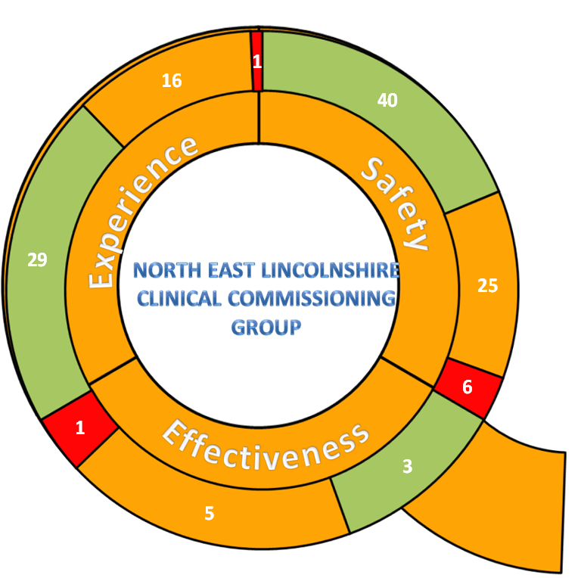
Please note the letter Q indicates a quality measure within the performance dashboard.
The risk heat maps are separated in to a CCG risk register and the CCGs Board Assurance Framework risks. These heat maps demonstrate the number of risks with a specific risk score. The risk summaries reflect the risk status as at 18th October 2016.

Risk Register risk profile Board Assurance Framework risk profile
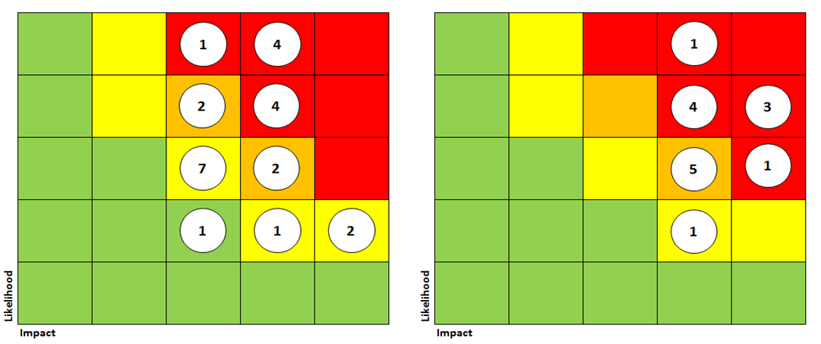

Performance Escalation

A&E performance
Currently there is significant pressures on A&E which is resulting in the trust not meeting the NHS Constitution target of 95% in respect of patients being seen within 4 hours, to add to this attendances are currently 6.35% above target. The chart below show A&E 4hr performance at DPoW.

The new A&E Delivery Board forum has now been established, covering NL and NEL, with the core responsibility of A&E improvement and this forum met for the first time in October 2016 to establish the A&E improvement plan.

A number of actions are being undertaken by this forum including a deep dive on the performance and issues surrounding A&E performance. The results of this deep dive will be brought back and presented to the Delivery Assurance Committee in December which will in turn then be fed back at the Partnership Board meeting in January 2017.

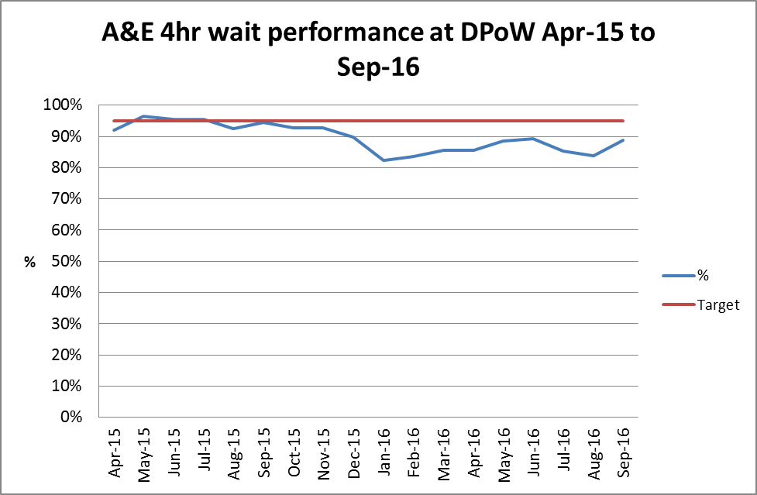

CCG Improvement and Assessment Framework

Background
NHS England introduced a new CCG Improvement and Assessment Framework in 2016/17 to replace both the existing CCG assurance framework and CCG performance dashboard. This new framework provides a greater focus on assisting improvement and aligns with NHS England’s Mandate and planning guidance.
The framework is intended as a focal point for joint work and draws together the NHS Constitution, performance and finance metrics and transformational challenges and will play an important part in the delivery of the Five Year Forward View.
The Forward View and the planning guidance set out national ambitions for transformation in a number of vital clinical priorities such as mental health, dementia, learning disabilities, cancer, maternity and diabetes. NHS England is publishing a rating for each of these six clinical areas for each CCG.
How we compare nationally
The charts below show North East Lincolnshire CCG’s assurance rating against these 6 clinical priority areas and how others are performing too. The charts below show the following;

- In terms of Dementia and Diabetes, NELCCG are amongst the ‘Top performing’ CCG’s in the country.
- For Mental Health NELCCG is rated at ‘Performing well’ which is similar to approximately to a third of other CCG’s in the country. (It should be noted over half the CCG’s are in the ‘Needs improvement’ rating).
- NELCCG is rated as ‘Needs improvement’ for Learning Disabilities, Cancer and Maternity. However when compared nationally the majority of other CCG’s are rated the same in these areas too

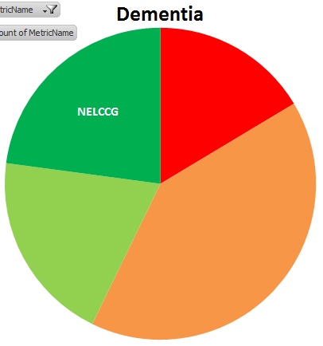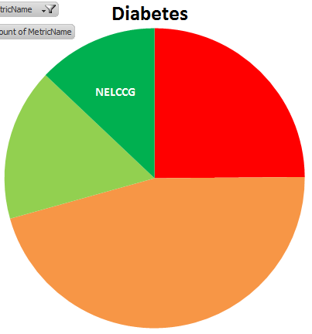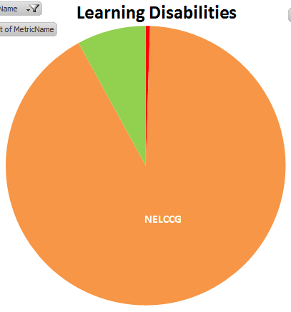
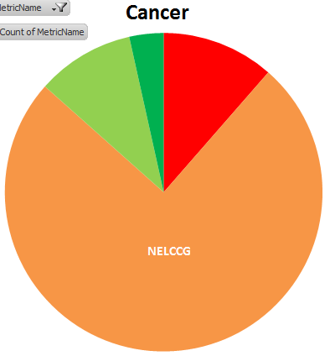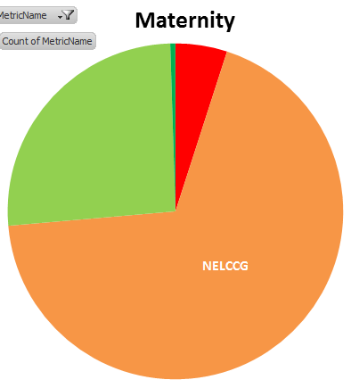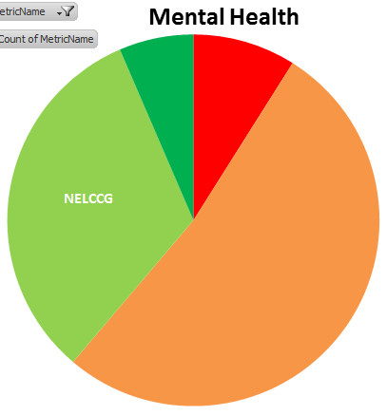

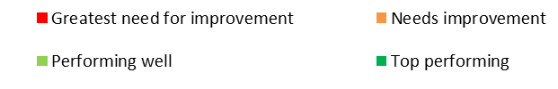

Quality Escalation

The 3 sections below headed as Safety, Effectiveness and Experience, escalate and highlight the key issues to be noted within the attached Quality Dashboard (Excel document attached on page 2), or concerns from the Quality Committee and Quality Team in the CCG.

Domain 1 - Safety
The red indicators within this domain relate to the themes and trends identified in the incidents reported by Navigo and the performance issues reported by EMAS.

Key points to note include:-
- NL&G – Themes & trends in Serious Incidents (SI’s). Four of the six SI’s relating to Maternity services, that were reported in Q1 16/17, have now been rated as assured. Commissioners are seeking further assurance from the Trust for the remaining two SI’s; this position is being monitored via the NL&G Collaborative SI Meeting. Commissioners have developed a positive working relationship with the Trust in relation to learning from SI’s, and as part of this work Commissioners attended a facilitated workshop with the Trust in October 2016 to identify and agree actions to improve the SI working processes. The Local Supervisory Authority (LSA) has undertaken a review of the Trust’s Maternity service, the outcome of this review has now been shared with the Trust and the CCG is working closely with the Trust to manage the recommendations from this review. Further updates on the impact from this review will be shared with Board members in due course.

Summary of action taken: Maternity site visit undertaken by Commissioners in August 16, feedback from the visit has been shared with the Trust and the outcome report has been discussed with the Trust as part of the NL&G QCR meeting on 22 Sep 16. Commissioners await feedback from the LSA following their recent review of the Trusts processes.

- NL&G: Outpatient waiting lists. The Trust continues to report a significant backlog in outpatient waiting lists, in some specialties. The areas with the greatest backlog in outpatient appointments are as follows; Trauma and Orthopaedics, ENT, Ophthalmology and Oral Surgery, Gastroenterology, Cardiology, Dermatology and Respiratory Medicine. However, Commissioners note the good progress made by the Trust in reducing the number of follow up patients that require an appointment, this number has reduced by 13,104 (as at 16/10/16). The Trust provides Commissioners with weekly update reports on the outpatient, inpatient and diagnostic waiting list backlog position, these reports are discussed in detail at the monthly NL&G Executive Contract Board meeting. Although good progress is being made in managing the waiting list backlog, Commissioners have formally requested, via the NL&G Executive Contract Board, further detail and assurance of the Trusts approach to clinically assessing those patients that are currently on a waiting list (especially those waiting >36 weeks). To date, this information remains outstanding.

Points 2 & 3, summary of action taken: Commissioners have requested a comprehensive RTT recovery plan (deadline for submission to Commissioners is 10th Nov 16) and details of the approach taken by the Trust to manage patient harm. Assurance is being managed as part of the NL&G contract management meeting process.

- NL&G: RTT recovery plan. The Trust has reported significant challenges in meeting the 18 week RTT incomplete target (92%) since January 2016, the Trust has reported a deteriorating trend between February 2016 and August 2016 (August is the most recent signed off position). The Trust submitted an interim recovery plan to Commissioners in August 2016. Commissioners have requested that the Trust provides an updated, comprehensive RTT recovery plan including detail and assurance of the Trusts approach to recovering the RTT waiting time position.

- NL&G: Out of hospital SHMI position. The out of hospital HED SHMI in North East Lincolnshire has continued to increase (currently 142 (vs. 114)), the position has increased 8 points since February 2016. This increase is likely to be a result of the Haven Team operating from Grimsby hospital. This service supports patients at end of life to die in their preferred place of care, if outside the hospital, within 3 days maximum. It could be argued that the HED SHMI rose during this time as the team started to rapidly discharge this cohort of patients out of hospital in to the community.

Summary of action taken: The CCG is working closely with Care Plus Group, as employers of the Haven Team, and the Trust to clarify the out of hospital SHMI position. Providers continue to facilitate the preferred place of death for patients at the end of their life. The CCG, Care Plus Group and NL&G staff continue to complete a case review audit to learn from the out of hospital deaths.

- EMAS: Performance Challenges. The Trust continues to report significant challenges in meeting its core performance targets (Red 1, Red 2 and A19), and has not yet met the national improvement trajectory for 2016/17, the Trust has stated (via the EMAS County Commissioning Meeting) that they will not achieve the National Performance Standards for 2016/17. However, the Trust’s performance against the local improvement trajectory is improving. Performance in North & North East Lincolnshire is better than performance across greater Lincolnshire, this is due to the fact that resource drift has had less of an impact in the north of the county than it does in the south of the county, and there are alternative resources available in North and North East Lincs. The Trust has not identified any direct correlation between performance challenges and patient harm.

Summary of action taken: Commissioners to the EMAS contract have jointly commissioned an independent strategic demand and capacity review, the outcome of the review will be implemented on a phased basis over three years commencing 2016/17 through to 2018/19. There are a number of objectives for the review which include the delivery of a clinically and financially safe and sustainable service. The review will align with local Sustainability and Transformation Plans whilst also recognising and being adapted to the changing urgent and emergency care network. It is expected that the final report will be issued to Commissioners early November 16.

- NAVIGO: Themes and trends in SI’s. There has been an increase in the number of SI’s reported by NAViGO relating to the apparent/actual/suspected self-inflicted harm category, 4 SI’s were reported under this category in Q2 16/17 and 1 in Q1 2016/17. All 5 SI’s occurred in the patient’s own home. NAViGO is currently developing action plans to ensure that all lessons learnt from these SI’s are actioned appropriately to mitigate the risk of reoccurrence.

Summary of action taken: The position is being closely monitored by the NELCCG Patient Safety Team as part of the Collaborative SI Meeting, and as part of the NELCCG Incident Meeting. The themes and patterns identified have been incorporated in to the Noise In The System (NITS) work stream.

- NL&G: Improved response to incidents relating to access, appointment and admission. The RAG status for NL&G relating to themes and trends in incident reporting has improved (red to amber); the Trust has provided Commissioners with assurance of action being taken in response to these concerns, as part of the NL&G Quality Review Committee and the NL&G Executive Contract Board. .

Summary of action taken: As part of the NITS work stream relating to patient administration Commissioners have submitted a report to the Trust, via the NL&G Quality Review Committee, outlining the main areas of concern that have been identified through complaints, incidents, SI’s, PALS, contract queries and other quality metrics. Further detail on the impact of the clinical admin review has been requested from the Trust, this information will be provided to Commissioners as part of the monthly contract management meeting structure.

- St Hugh’s: Governance arrangements. Commissioners have identified concerns with regards to the governance arrangements across St Hugh’s hospital, these concerns include delayed submission of quality reports, reduced quality of reports submitted to Commissioners, lack of organisational understanding of incident reporting, lack of triangulation of quality data, lack of evidence of organisational learning.

Summary of action taken: Members of the NELCCG Quality Team have been working closely with the Senior Team at St Hugh’s hospital to develop a new quality dashboard. In addition to this, the CCG has agreed to incentivise implementation of the Datix system across the hospital via the local CQUIN scheme during Q3 and Q4 2016/17.

Domain 2 - Effectiveness

Key points to include:-
- NL&G: Compliance with NICE guidance. The Trust continues to breach the performance target for compliance with NICE Guidance; the target is 90% (internal target) and the Trust achieved 65% compliance in July 16 (most recent data available). This is a deterioration of 11.5% since the previous reporting period. The Trust has not achieved the performance target for compliance with NICE guidance during 2016/17, and for the majority of 2015/16. The Trust has confirmed that the main obstacle to achieving this target relates to a vacancy of the NICE Co-ordinator, this is a pivotal role in overseeing co-ordination of the NICE compliance process. However, the Trust confirmed (on 20/10/16) that this vacancy has now been filled; and as a result of this the Trust anticipates that the compliance position will soon improve. In the meantime, the Trust will undertake a clinical review of NICE guidance that remains outstanding, the outcome from this review will be submitted to Commissioners via the NL&G Quality Review Committee for consideration.

Summary of action taken: This position is being closely monitored as part of the monthly NL&G contract management meeting structure. The Trust provides a comprehensive update report on the NICE compliance position to Commissioners on a quarterly basis and NICE compliance is incorporated into the monthly Quality Report.

- HEY: Compliance with NICE guidance. The Trust has reported deterioration in the number of NICE guidance that have been fully implemented by the Trust. The number of guidance that have not yet been implemented has risen to 75.

Summary of action taken: Commissioners have requested a full review of NICE compliance, including the Trusts approach to managing this position, to be submitted to Commissioners via the monthly HEY Clinical Quality Forum.

Domain 3 - Experience

Key points to include:-
- NL&G – Increase in the number of complaints relating to staff attitude, identified via the Trust’s Complaints Report. Pattern identified via the Trust’s PALS team relating to lack of communication between professionals, service users and patients.

Summary of action taken: These themes and patterns have been reported to the Trust via the NL&G Quality Review Committee (QRC), the Trust has agreed to provide feedback to Commissioners on these findings including action to be taken by the Trust via the NL&G QRC.

- HEY – Increase in the number of complaints made about waiting times and cancelled appointments, specifically in relation to follow-up appointments and elective waiting times.

Summary of action taken: Commissioners have requested, via the HEY Clinical Quality Review (CQF), that the Trust undertakes a clinical review of all patients on the waiting list, the outcome from this review will be completed by end of December 16 and submitted to Commissioners via the HEY CQF.

- EMAS – The Trust has fallen below the target for completion of PALS responses within 20 days. The CCG is working closely with the Quality Lead in NHS Hardwick CCG, as the Lead Commissioner for EMAS, to review the Trusts compliance with all quality metrics. The outcomes from these discussions are being escalated to the Lincolnshire County Commissioning Meeting.

Items for Escalation from the Quality Committee
Members of the NELCCG Quality Committee, that took place on 13/10/16, identified two items for escalation to the Board, these items are summarised below:

- Concern over delay, underinvestment and underfunding regarding support service for victims of Domestic Violence/Abuse
- Concerns around the culture, identified by the LSA, and themes and trends identified via the collaborative SI process, in relation to Maternity services at NL&G Foundation Trust

Other Key Points to Note (not already covered in the section above)
The CCG Quality Team is in the process of developing local quality requirements for inclusion in the contracts for our Providers; these requirements include KPI’s, audit programme and CQUIN scheme. The quality schedule for each contract will support implementation of the CCG’s Commissioning Intentions and will reflect areas identified for further development in the CCG’s quality dashboard.

The CQC have completed their unannounced inspection at NL&G NHS Trust prior to their announced inspection in November. The Trust has informed the CCG that feedback from the Trust has been positive following the unannounced inspection – good practice had been noted. The Trust reported that no immediate concerns requiring urgent action had been identified by the CQC.

NHSI continue to work closely with the Trust. NELCCG commissioners and Quality Team supported the Trust in an inspection of the DPoW site. Feedback and actions following the mock inspection will be received at the NL&G Quality Review Committee. Commissioners received thanks from the Trust for the support given in this improvement initiative.

Appendix A - Performance Exception Summary
Code | Indicator | Quality Measure? | Latest period |  |  |  | 2016/17 year to date |  |  | Year End Forecast
Code | Indicator | Quality Measure? | Period | Target | Value | Status | Target | Value | Status | Year End Forecast
Positive experience
DAC1000 | Total time in A&E: four hours or less | Yes | September 2016 | 95% | 92.34% |  | 95% | 91.79%
DAC1050 | The number of carers whose needs were assessed or reviewed by the council in a year who received a specific carer's service, or advice and information in the same year as a percentage of people receiving a community based service in the year. | Yes | September 2016 | 35% | 21.57% |  | 35% | 21.57%
DAC1065 | Friends & Family - Ambulance - % Who would recommend 'SAT' service | Yes | August 2016 | 95.49% | 77.78% |  | 94.62% | 83.33%
DAC1075 | Friends & Family - Ambulance Response (SAT) | Yes | August 2016 | 0.07% | 0.06% |  | 0.08% | 0.05%
DAC1080 | Friends & Family - AAE % Who would recommend service | Yes | August 2016 | 86.86% | 82.28% |  | 86.03% | 82.89%
DAC1090 | Friends & Family - AAE Response (NLAG) | Yes | August 2016 | 13.66% | 7.44% |  | 13.1% | 8.7%
DAC1110 | Friends & Family - Inpatient Response (NLAG) | Yes | August 2016 | 25.22% | 19.02% |  | 25.61% | 18.45%
DAC1120 | Friends & Family - Outpatient - % Who would recommend service | Yes | August 2016 | 92.88% | 78.65% |  | 92.79% | 86.53%
DAC1130 | Friends & Family - Outpatient Response | Yes | August 2016 | 6.48% | 0.28% |  | 6.46% | 0.3%
DAC1150 | Friends & Family - Community Response (CPG) | Yes | August 2016 | 3.76% | 1.11% |  | 3.68% | 0.64%
DAC1190 | Friends & Family - Maternity Response (NLAG) Birth | Yes | August 2016 | 22.86% | 5.85% |  | 23.72% | 17.31%
Preventing avoidable harm
No exceptions
Delaying and reducing the need for care and support
DAC3050 | Delayed transfers of care from hospital per 100,000 population | Yes | August 2016 | 6.61 | 2.39 |  | 6.61 | 7.33
DAC3060 | Delayed transfers of care from hospital which are attributable to adult social care per 100,000 population | Yes | August 2016 | 1.96 | 1.59 |  | 1.96 | 2.23
DAC3070 | Delayed transfers of care (delayed days) from hospital per 100,000 population (aged 18+). | Yes | August 2016 | 218.53 | 147.41 |  | 1092.65 | 1203.98
DAC3130 | The proportion of older people aged 65 and over offered reablement services following discharge from hospital. | No | March 2016 | 1.35% | 1.30% |  | No data available for 2016-17
Enhancing quality of life
DAC4110 | Total admissions - Unplanned hospitalisation for asthma, diabetes and epilepsy in under 19s | No | August 2016 | 10 | 7 |  | 37 | 40
DAC4130 | End of life care – Percentage of all deaths that occur at home (including care homes) | Yes | Q4 2015/16 | 52% | 48.18% |  | No data available in 2016-17
Preventing people from dying prematurely
DAC5000 | Category A (RED1) calls meeting eight minute standard (EMAS) | Yes | September 2016 | 75.00% | 70.33% |  | 75.00% | 69.10%
DAC5010 | Category A (RED2) calls meeting eight minute standard (EMAS) | Yes | September 2016 | 75.00% | 57.26% |  | 75.00% | 57.43%
DAC5020 | Category A calls meeting 19 minute standard (EMAS) | Yes | September 2016 | 95% | 84.92% |  | 95% | 85.29%
DAC5030 | Category A calls meeting 19 minute standard (NELCCG) | Yes | September 2016 | 95% | 89.84% |  | 95% | 89.54%
DAC5040 | Ambulance 30 minute average turnaround time target - DPOW | No | September 2016 | 30 mins | 33.23 mins |  | 30 mins | 33.61 mins
DAC5110 | Cancer 62 Days Referral to Treatment (GP Referral) | Yes | August 2016 | 85% | 83.67% |  | 85% | 78.41%
DAC5150 | Summary Hospital Mortality Index (SHMI) - NLAG | Yes | March 2016 | 100 | 108.9 |  | No data available in 2016-17
Helping people recover from ill health or injury
No exceptions

Appendix B – Provider-level Quality Dashboards
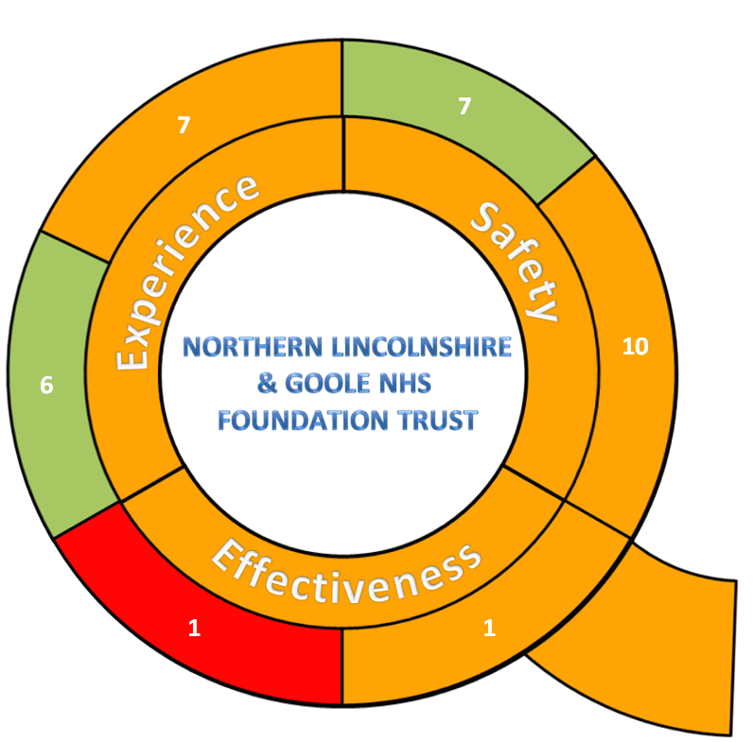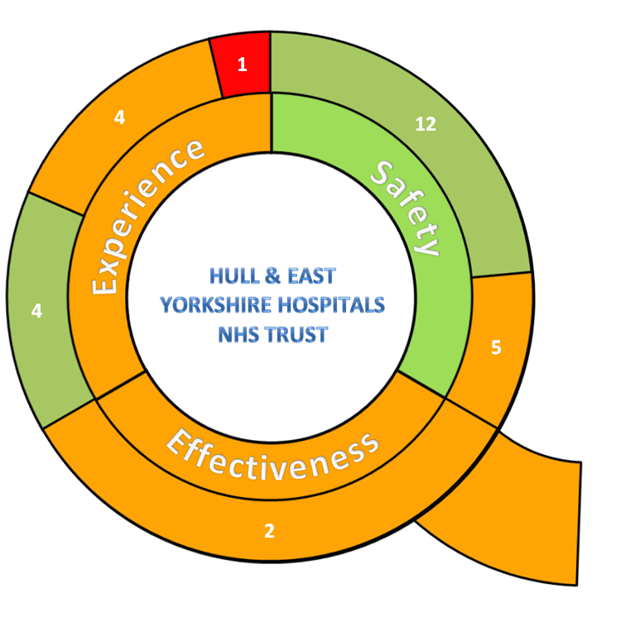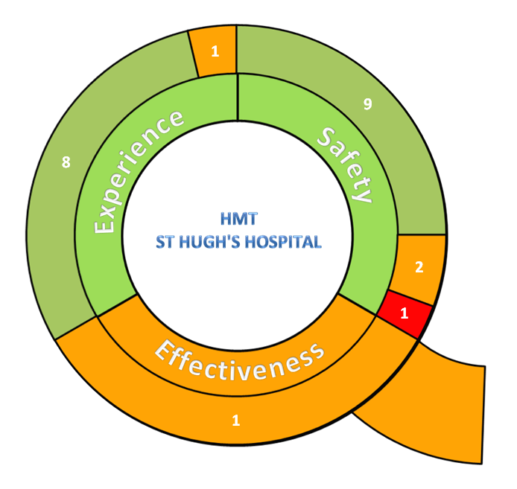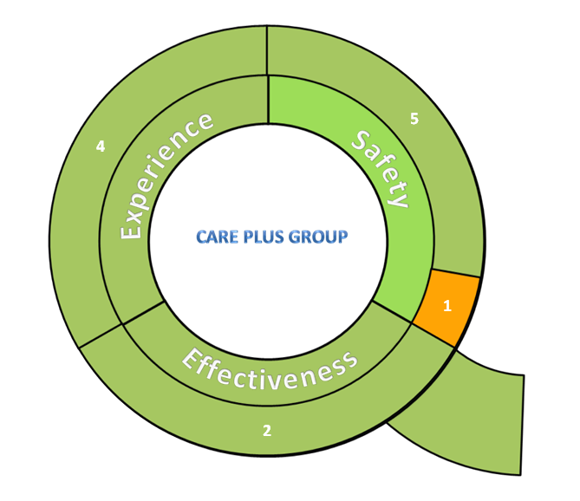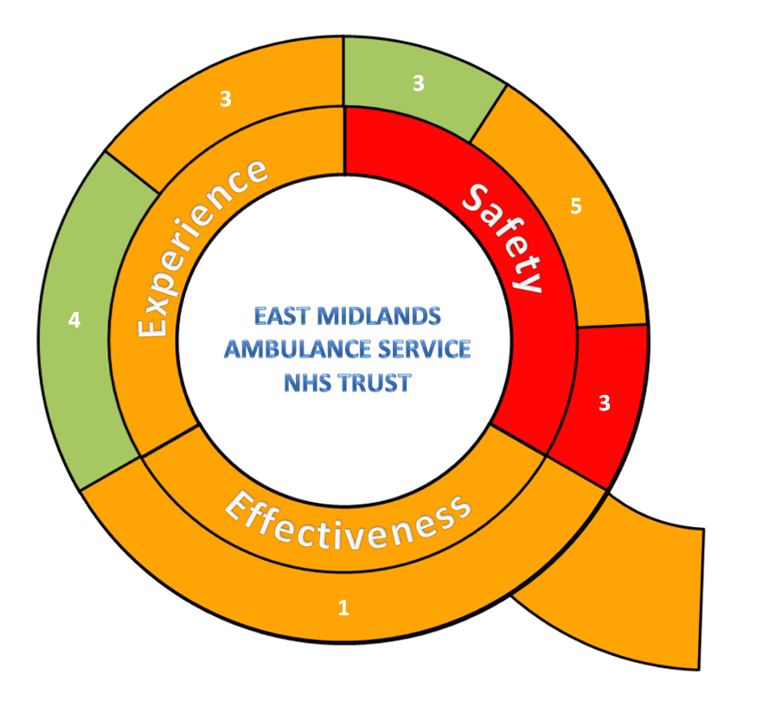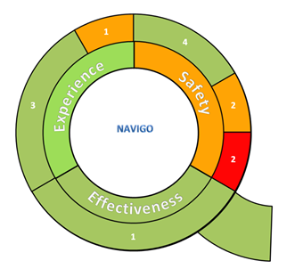
Appendix C – Risk Exception Summary

The table below reflects risks rated as 15+ (high to significant) on the risk register as at 18 October 2016

Code & Title | Risk Lead | Internal Controls | Current Residual Risk Rating | Latest Note
CCG-RR.2004 Failure to achieve Accident and Emergency 4 hour targets | Andy Ombler | CCG-RR.2004b Action Plans  CCG-RR.2004c A&E Delivery Board | 20 | 14/10/2016 - Andy Ombler reviewed the risk updated as follows:-  The A&E Delivery Board structure is now established and meets for first time 20th Oct 2016. Andy is to ensure the first meeting/ identifies membership & receives a paper on the mandated improvement initiatives and core responsibilities.
CCG-RR.2005 18 Week RTT Performance | Pauline Bamgbala | CCG-RR.2005a Commissioning Action Plan  CCG-RR.2006b Updates go to Service Lead meetings, CoM and System Resilience Group  CCG-RR.2005c Clinically led collaborative meeting with providers  CCG-RR.2005d Financial Penalties | 20 | 05/10/2016 - Pauline Bamgbala reviewed and updated the risk as follows:- There has been a further deterioration in 18w performance. The CCG has a recovery plan in place which has been shared with NHS England. The latest recovery trajectory from NLaG is that it will be back on track by March 2017. Risk rating increased.
CCG-RR.3006 Failure to manage residential and domiciliary care packages within budget | Joe Warner | CCG-RR.3006a Delivery and Assurance Committee  CCG-RR.3006b Risk and Quality Panel  CCG-RR.3006c Financial Programme Board  CCG-RR.3006d SWP/CCG joint meeting  CCG-RR.3006e Focus internal controls | 20 | 06/10/16 - Joe Warner reviewed & updated the risk as follows:- Whilst the current spend still looks on target we are entering the winter period when demand is likely to increase and therefore remains at 20.
CCG-RR.4004 The new DoLS requirements are unable to cope with the increasing number of requests for authorisation | Bruce Bradshaw | CCG-RR.4004a Monitoring of activity at DAC and Safeguarding Board  CCG-RR.4004b Strategic Mental Capacity Group | 20 | 22/9/16 Helen Kenyon reviewed & updated the risk as follows:- There is no change in the level of risk, it is still high, as we are still putting processes in place to manage the range of people in different settings which is adding to the overall capacity pressure.
CCG-RR.2002 NELCCG Response to the Francis report & recommendations made by East Coast Audit Consortium - Report Reference 140708 (June 2014) | Lydia Golby | CCG-RR.2002a The Francis Report  CCG-RR.2002b Action Plan | 16 | 17/10/12016 - Lydia Golby reviewed & updated the risk as follows:-  no change to the risk at this time as actions continue to progress, but are not yet complete..
CCG-RR.3003 Adult ADHD Pathway breakdown | Leigh Holton | CCG-RR.3003a Council of Members (CoM)  CCG-RR.3003b PALs monitoring logs | 16 | 05/10/16 Leigh Holton reviewed the risk - no changes to note  Last note of changes - 30/6/16 Leigh Holton reviewed this risk and amended the risk title, risk description and internal controls.
CCG-RR.3007 Failure to live within the CCG's allocated budget for ASC | Rachel Brunton | CCG-RR.3007a Transformational efficiency plan  CCG-RR.3007b QiPP Programme  CCG-RR.3007c Regular monitoring | 16 | 25/8/16 Rachel Brunton and Helen Kenyon will be reviewing this risk imminently to decide if the current risk rating should now be reduced.  19/8/16 Rachel Brunton reviewed and updated the risk as follows:-  The current 2016/17 budget monitoring suggests ASC will perform within its financial envelope for 2016/17.
CCG-RR.4008 Cash flow and management of one Domiciliary Care Provider (LQCS) | Brett Brown | CCG-RR.4008a On-going close monitoring of situation  CCG-RR.4008b Actions from LQCS | 16 | 14/10/2016 - Brett Brown reviewed & updated the risk as follows:-  No change to risk. LQCS are working to the submitted action plan with an end date of 3rd November.  No additional risks have been identified with LQCS working positively to the plan.
CCG-RR.1005 Failure to deliver 300 Extra Care Housing flats by the end of 2018 | Rachel Brunton | CCG-RR.1005a Delivery vehicle in place  CCG-RR.1005b Extra Care Housing Steering Group | 15 | 20/9/16 Rachel Brunton reviewed & updated the risk as follows:  Housing Benefit announcement from Government issued 15/9/16 relating to future funding model to protect the supported accommodation sector from the Local Housing Allowance Cap. This will be effective in 2019/20. However the announcement was unclear with its intention regarding the older people sector. Tour of available sites within North East Lincolnshire was held on 16/9/16; suitable sites are being appraised.

The table below reflects risks rated as 15+ (high to significant) on the assurance framework as at 18 October 2016

Code & Title | Assigned To | Internal Controls | Current Residual Risk Rating | Latest Note
CCG-BAF.3002 Risk that Healthy Lives, Healthy Futures will not deliver the quality and financial sustainability outcomes in the requisite timeframe | Donna Hill | CCG-BAF.3002a Healthy Lives Healthy Futures finance group  CCG-BAF.3002b HLHF System Board  CCG-BAF.3002c Governance Framework | 20 | 17/10/2016 - Donna Hill reviewed and updated as follows:- The internal controls and Gaps in Controls and Gaps in Assurances have all been updated.  Julie Wilson advised the programme management role has now been taken on by Donna Hill at Care Plus Group, on behalf of the ACP. Risk transferred to Donna.
CCG-BAF.3003 Financial challenges | Cathy Kennedy | CCG-BAF.3003a IG&A Committee  CCG-BAF.3003b CCG/LA position monitoring meetings  CCG-BAF.3003 HLHF programme and contract arrangements | 20 | 06/10/16 Cathy Kennedy reviewed & updated the risk as follows:-  No change to scores or controls but risks are escalating and remedial action is being taken led by Senior Management team, as reported to the Partnership Board in October 2016
CCG-BAF.4001 Statutory duty to consult | Lisa Hilder | CCG-BAF.4001a Senior management links to HLHF and STP programmes  CCG-BAF.4001b ASC Financial Programme Board  CCG-BAF.4001c DCU monitoring of service proposal management tool | 20 | 06/10/2016 Lisa Hilder reviewed & updated the risk as follows:-  Further conversation took place with Caroline Briggs who is not yet in a position to clarify what specific projects will be taking place under the renewed HLHF banner. This presents an on-going risk in relation to ensuring correct engagement and consultation processes are undertaken for this programme. An additional concern is the lack of resource allocated to deliver engagement and consultation which could place an unmanageable burden on the CCGs’ team.
CCG-BAF.4007e  Establishment of the Accountable Care Partnership in North East Lincolnshire | Helen Kenyon | CCG-BAF.4007e(1) ACP Shadow Board  CCG-BAF.4007e(2) ACP Workplan in place  CCG-BAF.4007e(3) Programme Manager appointed | 20 | 11/10/2016 - new risk added - Helen Kenyon provided the following update:-  Shadow Board for the ACP has been established which the CCG is a member of. This group is meeting regularly  Terms of Reference detailing the outputs required to establish the ACP, and a workplan to provide timelines and oversight of progress have been produced. A programme manager is in place to support overall delivery of the programme
CCG-BAF.4007 Establishment of new system management arrangements | Cathy Kennedy | CCG-BAF.4007a Senior Leadership  CCG-BAF.4007b Senior Officer Membership  CCG-BAF.4007c Existing Partnership Arrangements  CCG-BAF.4007d STP Plan | 16 | 06/10/16 Cathy Kennedy reviewed and updated the risk as follows:- controls and assurances to reflect progress, and reduce ‘impact’ assessment from 5 to 4 – risk decreased from 20 - 16
CCG-BAF.4007b Development of Joint strategic commissioner across NEL and NL | Cathy Kennedy | CCG-BAF.4007b(1) Board membership  CCG-BAF.4007b(2) Monitoring of delivery of terms of reference and effectiveness | 16 | 06/10/16 Cathy Kennedy reviewed this risk and made no amendments  Latest note of change  19/09/16 Cathy Kennedy advised an additional positive assurance has been added - Joint Strategic Commissioner forum established with Terms of Reference and clear reporting/interface with System Board and STP.  The gaps in assurances amended to note a forward work plan is under development
CCG-BAF.4007d  Sustainability Transformation Plan | Helen Kenyon | CCG-BAF.4007d(1) Executive Group  CCG-BAF.4007d(2) STP Programme Manager been appointed | 16 | 11/10/2016 - new risk added - Helen Kenyon  The STP programme has now been established. and currently working on strengthening the governance of the programme, the CCG's Deputy Chief Exec and Clinical Accountable officer are both to be members the Executive group  STP submissions have gone in on time and feedback received from NHSE, which is being acted on. CCG collaborative is looking to put in place a joint commissioning committee, which members of the CCG's leadership team will sit on, to ensure that decisions made by the STP reflect commissioner requirements and priorities.
CCG-BAF.2002 Risks in delivery of key annual performance indicators and standards including constitutional standards | Martin Rabbetts | CCG-BAF.2002a Delivery Assurance Committee (DAC)  CCG-BAF.2002b Contract performance management  CCG-BAF.2002c Quality Premium target setting and  monitoring arrangements  CCG-BAF.2002d Local Quality Schemes in primary care  CCG-BAF.2002e CCG/Focus joint meeting  CCG-BAF.2002f Public Health outcomes | 16 | 13/10/2016 - Martin Rabbetts reviewed the Risk advised no changes required.  Latest note of change:-  29/06/16 Cathy Kennedy & Martin Rabbetts carried out a full management review of this risk and amended the title, description, internal controls, assurances on controls, positive assurances and increased the current risk rating to 4x4=16.
CCG-BAF.1001 Summary Hospital Mortality Indicator (SHMI) Organisational Risk | Jan Haxby | CCG-BAF.1001a Strategic Mortality Stakeholder Groups  CCG-BAF.1001b NLaG Contract Management Board  CCG-BAF.1001c QCR meeting (quality contract control)  CCG-BAF.1001d HED SHMI action plan | 16 | 05/10/16 Jan Haxby reviewed & updated the risk as follows:- Amendments were made to Control 1001a, the assurances on controls, the positive assurances, gaps in controls and gaps in assurance. The risk rating remains the same.

