**Agenda Item:**

**Report to:** Integrated Governance & Audit Committee

**Date of meeting:** 30/08/2021

**Date paper distributed:** 15/03/2021

**Subject:** Performance Report (quarterly)

**Presented by:** N/A

**Previously distributed to:** N/A

**STATUS OF THE REPORT *(auto check relevant box****)*

**Decision required**

**For Discussion to give Assurance**  *(Only if requested by Committee member prior to meeting)*

**For Information**

**Report Exempt from Public Disclosure**   No  Yes

|  |  |
| --- | --- |
| **PURPOSE OF REPORT:** | To update and inform the Integrated Governance & Audit Committee on North East Lincolnshire CCG’s current and forecast performance position against the national and local health and adult social care frameworks. |
| **Recommendations:** | The Integrated Governance & Audit Committee is asked to note the contents of the report for information. |
| **Clinical Engagement** | N/A |
| **Patient/Public Engagement** | N/A |
| **Committee Process and Assurance:** | The Integrated Governance and Audit Committee manage and assure the performance contained within these dashboards. |

|  |  |  |  |  |
| --- | --- | --- | --- | --- |
| **Link to CCG’s Priorities** | * Sustainable services * Empowering people |  | * Supporting communities * Fit for purpose organisation |  |
| **Are there any specific and/or overt risks relating to one or more of the following areas?** | * Legal * Finance * Quality * Equality analysis (and Due Regard Duty) |  | * Data protection * Performance * Other |  |

**Provide a summary of the identified risk**

|  |
| --- |
| All measures within the Performance Dashboard have a performance implication, however the detail of these are managed by the respective Service Leads and at Contract meetings and then assurance is gained on that basis and presented to the Integrated Governance & Audit Committee for information only. |

**Executive Summary:**

This report aims to update and provide assurance to the Integrated Governance & Audit Committee on North East Lincolnshire CCG’s current and forecast performance position against the performance measures contained within the various national, local health and adult social care frameworks.

The report shows performance by service area, key changes since previous report along with drawing particular focus to those measures escalated by NELCCG’s Operational Leadership Team (OLT) as exceptions.

A full list of measures showing current and forecast performance is also included as Appendix A.

# **Performance by Service Area**

1. Below is a table showing NELCCG’s current and forecast performance position by Service Area and the number of measures in each status of either Green, Amber or Red.

**Service Area by Current Status**

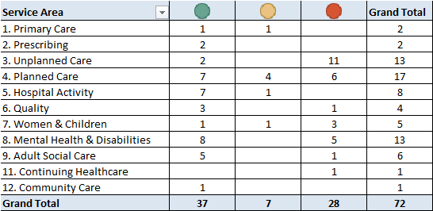

**Service Area by Forecast Status**

# **Key changes in Performance**

1. A number of the national measures have been suspended due to COVID-19 and their collection will not resume again until November 2021 (these are highlighted **grey** in the full report - Appendix A). It should be noted that because of this the CCG are currently unsighted in terms of performance on these measures.
2. Areas facing particular challenge in this quarter were;

**Unplanned Care**

* Total time in A&E: four hours or less –performance has been c72% for the last 6 months, however notably the most recent month July 2021 saw the figure fall to 63.9%. There is increased pressure both on the Emergency Care and Urgent Care system and therefore this has been escalated as an exception for this report (please see exception section below for full comments)
* A number of the Ambulance Response Time measures have seen a fall in performance over the last quarter again and as highlighted above there is an increased pressure on the Emergency Care system and therefore these measures have been escalated as an exception for this report (please see exception section below for full comments).
* Proportion of older people (65 and over) who were still at home 91 days after discharge from hospital into reablement/rehabilitation services – currently we only have the April 2021 figure from Care Plus Group due to resourcing issues they are currently experiencing however the figure for April was 63.6% which is a significant drop when compared to historical performance. Recurrent falls, a number of stroke patients, as well as a further cohort that arrived with significant health comorbidities and being generally unwell impacted on the attainment of this target. It should be noted that although we monitor performance on this measure on a monthly basis locally the actual national definition for this measure is only judged on discharged patients over a 3 month period from October to December.

**Planned Care**

* Cancer 62 Days Referral to Treatment (GP Referral) - is still below the national ambition, however performance has improved over the last 2 months.
* Cancer 62 Days Referral to Treatment (Screening Referral) - continues to be below the national ambition, however performance has been sustained at c70% and it should be noted that small numbers are involved in the calculation of this measure which in turn significantly impacts the performance.
* Cancer 62 Days Referral to Treatment (Consultant Upgrade) – performance for June 2021 was 50% however it should be noted that small numbers are involved in the calculation of this measure which in turn significantly impacts the performance.
* RTT – Waiting list size continues to increase and is above the target set although it should be noted this has been seen across other trusts too nationally.

**Women & Children**

* The proportion of CYP with ED (routine cases) that wait 4 weeks or less from referral to start of NICE-approved treatment - this measures performance has continued to deteriorate; however, it should be noted small numbers have a significant impact on this indicator.

**Mental Health & Disabilities**

* Estimated diagnosis rate for people with dementia - this measures performance has continued to be below the national ambition.

1. Areas seeing improvements in this quarter were;

**Planned Care**

* RTT - Incomplete Patients: % Seen Within 18 Weeks, is below the national ambition, however performance has improved very slightly month on months since February 2021.
* RTT - Number waiting on an incomplete pathway over 52 wks – performance has improved month on month since March 2021 aside from the latest month however the increase is only 5 over the previous month.
* Percentage of Patients waiting <6 weeks for a diagnostic test is below the national ambition, however performance has improved month on months since February 2021.

# **Performance Exceptions / Escalations – March 2021**

Please note key below to data and icons on Statistical Process Control (SPC) graphs;

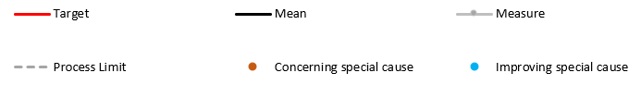

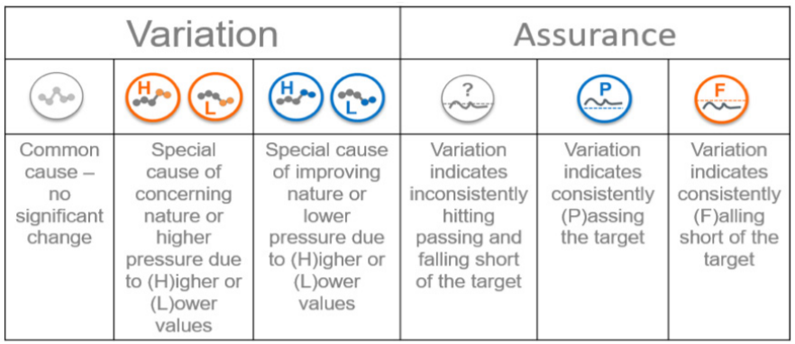

**Emergency and Urgent Care Pressures**

There is an increasing demand on Emergency and Urgent Care Services and this is expected to continue which will in turn pose a significant risk over the winter period. Some of the actions being taken include;

* HCV agreeing to extend VOCARE. The further development of the proposed services is to integrate the core and local CAS services to manage the increased volumes of patients expected to be received into the service and provide a clinical validation and redirection to a more clinically appropriate service or call closure via advice on self-help and safety netting. This will be achieved by patients who have contacted the service and have been assessed and deemed to require clinical input, receiving a clinical telephone or video consultation in order to validate their requirement and where appropriate offer a clinically safe alternative care pathway. The most efficient delivery model that provides best patient impact, system benefit and value for money is to aggregate the services together and provide a 24/7 CAS that incorporates the additional service of primary Care 1 & 2 hours, NHS111 online and clinical messaging. This service is expected to handle 1479 cases per week and redirect / close 70% of these (1035 cases) that would historically have attended ED or primary care, excluding enhanced clinical input to the YAS CAS and the clinical messaging proof of concept.
* An audit of A&E attendances was conducted in May and a full report will be provided to the AEDB in July to inform commissioning priorities. The Urgent Treatment Hubs are progressing as an alternative to UTC provision with the first Hub expected to go live before 1 October and further hub to follow by 1 November. The hubs will each have the capacity to divert approximately 25 patients per day away from A&E and can be scaled as demand and capacity allows. Direct booking remains a priority and developments with Any to Any booking are fed back via the regional 111 First Group. Work is underway to understand resource requirements for CUCT to deliver 2 hour crisis response from 1 April 22. The Trust are working with HCV to pilot an A&E streaming and redirection tool ahead of winter to ensure patients presenting to A&E are seen in the most appropriate service.

The 2 measures below have been raised as exceptions due to the current increased demand in Emergency and Urgent Care Services.



# **Appendix A – Full IG & Audit Report September 2021**

