Agenda Item:

Report to: Governing Body
Date of meeting: 17/02/2022
Date paper distributed: 14/02/2022
Subject: Q3 Finance report
Presented by: Laura Whitton
Previously distributed to: N/A

STATUS OF THE REPORT

Decision required ☐
For Discussion to give Assurance ☒
For Information ☐
Report Exempt from Public Disclosure ☒ No ☐ Yes

PURPOSE OF REPORT: | To provide an update on the financial position as at Q3 and the forecast for the Integrated Care System and CCG.
Recommendations: | To note the financial position at Q3, period ending 31st December 2021
Clinical Engagement | N/A
Patient/Public Engagement | N/A
Committee Process and Assurance: | N/A

Link to CCG’s Priorities | - Sustainable services  - Empowering people | ☒  ☐ | - Supporting communities  - Fit for purpose organisation | ☐  ☒
Are there any specific and/or overt risks relating to one or more of the following areas? | - Legal  - Finance  - Quality  - Equality analysis (and Due Regard Duty) | ☐  ☒  ☐  ☐ | - Data protection  - Performance  - Other | ☐  ☐  ☐

Provide a summary of the identified risk
Health:
- The key risk relates to the fact that year end work is having to be done alongside the transition and planning.
Adult Social Care:
- Forecasting “datasets” are not settled and as such are at risk of change
- Government covid-19 grant support to Care Providers is confirmed to 31st March 2022 however there is an increasing risk to workforce capacity and retention within the care sector

Executive Summary

Health:

The CCG has continued to operate within the revised finance regime which was put in place due to the pandemic. The figures in this report reflect the full year and combine H1 (Apr21-Sep21) and H2 (Oct21-Mar22).

2021/22 Allocation | Full Year (Q3) | H1 report (Q2)
 | £'000 | £'000
Confirmed & received
CCG programme | 281,512 | 140,080
CCG delegated | 29,459 | 14,550
CCG running costs | 3,174 | 1,587
Covid outside of envelope | 1,941 | 1,328
 | 316,086 | 157,545
Confirmed but not yet received
Agenda for Change Pay Award (Retrospective payment m1-m6) |  | 293
Elective Recovery Fund - risk share adjustment (subsequently reversed) | (227)
TOTAL ALLOCATION | 315,859 | 157,838

There has been a £158.0m increase in the allocation since Q2, the key movements being :-
- the H2 plan allocation (as per the Q2 report) of £155.1m
- Covid outside of envelope; hospital discharge funding claimed for Q2 & Q3
- Funding for specific initiatives, such as Primary Care IT, Mental Health

Q3 Summary
 | Budget Full Year | Forecast Over/(Under) spend | Q3 YTD Over/(Under) spend | Q2 YTD Over/(Under) spend
 | £000's | £000's | £000's | £000's
Acute Services | 151,651 | 980 | 608 | (277)
Mental Health Services | 37,826 | (11) | 37 | (56)
Community health Services | 22,316 | (94) | (87) | 24
Continuing Care Services | 9,555 | (267) | (221) | 45
Primary Care Services (inc. Prescribing) | 39,842 | (100) | (143) | 156
Primary Care Co-Commissioning | 29,536 | (222) | (232) | (77)
Other Programme Services | 13,912 | 4 | 269 | 233
Running Costs | 3,074 | (290) | (243) | (100)
TOTAL EXPENDITURE | 307,712 | (0) | (12) | (52)
TOTAL ALLOCATION | 315,859 | 0 | 0 | 0
Surplus/(Deficit) | 8,147 | 0 | (12) | 0
- In Year | 0 | 0 | (12) | 0
- Historic Surplus brought forward | 8,147 | 0 | 0 | 0
 | 8,147 | 0 | (12) | 0

Q3 YTD variances to note are:

- Acute Services:
- NOUS (Non-Obstetric Ultrasound); whilst monthly activity levels have reduced, the overspend year to date is £637k (Q2 - £619k overspend). As reported previously this is due increased activity of ultrasound guided injections, historically this activity was carried out by Northern Lincolnshire and Goole NHS Foundation Trust and was low volume.
- St Hughs; the levels of activity continue to be lower than pre COVID and therefore the budget set aside for St Hughes was reduced as part of the H2 planning.

- Prescribing: which is the largest area of spend within Primary Care Services, has overspent by £32k (Q2 - £332k). Data for Q3 has shown a reduction in spend brought about by a small reduction in the number of items and more significantly by a reduced cost per item. During the pandemic prescribing costs had significantly fluctuated and the cost per item has slowly reduced back to the same level as seen in pre covid times. This will be closely monitored for the remainder of the financial year.

- Primary Care Co-Commissioning: Q3 has seen a reduction in the spend on locum cover as well as a reduction in the dispensing fees tariff in October 2021.

- Other Programme Services: the trend in expenditure for Q3 is consistent with Q2 and reflects the cost reclassification between Running & Programme costs caried out in Q2.

Elective Recover Funding (ERF)

- As in H1 ERF will be earned on an ICS system basis.

- The CCG is not forecasting to receive any Elective Recovery Funding, however there is a risk that as part of the risk sharing arrangement in relation to this funding across HCV ICS, this may have a cost implication for those CCG’s not achieving the threshold. At Q3 the value of the risk share adjustment was calculated to be £227k, however subsequent to Q3 it has been agreed that the adjustment will not be enacted resulting in a nil impact to the CCG.

Covid (Outside of Envelope) spend

The table below gives a breakdown of the expenditure year to date
 |  | Q2 |  | Q3
 |  | 30/09/2021 |  | 30/12/2021
 |  | £'000 |  | £'000
Hospital Discharge programme |  | 1,318 |  | 1,926
Covid vaccination costs - Additional costs for reducing inequalities |  | 10 |  | 15
 |  | 1,328 |  | 1,941

Hospital Discharge Programme: The costs which can be claimed under this scheme are costs which are over and above what the individual was being funded pre the hospital admission. Discharge packages in H2 will have up to 4 weeks of care funded. The programme will be stopping at 31 March 2022.

Better Payment Practice

The CCG is currently achieving the 95% target in terms of value of invoices paid and number of invoices paid within 30 days. At December 21, 99.4% by value & 98.6% by number of invoices were paid within 30 days. This includes the invoices paid via NELC.

Humber Coast & Vale ICS Finance Overview
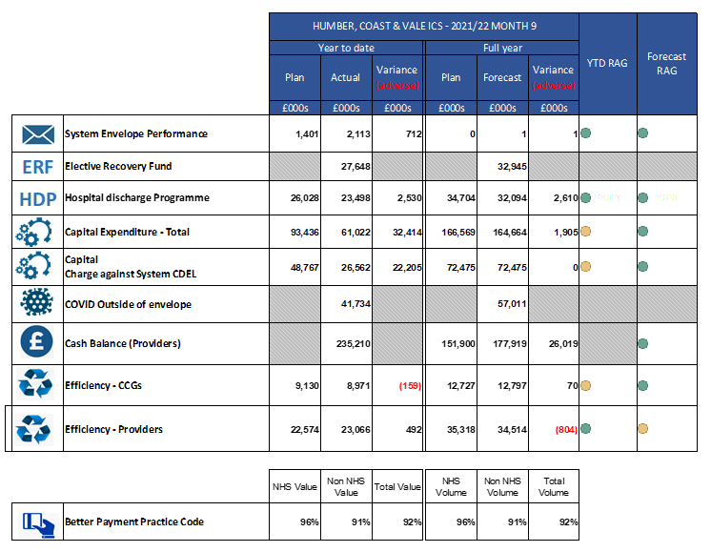
System Envelope Performance. Objective - To Break Even. M9 £0.7m surplus, Forecast Break Even.
- The ICS reported a positive position regarding H2 financial delivery.
- Additional elective recovery revenue funding approved of £23.3m
- ERF Ready Reckoner forecast to bring in £2.9m based on cumulative achievement.
- The ICS will be monitored on the full view of the 2021/2022 financial period. H1 forecast outturn and H2 plans are treated as a single financial period.
- Additional funding of £10.9m secured for social care – national living wage

Adult Social Care:

2021/22 Summary Position | Position as at Q3 |  |  |  | Q2
 | Annual Budget | Forecast Outturn | Forecast Variance |  | Forecast Variance
 | £000's | £000's | £000's |  | £000's
Better Care Fund | (4,790) | (4,790) | 0 |  | 0
Community Services | 32,718 | 32,085 | (633) |  | (375)
Running Costs | 1,382 | 1,515 | 133 |  | 157
Residential services - long & short term support | 16,154 | 14,609 | (1,545) |  | (602)
Universal services & service delivery | 3,075 | 2,915 | (160) |  | 310
TOTAL EXPENDITURE | 48,539 | 46,344 | (2,205 |  | (510)
TOTAL ALLOCATION | 48,539 | 46,334 | (2,205) |  | (510)
SURPLUS/(DEFICIT) | 0 | 0 | 0 |  | 0
Key points to note are:

- The overall forecast outturn position reported as at Q3 anticipates a year end underspend position of £2,205k (which includes £495k of better care fund underspend to be held in Earmarked reserve)
- Key variances relate to a reduced cost of commissioning of packages of care, in part due to lower than anticipated activity, anticipated overachievement of income relating to community client fees and additional capacity to manage and support the delivery of local Care services. The adult social care position has further benefited from Central government and Health funding to support workforce recruitment and retention, in addition to Covid funding via health to support discharge, release of provision and nonrecurrent expenditure not anticipated to be required during 21/22.
- Adult Social Care continues to be particularly affected by the Covid 19 pandemic and activity within our residential and community services continue to be unsettled compared to what may usually be expected.
- Pressures currently within the health system due to COVID and increasing activity are impacting on the delivery of care at home and may also increase the need for longer term, more complex care packages.
- Workforce shortages and ability to meet demand are increasing and there is a significant further risk to workforce supply. This is being felt across the whole of the Yorkshire and Humber region.
- The forecast outturn position is based on current income and expenditure activity levels and does not predict future activity changes due to future impact of Covid 19 or customer behavior which may impact later in 2021/22.

ASC savings plans

The current position assumes full achievement of savings of £0.7m. Capacity to deliver significant change programmes during the on-going pandemic response may place savings plans at risk.

Covid Grants

Adult social care is forecasting £5.5m of ringfenced COVID grants to be passported through to providers during 2021/22 as part of the Governments ongoing funding response, and additional funding of £1.0m will be distributed during Q4 in relation to Health support to workforce recruitment and retention. This additional funding is currently avoiding the need for base sustainability payments, however residential care services continue to operate at below optimum (and viable) occupancy levels and workforce shortages within the community and residential sector are of concern.

