Agenda Item 11
Report to: Governing Body

Date of Meeting:

Subject: Care Quality Commission (CQC) update report regarding Northern Lincolnshire and Goole NHS Foundation Trust (NLaG).
Presented by: Jan Haxby

STATUS OF THE REPORT

For Information ☐
For Discussion ☒
For Approval / Ratification ☐
Report Exempt from Public Disclosure ☐ No ☒ Yes

PURPOSE OF REPORT: | The following report provides the Governing Body with an overview of the current position, findings and subsequent outcomes in relation to the Care Quality Commission (CQC) inspection for NLaG that took place between September and October 2019. This paper is based on the report published by the CQC on the 7th February 2020.
Recommendations: | Members are asked to review, note and discuss the content of this report.
Committee Process and Assurance: | This report has been prepared by North Lincolnshire CCG Deputy Director of Nursing and Quality and North East Lincolnshire Nursing Lead for Quality, Designated Nurse for Safeguarding Adults and Children and the Quality Assurance Lead. This report is assured as a true and accurate record by the Nursing Lead for Quality, NELCCG.
Implications:
Risk Assurance Framework Implications:
Legal Implications: | None identified.
Data Protection Impact Assessment implications (DPIA): | Are you implementing a new system, data sharing arrangement, project, service redesign or changing the way you work? | No
 | If yes to the above – have the DPIA screening questions been completed? | Choose an item.
 | Does this project involve the processing of personally identifiable or other high risk data? | Choose an item.
 | If yes to the above has a DPIA been completed and approved? | Choose an item.
Equality Impact Assessment implications: | An Equality Impact Analysis/Assessment is not required for this report ☒  An Equality Impact Analysis/Assessment has been completed and approved by the EIA  Panel. As a result of performing the analysis/assessment there are no actions arising ☐  from the analysis/assessment  An Equality Impact Analysis/Assessment has been completed and there are actions arising ☐  from the analysis/assessment and these are included in section ____ of the enclosed report
Finance Implications: | None arising from this report.
Quality Implications: | This report details a positive impact on quality. ☒  - The report includes areas where the CQC have assessed the Trust as improved.  This report details a neutral impact on quality. ☐  This report details a negative impact on quality. ☒  - Deterioration within the CQC assessed safety domain.
Procurement Decisions/Implications (Care Contracting Committee): | N/A.
Engagement Implications: | N/A.
Conflicts of Interest | Have all conflicts and potential conflicts of interest been appropriately declared and entered in registers which are publicly available  ☒ Yes ☐ No
Links to CCG’s Strategic Objectives | ☒ Sustainable services ☒ Empowering people  ☒ Supporting communities ☒ Delivering a fit for purpose organisation
NHS Constitution: | https://www.gov.uk/government/publications/the-nhs-constitution-for-england
Appendices / attachments | Link provided to the CQC full report:-  https://www.cqc.org.uk/provider/RJL

Care Quality Commission (CQC) update report regarding Northern Lincolnshire and Goole NHS Foundation Trust (NLaG).

- Purpose

The following report provides the Governing Body with an overview of the current position, findings and subsequent outcomes in relation to the Care Quality Commission (CQC) inspection for NLaG that took place between September and October 2019. This paper is based on the report published by the CQC on the 7th February 2020.

- Background - Northern Lincolnshire and Goole NHS foundation Trust (NLaG)

Since 2014 NLaG have received five CQC inspections and the overall outcomes/ratings for each of these inspections were as follows;

  - Inspection April 2014, report July 2014 – Requires Improvement
  - Inspection October 2015, report April 2016 – Requires Improvement
  - Inspection October 2016, report April 2017 – Inadequate
  - Inspection May 2018, report September 2018 – Requires Improvement
  - Inspection September 2019, report February 2020 – Requires Improvement

A full planned inspection by the CQC was undertaken between the 24th and 27th September 2019. The inspection covered all 3 Hospital sites and North Lincolnshire Community Services, followed by an unannounced visit on the 10th October 2019. As part of the inspection the CQC also completed a ‘Use of Resources’ assessment.

On the 21st October 2019 the CQC Deputy Chief Inspector for the North Region submitted a letter to the Trust under Section 31 of the Health and Social Care Act 2008. This was an advance notice of possible enforcement action if sufficient evidence and actions could not be demonstrated in relation to CQC concerns regarding the overdue backlog position for outpatient appointments, diagnostic imaging and waiting times for new appointments.

NLaG submitted a response to the Section 31 letter on the 23rd October 2019 and the CCG understands that a subsequent meeting, between NLaG and the CQC, took place on the 31st October 2019 to discuss the information submitted in more detail. Further supporting information detailing the Trusts actions was provided to the CQC on the 8th November 2019.

In December the Trust received the draft CQC report for factual accuracy checking and this was completed and returned to the CQC on the 18th December 2019. Additionally NLaG met with the regional lead for the CQC on the same day to discuss the draft report. The report went to the CQC rating panel on the 23rd January 2020 and the final report was published on the 7th February 2020.

- Outcome from the September to October 2019 CQC inspection – published report on the 7th February 2020.

Overall Trust ratings

The Trusts overall position has remained the same as the 2018 inspection and is rated as ‘Requires Improvement’. It has been confirmed that the Trust will remain in ‘Quality Special Measures’.

The overall Trust ratings within the 5 domains of safe, effective, caring, responsive, and well-led are as follows;
  - The ‘Well led’ domain has improved from Inadequate to Requires Improvement.
  - The Effective domain has remained unchanged and is rated as Requires Improvement
  - The Caring domain has remained unchanged and is rated as Good.
  - The Responsive domain has remained unchanged and is rated as Requires Improvement.
  - The ‘Safe’ domain has dropped from Requires Improvement to Inadequate.

The ‘Use of Resources’ inspection was rated as Requires Improvement.

Table 1 below is the NLaG overall ratings from the 2019 Inspection – the arrows indicate the change from the previous CQC inspection in 2018.
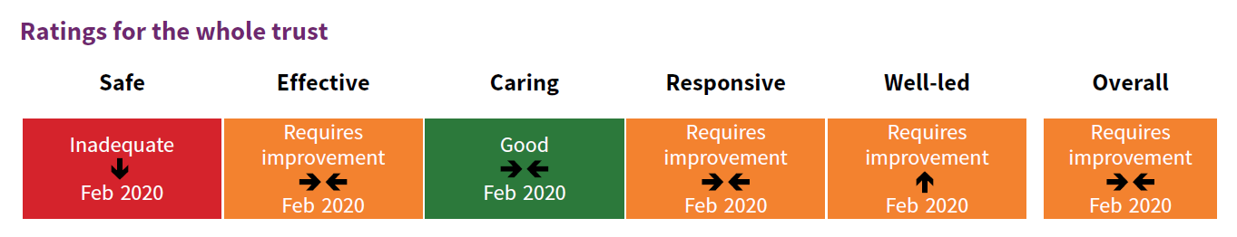

Diana Princess of Wales Hospital ratings

The Diana Princess of Wales Hospital overall rating has remained the same as the 2018 inspection and is rated as ‘Requires Improvement’.

The Diana Princess of Wales Hospital ratings within the 5 domains of safe, effective, caring, responsive, and well-led are as follows;
  - The Effective domain has remained unchanged and is rated as Requires Improvement
  - The Caring domain has remained unchanged and is rated as Good.
  - The Responsive domain has remained unchanged and is rated as Requires Improvement.
  - The Well led domain has remained unchanged and is rated as Requires Improvement
  - The Safe domain has reduced from Requires Improvement to Inadequate.

Table 2 below is the Diana Princess of Wales Hospital ratings for each core service from the 2019 Inspection – the arrows indicate the change from the previous CQC inspection in 2018.

Scunthorpe General Hospital ratings

The Scunthorpe General Hospital overall rating has remained the same as the 2018 inspection and is rated as ‘Requires Improvement’.

The Scunthorpe General Hospital ratings within the 5 domains of safe, effective, caring, responsive, and well-led are as follows;
  - The Effective domain has remained unchanged and is rated as Requires Improvement
  - The Caring domain has remained unchanged and is rated as Good.
  - The Responsive domain has remained unchanged and is rated as Requires Improvement.
  - The Well led domain has remained unchanged and is rated as Requires Improvement
  - The Safe domain has reduced from Requires Improvement to Inadequate.

Table 3 below is the Scunthorpe General Hospital ratings for each core service from the 2019 Inspection – the arrows indicate the change from the previous CQC inspection in 2018.
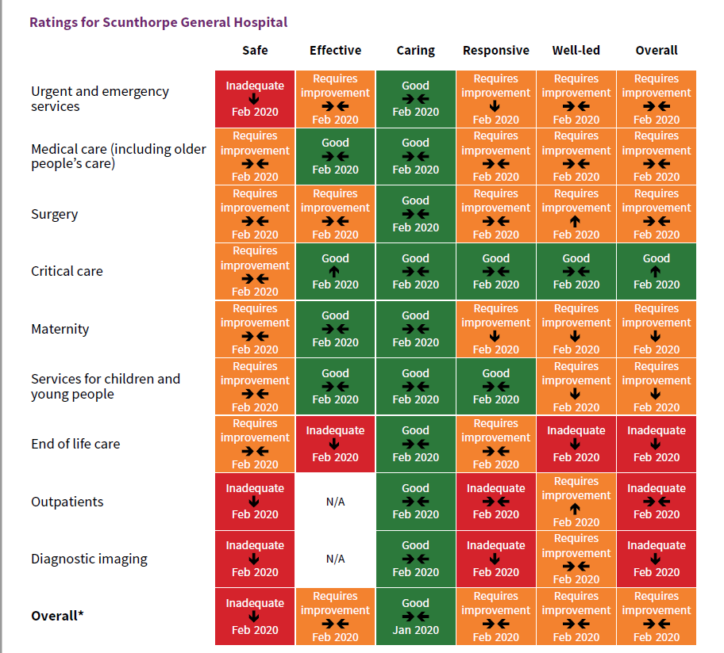

Community Services ratings - (predominately North Lincolnshire based)

The Community Services overall position has remained the same as the 2018 inspection and is rated as ‘Requires Improvement’.

The Community Services ratings within the 5 domains of safe, effective, caring, responsive, and well-led are as follows;
  - The Safe domain has remained unchanged and is rated as Requires Improvement
  - The Caring domain has remained unchanged and is rated as Good.
  - The Responsive domain has remained unchanged and is rated as Requires Improvement.
  - The Well led domain has remained unchanged and is rated as Requires Improvement
  - The Effective domain has reduced from Good to Requires Improvement

Table 4 below is the Community Services (predominately North Lincolnshire based) overall ratings for each core service from the 2019 Inspection – the arrows indicate the change from the previous CQC Inspection in 2018.
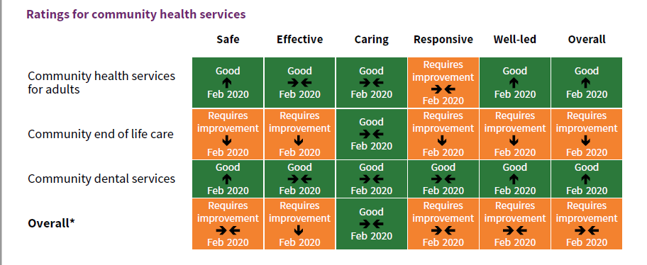
Goole and District Hospital
The Goole and District Hospital overall position has remained the same as the 2018 inspection and is rated as ‘Requires Improvement’.
The Goole and District Hospital ratings within the 5 domains of safe, effective, caring, responsive, and well-led are as follows;
- The Safe domain has reduced from Requires Improvement to Inadequate.
- The Caring domain has remained unchanged and is rated as Good.
- The Responsive domain has remained unchanged and is rated as Requires Improvement.
- The Well led domain has remained unchanged and is rated as Requires Improvement
- The Effective domain has improved from Requires Improvement to Good.
Table 5 – below is the Goole and District Hospital overall ratings for each core service from the 2019 Inspection – the arrows indicate the change from the previous CQC Inspection in 2018.

- Key points from the Safe Domain

The safe domain has been rated as inadequate because;
- There had been incidents where patients had come to harm due to delays in receiving appointments in both outpatients and diagnostic imaging. The CQC had concerns regarding this and after the inspection, the CQC completed a section 31 letter of intent to seek further clarification from the trust.
- Across most services there was still insufficient numbers of staff with the right qualifications, skills, training and experience to keep patients safe from avoidable harm and to provide the right care and treatment.
- The Trust provides mandatory training in key skills to staff but had not ensured everyone had completed it. Across most services there are continued low levels of mandatory training.
- CQC had ongoing concerns that patients with mental health conditions were not always cared for in a safe environment.
- Within the emergency department there were significant numbers of black breaches and the department failed to meet the medium time to initial assessment.
- The Trust did not always manage infection control risks.

However:
- On the whole the Trust managed incidents well and there was evidence that there was shared learning.
- The Trust manages medicines well. CQC saw improvements in the safe administration, storage and handling of medicine management.
- The CQC noted that staff reported receipt of good support from the central safeguarding team.

- NLaG’s initial response

The CCG is aware that following publication of the report NLaG have identified the following priority areas;
- Mandatory training, appraisals and complaints
- A&E – mandatory training and paediatrics
- Ophthalmology – backlog and clinical harm reviews
- Cancer waiting times
- Documentation – patient notes, controlled documents and following the correct governance routes and processes

In order to respond to these priority areas initial actions have been identified by NLaG and these are;
- Sourcing extra support from NHS England/Improvement
- An imminent Directors meeting to plan resources for a new targeted approach to drive changes in the key areas.
- Divisional Performance Review Improvement Meetings and line managers are being requested to focus more on progress against the recommendations.
- Clinical Teams have been asked to look at the priorities and ensure everyone owns the improvements in the same way the Trust Board, Directors and Clinical Leads do.

- CCG response

The CCG is pleased to see an improvement in the Well-led domain which has moved from Inadequate to Requires Improvement. However there are significant concerns regarding the reduction to Inadequate within the safe domain and the lack of progress, pace and improvement within the other domains across the Trust. It is a significant concern that over the past six years the Trust has not made any sustained improvements despite the different actions taken to date.

Senior Leaders from the executive teams within the four CCG’s (North Lincolnshire, North East Lincolnshire, East Riding and Hull) across the region met on Friday 7th February to discuss, coordinate and support the system response to NLaG’s CQC publication. The CCG and the wider system is considering what other support or actions are required to secure improvement within the Trust going forward.

The CCG will also seek further clarification from the Trust at the System Improvement Board - Patient Safety Group (SIB-PSG) to understand what the expected outcomes and timeframes are regarding the priority actions that NLaG have identified. In November 2019 an agreement was made at the SIB-PS to defer undertaking the Quality Risk Profile (QRP) for NLaG that was due in January 2020 until the CQC report was published. The CCG will request that this is considered at the February 2020 SIB-PSG.

The CCG is also taking action to ensure that the CQC report is communicated and understood across the entire CCG. All individuals throughout the organisation will be supported to ensure they understand their individual responsibilities and of the ‘Must Do’ and ‘Should Do’ actions from the CQC report that align to their roles. Multiple methods of communicating this will be used throughout the coming weeks to ensure that the whole CCG responds appropriately and timely to the findings and actions required.

Additionally the Friday morning ‘Planning Meeting’ that is attended by NLaG, North East Lincolnshire CCG and North Lincolnshire CCG will have a responsibility to ensure the system is responding appropriately and at pace to the required actions within the CQC report.

