Humber Coast and Vale Strategic Elective Network
Communication Update - December 2018

Strategic Elective Network Meeting 13th December
The 3rd Strategic Elective Network Board meeting took place on the 13th December with membership from organisations across Humber Coast & Vale. The focus of the meeting was Medicines Optimisation, there was recognition of the work to date across CCG’s and Trusts as well as across health systems the consensus was to support the development of a HCV wide delivery plan to maximise potential including exploring areas that could be done once across the HCV Partnership such as self-care communications

Outpatients Transformation/RTT
A dashboard pulling together the position on waiting list numbers, RTT and 52 week waits is now in place across HCV to support shared understanding of the overall position.
Leads from the 3 acute trusts working on transforming outpatients are now working together to share learning and opportunities. An update was provided to the Strategic meeting on the 13 December and a fuller discussion will take place at their next meeting in March.

MSK North Collaborative Programme 100 day challenge
The Humber Coast & Vale Health & Care Partnership is taking part in the North Region 100 day challenge, focusing on back pain. The launch event took place on the 22 November with over 35 attending from a broad range of professions and organisations across HCV. There were 4 chosen initiatives which are all consistent with the implementation of the National Back Pain Pathway.
- Care navigation to Physio First intended to reduce GP time & appointments by directing patients to more appropriate physiotherapy services earlier.
- Referral guidance for lumbar spinal MRI which aims to reduce referrals from primary care by 20 – 50%
- Patient Education programme to develop materials and potentially patient webinars
- Support for Clinical education campaigns piloted in a selection of practices, supported by an initial survey regarding current awareness and practice of the NICE back pain pathway.
All four are progressing well. We took part in a regional 25 day webinar on 19th December to share progress.
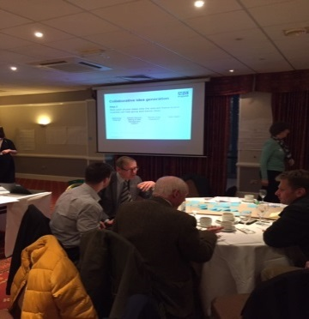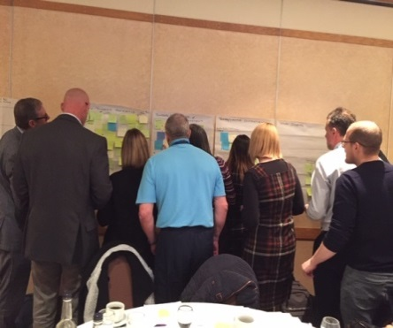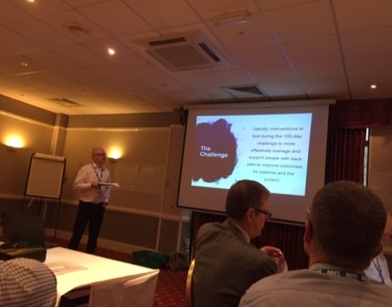
Faecal Calprotectin Care Pathway
The Yorkshire & Humber AHSN is supporting the roll out of the pathway across the Yorkshire and Humber region. They produced resources to enable easy implementation in to primary care such as templates, leaflets, as well as facilitation of discussions between primary and secondary care for whole pathway discussions.
A health economic evaluation based on the first 1000 patients who went through the pathway at York has been completed by York Health Economic Consortium (YHEC). The benefits of this pathway demonstrated in the evaluation are: for every 1000 patients through the system £100K-£150K is saved, 147-262 colonoscopies, and 190-297 outpatient appointments are saved.
In the Humber Coast and Vale region all six CCG have now implemented the FCP pathway. This means the HCV STP footprint, is the first STP in the country to have implemented the pathway. AHSN have asked for representatives from the STP to participate in a good news video and communication piece to celebrate this achievement

Hypertension
The British Heart Foundation sponsored Hypertension work is progressing well within the East Riding and Hull CCGs and planned to accelerate to include the Community Pharmacists. There are currently 40 pharmacists undertaking the programme to test blood pressure and there had been agreement from ophthalmologists and dentists to signpost potential clients to the service.

Complex Rehab
The Operational Delivery Network met on the 29 November, followed by a specialty design workshop, held as part of the Humber Acute Services Review to develop the case for change in relation to complex rehab services across the Humber.

Cardiology
The Operational Delivery Network met on the 21 November, followed by a specialty design workshop, held as part of the Humber Acute services Review to develop the case for change in relation to complex rehab services across the Humber.

CVD Prevention
A CVD prevention group has been established to develop a HCV CVD workplan for implementation. This group feeds into the Cardiac ODN. The work plan will focus on key interventions that will have the greatest impact across HCV. This approach has been endorsed by the HCV Executive.

Yorkshire and Humber AHSN is a key partner in the prevention of Atrial Fibrillation (AF) related strokes across the region. They are supporting the Atrial Fibrillation (AF) programme roll out currently working with 17 practices. To date they estimate to have prevented 18 strokes. Moving forward as part of the CVD prevention workplan the AHSN are recommending a targeted approach following receipt of revised prevalence data with practices who may need the most support, to deliver the greatest impact.

Medicines Optimisation
Yorkshire and Humber AHSN are also working with the Chief Pharmacists in the Acute Trusts and with the LPC to implement ‘Transfer of Care around Medicines’ (TCAM). TCAM is an electronic system for referring patients from hospital to their community pharmacy for follow up. This referral, when actioned by the community pharmacy:
- Improves medicines optimisation;
- Improves patient knowledge of their medicines;
- Reduces medication errors post-discharge;
- Reduces hospital readmissions;
- Reduces length of stay for those patients who are subsequently re-admitted; and,
- Reduces medicines wastage.

Urology Network
The Urology network met on the 20 December and held a workshop with clinicians and managers from the 3 Acute Trusts and members of the GiRFT team. Through the workshop a number of actions have been identified where there are opportunities for improving services by working together, for example in relation to metabolic stone services. These will be worked up further as part of the networks workplan.
If you have any queries please contact Alex Seale (SRO), alex.seale@nhs.net , Caroline Briggs (Programme Director) carolinebriggs@nhs.net or David Thundercliffe (PMO officer) david.thundercliffe@nhs.net

