Report to: (Governing Body/Committee): Primary Care Commissioning Committee

Date of Meeting: 30th July 2019

Subject: Delegated Commissioning Audit update: Primary Care Immediate
Disruption to Service checklist

Presented by: Rachel Barrowcliff – Service Manager
Agenda Item 05

STATUS OF THE REPORT (auto check relevant box)

For Information ☐
For Discussion ☐
For Approval / Ratification ☒
Report Exempt from Public Disclosure ☒ No ☐ Yes

PURPOSE OF REPORT: | The Committee received a copy of the final audit report for delegated commissioning arrangements in May 2019 which set out a number of actions to be completed.  This report has been prepared to provide an update on the actions and in particular the requirement for the CCG to have in place an Immediate Disruption to Service Procedure, which has been developed to ensure continuity in service to patients should there be an immediate GP Practice closure.  The checklist requires approval by this Committee in order for it to be adopted as a formal procedure within the CCG which can be appended to the existing Failing Services Policy.
Recommendations: | The PCCC is asked to:  - Note the update on the actions arising from the delegated commissioning audit  - Approve the Immediate Disruption to Service procedure
Committee Process and Assurance: | N/A
Implications:
Risk Assurance Framework Implications: | The final report provided assurance regarding potential risks relating to delegated commissioning and the Immediate Disruption to Service procedure will enable the CCG to undertake immediate actions should there be an immediate practice closure, to mitigate risks to continuing patient care.
Legal Implications: | N/A
Data Protection Impact Assessment implications (DPIA): | Are you implementing a new system, data sharing arrangement, project, service redesign or changing the way you work? | No
 | If yes to the above – have the DPIA screening questions been completed? | Choose an item.
 | Does this project involve the processing of personally identifiable or other high risk data? | Choose an item.
 | If yes to the above has a DPIA been completed and approved? | Choose an item.
Equality Impact Assessment implications: | An Equality Impact Analysis/Assessment is not required for this report ☒  An Equality Impact Analysis/Assessment has been completed and approved by the EIA  Panel. As a result of performing the analysis/assessment there are no actions arising ☐  from the analysis/assessment  An Equality Impact Analysis/Assessment has been completed and there are actions arising ☐  from the analysis/assessment and these are included in section ____ of the enclosed report
Finance Implications: | N/A
Quality Implications: | This report details a positive impact on quality. ☒  The proposal put forwards, if agreed, would have a positive impact in terms of enabling providers to meet safe staffing targets. Retention and recruitment is forecast to be improved, which would have a positive impact on the safe delivery of local services.  This report details a neutral impact on quality. ☐  The report will not make any impact on experience, safety or effectiveness.  This report details a negative impact on quality. ☐  The report details the need for budgets to be significantly reduced. It is clear that the report summarises that quality will be negatively impacted by this as decisions to remove services/provide a lower level of provision to solely meet the ‘must do’s’ of provision in terms of meeting people’s needs has to be made. It is forecast that service user experience will be negatively impacted by this position.
Procurement Decisions/Implications (Care Contracting Committee): | N/A
Engagement Implications: | The emergency disruption procedure has been shared and agreed with NHS England.
Conflicts of Interest | Have all conflicts and potential conflicts of interest been appropriately declared and entered in registers which are publicly available?  ☒ Yes ☐ No
Links to CCG’s Strategic Objectives | ☒ Sustainable services ☐ Empowering people  ☐ Supporting communities ☒ Delivering a fit for purpose organisation
NHS Constitution: | https://www.gov.uk/government/publications/the-nhs-constitution-for-england
Appendices / attachments

Actions from the Delegated Commissioning Audit

The actions identified in the Delegated Commissioning audit report are shown in the table below.

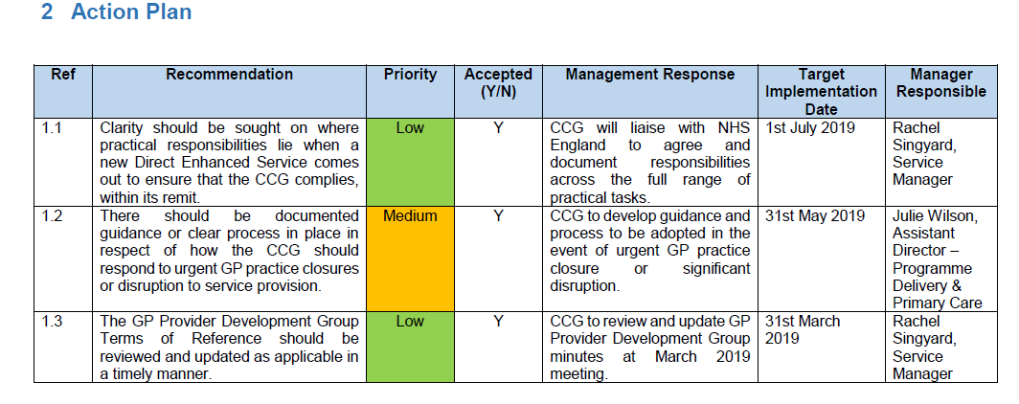

Actions 1.1 and 1.3 are now completed. In respect of action 1.2, the CCG have developed an Immediate
Disruption to Service Procedure, detailing all the tasks that would be required should there been an immediate GP practice closure, e.g. as a result of removal of the practice’s CQC registration. This procedure has been shared and agreed with NHS England.

The procedure is attached to this report for consideration and approval by the Committee.

Recommendation

The Primary Care Commissioning Committee are asked to:-

- Note the update on the actions arising from the delegated commissioning audit
- Approve the Immediate Disruption to Service procedure

