Report to: (Governing Body/Committee): Primary Care Commissioning Committee

Date of Meeting: 24th September 2019

Subject: National GP Patient Survey results

Presented by: Rachel Barrowcliff – Service Manager
Agenda Item 10

STATUS OF THE REPORT (auto check relevant box)

For Information ☒
For Discussion ☐
For Approval / Ratification ☐
Report Exempt from Public Disclosure ☒ No ☐ Yes

PURPOSE OF REPORT: | To update the Committee regarding the latest national GP Patient Survey results and actions that are being taken forward that will support improvements in the experience of general practice.
Recommendations: | The Committee is asked to note the latest GP survey results and the actions that the local practices and the CCG are taking that will support improvements.
Committee Process and Assurance: | N/A
Implications:
Risk Assurance Framework Implications: | There is a risk of deterioration in general practice patient experience and access if on-going and planned developments are not supported / progressed.
Legal Implications: | N/A
Data Protection Impact Assessment implications (DPIA): | Are you implementing a new system, data sharing arrangement, project, service redesign or changing the way you work? | No
 | If yes to the above – have the DPIA screening questions been completed? | Choose an item.
 | Does this project involve the processing of personally identifiable or other high risk data? | Choose an item.
 | If yes to the above has a DPIA been completed and approved? | Choose an item.
Equality Impact Assessment implications: | An Equality Impact Analysis/Assessment is not required for this report ☒  An Equality Impact Analysis/Assessment has been completed and approved by the EIA  Panel. As a result of performing the analysis/assessment there are no actions arising ☐  from the analysis/assessment  An Equality Impact Analysis/Assessment has been completed and there are actions arising ☐  from the analysis/assessment and these are included in section ____ of the enclosed report
Finance Implications: | N/A
Quality Implications: | This report details a positive impact on quality. ☐  The proposal put forwards, if agreed, would have a positive impact in terms of enabling providers to meet safe staffing targets. Retention and recruitment is forecast to be improved, which would have a positive impact on the safe delivery of local services.  This report details a neutral impact on quality. ☒  The report will not make any impact on experience, safety or effectiveness.  This report details a negative impact on quality. ☐  The report details the need for budgets to be significantly reduced. It is clear that the report summarises that quality will be negatively impacted by this as decisions to remove services/provide a lower level of provision to solely meet the ‘must do’s’ of provision in terms of meeting people’s needs has to be made. It is forecast that service user experience will be negatively impacted by this position.
Procurement Decisions/Implications (Care Contracting Committee): | N/A
Engagement Implications: | N/A
Conflicts of Interest | Have all conflicts and potential conflicts of interest been appropriately declared and entered in registers which are publicly available?  ☒ Yes ☐ No
Links to CCG’s Strategic Objectives | ☐ Sustainable services ☒ Empowering people  ☒ Supporting communities ☐ Delivering a fit for purpose organisation
NHS Constitution: | https://www.gov.uk/government/publications/the-nhs-constitution-for-england
Appendices / attachments

National Patient Survey: Latest Results

- Introduction

The annual national patient survey regarding GP services, which is undertaken by Ipsos Mori was published in July 2019. In NHS North East Lincolnshire, 8807 questionnaires were sent out and, 2821 were returned completed. This represents a response rate of 32% (1% lower return than last year).

This report has been prepared to inform the Primary Care Commissioning Committee members of the latest GP survey results for NEL, and to update regarding the actions that will be taken to address some of lower results in the survey.

- Latest local Results

The full results for North East Lincolnshire are included in the attached presentation. Some keys areas to note have been extracted for your information and are summarised below. Results have also been presented by Practice, and grouped by Primary Care Networks, on the following pages.

Improved between 2018 and 2019:

- Awareness of online services:-
  - Booking online = increased by 1% (30%, national = 44%)
  - Ordering repeat prescriptions = increased by 2% (37%, national = 47%)
  - Accessing medical records = increased by 3% (12%, national = 15%)
- Support from local services and organisations to help manage conditions = increased by 3% (77%, national = 78%)
- Satisfaction with waiting time for receiving care out of hours = increased by 4% (71%, national = 66%)

Deteriorated between 2018 and 2019:

- Ease of getting through on the phone = decreased by 4% (66%, national = 68%)
- Satisfaction with appointment times = decreased by 3% (62%, national = 65%)
- Recognising the mental health needs of patients = decreased by 2% (85%, national = 86%)
- Ease of use of online services = decreased by 2% (77%, national = 77%)

No change between 2018 and 2019:

- Overall experience of GP Practice = remains at 80% (nationally 83%)
- Helpfulness of receptionists = remains at 88% (nationally 89%)
- Experience of making an appointment = remains at 65% (nationally 67%)
- Satisfaction with appointment offered = remains at 71% (nationally 74%)

Results by Practice and Primary Care Network

The following charts show a number of the areas by practice and Primary Care Network.

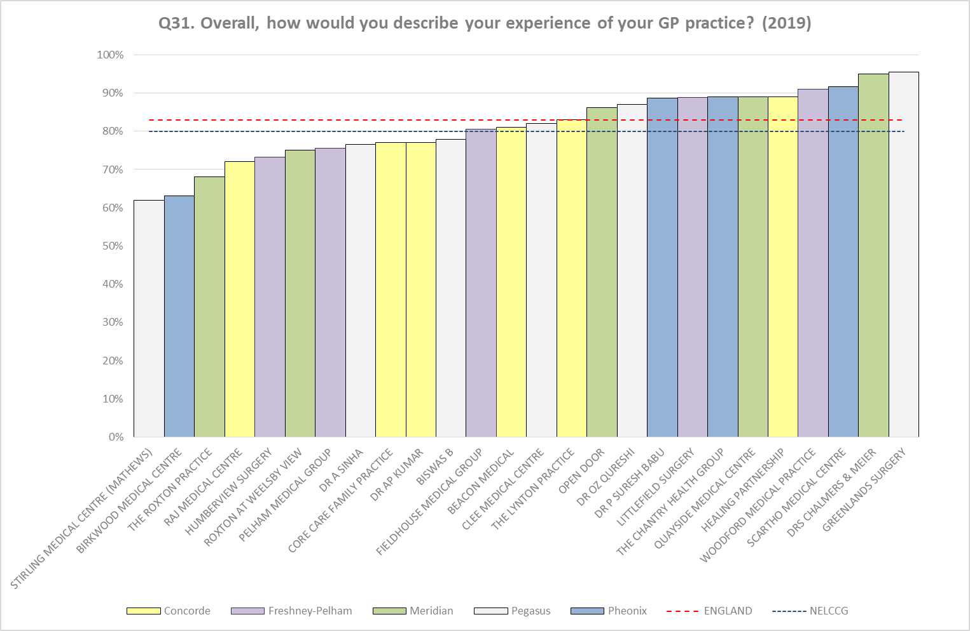

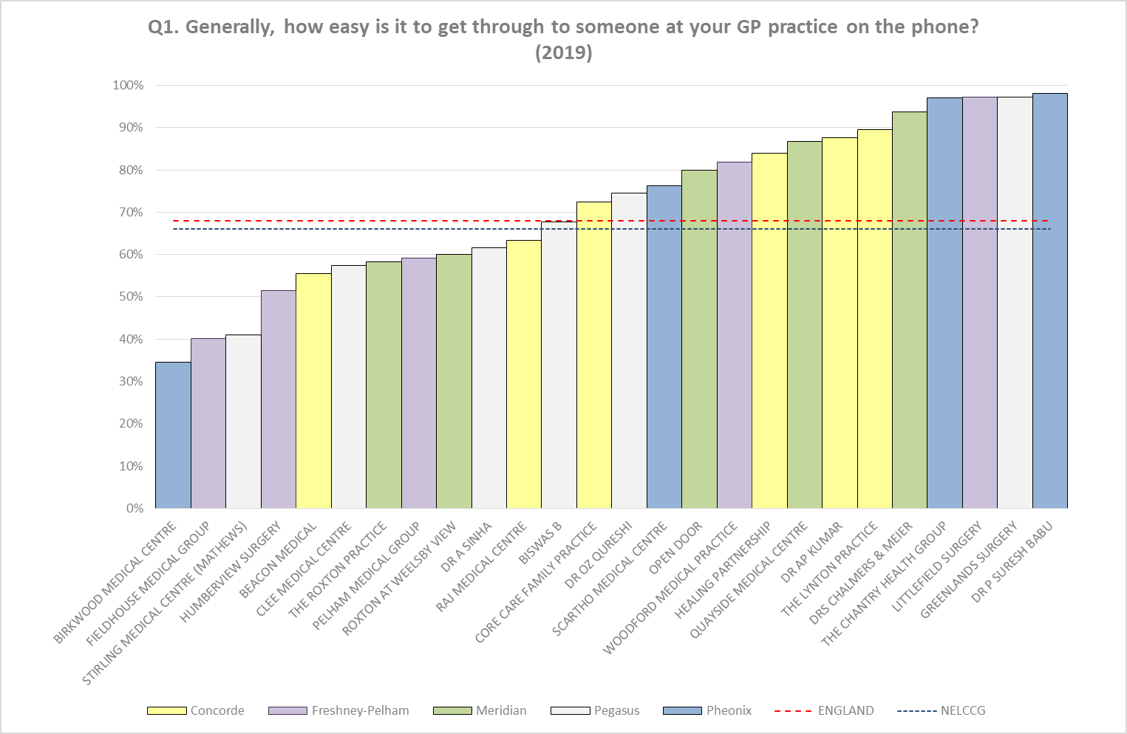

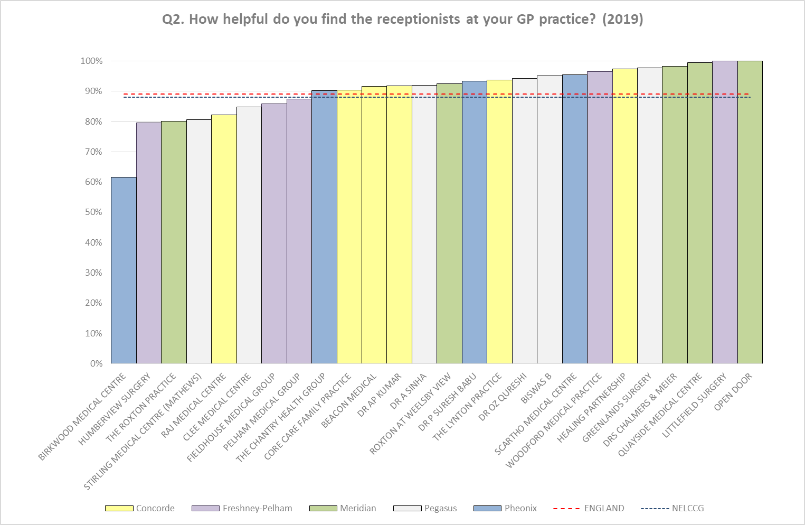

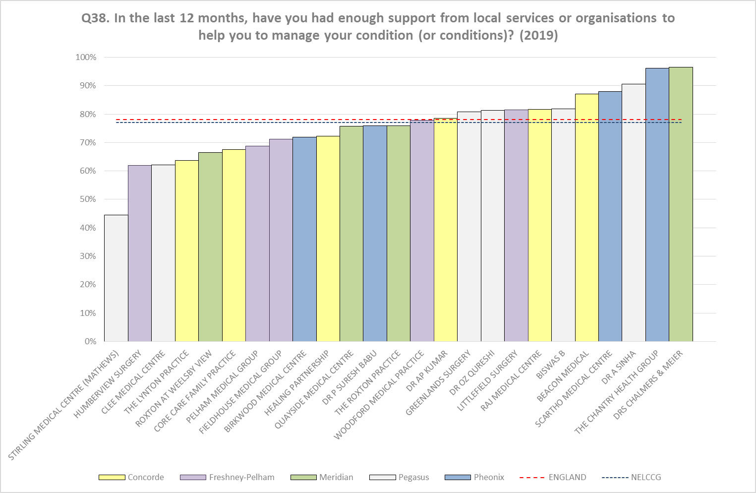

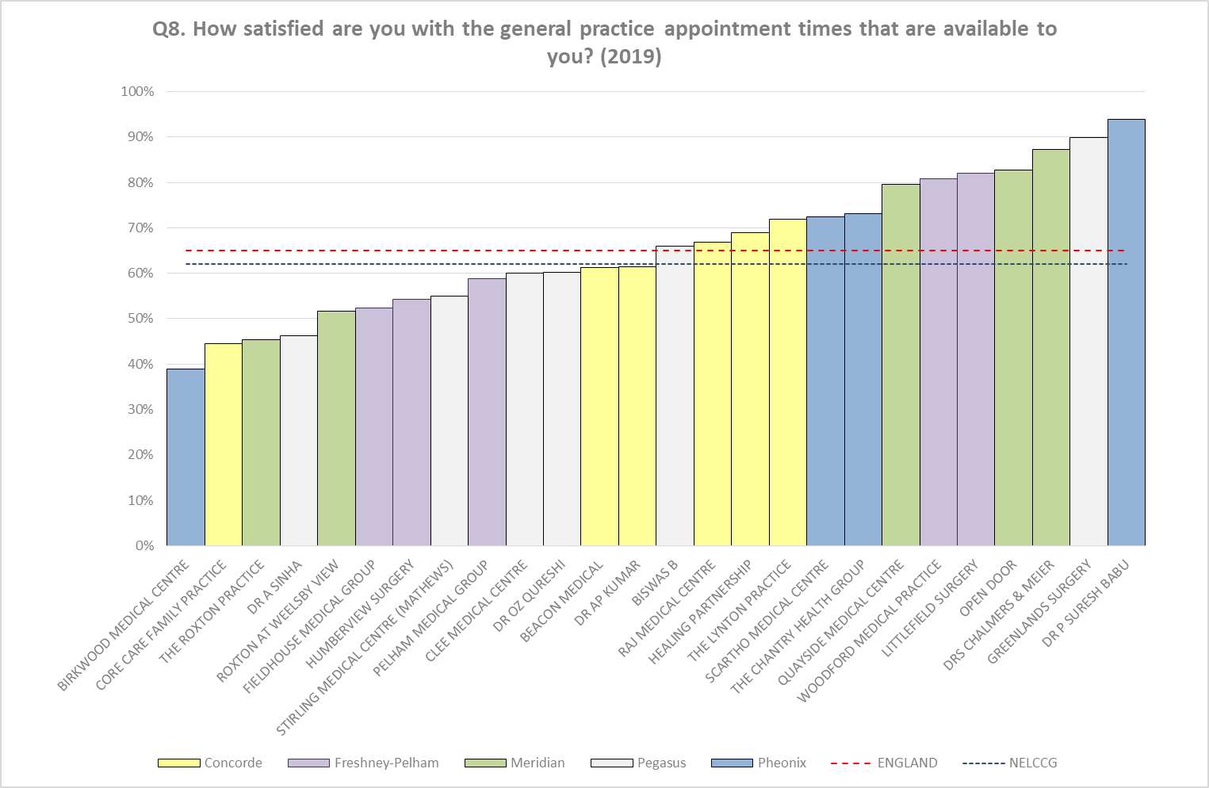

The CCG will review and discuss these results with the Primary Care Networks and also at individual level as part of the Practice visits assurance process.

- Actions to support improvement

There are a number of projects and initiatives that are already underway, and others that are planned, which support improvements around access and general experience within Primary Care. These are reported regularly to the Primary Care Commissioning Committee and include:

- Reception training, including care navigation
- Workforce developments, including the introduction and continued support for correspondence management and introducing new roles to support GPs such as Clinical Pharmacists and Physicians Associates.
- Recruitment initiatives including the NHS England International GP Recruitment scheme
- Rollout of online consultations to all practices
- Sharing of best practice in relation to ease of use of practice websites and promotion of online access
- Collaborative working, particularly the development of the multi-disciplinary teams around the newly formed Primary Care Networks
- Work around the Personalised care agenda

- Recommendation

Members are asked to note the latest GP survey results and the actions that the local practices and the CCG are taking that will continue to support improvements.

