Equality Impact Risk Analysis: Insert title of service/function here

Policy / Project / Function/Service: | Community Engagement Strategy
Date of Analysis: | October 2019
Analysis Rating:
(Please Tick )

(See Completion Notes)

 | Red | Red /Amber | Amber | Green
Type of Analysis Performed:  Please Tick | Systematic Policy Analysis
 | Consultation
 | Meeting
 | Service Proposal
 | Other
Please list any other policies  that are related to or referred  to as part of this analysis | Volunteer Expenses Policy  This strategy will inform future commissioning policies
Who does the policy, project function or service affect ?  Please Tick | Employees
 | Service Users
 | Applicants
 | Members of the Public
 | Other (List Below) |  |  | Providers/strategic partners

Equality Impact Risk Analysis:

What are the aims and intended  effects of this policy, project or  function ? | We want to get better at how we talk, listen and work together with our communities and:  • talk to the public as early as possible so we can all work together to develop solutions;  • make sure everything we do is informed by what local people share with us about their experiences, concerns and aspirations;  • be confident that none of our communities are left out of the conversation.  We have adopted the ‘North East Lincolnshire Commitment’ (see attached) and the strategy sets out how the council and the CCG will work to meet this.  This is a first step towards a clear and more consistently applied approach to developing an ‘on the ground’ understanding of North East Lincolnshire and its communities. This will build mutual trust and sincere relationships to inform strategic decision- making and support community-led change.
Is any Equality Data available  relating to the use or  implementation of this policy,  project or function ?  (See Completion notes) | Yes | Yes
 | No
 | Where you have answered yes, please incorporate this data when performing the Equality Impact Assessment Test (the next section of this document).
List any Consultation e.g. with  employees, service users,  Unions or members of the  public that has taken place in  the development or  implementation of this policy,  project or function | This strategy has been co-produced by community members, and representatives from the Voluntary, Community and Social Enterprise (VCSE) sector working as equal partners with the CCG and council.  During the course of the consultation and engagement we have carried out visits to local groups including MS Society, Voluntary, Community and Social Enterprise (VCSE) Sector forum, Carers Forum, Friendship at Home, ADDACTION, local markets, GP surgeries, Centre4, staff and students at Grimsby Institute, Accord members, PPG Chairs group, Older People’s Forum, SEND Executive Board, Healthwatch NEL.  As part of the consultation we asked peope to complete an online or paper copy survey which also asked people to provide demographinc information. The information provided tells us that the following protected characteristic groups took part  - Sex  - Age  - Disabilties  - Sexual orientation (LGB)  - Religion or belief  We have also engaged with council and CCG staff, elected members and the Health and Care Executive.  We have also shared the online survey with members of the Hidden Heritage Group and the Equality Practice Independent Advisory Group.
Financial Analysis  If applicable, state any relevant cost implications  (e.g. expenses, returns or savings) as a direct result  of the implementation of this policy, project or  function | Costs (£m) *  Implementation £  Projected Returns £  Projected Savings £

Equality Impact Risk Assessment Test:
What impact will the implementation of this policy, project or function have on employees, service
users or other people who share characteristics protected by The Equality Act 2010 ?
Protected  Characteristic: | Neutral  Impact: | Positive  Impact: | Negative  Impact: | Evidence of impact and if applicable, justification  where a Genuine Determining Reason exists
Gender  (Men and Women) |  | x |  | Currently the CCG gathers data on our Engagement activity via  • Surveys - ‘About you’ section  • Equality monitoring forms from events, workshops and focus groups  • Accord membership equality searches  We maintain a stakeholder database of local stakeholders, groups and organisations, including those representing groups with protected characteristics under the Equality & Diversity Act, and other membership schemes has been developed. This database is utilised to identify other people / groups that may have an interest in being involved in engagement activities with the CCG.  The Acord Database is regularly analysed to ensure that the membership is representative of the local population. Where diverse groups appear to be underrepresented, work should be carried out to ensure that they are being communicated and engaged with effectively.  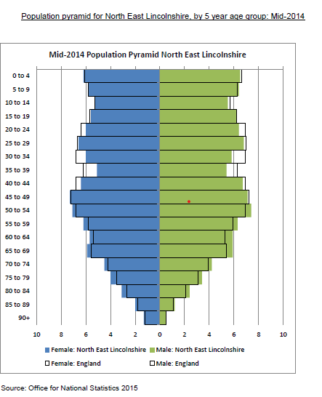  Currently the the gender split for NEL is 49% male, 51% female. The Accord membership is 31% male, 68% female- with similar rates of participation.  This strategy seeks to actively promote or improve equality of opportunity to ensure none of our communities are left our of the conversation.
Race  (All Racial Groups) |  | x |  | 95.4% of the resident population of NEL are White British.  The largest ethnic group in NEL is Other White, with 1.7% of the overall population.  The proportion of ethnic minorities in NEL (4.6%) is significantly lower than seen in the Yorkshire and Humber region (14.2%) and in England as a whole (20.2%).  The Accord database is reflective of the local picture in terms of race.  As part of the implementation plan for the strategy we will develop an Engagement Toolkit with methods of ensuring that diverse groups are communicated with effectively. For example, distributing posters and leaflets in locations where diverse groups congregate (social clubs for ethnic minority groups/shops aimed at diverse ethnic groups). When engaging in the community we will ensure that diverse groups are included and suitable support such as interpreters are employed.
Disability  (Mental and Physical,Sensory impairment, Autism, mental health issues) |  | x |  | The 2012/13 Annual Population Survey indicates that 20.1% of the working age (16 to 64) population of North East Lincolnshire have a known disability. More women have a disability (22%) than men (18.2%). This is broadly in line with national and below Yorkshire and Humber comparator groups.  An estimated 14,786 residents (9.3% of the population) felt that their daily activities were significantly limited due to a health condition or disability at the time of the 2011 census.  An estimated 26.8% of all households in North East Lincolnshire had at least one person with a long-term health problem or disability at the time of the 2011 census.  Figures for November 2014 show 7430 people claiming ESA or IB equivalent equates to 7.48% of the working age population, compared to 6.66% in Yorkshire and the Humber and 6.05% in England. The rate has increased from 7.34% in November 2010.  17% of Accord members report that they have a disability with between 10 to 20% of attendees at Way Forward and Accord annual engagement meetings identifying as having a disability.  29% of the people completing the survey (who opted to provide demongraphic information) told us they had a disability/long term health condition.  The Strategy will ensure that our communication and engagement materials should be accessible and where appropriate provide information in other formats such as paper copies, audio and Easy Read.
Religion or Belief | x |  |  | The 2011 Census indicates that 60.7% of North East Lincolnshire residents are Christian. Of those estimated under another religion the highest percentage was Muslim at 0.8%.  30.4% of residents were indicated as having no religion. This is above comparator groups in England (24.7%) and the Yorkshire and Humber region (25.9%).  We do not record this equality strand on the Accord database.  Of the survey participants providing the information 55% reported as Christian, 6% Buddhist, 32% no religion and 7% other. Building better connection with faith groups hs been identified in the action plan
Sexual Orientation  (Heterosexual, Homosexual  and Bisexual) |  | x |  | Public Health Observatory information on sexual orientation is limited. Consultation on the content of the 2011 Census questionnaire established a strong user requirement for information on sexual orientation, for the purposes of equality monitoring, providing and targeting services in relation to the LGBT community. However a number of issues were taken into consideration in arriving at the final decision to not collect information on this equality strand.  However, a question on sexual identity was developed and tested as part of a number of the Integrated Household Surveys held since 2009. The question was asked of respondents aged 16 and over. Data is not published at local authority level.  Latest survey results estimate that the proportion of the population who have a gay or lesbian identity in the Yorkshire and the Humber region is 0.9% compared with 1.3% in England as a whole.  This information is not collected on the Accord database however it is on surveys and at meetings/events. The strategy seeks to actively promote or improve equality of opportunity and there will be specific targeting work identified in the Action plan to strengthen links with LGBT groups.

Equality Impact Risk Assessment Test:
What impact will the implementation of this policy, project or function have on employees, service
users or other people who share characteristics protected by The Equality Act 2010 ?
Protected  Characteristic: | Neutral  Impact: | Positive  Impact: | Negative  Impact: | Evidence of impact and if applicable, justification  where a Genuine Determining Reason exists
Pregnancy and  Maternity | x |  |  | The CCG stakeholder database of local stakeholders, groups and organisations, including those representing groups with protected characteristics under the Equality & Diversity Act includes groups with a focus on this characteristic who receive regular information about engagement opportunities.
Transgender |  | x |  | Data in relation to this protected characteristic is limited.  In 2015, the Government Equalities Office (GEO) commissioned the National Institute of Economic and Social Research (NIESR) to conduct a wide-ranging, critical assessment of the evidence base regarding inequality experienced by LGBT people in the UK. The NIESR review found that “the evidence base for an effective assessment of inequality and relative disadvantage by sexual orientation and gender identity is deficient and has major gaps.” Further, it found there was a lack of research involving robust sample sizes that could look at different sexual orientations and gender identities at a more granular level. It also noted that national and administrative datasets tend not to hold LGBT-related data, limiting the government’s ability to understand how LGBT people were accessing public services and what their experiences were. Yet despite the above, NIESR noted that the research tended to point in one direction – continued inequality for LGBT people in many areas of public life.  The strategy seeks to actively promote or improve equality of opportunity and there will be specific targeting work identified in the Action plan to strengthen links with LGBT groups.
Marital Status | x |  |  | At the time of the 2011 Census there were 129377 people aged 16 and over living in North East Lincolnshire, 45.2% of whom were married and 33.1% were single (and never married). The proportion of married people (45.2%) in North East Lincolnshire is slightly lower than in the average for the Yorkshire and the Humber region (46.8%) and in England as a whole (46.6%). The proportion of the population of married status in North East Lincolnshire decreased by 6.6% from 51.8% in the 2001 census to 45.2% in the 2011 census.  11.2% of the population aged 16 and over in the area were divorced at the time of the 2011 census compared with 9.3% in the Yorkshire and Humber region and 9.0% in England as a whole. The percentage of divorced residents has increased by 0.7% on the 10.5% reported in the 2001 census.  The Civil Partnership Act 2004 came into force in England on 21 December 2005. The 2010 Census estimated 8 persons in a registered same-sex civil partnership. The rate of partnerships formations taking place in North East Lincolnshire has followed the national and regional trends but a lower level.  The strategy seeks to actively promote or improve equality of opportunity for all groups that share a protected characteristic.
Age |  | x |  | This strategy seeks to overcome barriers to participation and provide accessible engagement opportunities for all age groups for example digital, audio and paper copy information and holding meetings at different times of the day and at accessible locations.  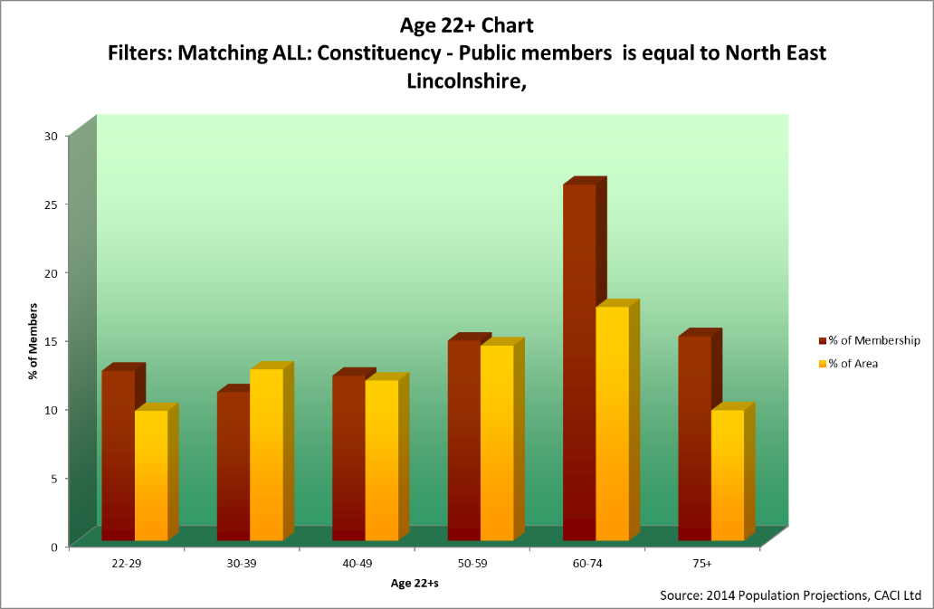  Accord membership breakdown by age  Broad age band estimates for 2018 indicate the proportion of population in North East Lincolnshire, who are of working age (60.3 %) was lower than in Yorkshire and the Humber (62.4 %) and lower than England (62.6 %) as a whole. Currently around 20% of the NEL population are over 65 compared with 18% nationally.  Currently 90% of the current Accord membership are over 22 years of age (41% over 60 years), this trend has continued since the scheme was introduced. The membership does cover a wide spectrum of ages, however, when we look at the ages of the people who attend CCG engagement events (Way Forward & Accord Annual Members Meeting) and who take part in consultations etc, it is often the case that we receive limited responses/attendance from people of college & working age.  Part of our implementation plan to deliver this strategy will be to continue to strengthen our links with schools and colleges and increase participation by young people.
Deprivation |  | x |  | North East Lincolnshire is ranked as the 31st most deprived local authority in England, out of 326 (increased from 46th in the ID 2010).  32,567 residents, which is approximately 20% of the population, 43 are classed as income deprived.  25% of LSOAs are in the 10% most deprived for income nationally.  15,140 residents are classed as employment deprived.  49% of the 106 LSOAs in North East Lincolnshire are ranked within the top 30% most deprived LSOAs in England. Of these, 29% of the 106 are ranked within the top 10% and 7% in the top 1%.  There are a higher number of Accord members from more affluent wards in NEL than there are from less affluent areas. The strategy seeks to actively promote or improve equality of opportunity by reaching out into community ‘We will come to the places where you are”.  The strategy also references our Volunteer Reimbursement policy which sets out how we will ensure people can afford to take part and engage with us.

This Equality Impact Risk Analysis was completed by: (Name and Department) Sally Czabaniuk, Communications and Engagement

Action Planning:
As a result of performing this analysis, what actions are proposed to remove or reduce any risks of
adverse outcomes identified on employees, service users or other people who share characteristics
protected by The Equality Act 2010 ?
Identified Risk: | Recommended Actions: | Responsible Lead: | Completion Date: | Review Date:
Under representation of men in Accord membership scheme and other engagement activites (survey’s) | Carry our targeted work to community and membership groups such as ‘Men in Sheds’ and sports organisations to increase awareness of engagement opportunities | Sally Czabaniuk | December 2020
Lack of engagement with ‘seldom heard’ groups | Targeted outreach work with BME/LGBT and faith groups | Sally Czabaniuk | December 2020
Young people not being engaged/involved | Targeted work to strengthen our links with schools and colleges and increase participation by young people. | Sally Czabaniuk | December 2020
Lack of engagement with ‘seldom heard’ disabilities groups/individuals (LD/MH) | Targetted work to build links with people/groups with disabilities such as Mental Health and Learning Disabilty | Sally Czabaniuk | December 2020

Completion Notes:

Analysis Ratings: | After completing this document, rate the overall analysis as follows:  Red: As a result of performing the analysis, it is evident that a risk of discrimination exists (direct, indirect, unintentional or otherwise) to one or more of the nine groups of people who share Protected Characteristics. It is recommended that the use of the policy be suspended until further work or analysis is performed.  Red Amber: As a result of performing the analysis, it is evident that a risk of discrimination exists (direct, indirect, unintentional or otherwise) to one or more of the nine groups of people who share Protected Characteristics. However, a genuine determining reason may exist that could legitimise or justify the use of this policy and further professional advice should be taken.  Amber: As a result of performing the analysis, it is evident that a risk of discrimination (as described above) exists and this risk may be removed or reduced by implementing the actions detailed within the Action Planning section of this document.  Green: As a result of performing the analysis, the policy, project or function does not appear to have any adverse effects on people who share Protected Characteristics and no further actions are recommended at this stage.
Equality Data: | Equality data is internal or external information that may indicate how the activity being analysed can affect different groups of people who share the nine Protected Characteristics – referred to hereafter as ‘Equality Groups’.  Examples of Equality Data include: (this list is not definitive)  1: Application success rates Equality Groups  2: Complaints by Equality Groups  3: Service usage and withdrawal of services by Equality Groups  4: Grievances or decisions upheld and dismissed by Equality Groups
Legal Status: | This document is designed to assist organisations in “Identifying and eliminating unlawful Discrimination, Harassment and Victimisation” as required by The Equality Act Public Sector Duty 2011. An Equality Impact Analysis is not, in itself, legally binding and should not be used as a substitute for legal or other professional advice.
Genuine  Determining  Reason | Certain discrimination may be capable of being justified on the grounds that:  - A genuine determining reason exists  - The action is proportionate to the legitimate aims of the organisation  Where this is identified, it is recommended that professional and legal advice is sought prior to completing an Equality Impact Analysis.

