Freedom of Information (FOI) Quarter One Report
NHS North East Lincolnshire Clinical Commissioning Group (CCG)
Quarter One 2020/2021 report covering the period: 1 April to 30 June 2020
Freedom of Information Delivery Manager

INTRODUCTION

This report provides the Quarter One position for Requests received by NHS North East Lincolnshire Clinical Commissioning Group (CCG) under the Freedom of Information Act 2000 (FOIA) from 1 April to 30 June 2020, a comparison against the previous Quarter and the same period in 2019/2020. It also provides the cumulative year position 2020/2021- and 2019/2020-Year comparison.

Volume of Requests – Timeliness of Responses

 | Quarter 1  2019/20 | Quarter 4  2019/20 | Quarter 1 2020/21 | Quarter 2  2020/21 | Quarter 3  2020/21 | Quarter 4  2020/21 |  | Year to Date Comparison
Requests Received | Jan - Mar 2020 | Jan - Mar 2020 | Apr – Jun 2020 | Jul – Sep 2020 | Oct– Dec 2020 | Jan - Mar 2021 |  | 2019/20 | 2020/21
Total number of FOI requests received: | 67 | 60 | 32 |  |  |  |  | 67 | 32
Total Number of FOIs Processed | 67 | 59* | 32 |  |  |  |  | 67 | 32
Requests processed within 20 working days | 67 | 59* | 32 |  |  |  |  | 67 | 32
Percentage processed FOIs Completed within 20 working days | 100% | 100% | 100% |  |  |  |  | 100% | 100%
Average time taken to process (days) | 17 | 16 | 15 |  |  |  |  | 17 | 15

* Clarification was requested and not received therefore closed.

Quarter One 2020/2021 saw a decrease of 45.8% in the number of FOIA requests received and processed compared to the number of requests received and processed in Quarter Four 2019/2020 and the average number of days to process the requests decreased to 15 days.

Against the same period in 2019/2020 there has been a 52.2% decrease and the average number of days to process the requests also decreased. All requests processed during the Quarter were completed within the statutory 20 working day deadline.

It is assumed that the decrease in the number of requests during the period was due to the Covid-19 Pandemic. However, despite a level 4 emergency being declared, the CCG continues to maintain the FOI service and responses are provided within the statutory timeframe.

Subject Area of Request

The CCG receives a variety of FOI requests on various topics and in some cases, they contain multiple questions for various types of information. They are diverse and singular, however the predominant subject area in Quarter One was COVID-19 with 6 requests, followed by Continuing Healthcare Services with 5 requests also proving a popular topic.

For a full illustration of the various topics for Quarter One please see Appendix One.
Outcome of Requests Processed

The outcome of the 32 requests processed in Quarter One is illustrated below:

Quarter 1
Information was Held and Disclosed in Full 22 - 69%
Information was Held and Refused in Full as Exempt 1 - 3%
Information not provided as not held by the CCG 3 - 9%
Partially disclosed as not held by CCG or Exemption(s) applied 6 - 19%
Total Number of Requests 32

The chart below displays the proportion of requests by Outcome for the Quarter.

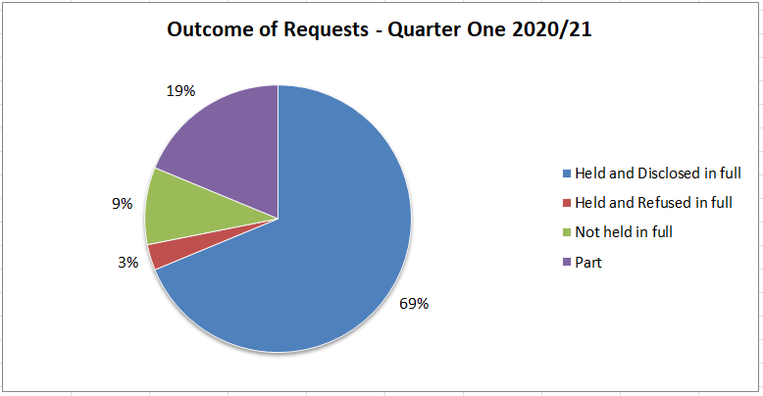

During Quarter One 2020/2021, of the 28 requests processed; 13% - 4 had one or more exemptions applied to the request.

The following table illustrates the number of instances information was not disclosed and the reason for refusal / exemption applied during the Quarter. During Quarter One the most commonly applied exemption was Section 12, which demonstrates the CCG is able to apply FOIA exemptions when a request would exceed the appropriate cost limit and provide reasonable advice and assistance to refine the request as appropriate.

Exemption / Reason for Refusal Quarter One | Number of instances applied
Section 12 - Cost of compliance | 3
Section 40 - Personal Information | 1
Total | 4

The CCG has a duty under Section 16 to provide advice and assistance to individuals making requests for information under FOIA. In instances where the CCG does not hold the information requested or when information is accessible by other means, the CCG will advise applicants as to which organisation may hold the information. The table below shows which organisation(s) were highlighted as sources of information and on how many occasions during the Quarter.
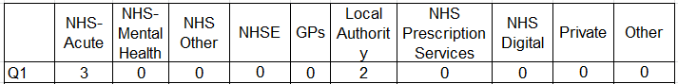

Category of Requester

In accordance with the FOIA, the CCG maintains an ‘applicant-blind’ approach when providing information in response to requests. Where possible the type of FOI requester is recorded by the FOI team to help identify where the main demand for information originates.

As shown in table and chart below; the main types of requester appear to be Individual Members of the Public in this Quarter.

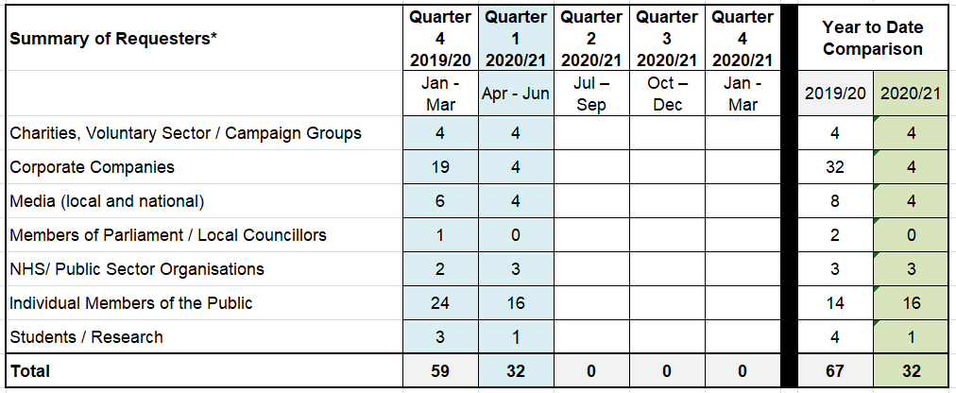
*Figures based on completed requests.

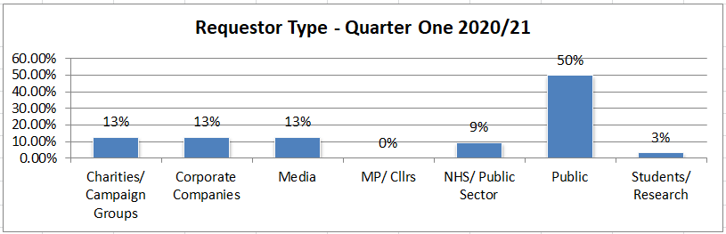

Internal Reviews

There were no Internal Review requests received in Quarter One between 1 April and 30 June 2020.

Training

No Freedom of Information Act specific training sessions were provided during Quarter One During 2020/2021 the FOI team plan to review and update a two page ‘Quick Guide to FOI’ to help staff understand their responsibilities under FOIA. The Guide will be circulated during Quarter Two. FOI general or specific training is available from the FOI Team on request.

Customer Feedback

The FOI Team provide an electronic survey link for the collection of anonymous feedback which is sent with every FOI response email. During Quarter One only two were returned. The feedback was very positive in all areas, receiving Very Good for; Ease of understanding the response, Quickness of response, CCG website information, Publication Scheme and Format of Response. The ratings given for Quality of Service Provided; were both 6 and Overall Helpfulness; 6 and 5 based on rate of 1–6, with 6 being Very Helpful and 1 being Unhelpful. No additional feedback was provided. More information can be found in Attachment One.

During Quarter One 2012/2021, the FOI team also sought feedback from the individuals and teams within the CCG that have been involved in the FOI process, either by supplying information to satisfy a request and/or approving responses for distribution during 2019/2020.

The feedback provided was very positive with the average scores, on a scale of 1-6 where
6 being: Excellent and 1 being: Very Poor, the scores were:

5.53 The Approachability of the FOI Team.
5.47 Helpfulness of the FOI Team.
5.42 The Overall Experience.

The team received complimentary comments on for their professionalism, friendliness, approachability, accessibility, helpfulness and lovely customer service currently and always readily available for help and support as well as compliments for the overall service provided; great service, no suggestions to improve. More information can be found in Attachment Two.

The feedback suggested areas for improvement:
- Review process with regard to identifying the correct person to provide the response and the turnaround time given for complex requests or where the response is held on behalf of the CCG by another body or an integrated department.
- Opt for more verbal communication when chasing requests, rather than using email.
- Providing training on interpreting FOI requests.

The FOI Quarterly Reports have been published on the CCG website once approved at the relevant Committee for some time and currently contains Reports from 2018/2019 to 2019/2020. Recently it was agreed that the publication of each Report will be highlighted to all CCG staff in the Staff Newsletter along with a web link. The first report included in the July/ August staff newsletter was the Quarter Four/2019/2020 Year End Report.

Decision Notices - Information Commissioners Office (ICO) and News

Appendix Two shows the ICO’s health related Decision Notices for the quarter and Decision Notices relating to Adult Social Care for the quarter.

The COVID-19 Pandemic has continued to affect the NHS and FOI during Quarter One. As the UK’s response to COVID-19 continues to evolve towards recovery, The Information Commissioner has continued to make changes to adapt the regulatory approach with regard to Freedom of Information and Data Protection and published it on the ICO website as changes were made in order to provide up to date information. The ICO have remained pragmatic and empathetic to the pressures faced by public authorities and continues to be supportive and offer advice on responding to the challenges of the pandemic. More information can be found on the ICO website at: https://ico.org.uk/about-the-ico/news-and-events/icos-blog-on-its-information-rights-work/

In line with the guidance, the FOI Team continue to advise requesters of the ICO regulatory approach in the acknowledgment along with reassurance of our continued commitment. We have also continued to support and assist CCG staff, who provide information for FOI requests and have maintained 100% compliance with FOIA response times during the Quarter.

Freedom of Information Delivery Manager
Quarter One: 1 April 2020 to 30 June 2020

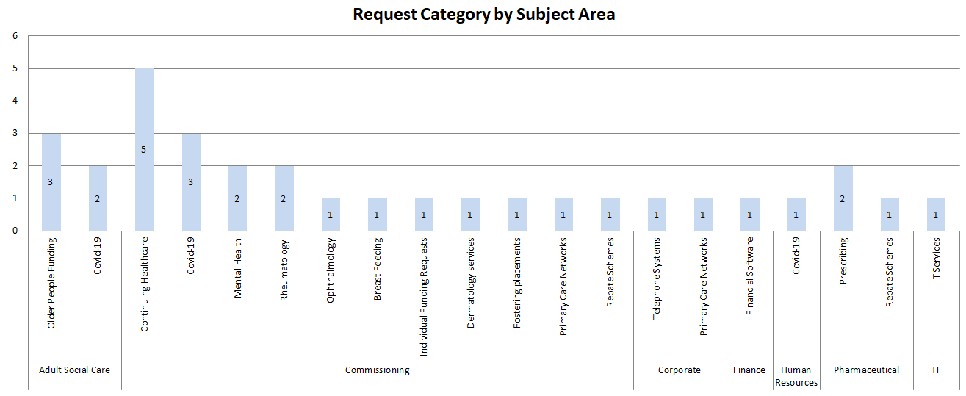

DECISION NOTICES
Appendix Two
Health Related (11 in total)
1 April – 30 June 2020

NHS Supply Chain Coordination Ltd
29 Jun 2020, Health
The complainant has requested information from NHS Supply Chain Coordination Ltd (“SCCL”) about the volume, units, quantity and revenue of certain product lines it sold in 2017 and 2018. SCCL initially withheld all the information under section 43(2) but subsequently disclosed information regarding the first three items. It continued to cite section 43(2) for the revenue information. The Commissioner’s decision is that SCCL has correctly withheld the requested information under section 43(2) but that in providing information late, SCCL breached section 10(1) of the FOIA. The Commissioner does not require the public authority to take any further steps.
FOI 43(2): Complaint not upheld FOI 10(1): Complaint upheld

Decision notice FS50886190 PDF (1k)

North Cumbria Integrated Care NHS Foundation Trust
25 Jun 2020, Health
Through an eight part request to North Cumbria Integrated Care NHS Foundation Trust (NCIC), the complainant has requested information on various types of complaints and concerns that may have been raised about NCIC and its consultants, and information about one of NCIC’s contracts. NCIC addressed the parts of the complainant’s request: releasing information it holds, confirming where it does not hold relevant information and directing him to its website where other information is published. The complainant considers that NCIC holds further relevant information. The Commissioner’s decision is as follows: On the balance of probabilities, NCIC does not hold recorded information relevant to parts 4, 5, 7 and 8 of the request and has released all the information it holds that is relevant to part 3. As such, NCIC has complied with section 1(1) of the FOIA in relation to those parts. The information the complainant has requested in parts 1, 2 and 6 is exempt information under section 21(1) of the FOIA as it is accessible to him by other means. In relation to the section 21 exemption, NCIC breached section 17(1) of the FOIA as its refusal notice was inadequate. The Commissioner does not require NCIC to take any remedial steps.
FOI 17: Complaint upheld FOI 21: Complaint not upheld FOI 1: Complaint not upheld

Decision notice FS50891138 PDF (1k)

Kingston Hospital NHS Foundation Trust
20 Jun 2020, Health
The complainant has requested information in relation to the medication Midazolam and serious incident reports. Kingston Hospital NHS Foundation Trust (the Trust) considers the request to be vexatious under section 14(1) of the FOIA. The Commissioner’s decision is that the Trust has correctly cited section 14(1) of the FOIA in response to the request. The Commissioner does not require any further steps to be taken as a result of this decision notice.
FOI 14: Complaint not upheld

Decision notice FS50837460 PDF (1k)

Barts Health NHS Trust
18 Jun 2020, Health
The complainant requested information relating to a particular information governance breach. Barts Health NHS Trust (the Trust) refused to comply with the request and cited section 14(1) of the FOIA (vexatious requests) as its basis for doing so. The Commissioner’s decision is that The Trust was not entitled to rely on section 14(1) to refuse the request. She also finds that the Trust breached section 10(1) of the FOIA by failing to provide its substantive response to the request within the statutory timescale of 20 working days. The Commissioner requires the Trust to issue a fresh response to the request which does not rely on section 14(1) of the FOIA.
FOI 14: Complaint upheld FOI 10: Complaint upheld

Decision notice FS50872020 PDF (1k)

Dicconson Group Practice
18 Jun 2020, Health
The complainant has requested information about complaints from Dicconson Group Practice (DGP), for the years 2009 to 2019. DGP did not release some of the relevant information it holds, it released other information and appeared to advise that it does not hold relevant information for two of the years requested. The Commissioner’s decision is that: DGP’s response to the request breached section 1(1)(a) and 1(1)(b) of the FOIA but it holds no further information falling within the scope of the complainant’s request. DGP’s response breached section 10(1) and section 17(1) as it did not comply with section 1(1) or provide a refusal notice for an element of the request within 20 working days. The Commissioner requires DGP to take the following step to ensure compliance with the legislation: Re-issue to the complainant the ‘Internal Review’ it says it had originally sent to him on 6 October 2019. As well as the two pdf documents, this communication should include the two Excel documents also discussed at paragraph 27 of this notice. Where it is not currently clear, DGP should identify each of the years the complaints information included across the two Excel documents covers.
FOI 17: Complaint upheld FOI 10: Complaint upheld FOI 1: Complaint upheld

Decision notice FS50853607 PDF (1k)

East Sussex and North Essex NHS Foundation Trust
12 Jun 2020, Health
The complainant has requested information on the awarding of a contract, including the options report, valuation report and legal advice. East Suffolk and North Essex NHS Foundation Trust (“the Trust”) provided some information but refused to provide the remaining information on the basis of the exceptions at regulation 12(5)(b) and 12(5)(e). The Commissioner’s decision is that the Trust has correctly applied the cited exceptions to the remaining information and the public interest favours maintaining the exception. The Commissioner requires no steps but does expect the Trust to disclose the additional information it is no longer seeking to withhold as set out in its submissions to the Commissioner.
EIR 12(5)(e): Complaint not upheld EIR 12(5)(b): Complaint not upheld

Decision notice FS50840962 PDF (1k)

Cambridgeshire and Peterborough NHS Foundation Trust
4 Jun 2020, Health
The complainant has requested a copy of a serious incident report. Cambridgeshire and Peterborough NHS Foundation Trust relied on section 40(2) of the FOIA to withhold the information. The Commissioner’s decision is that the Trust has correctly relied on section 40(2) of the FOIA to withhold most, but not all of the information. The Commissioner requires the Trust to take the following steps to ensure compliance with the legislation: disclose, to the complainant, the information identified in the Confidential Annex to this notice.
FOI 40: Complaint partly upheld

Decision notice FS50900864 PDF (1k)

Care Quality Commission
6 May 2020, Health
The complainant has requested information on a whistleblowing concern sent to the CQC. The CQC withheld some of the information on the basis of section 40(2), 44(1)(a) and 31(1)(g). The CQC also refused to confirm or deny if some of the information was held under the exclusions at these same exemptions. The Commissioner’s decision is that the CQQ has correctly withheld information at parts a) and b) of the request under section 31(1)(g) of the FOIA and has correctly refused to either confirm or deny if the information at parts c), d) and e) is held by virtue of the exclusion at section 31(3) of the FOIA. She does not require the CQC to take any steps.
FOI 31: Complaint not upheld

Decision notice FS50861021 PDF (1k)

East London NHS Foundation Trust
24 Apr 2020, Health
The complainant has requested information relating to ECT, serious incidents, restraints and seclusion. The Trust provided information relating to ECT but refused to comply with the requests relating to serious incidents, restraints and seclusions as it said it would exceed the cost limit under section 12 FOIA to do so. The Commissioner’s decision is that the Trust was correct to apply section 12 FOIA and that it was not therefore obliged to comply with the requests. The Commissioner does not however consider that the Trust provided the complainant with appropriate advice and assistance in accordance with its obligations under section 16 FOIA. The Commissioner requires the public authority to provide the complainant with appropriate advice and assistance in accordance with its obligations under section 16 FOIA. Information Tribunal appeal EA/2020/0163 under appeal.
FOI 12: Complaint partly upheld FOI 16: Complaint partly upheld

Decision notice FS50878182 PDF (1k)

Cambridgeshire and Peterborough Clinical Commissioning Group
7 Apr 2020, Health
The complainant has requested Cambridgeshire and Peterborough Clinical Commissioning Group (the CCG) to disclose information relating to an IT trainer vacancy; information including the application forms and supporting information of all those shortlisted, the completed interview question, answer sheets and scorecards for those shortlisted, whether the preferred candidate had previous NHS experience or connections with the CCG and whether they started on the opening salary for the grade. The CCG disclosed some information to the complainant, cited section 12 for one element of the request and refused to disclose the remainder under section 40 of the FOIA. During the Commissioner’s investigation the CCG withdrew its application of section 12 and disclosed the requested information to the complainant. In relation to this element of the request, the Commissioner has recorded a breach of section 1 and 10 of the FOIA, as the CCG failed to disclose information to which the complainant was entitled within 20 working days of receipt. In relation to the application of section 40 of the FOIA, the Commissioner’s decision is that the CCG is entitled to withhold the remaining requested information in under this exemption. The Commissioner does not require the CCG to take any further action.
FOI 10: Complaint upheld FOI 40: Complaint not upheld FOI 1: Complaint upheld

Decision notice FS50861656 PDF (1k)

Care Quality Commission
2 Apr 2020, Health
The complainant has requested the Care Quality Commission (CQC) to disclose all the information it holds relating to production and subsequent withdrawal of fixed penalty notices issued at three locations. Initially, the CQC refused to confirm or deny if the recorded information is held citing section 44(2) of the FOIA. During the Commissioner’s investigation, however, this was withdrawn and replaced by section 31(3). The Commissioner’s decision is that the CQC is entitled to refuse to confirm or deny whether the recorded information is held in accordance with section 31(3) and she is satisfied that the public interest rests in maintaining this exemption. The Commissioner does not therefore require any further action to be taken.
FOI 31: Complaint not upheld

Decision notice FS50859838 PDF (1k)

DECISION NOTICES
Keyword: Adult Social Care (2 in total)
1 April – 30 June 2020

North Yorkshire County Council
17 Jun 2020, Local government
The complainant has requested proof held by the council that her late mother informed the council that it should not provide her with information on her care. The council did not respond to the request on the basis it had responded to a similar request previously. She therefore complained that the council did not respond to her request for information. She also complained that the council was withholding information on the basis that section 41 of the Act applies (information held under a duty of confidence). The Commissioner’s decision is that the council was correct to apply section 41 to withhold the information from disclosure. She has also decided that the council was correct to apply section 14(2) and refuse to respond to the request as required by section 1(1). The Commissioner does not require the council to take any steps.
FOI 14(2): Complaint not upheld FOI 41: Complaint not upheld

Decision notice FS50903366

Northamptonshire County Council
15 Jun 2020, Local government
The complainant has asked Northampton County Council for all documents which relate to the investigations of the Adult Safeguarding Team following the death of her mother. The Council initially refused to disclose some of the information it holds in reliance on section 40(2) of the FOIA, on the grounds that the withheld information constitutes the personal data of third part individuals. During the Commissioner’s investigation the Council also confirmed its additional reliance on section 41(1)(a) of the FOIA. The Commissioner’s decision is that Northampton County Council has properly applied sections 40(2) and 41(1)(a) of the FOIA to the information it is withholding.
FOI 40: Complaint not upheld FOI 41(1): Complaint not upheld

Decision notice FS50893309

