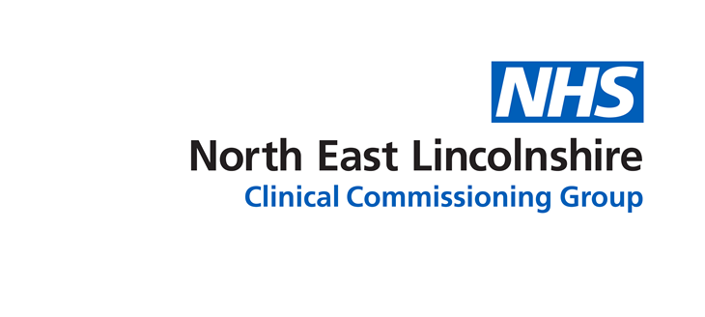

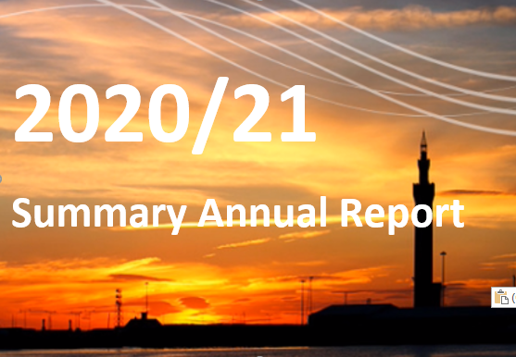

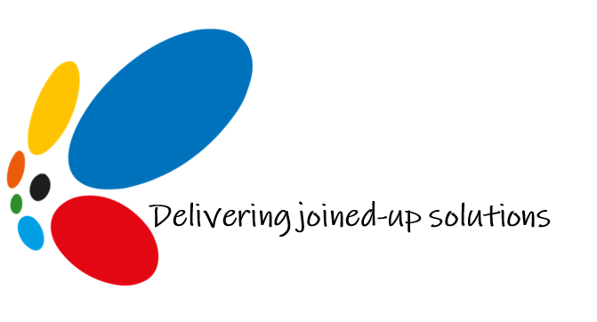

Introduction
This year our Annual Report and Accounts was prepared as North East Lincolnshire took its first steps out of the UK’s third Lockdown. This has been a series of tough social measures aimed at suppressing a second wave of coronavirus infections, hospitalisations and, sadly, deaths to give the NHS the opportunity to push out the unprecedented national COVID vaccination programme. Achieving the ambitious vaccination target will without doubt save many, many lives. It will also accelerate the restoration of elective and cancer care, support health and care staff to recover after working under a Level 4 Critical Incident for such an extended period of time and allow our population to spend quality time with family, friends and work colleagues again, taking part in the activities essential to their physical, emotional and mental health wellbeing. We are extremely proud of the health and care staff and volunteers who have enthusiastically risen to the challenge of rolling out the COVID vaccines in North East Lincolnshire. As of the end of March, more than 82,000 doses had been administered to adults in the Borough.
While the CCG is an NHS organisation led by family doctors and other clinicians, we also work closely with North East Lincolnshire Council under an arrangement we call the Union to make the most of the total money that is available to us to improve the health, care and support services that enable local communities to enjoy a good quality of life, recover from ill health as near home as possible, make healthier choices about their lives and stay active, engaged and independent for as long as they can. Much of this work is about how we can support local people to do more for themselves and for each other as communities. Together we recently launched Livewell, a bright, accessible new website that aims to make it easy for people to find the advice, information and support they need without going around the houses. There's also information on what to do if you are concerned about someone else’s wellbeing, interactive sections on living with dementia or a sensory impairment and a link into the new social prescribing portal for North East Lincolnshire which puts people in touch with practical support to help them overcome emotional or social difficulties that have come about as a result of health conditions.
During the past 12 months, working with other organisations has been more important than ever to manage the pandemic in our area and lessen the impact as much as possible on local people. The CCG has been part of the Humber-wide emergency response to COVID through the Local Resilience Forum (LRF) working with the local authorities, police, fire and port authority since the start of the crisis, and later part of the local authority led recovery work.
Alongside the organisations that provide health and care in North East Lincolnshire, the CCG is part of the NEL Health and Care Executive which has met weekly throughout the last 12 months to plan and manage the response. To reduce the spread of COVID-19, some local health services had to be suspended to reduce footfall in clinical settings and risky face-to-face contact. Working as a system meant we could identify and take action to prevent harm from unintended consequences as much as possible.
Areas that worked well included:
- rapid rollout of digital solutions to support the delivery of essential services via remote working in the majority of cases, which helped to limit spread of the virus.

- working as an integrated system and embracing a digital 1st approach meant we were able to quickly implement innovative solutions to problems which could normally take years to fix.

- reducing the risk to people living in care home or receiving support at home by supporting providers through access to Personal Protective Equipment (PPE), testing symptomatic patients in homes and people returning to a home after a stay in hospital, providing digital solutions to support remote GP consultations, moving staff from other organisations to tackle shortages due to staff self-isolating and system wide support on hand to help care homes with any other emerging issues.

- a collective response to sourcing PPE such as face masks, goggles, gloves and aprons and distributing across the health and care providers as needed to ensure no one ran out.

- early recognition of the mental health impact of COVID19 on staff and the wider population which led to the establishment of an 24/7 all-age mental health support line, which can be accessed by all.

- system planning in relation to staffing and an agreement as to where staff would be deployed should the pandemic impact significantly locally.

- agreement to quickly bring online extra community capacity in partnership across the CCG, Council and Care Plus Group, and the other partners to support step down from hospital, and step up from community, including support to care homes, where needed.
While many positives and better ways of working, such as those highlighted above, have come out of the pandemic, it is very clear that life has changed irrevocably for many people as a result.
We also must not forget that COVID-19 will be with us for a long time to come and the impact of the pandemic will be far reaching. As it becomes clearer what our “new normal” will look like and how all our lives will adapt around the continued presence of the virus, the CCG and its partners must now build on what we have learned during the height of the pandemic to transform the delivery of care and support, to accelerate the restoration of those services that had to be suspended or reduced to keep patients safe and meet the needs of those fighting the terrible effects of the virus. We also must manage the increasing demand on mental health services and NEL CCG remains committed to delivering the Mental Health Investment Standard.
While, against a challenging backdrop, the CCG has once again been rated “Good” by NHS England, we know there are areas where our local health and care system needs to make improvements in both the short and long terms and we must drive these positive changes forward.
Our full Annual Report addresses in detail some of the difficulties that we and our partners face, along with what we are doing as a local system and a wider health and care partnership to address them. This is summarised in the Health Check section of this document. Some of our challenges are national ones and are faced by organisations across the country. We also need to address these at a local level and ensure that people of all ages continue to have access to safe, quality and caring services and live within communities that support them to enjoy the best wellbeing possible through access to a decent job, a decent place to live and the prospects a decent education bring.
We continue to work with neighbouring CCGs in North Lincolnshire, the East Riding of Yorkshire and Hull as well as organisations in our wider region to plan those services that fortunately fewer patients need or need less often, such as hospital treatment for very serious illnesses or critical injuries.
All of this is underpinned by the NEL Commitment to involving local people in our plans and supporting our communities to play the most active role possible in the way we make decisions. The CCG received its third Green Star (the highest rating possible) this year for how it meets its duty to involve the public in health and care issues and this is something we remain very proud of.
Once again would like to place on record our sincere thanks to our entire team, including clinicians, support staff, managers, community members and our partners in the local health and care system and beyond for their continued support over the past 12 months.

Dr Peter Melton
Clinical Chief Officer

Rob Walsh
Chief Executive NELCCG/NELC

Mark Webb
CCG Lay Chair

About this document
NHS organisations like the CCG have a duty to keep the public up to date with their activities by publishing an annual report and financial accounts at the end of each financial year.
This document is a summary that can be read on its own. However, more detail about our performance, the way we make decisions and our structure and staffing is available in the full Annual Report where our Annual Accounts for the year 2020-2021 are also to be found.
Reducing the impact our organisation has on our environment is extremely important to us and we no longer routinely produce large, printed documents like the annual report and accounts. However, a printed copy can be provided on request. The information contained in the report will also be made available in other languages and in different formats such as audio, large print and Braille if needed.
For more information or to ask us for a copy of the report in a format you find more suitable to access please contact us at the address at the end of this section.

Who we are and what we do
CCGs are made up of GPs, other people who are employed in health or care and members of the public who do not work for the NHS. Together they look at what the local population needs and plan and buy those services. Our CCG is led by GPs representing 26 practices who provide health services to families living in Grimsby, Cleethorpes, Immingham and rural North East Lincolnshire, supported by a team of non-clinical staff who carry out the day-to-day running of the organisation. We are accountable to our members, patients and our local communities and are overseen by NHS England and NHS Improvement, a single organisation that supports the NHS and helps us to improve care for patients.
CCGs are allocated a sum of money to spend on health services each year based on the overall health and wellbeing needs of the (just under) 160,000 people who live in our area. This money has to pay for a wide range of services. These are services such as life-saving emergency care, the treatment of acute physical and mental illnesses, routine family health care and managing long term health difficulties such as dementia, heart and breathing problems, diabetes and their complications.
Our CCG is unique in England because we also commission care services for adults who need practical support due to illness, disability or old age (Adult Social Care). The CCG receives funds from North East Lincolnshire Council (NELC) to pay for Adult Social Care.
The range of NHS services commissioned for our population is set out in the Health and Social Care Act 2012. The CCG and council have a strong and established partnership, the governance of which is underpinned by a s75 agreement, a statutory provision that governs arrangements between NHS organisations and local authorities allowing them to operate pooled budgets at a local level, as well as Integrated Commissioning arrangements.
Like all other CCGs, we are not responsible for commissioning preventative or some very specialist health services.
The CCG has delegated responsibility for commissioning primary care services.
We work with our partners in the Council and Public Health, as well as with a panel of knowledgeable volunteers from the local community (known as the Community Forum) and the organisations that provide health care, to understand local needs and decide how to best use the money allocated to us.
Planning and buying health and adult social care services together means we can use the total funds we receive to get the very best value for money. It also means we can make the way that services are delivered across health and social care much more “joined up” which helps us to make sure people do not experience wasteful and frustrating duplication of services and minimises the risk of people falling through gaps in services.
The CCG Constitution sets out the membership of the CCG and describes the rules and the internal controls (governance) that ensure quality. Patient safety, effectiveness of care and the experience of people who use commissioned services are at the heart of everything we do.
In 2020/2021, the CCG was allocated £301.5 million by NHS England. This includes £28.5 million to support delegated Primary Care and £3.5 million to pay for the management and operation of the organisation which leaves a total of £269.5million to pay for health services.
The income to fund Adult Social Care is set by North East Lincolnshire Council as part of its annual resource and priorities process, and in 2020/2021 the CCG received £46.5 million.

Our plans
Our plan for the coming year will naturally focus on the ongoing management of the consequences of the COVID-19 pandemic and ensuring that services to patients continue in the best possible way
This will include managing our local delivery of the national vaccination programme for coronavirus and reinstating as many of the pre-COVID services as the capacity in health and care will allow.
Having responded admirably to the challenges of the pandemic our local services adapted to include a range of care and services delivered remotely and online – we plan to take the learning from this experience and include this effective way of working in our future delivery.
Alongside the focus on COVID recovery we will continue to respond to what local people need and reflect the work set out in both the Union strategic plan. What we do in North East Lincolnshire also has to take into account national ideas to improve the way the NHS works.
We plan to continue to work with our statutory partners across Humber Coast and Vale and to contribute to the creation of the Integrated Care System which will co-ordinate care in an even more integrated way in our geographical area.
This will support the different organisations who work together to either plan or deliver health and care in an area (the health and care system) to continue to deliver high-quality care to their communities but in a way that is much less legally bureaucratic, more accountable and more joined up. This will be done by bringing the NHS, local government and partners closer together to provide for the needs of their communities as a whole. this has come at a unique point in time when organisations in North East Lincolnshire have never worked so closely together as we continue to tackle COVID-19 in our community. Over the last 25 years, we have an established track record of working together to improve health outcomes and reduce inequalities by making the most of our shared experience and efficiencies. The new organisational arrangements will support our ambition to embed this integration at the heart of our system.
We will work with organisations across the Humber, Coast and Vale area to tackle the big issues that cause problems for people living in North East Lincolnshire. Working with different health, care and voluntary organisations will help us see where we can be more efficient and spend our limited financial resources to the best advantage, as well as making sure our population gets the best possible clinical care. The Humber Coast and Vale Integrated Care System is made up of six NHS CCGs and six local authority boundaries representing our communities here in North East and North Lincolnshire alongside Hull, East Riding, York and Scarborough and Ryedale. Working together like this will let us share resources in areas where we are currently stretched, providing a better service to patients. Support services such as finance can be shared to make things more efficient and save money. You can find out more by visiting the Humber Coast and Vale website.
Most of the things we do, however, will aim to deliver the best care we can locally, shaped around what the people in our area really need.
The CCG adopts an integrated approach to risk management which enables consideration of the potential impact of all types of risks on processes, activities, stakeholders and commissioned services. The CCG Risk Management Framework provides strategic direction and guidance on embedding the integrated risk management approach in all CCG business. Further analysis of the main risks can be found in the risk assessment section of the Annual Governance Statement in the full Annual Report.

Health check
Measuring our performance helps us make sure services are being delivered both to a high-quality standard and providing value for money. The CCG has internal processes to manage performance against a range of national and local indicators, including a way of working with internal and external colleagues to identify areas of risk and implement action plans to mitigate these and ensure improvements are delivered. Throughout the year reports go to our Governing Body that set out our performance against the agreed local and national measures so we can ensure we are meeting our commitment to ensure the decisions and actions we take improve healthcare for the people of North East Lincolnshire and ensure patients receive the highest quality health and social care. These reports can be found on our website.
The following section is a summary of how our local health system performed against its targets in 2020-21.
Looking back on our overall performance over the year, we have continued to meet or exceed national targets in some areas such as certain cancer and mental health waiting times measures. We have also continued to meet our targets across several of the Adult Social Care measures.

However, the coronavirus pandemic and the increased demand for NHS services in 2020/21 has been the most serious challenge the NHS has ever experienced. Although we had planned to meet all national planning standards and commitments, this has not been possible for some of the services we arrange for the people of North East Lincolnshire because of the pandemic. This means a number of our measures have had revised targets for September 2020 to March 2021 due to the COVID-19 pandemic as directed by national guidance from NHS England.

Some of our key challenges include:

- A&E waiting times

The numbers of people attending A&E have continued to increase up to (and exceeding in some cases) our pre-COVID levels. There has been a high number of seriously ill patients and challenges presented by the high numbers of COVID positive patients.

The organisations involved in health and care in North East Lincolnshire have worked together to manage this. Some of the actions taken include:

- Establishing a community discharge hub.
- Encouraging the public to think 111 First.
- Establishing 3 Primary Care Access Hubs to divert people with less acute health needs away from A&E into Primary Care via 111.

- Some cancer treatment waiting times

We continue to be actively involved in system wide work being undertaken by the HCV Cancer Alliance and ICS and plans are fully aligned to those of the National Cancer Policy Programme. The CCG continues to have input to the Humber Cancer Board, Regional Primary Care Strategy Group, and HCV CA System Board. Locally some of the actions being taken include:

  - Trust Cancer Restoration Plan in line with national guidance to restore demand, reduce waiting times and ensure sufficient capacity to manage future increased demand for follow up care.
  - Rapid Diagnostic Centre
  - PTL Lung Cancer Awareness Events held in North and North East Lincolnshire.
  - Colorectal recovery plan in place to reduce the backlog of this speciailty

- Referral to treatment waiting times

Referral to treatment waiting times have continued to decline over the year due to the COVID-19 impact. The proportion waiting less than 18 weeks is approximately 13% lower than the same time in the previous year and the number waiting over 52 weeks is 673 (previous year at the same time the number was 5) and these numbers are on a significantly lower referral rate due to COVID-19 impact. The Trust have been utilising the independent sector for ophthalmology and the expectation is that they will continue to support them over the forthcoming year and funding may be given for extending capacity. However, there is a concern that more referrals which were delayed will come into the Trust which would impact on backlogs and waiting times further.

- People receiving psychological therapies

Proportion of people who have depression and/or anxiety disorders who receive psychological therapies – COVID-19 has impacted this measure and performance follows the national picture of reduced number of referrals and self-presentations. Future planned better integration with Primary Care and national communications are expected to help improve referrals.

Some of the key successes for the CCG in 2020/21 have included:

- Other cancer waiting times continue to be achieved, both the two-week wait measures and three of the four 31 day wait measures.

- Several of our hospital activity measures that had revised targets for September 2020 to March 2021 due to the COVID-19 pandemic have been achieved such as referrals, elective spells and non-elective spells.

- Good progress has been made on the mental health targets with IAPT waiting times, IAPT Recovery and First Episode Psychosis treatment with NICE recommended package of care within two weeks of referral all above their respective national standards.

- Many of our adult social care measures continue to achieve the targets set such as people receiving a review, permanent admissions to residential and nursing care and people receiving self-directed support.

Our 2020-2021 objectives
The challenges of the global pandemic impacted significantly across the health and care system, including for the CCG. In terms of our corporate plan for the financial year 2021, we were forced to suspend work in several areas in order to respond effectively to the needs and constraints of COVID-19. These actions and priorities have been reviewed and revisited for 2021/22 and relevant workstreams will be picked up and pursued in the coming months.

Financial information
CCGs are accountable for how they spend public money. The financial performance in this year has built on the excellent performance of previous years, despite continued pressures on health and social care funding.

As part of the NHS response to COVID a different finance regime has been in place during 2020/21. In the first half of the year (months 1-6) a retrospective non-recurrent allocation adjustment equal to the overall year to date variance was enacted. As such all CCGs have reported a breakeven position. Two key elements of this revised finance regime were 1) Centrally mandated fixed value contract arrangements with NHS providers and 2) a claims process for additional costs linked to COVID. In the second half of the year (months 7-12) the Humber Coast & Vale Integrated Care System, which North East Lincolnshire CCG is part of, was issued with an allocation envelope and there was a requirement for the system to breakeven. This requirement was achieved. Mandated payments to NHS providers continued and there was a claims process in relation to hospital discharge funding.

The CCG has a range of statutory and operational duties and all these have been met.

Find out more
We hope you have found this a useful introduction to NHS North East Lincolnshire CCG and have gained an insight into our work during 2020-21.
The full Annual Report and Accounts provide a more detailed examination of our year and tell you a lot more about how the CCG is governed and its day-to-day operation. You can download this from our website.

How to get in touch with us
We are always keen to hear from the people who use health or care services in North East Lincolnshire as well as their carers or families. The experiences they share with us can help us to improve future services.

You can contact North East Lincolnshire CCG in the following ways:

By post: North East Lincolnshire Clinical Commissioning Group, Municipal Offices, Town Hall Square, Grimsby, DN31 1HU

By phone: 0300 3000 400

By email: nelccg.askus@nhs.net

Visit our website for more information about the CCG

Follow us on Twitter
Follow us on Facebook
We are also active on Instagram, look for nhs_nelccg

